3KNT FRETARNITY EXAMINATION
NAME ……………………………………………………………………………………………. ADM NO……………………………………..
SCHOOL ………………………………………………………………………………………….. INDEX NO …………………………………
TIME: 2 ¾ HOURS
MARCH/APRIL 2017
GEOGRAPHY
GEO 312 /2

INSTRUCTIONS TO CANDIDATES
- WRITE YOUR NAME AND INDEX NUMBER IN THE SPACES PROVIDED ABOVE.
- ANSWER ALL THE QUESTIONS IN SECTION A.
- ANSWER QUESTION 6 AND ANY OTHER QUESTION FROM SECTION B.
- ALL ANSWERS SHOULD BE WRITTEN IN THE ANSWER BOOKLET PROVIDED.

SECTION A (25MKS)
ANSWER ALL THE QUESTIONS IN THIS SECTION
1a) Give two uses of diamond. (2mks)
b) Identify three problems facing diamond mining in south Africa. (3mks)
2a) State 3 advantages of cultivating horticultural crops in green houses in Kenya and Netherlands.(3mks)
b) Name 2 types of flowers grown in Kenya. (2mks)
3Use the map of East Africa to answer question a)

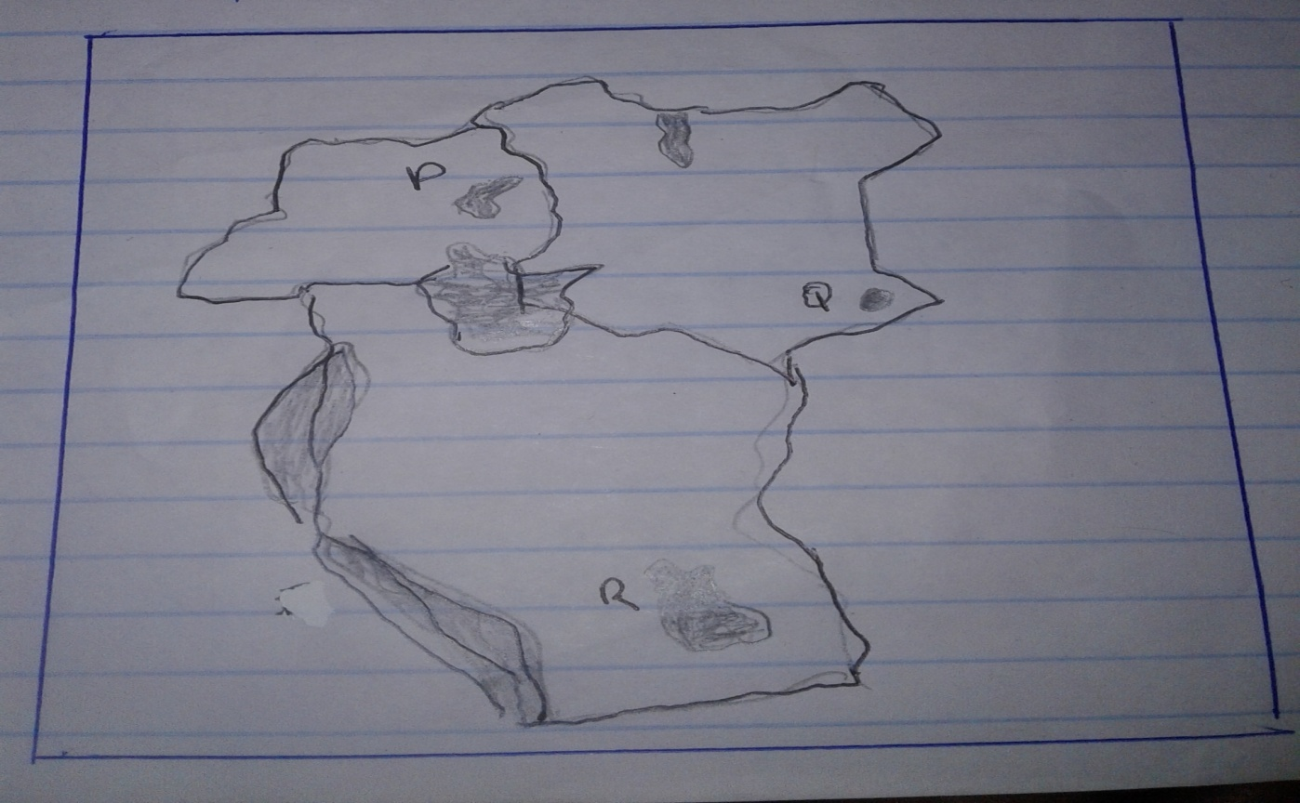
a)Name the game reserve marked P,Q and R. (3mks)
b) State 2 factors which influence the distribution of wildlife in East Africa. (2mks)
4a) Name 2 renewable sources of energy which are exploited in Kenya. (2mks)
B) State 3 advantages of using hydo-electric power. (3mks)
5a) what is industry inertia? (2mks)
b) Outline 3 causes of industrial inertia. (3mks)

SECTION B (75 KS)
ANSWER QUESTION 6 AND ANY OTHER TWO QUESTIONS FROM THIS SECTION
6. The table below shows the number of the tourists who visited Kenya from various parts of the world in 2005 and 2006. Use it to answer questions a) and b).
Place of origin | No. of tourists per year
 | 2005 | 2006
 | 942,000  120,000  97,000  94,000  19,000  29,000 | 965,000  154,000  128,000  103,000  24,000  41,000
 | 1,301,000 | 1,415,000
Ai) Which continent had the highest increase in the number of tourists visiting Kenya between 2005 and 2006. (2mks)
ii) Calculate the percentage increase of tourists from Australia and new Zealand between 2005 and 2006. (2mks)
iii) Draw a divided rectangle 15cm long te represent the number of tourists tat visited Kenya in 2006. Show your calculation.(8mks)
bi)State two advantages of using divided rectangle te represent geographical data. (3mks)
ii) Give 4 reasons why in 2005 and 2006 there were more tourists visiting Kenya from Europe compared to those from other parts of the world.(4mks)
c) Give 5 reasons why domestic tourism is being encouraged in Kenya. (6mks)
7ai) What is agroforestry? (2mks)
ii) Give 4 reasons why agro forestry is encouraged in Kenya. (4mks)
b) Use the map of Kenya below to answer questions bi) and ii).
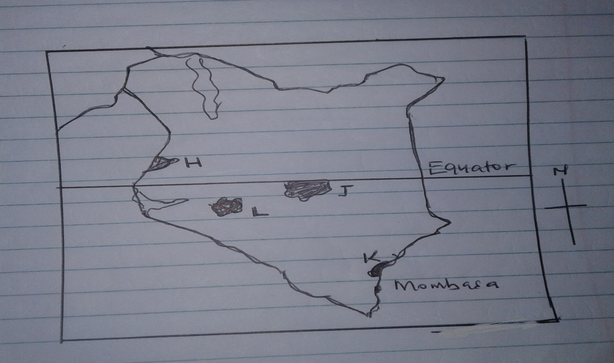
i) Name the forest reserves marked H,J and K. (3mks)
ii) Explain 4 factors that favour the growth of natural forest in the area marked L. (8mks)
c) Describe 4 measures that the government of Kenya is taking to conserve forests in the country. (8mks)
8ai) Define the term nomadic pastoralism. (2mks)
ii) State 4 factors that favoured nomadic pastoralism in Kenya. (4mks)
iii) Give 3 characteristics of nomadic pastoralism. (3mks)
b) Explain 4 problems faced by nomadic pastoralism in Kenya. (8mks)
c) Explain 4 efforts by the government of Kenya to improve nomadic pastoralism. (8mks)
9ai) Differentiate between land reclamation and land rehabilitation. (2mks)
ii) Name 4 ways in which land can be reclaimed in Kenya. (4mks)
b) Explain 4 factors which influenced the location of perkerra irrigation scheme. (8mks)
c) Outline 5 problems affecting the farmers in perkerra irrigation scheme. (5mks)
d) Give 3 differences between land reclamation in Kenya and I Netherlands. (6mks)
10a) What is fish farming. (2mks)
b) Explain 4 factors which favour fishing in the temperate regions. (8mks)
ci)Explain 3 methods of conserving fisheries. (6mks)
ii) State 4 problems that face inland fisheries in East Africa. (4mks)
d) Describe trawling fishing method. (5mks)

