NAME---------------------------------------------------------------------------INDEX NO.---------------
231/1
PHYSCIS PAPER 1 (THEORY) – 2017 2 HRS

INSTRUCTIONS TO CANDIDATES
a) Write your name and index number in the spaces provided above.
b) This paper consists of two sections A and B.
c) Answer all the questions in sections A and B in the spaces provided.
d) All working must be clearly shown.
e) Non-programmable electronic calculators may be used.
f) The paper consists of 18 questions.
g) Use English to answer the questions.

FOR EXAMINER’S USE ONLY

SECTION | QUESTION | MAX SCORE | CANDIDATE’S  SCORE
A | 1 – 13 | 25
B | 14  15  16  17  18 | 14  10  10  10  12

- The figure below shows water placed in a measuring cylinder calibrated in cm³.

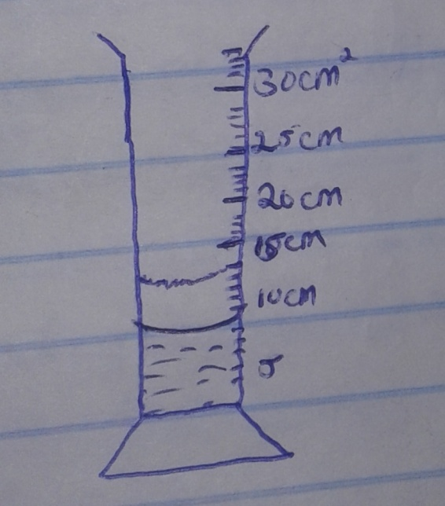

An object of mass 50.1g and density 16.7g/cm⁻³ is lowered gently in water. Indicate on the diagram the new level. (2mks)

2. A train of mass 200 tonnes starts from rest and accelerated uniformly at 1.5ms⁻². Determine its momentum after moving 200m. (3mks)

3. A body of mass M is allowed to slide down an inclined plane. State two factors that affect its final velocity at the bottom water. (2mks)

4. Determine the density of glass that weighs 0.5N in air and 0.3N in water. (density of water 1g/cm³) (3mks)

5. Explain why a pail of water can be swung in a vertical circle without the water pouring. (1mk)

6. The figure below shows the potential energy of a ball thrown vertically upwards varies with height.
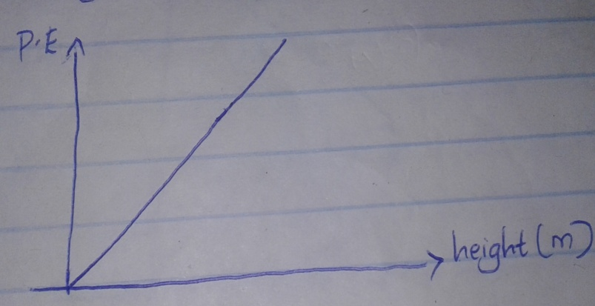

On the same axes plot the graph of kinetic energy of the ball. (1mk)
7. State why a pin floating on water sinks when a detergent is added. (1mk)

8. The reading on a mercury barometer at Mombasa is 760mm. Calculate the pressure at Mombasa in
Nm⁻². (Density of mercury is 1.36 x 10⁴Kgm⁻³) (2mks)

9. A house in which a cylinder containing cooking gas is kept unfortunately catches fire. The cylinder explodes. Give a reason for the explosion. (2mks)

10. A uniform mere rule is balanced at the 30cm mark when a load of 0.48N is hung at the zero mark. Calculate the weight of the metre rule. (3mks)

11. 3kg of hot water was added to 9kg of cold water at 10⁰C and the resulting temperature of the mixture was found to be 20⁰C. Ignoring the heat gained by the container, determine the initial temperature of the hot water. (Specific heat capacity of water = 4200JKg⁻¹K⁻¹) (3mks)

12. The figure below shows a cone tilted to the left. Explain why the cone will fail to the right when released. (1mk)

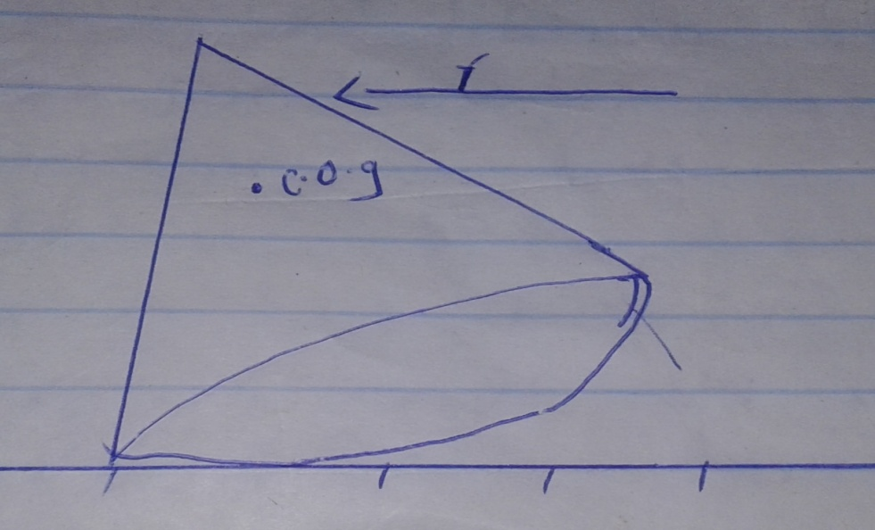

13. A boy of mass 50.0kg stands on a weighing balance in a lift which is accelerating upwards at 2.0ms⁻². Calculate the reading on the weighing balance. (2mks)

SECTION B (55MKS)
14. The figure below shows a heating curve of a substance W.

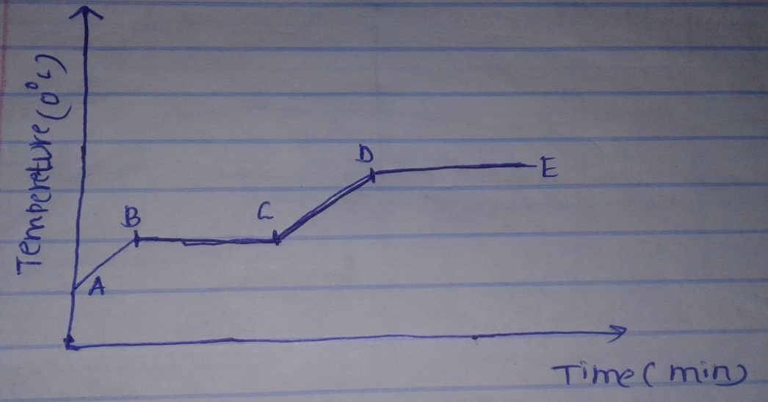

I Explain the shape of the graph between points;
i) B and C (1mk)

ii) D and E (1mk)

II define the term specific heat capacity. (1mk)

III A block of metal of mass 150g at 120⁰C is dropped into a lagged calorimeter of heat capacity 40Jk⁻¹ containing 100g of water at 40⁰C. The temperature of the resulting mixture is 46⁰C. Taking specific heat capacity of water to be 4200Jkg⁻¹K⁻¹ determine;
a) The heat gained by the calorimeter. (2mks)

b) The heat gained by water. (2mks)

c) The heat lost by the metal block. (2mks)

d) The specific heat capacity of the metal block. (3mks)

IV The boiling point of water is normally 100⁰C. A student heated some water and boiled it. He noticed that it boiled at 110⁰C. State two possible reasons for this high boiling point. (2mks)

15.a) State the law of floatation. (1mk)

b) The figure below shows a plastic disc floating to a depth of 0.12m in water.

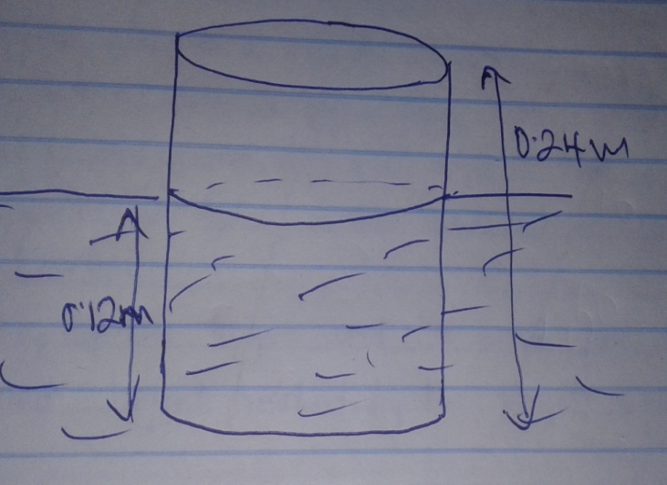

Determine;
i) The mass of the disc. (3mks)

ii) The density of the disc. (3mks)

iii) Determine the number of 10g coins which will make the disc to be just submerged if placed on it. (3mks)

16.a) What is the Brownian motion. (1mk)

b) Brownian motion of smoke particles can be studied by using the apparatus shown in the figure below. To observe the motion some smoke is enclosed in the smoke cell and then observed through a microscope.

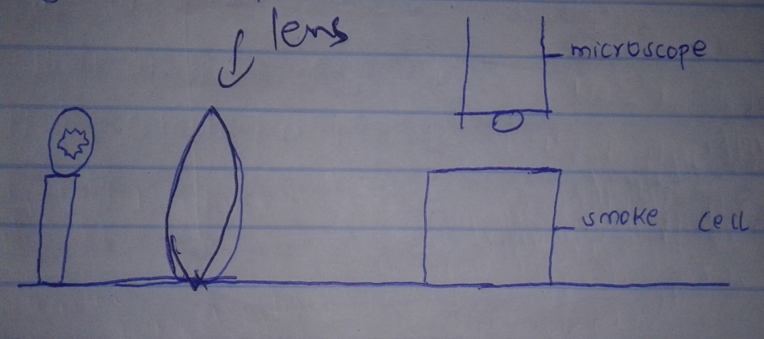

i) Explain the role of the smoke particles and the lens in the experiment. (2mks)

ii) State and explain the nature of the observed motion of the smoke particles. (2mks)

c)i) In an experiment to estimate the diameter of an oil molecule, an oil drop of radius 2.5 x 10m⁻⁴ spread over a circular patch of radius 0.1m. Determine the diameter of the oil molecule. (3mks)

ii) State two assumptions made on the question 16 c (i) above. (2mks)

17.i) a water pump, pumps 900 litres of water per hour from a reservoir 8m underground to a tank 4m above the ground, if the pump is operated on a 240V main supply and draws a current of 200mA, determine;
a) The work done by the pump in an hour. (3mks)

b) The power of the pump. (2mks)

c) The efficiency. (4mks)

ii) Suggest two methods of improving efficiency. (2mks)

iii) It is found that the power determined in this experiment is lower than the manufacturer’s value indicated on the pump. Explain. (1mk)

18.a) State two factors that must be kept constant for a gas to obey Boyles law. (2mks)

b) An air bubble rises from the bottom of a pond 20m deep until it reaches the top of the pond. The graph below shows variation of pressure exerted on the bubble with volume of the bubble.

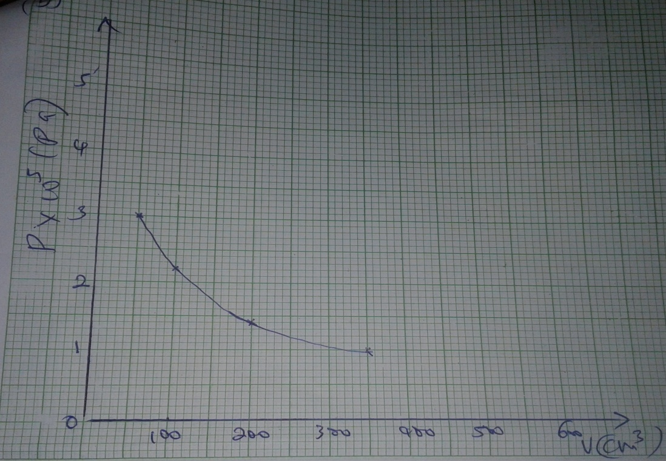

i) From the graph, determine the pressure exerted on the bubble and volume of the bubble at;
I The bottom of the pond. (2mks)

II The top of the pond. (2mks)

ii) Explain the shape of the graph. (2mks)

iii) Determine the atmospheric pressure at the place of the experiment. (2mks)

iv) Sketch in the space provided the graph of volume against reciprocal of pressure for the bubble. (2mks)

