NAME-----------------------------------------------------------------------INDEX NO.---------------
3KNT FRATERNITY EXAMINATIONS
231/2
PHYSCIS PAPER 2 (THEORY) – 2017 2 HRS

INSTRUCTIONS TO CANDIDATES
a) Write your name and index number in the spaces provided above.
b) This paper consists of two sections A and B.
c) Answer all the questions in sections A and B in the spaces provided.
d) All working must be clearly shown.
e) Non-programmable electronic calculators may be used.
f) The paper consists of 18 questions.
g) Use English to answer the questions.

FOR EXAMINER’S USE ONLY

SECTION | QUESTION | MAX SCORE | CANDIDATE’S  SCORE
A | 1 – 9 | 25
B | 10  11  12  13  14  15 | 14  10  10  10  12

1. The diagram below shows an object O placed in front of a plane mirror.
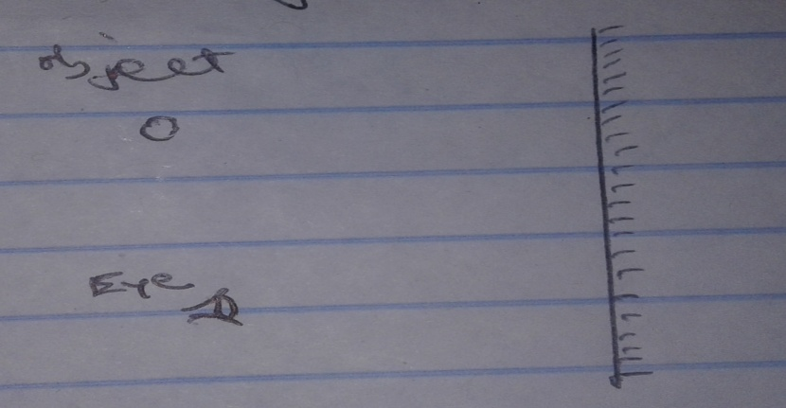

Draw rays to locate the position of the image as seen by the eye through the mirror. (3mks)

2. Outline how a gold electroscope can be charged positively through induction. (3mks)

3.i) The diagram below shows one method of demagnetization. Complete the diagram for demagnetization. (1mk)

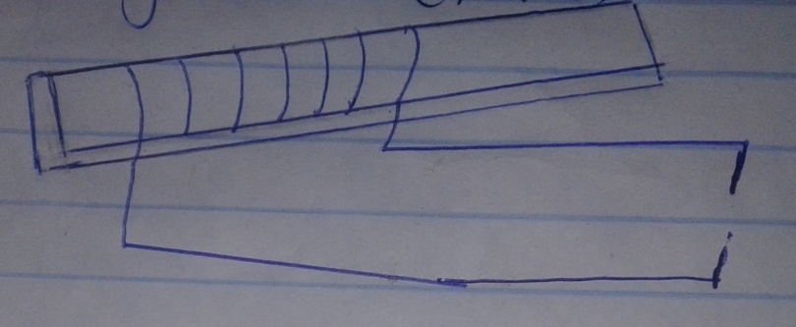

ii) In the diagram below, show the arrangement of the dipoles after demagnetization. (2mks)

4. The figure below shows the displacement – time graph for a certain wave. (see the graph) Determine the frequency of the wave. (3mks)

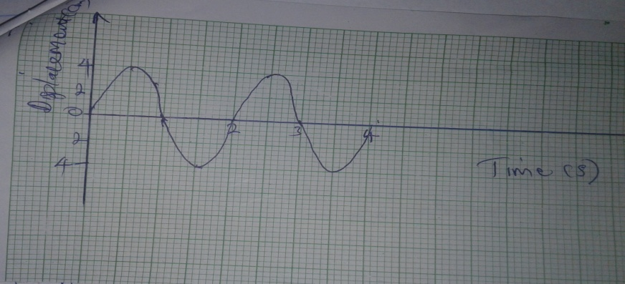

5. A child drops a rock down a well 25m deep and hears the sound of the rock hitting 2.32 seconds after the rock is dropped. Calculate the speed of sound in air. (take acceleration due to gravity g = 10m/s2 and air resistance is negligible. (2mks)

6.a) Distinguish between ultraviolet rays and infra red rays. (1mk)

b) State the application of ultraviolet rays. (1mk)

7. An object whose height is 24cm is placed 20cm in front of a diverging lens of focal length 20cm. Determine the image distance. (3mks)

8. The figure below shows two parallel current carrying conductors A and B cutting through a piece of card board.

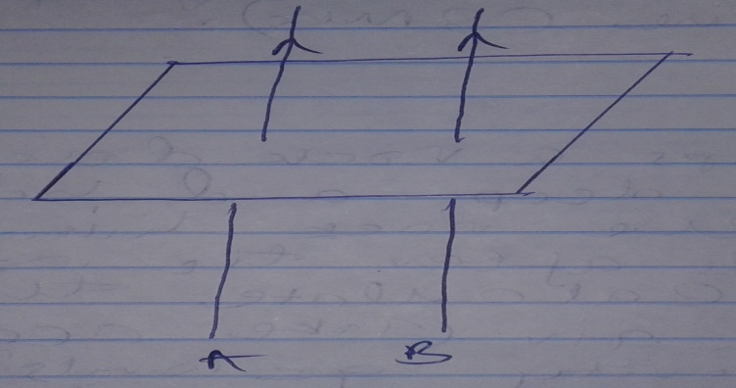

i) Sketch the magnetic field pattern produced. (2mks)

ii) Identify the nature of the force between them. (1mk)

9. Derive an expression for the total electrical energy converted into heat in a wire of resistance R when a current I is maintained for a time t. (3mks)

SECTION B (55MKS)
10.a) The following graph shows the potential difference, V, against current I for a certain device.
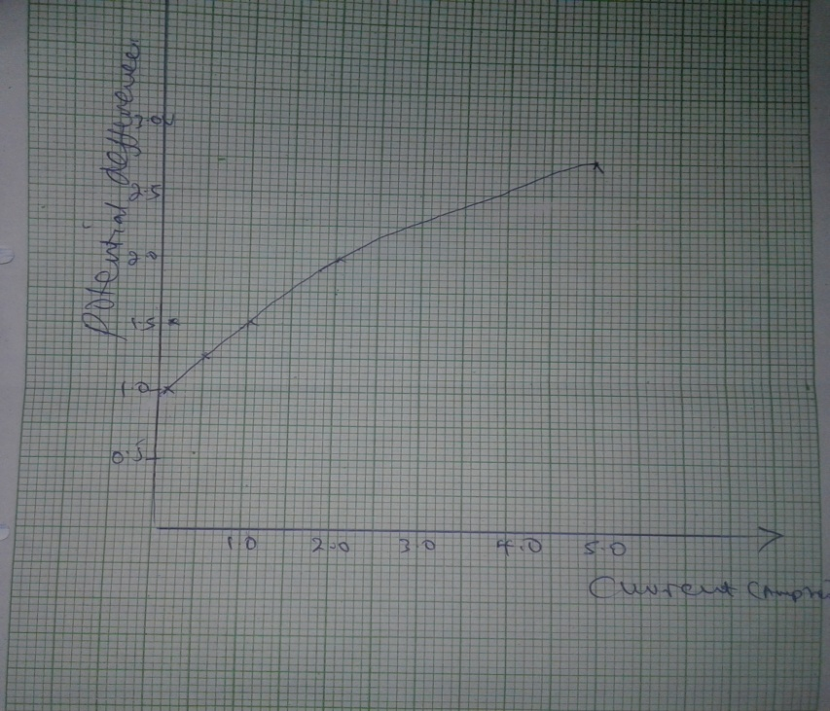

i) State with a reason, whether or not the device obeys Ohmis law. (1mk)

ii) Determine the resistance of the device when the current I is 1.5A and when it is 3.5A. (4mks)

iii) State how the resistance of the device varies as the current increases from the result obtained above. (2mks)

iv) State the possible cause of this variation in resistance. (1mk)

b) The diagram below shows four resistors connected together in circuit.

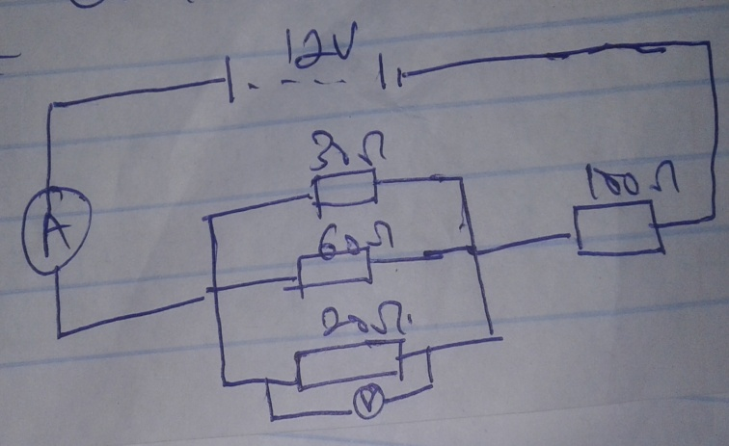
i) The ammeter reading. (3mks)

ii) The voltmeter reading. (3mks)

11. Light passes from a prim made of flint glass of refractive index 1.8g to second prism made of crown glass of refractive index 1.52 as shown in the diagram below.

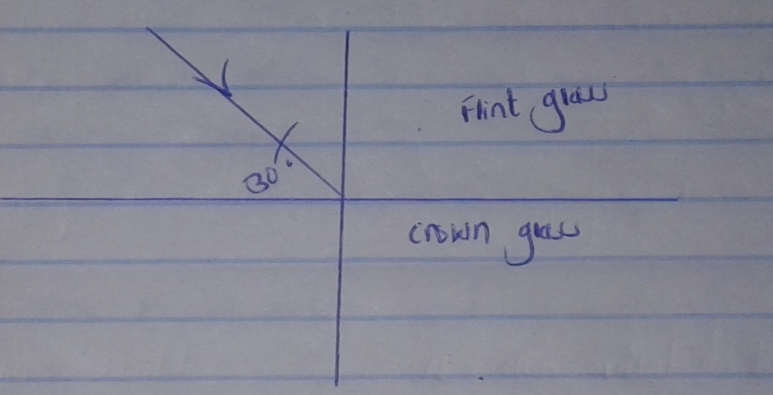

Given the angle between the interface and the incident rays is 30⁰
i) Determine the critical angle for the pair of media. (3mks)

ii)a) Show the direction of light and indicate the angles after the rays of light hits the interface. (2mks)

b) State Snell’s law. (1mk)

c) The figure below shows a defect of the human eye.

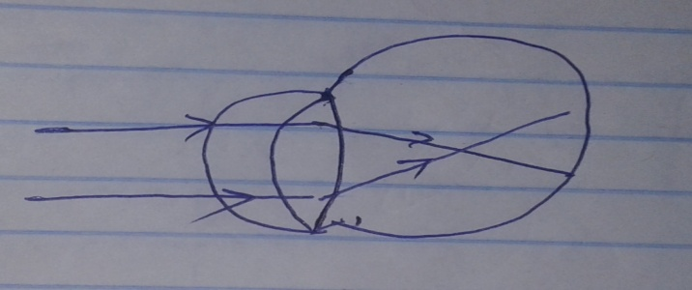

i) State two possible causes of the defect. (2mks)

ii) Show on the diagram how the defect above is corrected. (1mk)

12.a)i) Give a reason why the caps of lead acid accumulator are opened during charging. (1mk)

ii) Name the electrolyte used in the lead acid accumulator. (1mk)

b) The diagram below shows a parallel plate capacitor.

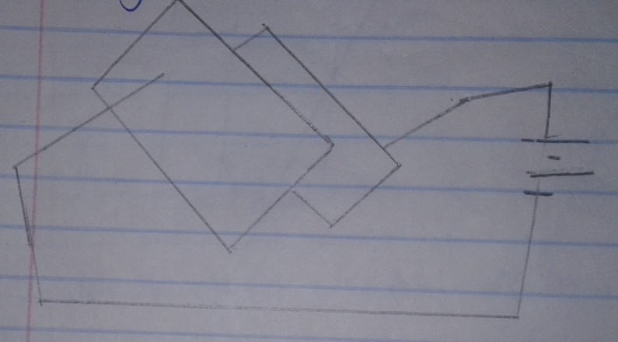

State one way by which the capacitance above can be reduced. (1mk)

c) Three capacitors are connected as shown.

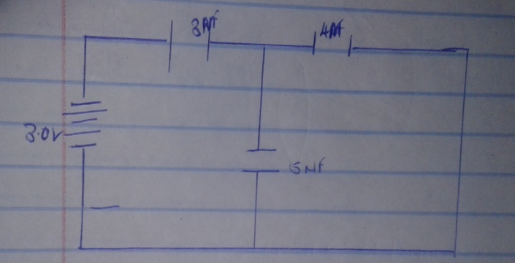

i) Calculate the total capacitance of the circuit above. (3mks)

ii) Calculate the total energy stored by the capacitor network above. (2mks)

13.a) The diagram below shows a convex lens with principal foci as shown.

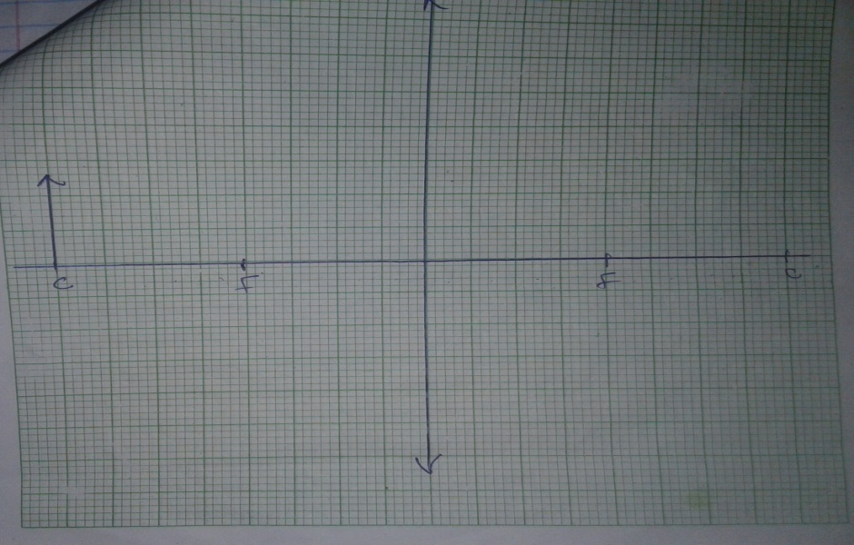

i) Draw a ray to show the image of L1 using a pencil. (2mks)

ii) Stat two characteristics of the image formed. (2mks)

b) The near point for a detective eye is found to b 40cm. what kind of lens is needed to correct this defect. (1mk)

c) The power of lens is defined a P = $1/f$ where f is the focal length of the lens. What happens to the power of the eye lens for the eye to be myopic. (1mk)

d) The diagram below shows a ray passing into a triangular glass prism. n = 15

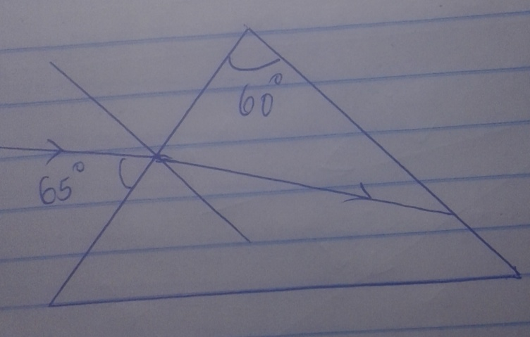

i) Determine the critical angle of the prism. (2mks)

ii) What do you understand by the term critical angle. (1mk)

iii) Indicate on the diagram the emergent ray after passing through the prism. (1mk)

14.i) Define capacitance of a capacitor. (1mk)

ii) Figure 12 below shows a pair of parallel plates of a capacitor connected to a battery. The upper plate is displaced slightly to the left.

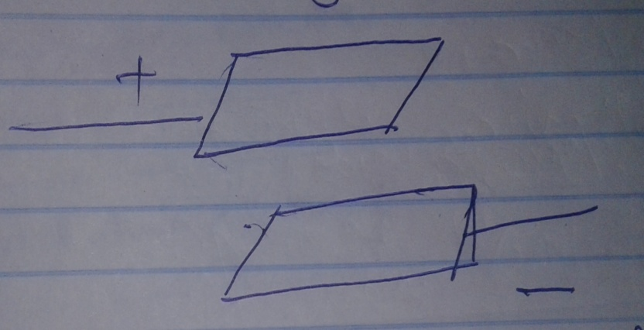

State with a reason the effect of this movement on the capacitance. (1mk)

iii) The circuit diagram in figure 13 below shows four capacitors connected between two points A and B.

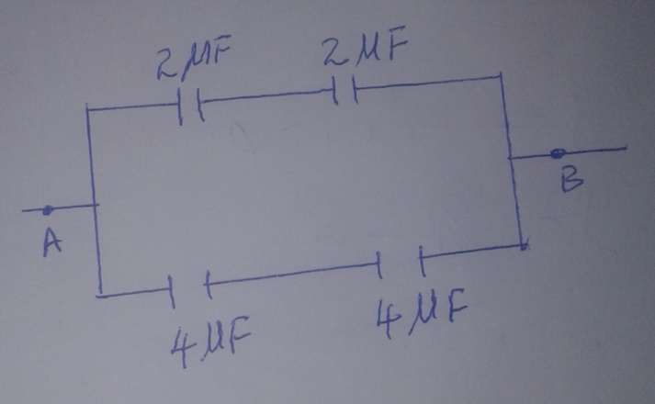

Determine the capacitance cross AB. (3mks)

15.a) Distinguish between a real image and virtual image. (1mk)

b) The distance between an upright image and the object produced by a curved mirror is 40cm. The image is 3 times as tall as the object.
i) State the type of mirror used. (1mk)

ii) Determine the object distance. (2mks)

iii) The radius of curvature of the mirror. (2mk)

iv) State one application of the mirror used question (b) above. (1mk)

