NAME-----------------------------------------------------------------------INDEX NO.---------------
3KNT FRATERNITY EXAMINATIONS
231/3
PHYSCIS PAPER 3 (PRACTICAL) – 2017

QUESTION 1
You are provided with the following:
- A glass marble
- A stop watch
- A 105cm plastic tube split open with a mark near one end.
- Vernier calipers (to be shared)
- A meter rule of half meter rule.
- A balance (to be shared)
- Retort stand one boss and one clamp.
- Wooden block (for blocking the marble from rolling away.)

Proceed as follows:
a) Use the vernier calipers provided to measure the diameter of the marble hence determine the radius.
i) Diameter of the marble ‘d’ = (1mk)

ii) Radius of the marble ‘r’ = (1mk)

bi) Using the balance provided obtain the mass of the marble. (1mk)

ii) Determine the constant ‘p’ given that p = 0.4mr² (1mk)

c) The experiment involves timing a marble as it rolls down the split tube as a runway, lamp the marked end of the split tube with the inside uppermost. Ensure the end with the mark is on the greater slope. Raise this end such that the mark is at a height h = 8cm above the bench level. The other end should rest on the bench as shown in the figure below.

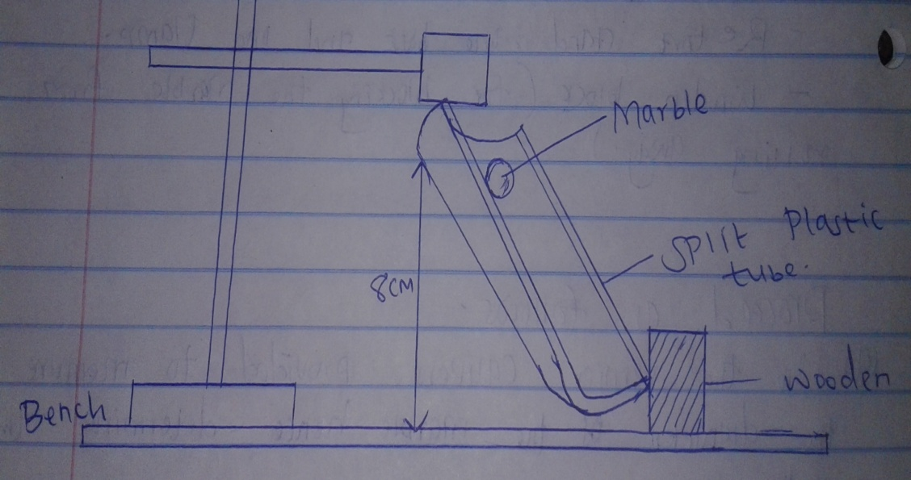

Place the marble at the mark on the runway and hold it in place gently with the finger as shown in the figure. By simultaneously releasing the ball and starting the stop watch measure and record in the table below the time taken by the marble to reach the lower end of the runway. (It is advisable to measure the time twice and record the average value.)
Vary the height h to other values shown in the table below. Measure and record in the table the corresponding average value of t.
Complete the table. (6mks)

Height h (cm) | 8 | 9 | 10 | 11 | 12 | 13 | 14 | 15
Average time t (s)
T² (s²)
$1/h$ (cm⁻¹)

d)i) On the grid provided plot the graph of t² (y – axis) against $1/h$ (5mks)

ii) Determine the slope S of the graph. (3mks)

iii) Determine the constant G ffor the marble given that; (2mks)

G = Mr² ($s/{20}$ - 1)

Question 2
You are provided with the following.
- A stop watch.
- A milliameter
- A capacitor
- Two switches S₁ and S₂
- Six 1000 ohms resistors.
- A dry cell and a cell holder.
- Seven pieces connecting
- At least six crocodile clips
Proceed as follows.
a) Connect the circuit as shown in figure 1.0 below.

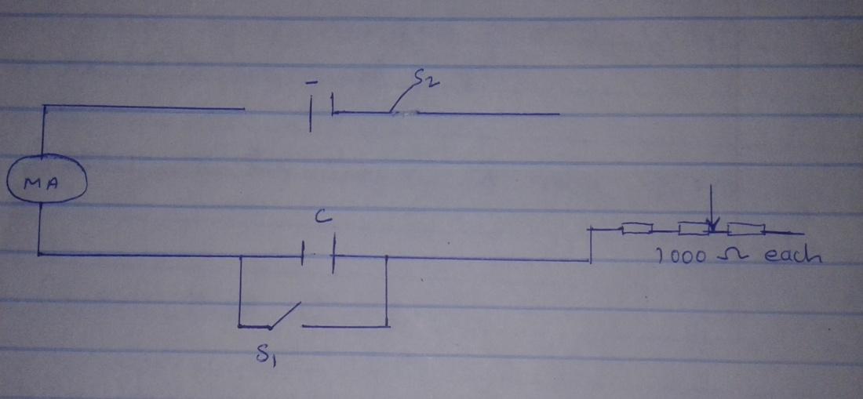

(make sure the positive terminal of the capacitor connects to the positive terminal of the cell and negative to negative)

b) Close switch S₁ and then switch S₂ and record the maximum reading of the milliameter in the table 1.0 below.

c) Open switch S₁ and at the same instant, start the stop clock. Record the time taken for the value of current to fall to a half of its original value.

d) Repeat step (b) and (c) with other values R (Ω)

Resistance R(Ω) | 2000 | 3000 | 4000 | 5000 | 6000 | 7000
Maximum current I (mA)
Time t (s)

e)i) On the grid provided, plot a graph of R (Ω) against t (s)

ii) Determine the slope of your graph.

iii) given that R = $t/k$ use the graph to determine the constant k.

f) Why should the switch S₁ be closed first and S₂ later?

g) What is happening to the capacitor when the milliameter reading is decreasing?

