NAME____________________________ INDEX NO____________________
DATE___________________________ SIGNATURE ___________________
3KNT FRATERNITY 2017
TERM II FORM IV EXAM
312/1
GEOGRAPHY PAPER 1
Instructions to candidates
- This paper consists two sections A and B
- Answer all the questions in section A
- Answer questions 6 in section B and two questions
- Candidates should check the questions paper to ascertain that all the pages are printed as indicated and that no questions are missing.
- Candidates should answer all questions in ENGLISH

SECTION A 25MKS
1a. Give three component of the solar system (3mks
b.Name the two layers of discontinuity that are part of the interior structure (2mks)
2a.Give an example of each of the following types of igneous rocks
- Plutonic rocks ( 1mk)
- Hypabyssal rocks (1mk)
- Volcanic rocks (1mk)
b.In each case name the type of rock which result from the metamorphism of
Granite (1mk
Clay (1mk)
3.The table below shows the temperature and rainfall figures for a weather station in Kenya
Month | J | F | M | A | M | J | J | A | S | O | N | D
Mean monthly temp in ⁰c | 16.2 | 16.5 | 17.1 | 17.1 | 16.1 | 15.2 | 15.2 | 15.0 | 16.0 | 16.1 | 16.1 | 16.3
Rainfall 2125mm | 100 | 104 | 175 | 232 | 323 | 218 | 196 | 231 | 196 | 152 | 127 | 71
a.Name the wettest month (1mk)
b.Calculate
i.The mean annual temperature for the station (2mks)
ii.The annual range of temperature for the station (2mks)
4a.Name three major stages of a volcano (3mks)

b.

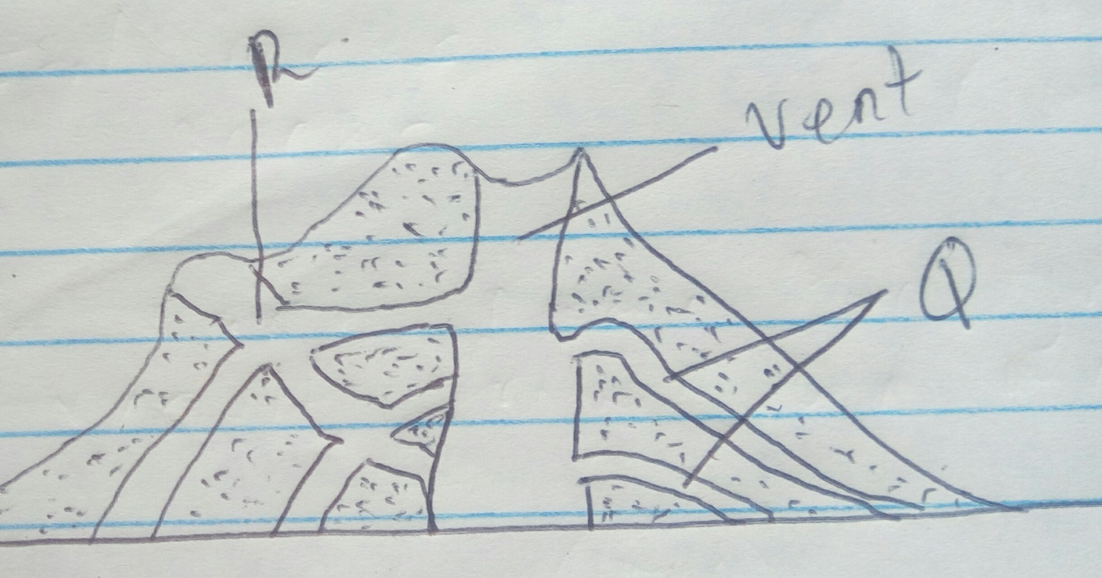

Name Q and R (2mks)
Q
R
5.Draw a sketch map of Africa in it mark and name the following (5mks)
- Mediterranean climate
- Tropical continental climate
- Canary current

SECTION B 75MKS
Answer question 6 and any other two questions from this section
6.Study the map of Kitale 1:50000 (sheet 75/3) provided and answer the following questions
a) i.Give a six figure grid reference of the junction where the road C641 meets with the road C638 in Kitale municipality (2mks)
ii) .Using the marginal information, given the magnetic variation of the area when the map extract was drawn (2mks)
b) i.Give the approximate height of the dam in the grid square 3630 (2mks)\
ii).Calculate the area of Kitale municipality shown on the map. Give your answer to the nearest square kilometers (2mks)
c) i.Using a scale of 1cm to represent 40 metres, draw a cross section from grid reference 370240 grid reference 44024
On the cross section mark and name the following (4mks)
- River Kapolet (1mk)
- Steep slope(1mk)
- Forest boundary (1mk)
iii).Calculate the vertical exaggeration (VE) of the cross section (2mks)

d) .Citing evidence from the map, name three economic activities carried out in the area covered by the map (3mk

e) .Describe the drainage of the area covered by the map extract
7 a) i.What is the difference between weathering and mass wasting (2mks
ii) .Apart from plants, give three other factors that influence the rate of weathering (3mks
iii).Explain two ways in which plants cause weathering (4mks
b) i.List two types of mass wasting other than soil creep (2mks)
ii) .Explain three factors that cause soil creep (6mks
c) .Explain four effects of mass wasting on the environment (8mks)
8 a) i.What is river divide (2mks)
ii) .Describe 3 ways by which a river transport its load . (6mks)
b) .Describe any 4 characteristics of a river in its old stage (8mks)
c) Describe each of the following drainage patterns.
i)Centripetal drainage pattern (2mks)
i)Trellis drainage pattern (3mk
d).Name 3 features that result from river rejuvenation (3mk
9. a) i.What is an ice sheet (2mks)
ii).Give two reasons why there are no ice sheets in Kenya (2mks
iii).Explain three factors that influence the movement of ice from the place where it has accumulated (6mks)
b).Describe how an arête is formed (4mks)
c).The diagram below shows types of moraine in a valley glacier
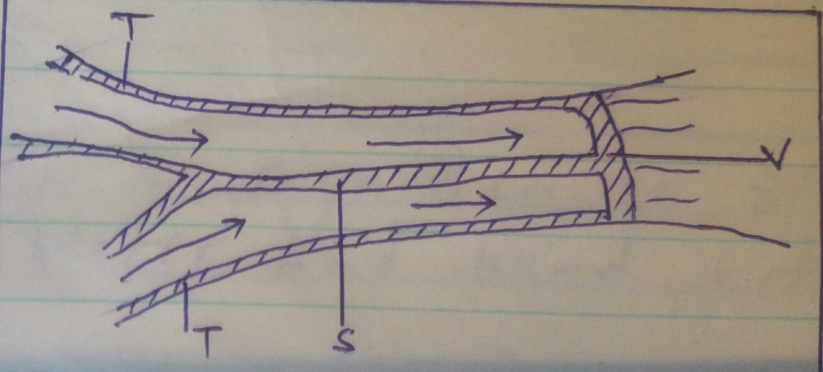
i.)Name the type moraines marked S,T and V (3mks)
d).Explain four positive effects of glaciations in lowland areas, (8mks)
10) a.What is deflation (2mks)
b).Give 3 reasons why wind erosion is more effective in the hot desert than the cold desert (3mk)
c) .Explain 3 factors which influence transportation of material in desert by wind (6mks)
d).Describe how the following features are formed
I )Messa (3mks)
- Bajada (3mks)
e.Explain 4 significance of features resulting from water and wind action in arid areas (8mks)

