3KNT FRATERNITY FORM FOUR
MATHEMATICS
121/1
PAPER 1
TERM TWO 2017
MARKING SCHEME.
1.-8+(-4)+8÷(-2)
-6+(-2)+(-1)

-8+(-4)(-4)
-6-2-1 M1

-12-4 M1
9

-16=16 =1$\frac{7}{9}$ A1
9 9

2.Numerator (2x+3y)(2x-3y) M1
Denominator 2$x^{2}$-2xy-3xy+3$y^{2}$
2x(x-y)-3y(x-y)

=(2x+3y)2x-3y) m1
(2x-3y)(x-y)
= 2x+3y
x-y A1

B1 –line PQ
B1 – 4 subdivisions of PQ
B1 – location of M
3.

P M Q

4.Gradient AB =6-4 =$\frac{1}{2}$ M1
5-1

Gradient PQ :$M_{2}$x$\frac{1}{2}$ =-1
$m_{2}$=-2 Q(x,y) M1

y-2=-2
x-3 1

y-2=-2x+6
y=-2x+8
or
y+2x=8 A1

5. Vol=1.05x1000=125${cm}^{2}$ M1
8.4

Length=125=25cm A1
0.5

6.105$=110jy
?= 3850000
3850000x1=35000 us $ M1
110

1 us $ = 90 ksh
35000=? =90x35000=3,150,000 M1

Duty paid =3150000x20
100

= Ksh 630000 A1

7. <CDE=180-64=${116}^{0}$ B1
<CBE= ${116}^{0}$ (AH<) B1

$∴$<ABE=64
<BE A=180$°$(76$°$+64)=400 B1

8. Tan 23.61=$l/x$
H= x tan 23.61 M1
Tan 35=$h/{x-2} ≈$h=(x+6) Tan 35
xTan 23.61=(x-6)tan 35 M1
x tan 23.61=x tan 35-6 tan 35
O 2631x=-4.210
X=16 M1
H=16 tan 23.61=6.994
$≅$7.0 cm A 1

9. X=$√{13}^{2}$-$√5^{2}$
=$\sqrt{13}-5$
=$\sqrt{8} M 1$
Tan A=$√8$ /$\sqrt{5}$ $»\sqrt{8 }\left(\sqrt{5}\right)=\sqrt{40}$
$\sqrt{5}$ $√5)$ 5

2$\sqrt{10}$
5 A1

10.$(2$ (6-4)90=720 (sum of interior angles) M1
2X+$\frac{1}{2}$x+x+40$°$+110+130+160=720 M1
3$\frac{1}{2}$X=720-440=280
X=280x2=80
7
$\frac{1}{2}$X=40$°$(smallest) A1

11.(1)+(x)=-(1) M1
(2) (y)=(2)
1+ x=-1
X=-2≥
2+y=2
Y=0 M1 (for values of x and y)

(a)+(2)=(-3) M1
(b) (0) (-3)
a-2=3;a=-1
b=-3
therefore the coordinates of B are
(-1,-3) A1

12. X≤0 B1
Y≥2 B2
Y≤-x+2 B1

13.
D C

A B
14). 4.5 litres= 4.5x1000${cm}^{3}$
9$m^{3}$=9x1000l=9000x1000${cm}^{3}$
VSF=4.5X1000=$\frac{1}{2000}$
9X1000000
LSF=$\frac{1}{12.599}$
Height=90X12.6=1134cm.

15.Total hours 24x3+12=84 hrs B1
In 1 hr =15 sec(cat)
84 hrs=?
=1260 sec
=21 min B1
1745
21
1806 hrs
6.06 pm B1
16.
X | 4 | 8
Y | 26 | 138
B1
W=10=2 units
5
$\frac{2}{2}$ (240+2(6+26+70+138) M1

240+480
=720 A1
17.a
X | -4 | -3 | -2 | -1 | 0 | 1 | 2 | 3 | 4 | 5
Y | -14 | -6 | 0 | -4 | 6 | 6 | 4 | 0 | -6 | -14
B2
Check the graph
Scale B1
Plotting B1
Curve B1
B(i)
X | 0 | 1
Y | 2 | 0
Check the line B1
(ii) (-1,4) and (4,-6) B1 for both

SECTION II
18.After 2 hrs
Boat P 750x2=150 km
Boat Q 900x2=1800km
Scale 1cm rep 300km
1500=5cm 1800=6cm
2 300

QP=10.6±0.1 M1
10.6x300=3180km A1
Bearing of Q from p=225$°$
Bearing of P from Q=45$°$

19. a$\%$profit for taxes and insurance
40 x75
100 100 M1

Amount showed=100-(25+30)x225000
100

45x225000=101250 M1
100
Amount Cherop received more than Asha;
Ratio of contribution 60000:8500:1050000
=12:17:21 M1
21.12 x101250=18225 A1
50

(b)Profit during 2nd year
2250000x$\frac{10}{9}$=2500000 M1
Nangilas new ratio
$\frac{110000}{275000}=\frac{2}{5}$ M1
Nangilas new share of profit.
$\frac{2 }{5}$x112500=45000 A1

20.(a) L=${18}^{2}{+6}^{2}$=
A=3.142 x6x18.97+3.142x6x6 M1
=35.7.62244+113.112 M1
=470.7344
=470.73 A1

(b)V=$\frac{1}{3}$AH=$\frac{1}{3}$x113.112x18 M1
=678.672
(c)$\frac{11}{18}=\frac{X}{6}»X\frac{11}{18}$x6=3.667 M1
V=$\frac{1}{3}$ii(7)($6^{2}$=6(3.667)+3.667) M1
$\frac{7}{3}$ii(71.448889) M1
=523.82 A1
21.

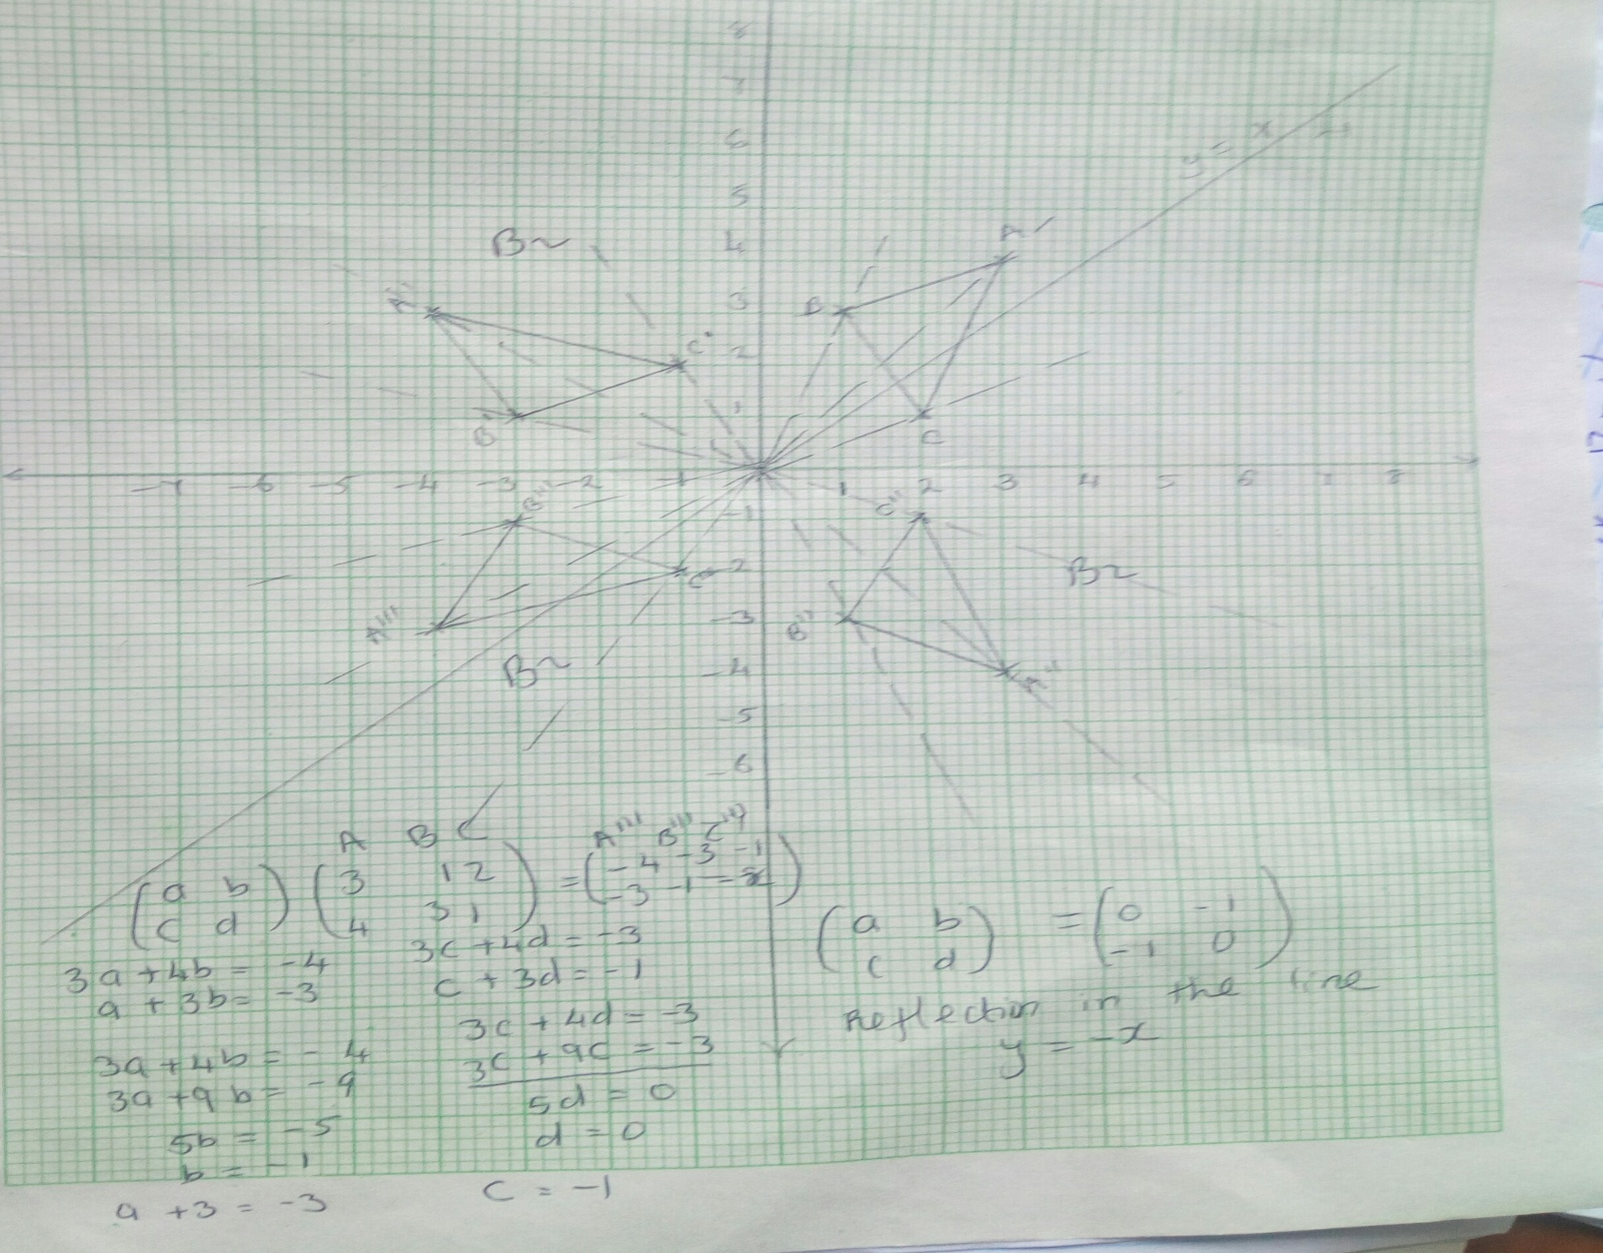
3a+4b=-4 3c+4d=-3
A+3b=-3 c+3d=-1
3a+4b=-4 3c+4d=-3
3a+9b=-9 3c+9c=-3

5b=-5 5d=0
B=-1 d=0
A+3=-3 c=-1
Reflection in the line
Y=-x
22. (a)Max speed (the length)
$\frac{1}{2}$ x(350+850)h=1500 M1
H=15000x2=25m/s M1
1200
In km/h=$\frac{25}{100}$x3600=90km/h A1

(b)Accelelator=$\frac{change in relation }{time}$
=$\frac{25-0}{200}$=$\frac{1}{8}$m/s
(c) Distance =speed x time

$\frac{\begin{aligned} \\ 300\end{aligned}}{ 150}=\frac{25}{x}$ M1
X=150x25
300

=125m/sec
Distance =$\frac{1}{2}$x150x125=937.5 A1

(d)Distance=7500m
1st part ½ x200x25=2500m
2nd part tx25=25t
2500m+25t=7500m M1
25t= 7500-2500
T=$\frac{500}{25}$ =200sec M1

Total time=200+200
=400sec A1

23.class frequency cf
40-43 5 5
44-47 4 9
48-51 5 14
52-55 3 17
56-59 6 23
60-63 2 25
(b)median=25/2 =12.5
47.5+4/5 x4=50.7 kg

(c) Axes well labeled
Bars draws with uniform width
Class line used as boundaries.
24. sin$Q_{1}$=$\frac{4}{12.1}$=0.3200
$Q_{1}$ =18.66
ThereforeP$o_{1 }$Q=2x18.66=37.33$°$ B1
sin$Q_{2}$=$\frac{4}{10}$=0.400
$Q_{2 }$ 25.58
Therefore P$O_{2}$Q=2x25.58=47.16 B1
Area of sector $O_{1}$py Q=37.33 x3.142x12.52
360
=50.19${cm}^{2}$
Area of O1 PQ=1/2 x12.5cm x 12.5cm sin 37.33$°$
=47.38${cm}^{2}$ M1
Area of segment PY QP=50.91-47.38
=3.53${cm}^{2}$ M1
Area of sector OPxQ=47.16x3.142x${10}^{2}$
360
=41.16 M1
Area of D =1/2 x${10}^{2}$xsin 47.16=36.66
Area of segment=41.16-36.66
=4.5 M1
Shaded area=3.53+4.5
=8.03${cm}^{2}$ A1
Area of sector=41.16-8.0=33.13${cm}^{2}$ A1.

