KASSU JOINT EXAMINATIONS, 2018
Kenya Certificate of Secondary Education(K.C.SE)
121/2
MATHS
PAPER 2
MARKING SCHEME
1. | $$x^{2}-\frac{x}{2}-18=0$$  $$x^{2}-\frac{x}{2}+{(-\frac{1}{4})}^{2}=18+\frac{1}{16}$$  $${(x-\frac{1}{4})}^{2}=\frac{289}{16}$$  $$x=-4 or x=4\frac{1}{2}$$ | M1  M1  A1
 |  | 03
2. | $$\left(\frac{4-\sqrt{2}}{3+\sqrt{2}}\right)\left(\frac{3-\sqrt{2}}{3-\sqrt{2}}\right)$$  $$N=14-7\sqrt{2}$$  D= $9-2=7$  $$\frac{14-7\sqrt{2}}{7}$$  $$2-\sqrt{2}$$ | M1  M1  A1
 |  | 03
3. | $$3x-{180}^{0}={30}^{0}$$  $$3x-{180}^{0}={30}^{0},{330}^{0},{390}^{0},{690}^{0},{750}^{0}$$  $$x={70}^{0},{170}^{0},{190}^{0},{290}^{0},{310}^{0}$$ | M1  M1  A1
 |  | 03
4. | 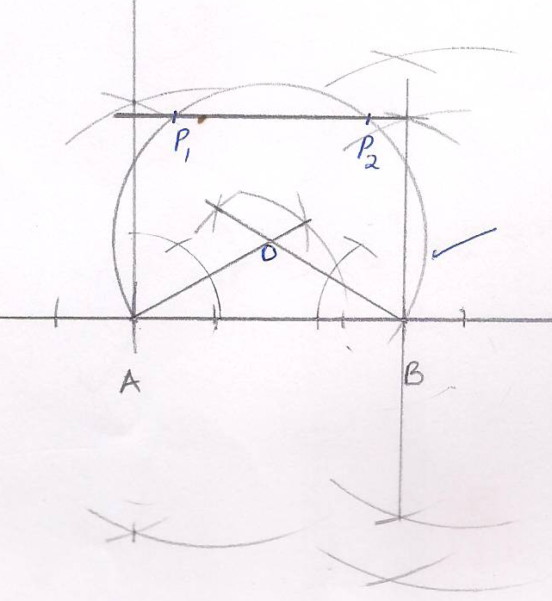 | B1  B1  B1 | For parallel line 3cm above AB  For correct arc  Locus of both P1 and P2
 |  | 03
5. | $$32+\frac{240}{x}+\frac{720}{x^{2}}+\frac{1080}{x^{3}}+\frac{810}{x^{4}}+\frac{32}{x^{5}}$$  $$2+\frac{3}{x}=2.5$$  $$x=6$$  $$32+40+20+5=97$$ | M1  M1  A1
 |  | 03
6. | $$max.p.Area=4.15×2.25=9.3375$$  $$min.p.Area=4.05×2.15=8.7075$$  $$actual Area=4.1×2.2=9.02$$  $$Absolute error in the area=\frac{1}{2}(9.3375-8.7075)$$  =$0.5×0.635$  $$=0.3175$$  % error=$\frac{0.3175}{9.02}×100\%=3.520\%$ | M1  M1  A1
 |  | 03
7. | $$Let t=logx$$  $${3t}^{2}-5t+2=0$$  $$t=1,t=\frac{2}{3}$$  $$\log_{10}{x=1},\log_{10}{x=\frac{2}{3}}$$  $$x=10 or 4.642$$ | B1  M1  A1
 |  | 03
8. | $${(sa)}^{2}=\frac{s^{2}+q}{t^{2}}$$  $$s^{2}=\frac{q}{a^{2}t^{2}-1}$$  $$s=±\sqrt{\frac{q}{a^{2}t^{2}-1}}$$  $$s=±\sqrt{\frac{q}{\left(at-1\right)(at+1)}}$$ | M1  M1  A1
 |  | 03
9. | 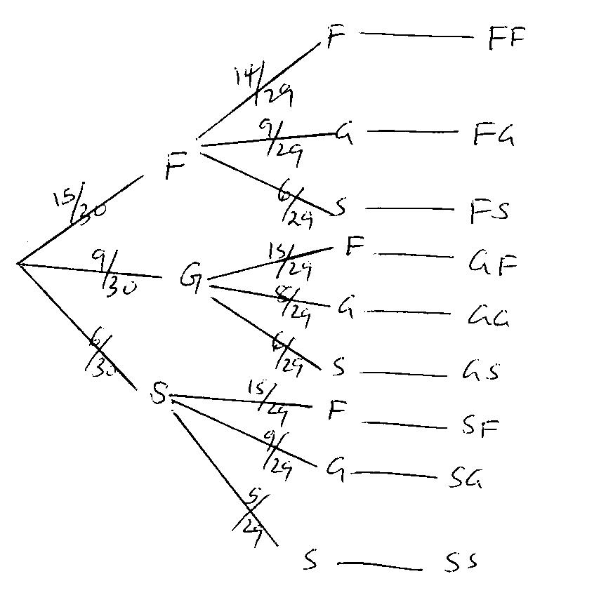  $$p\left(FG\right)OR P\left(FS\right)OR P\left(GF\right)OR P\left(GS\right)OR P\left(SF\right)OR P(SG)$$  $\left(\frac{15}{30}×\frac{9}{29}\right)+\left(\frac{15}{30}×\frac{6}{29}\right)+\left(\frac{9}{30}×\frac{15}{29}\right)+\left(\frac{9}{30}×\frac{6}{29}\right)+\left(\frac{6}{30}×\frac{15}{29}\right)+(\frac{6}{30}×\frac{9}{29})$  $$\frac{135}{870}+\frac{90}{870}+\frac{135}{870}+\frac{54}{870}+\frac{90}{870}+\frac{54}{870}$$  $$\frac{558}{870}=\frac{93}{145}$$ | B1  M1  A1 | $$for the tree$$  $$diagram$$
 |  | 03
10. | A= kd$s^{2}$  K=$\frac{1}{1296}ds^{2}$  A= $\frac{1}{1296}×360×18×18$  $\frac{360}{4}$= 90 Barrels | M1  M1  A1
 |  | 03
11. | No. Std form log working  45.3 4.53$×{10}^{1}$ 1.6561  6.97$×{10}^{-3}$  0.534 5.34$×{10}^{1}$  $$\frac{-3+2.7718}{3}$$  0.8392 $${8.392×10}^{-1}$$ $$-1+0.9239$$ | M1  M1  M1  A1 | - M1For all correct logs  - For attempt to divide
 |  | 04
12. | $CS=\sqrt{{7.5}^{2}+4^{2}}$  $$CX=8.5$$  $${7.5}^{2}=22.5x$$  $$x=2.5$$  $$CZ=8.5-2.5=6cm$$  $$4CX=14×6$$  $$CX=21cm$$ | M1  B1  A  1
13. | $$2x-2x^{2}=0$$  $$2x\left(1-x\right)=0$$  $$x=0, 1$$ | M1  M1  A1
 |  | 03
14. | $$Bp of a kg of mixture=\frac{100}{120}×\frac{120}{2}=sh50$$  A B  bp 56 48  $$bp of mixture$$ $$50$$  Difference 2 6  Ratio 1$:3$ | M1  M1  A1
 |  | 03
15. |  | B1  B1  B1  B1
16. | $$c1=({\frac{4}{2})}^{2}=4, c2={\left(\frac{-2}{2}\right)}^{2}=1$$  $${(x+2)}^{2}+{(y-1)}^{2}=9$$  $$centre\left(-2,1\right)radius r=3 units$$ | M1  M1  A1
 |  | 03
17. | (a) T.I=$\frac{115}{100}×27000+11000-3500$  $$=Ksh38550P.m$$  $$K£23130 p.a$$  $$3900×2=7800$$  $$3900×3=11700$$  $$3900×4=15600$$  $$3900×7=27300$$  $$3630×9=32670$$  $$Total tax due=Ksh114570 p.a$$  $$=ksh 9547.50 p.m$$  $$b. Net salary=ksh38000-\left(9547.50+2500+3000\right)$$  $$=ksh 3800-15047.50$$  $$=ksh 22952.50$$  $$c.\frac{30}{100}×2700=sh 8100$$  $$11730×9=ksh105570$$  $$81900+105570=187400 p.a$$  $$=ksh 15 622.50 p.m$$  $$gross salary=27000+11000+8100=ksh46100$$  $$Total deduction=15622.50+2500+3000+2700=ksh 23822.50$$  $$Net salary=46100-23822.50=ksh22277.50$$  $$\frac{22277.50}{22952.50}×100=97.059$$  $$Decreased by 2.94\%$$ | M1  M1  M1  A1  M1  M1  A1  M1  M1  M1  A1
 |  | 10
18. | 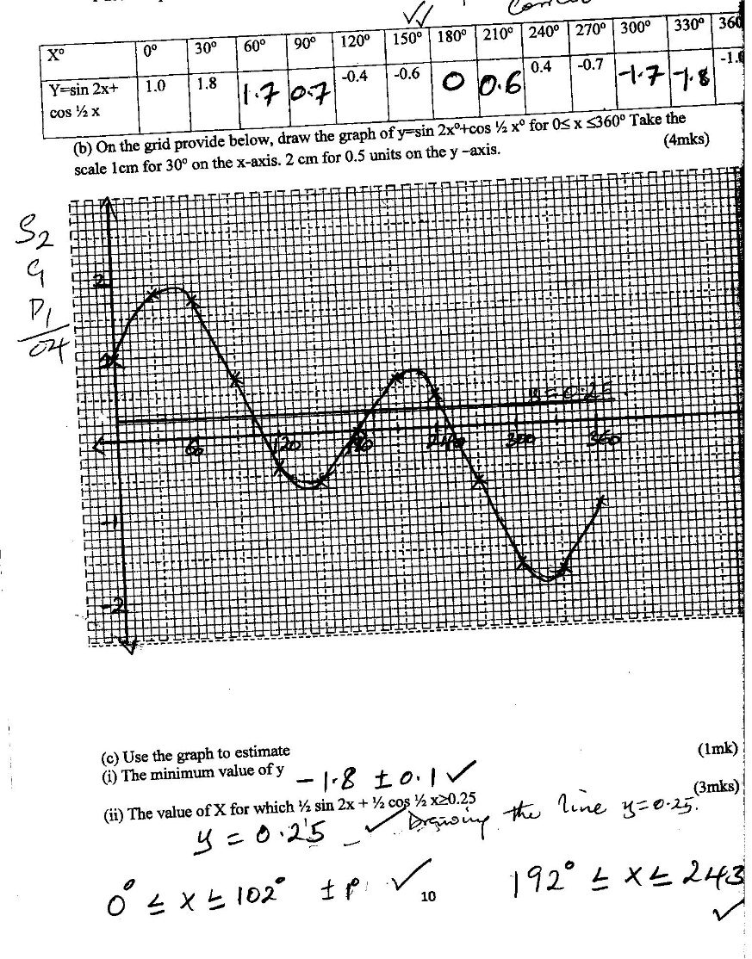 | B1  B1  M1  M1  M1  M1  A1  M1  A1  A1
 |  | 10
19. | 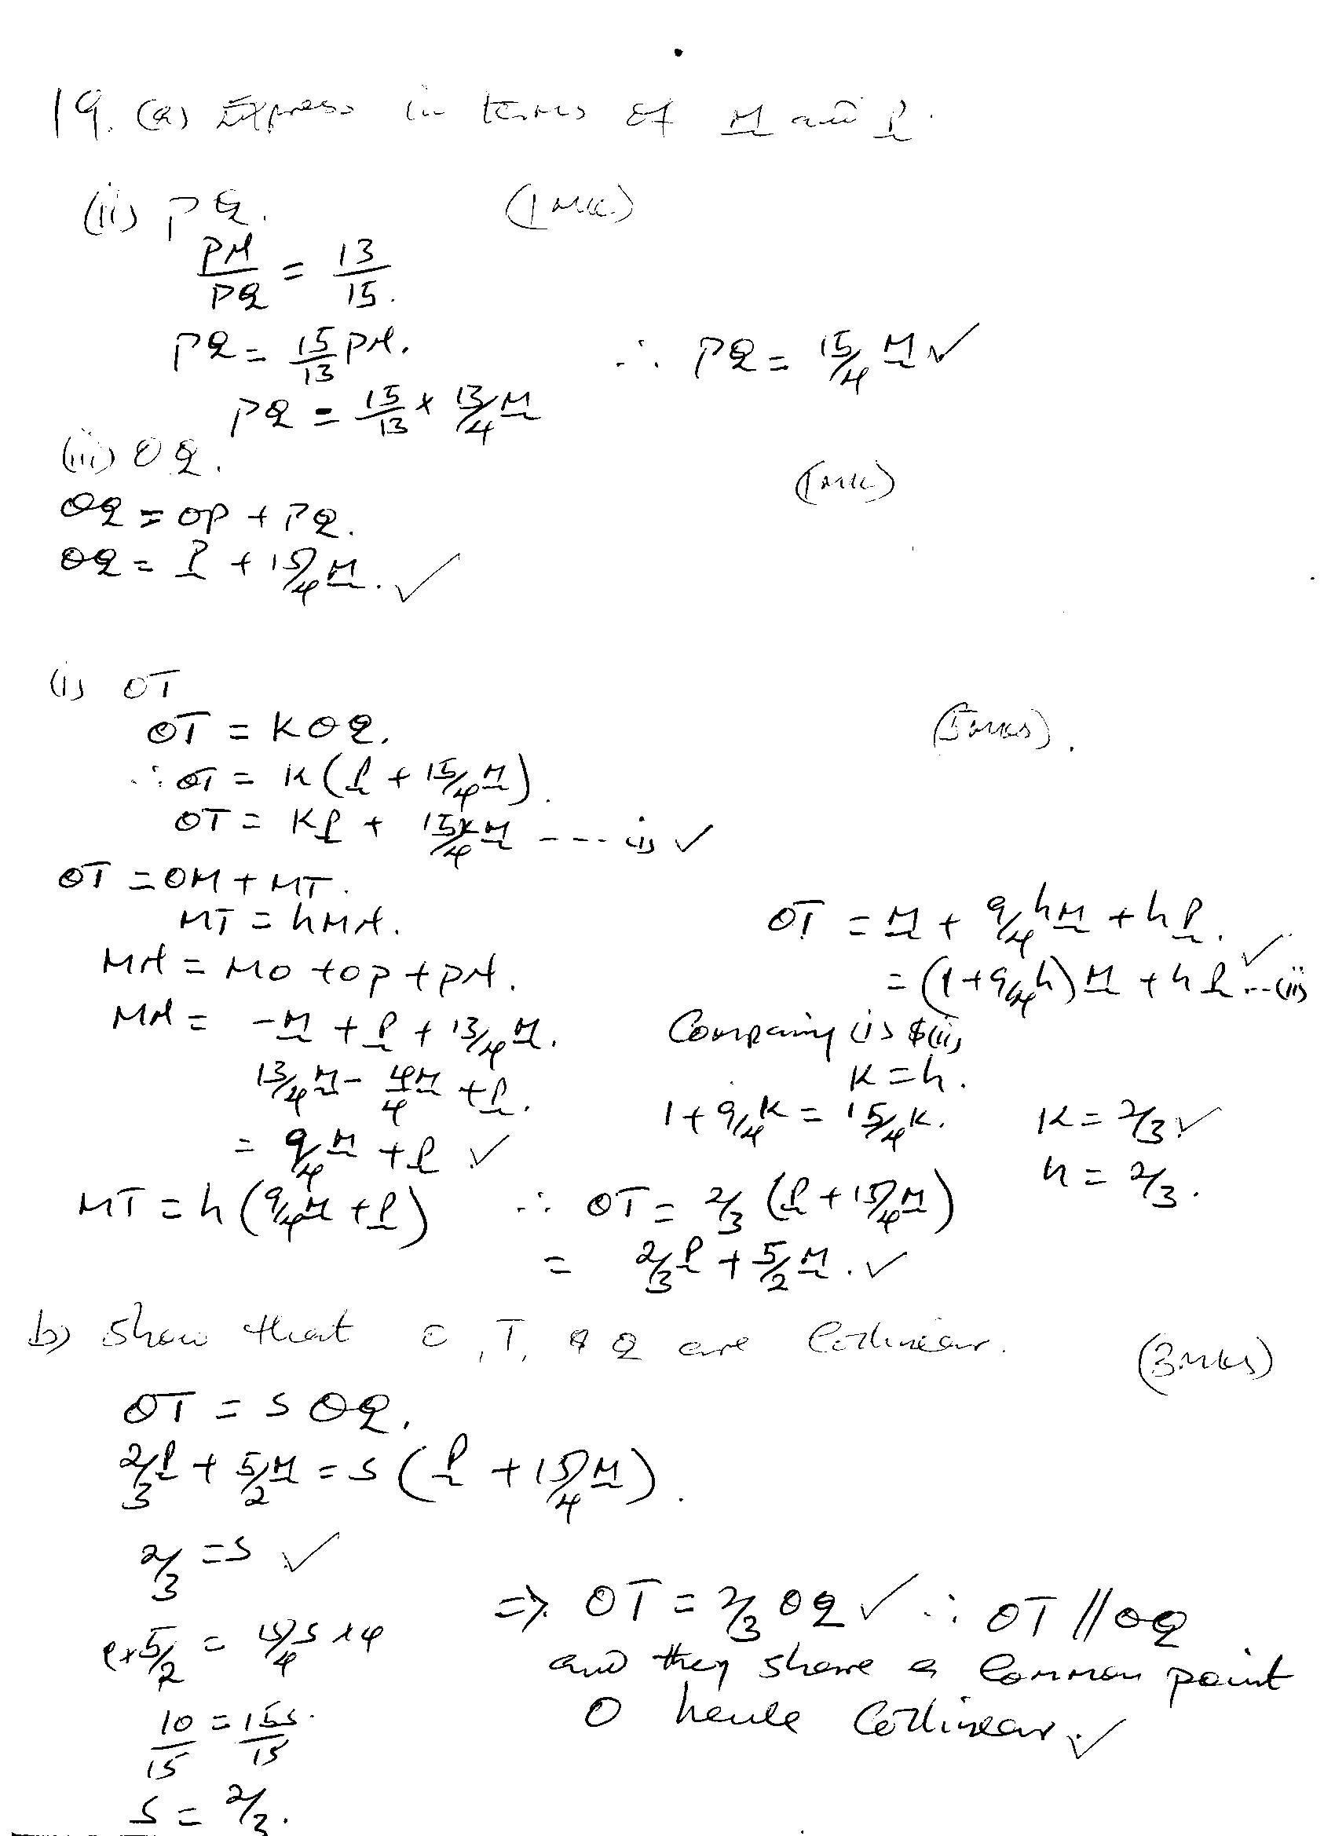
 |  | 10
20. | $$\left(a\right)PO=\sqrt{{12}^{2}+{12}^{2}}=\frac{16.97}{2}$$  $$=8.485cm$$  $${VP}^{2}={14}^{2}+{8.485}^{2}$$  $$VP=16.4cm$$  $$\left(b\right).Tan θ=\frac{14}{8.485}$$  $$Tanθ=1.650$$  $$θ={Tan}^{-1}1.650={58.78}^{0}$$  $$\left(c\right).Slanting height=\sqrt{{16.37}^{2}-6^{2}}$$  $$h=15.23cm$$  $$Slanting area=4\left(\frac{1}{2}×12×15.23\right)={365.52cm}^{2}$$  $$Base area=12×12=144{cm}^{2}$$  $$Total surface area=365.52+144$$  $$=509.52{cm}^{2}$$  $$\left(d\right)Volume=\frac{1}{3}×{12}^{2}×14$$  $$=672{cm}^{2}$$ | M1  M1  A1  M1  A1  M1  M1  A1  M1  A1
 |  | 10
21. | $$\log{P=logkA^{t}}$$  $$logP=tlogA+logk$$  $$t$$ 2010 2011 2012 2013 2014 2015 2016  $$logP$$ 3.70 3.78 3.87 3.95 4.04 4.12 4.21  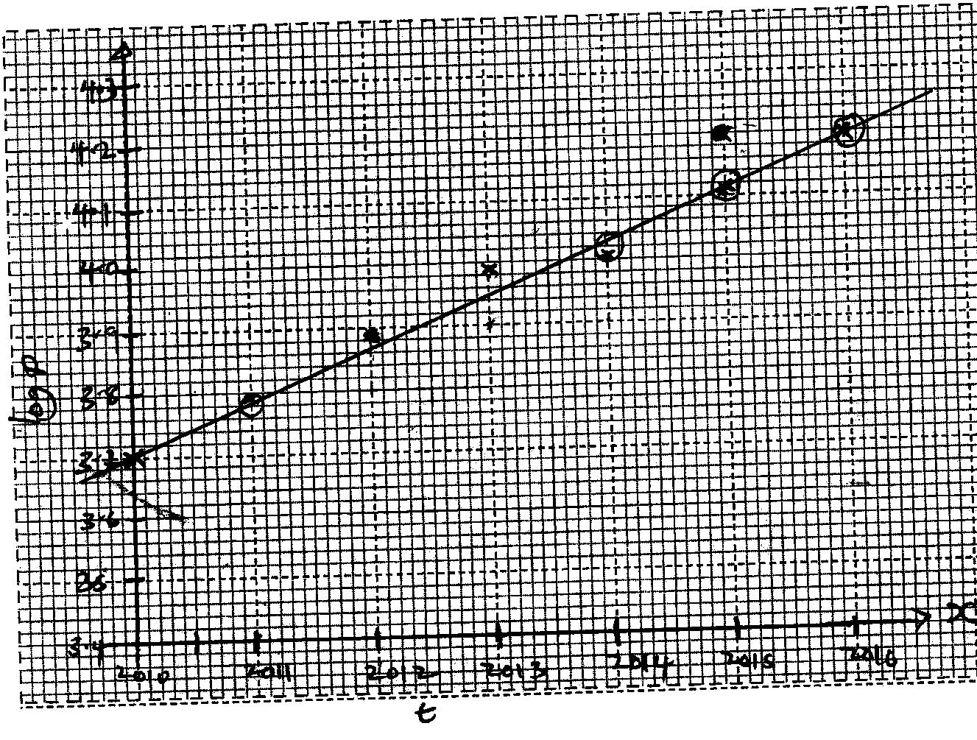  $$\log{k=3.7}$$  $$k=1585$$  $$\frac{4.12-3.78}{2015-2011}=0.085$$  $$\log{A=0.085}$$  $$A=1.216$$ | M1  B2  S1  P1  L1
 |  | 10
22. | $$400x+300y≤6800$$  $$x+y≤20$$  $$y≤2x$$  $$x>0, y>0$$  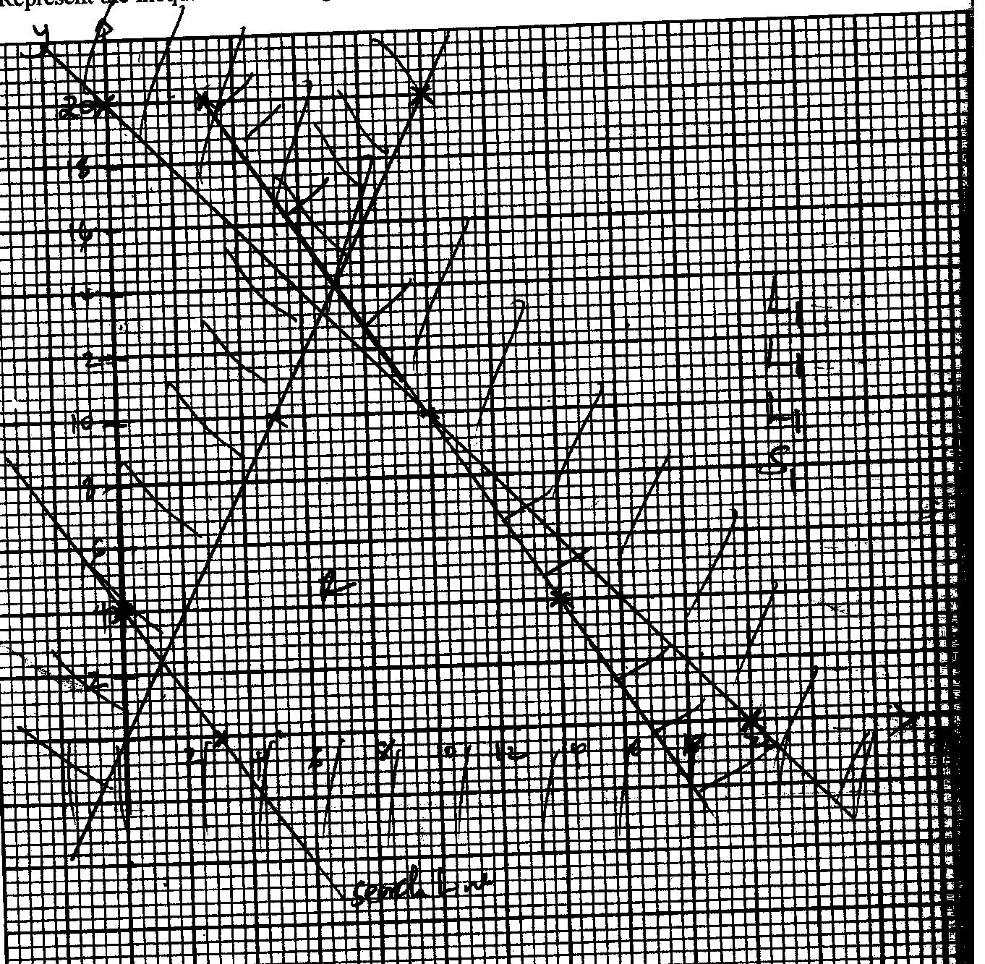  10 goats  10 sheep | B1  B1  B1  B1  B1  B1
23. | a.$420=\frac{y}{{360}^{0}}×3.142×2×6400$  $$y={3.76}^{0}$$  ${20}^{0}+{3.76}^{0}={24}^{0}N$  b. $α=2\{\sin^{-1}\left(sin35cos60\right)\}$  $2(\sin^{-1}0.28678)$  $$16.67×2={33.33}^{0}$$  $\frac{{33.33}^{0}}{360}×2×\frac{22}{7}×6400=3724.50km$  c. $15+33={48}^{0}$  $$1^{0}=4mins$$  $${48}^{0}=192mins→3hrs 12mins$$  $$1045+3:12=1357hrs$$ | M1  M1  A1  M1  M1  A1  M1  M1  A1
 |  | 10
24. | $$x$$ -2 -1.5 -1 -0.5 0 0.5 1  $$y$$ 0 0.25 2.25 4 4 6.25 9  $$\frac{1}{2}×0.5[0+9+2\left(0.25+1+2.25+4+6.25\right)]$$  $$0.25\left(9+27.5\right)$$  $$0.25×36.5$$  $$9.125 square units$$  $$\int_{-2}^{1}{\left(x^{2}+4x+4\right)dx}$$  $\left[\frac{x^{3}}{3}+\frac{{4x}^{2}}{2}+4x\right]$¹₋₂  $$\left[\frac{1}{3}+2+4\right]-\left[\frac{-8}{3}+8-8\right]$$  $$\frac{27}{3}=9 square units$$  $$\frac{0.125}{9}×100\%$$  $$1.389\%$$ | B2  M1  M1  A1  M1  M1  A1  M1  A1
 |  | 10

