NAME…………………………………………………………… ADM NO…………………CLASS……………………
232/1
Physics
Paper 1
March/April 2018
Time: 2hours
MOI HIGH SCHOOL KABARAK
Kenya Certificate Secondary Education
K.C.S.E

Instructions to the candidates;

- Write your name, class and admission number in the spaces provided above.
- This paper consists of TWO sections: Sections A and B.
- Answer ALL the questions in sections A and B in the spaces provided.
- ALL working MUST be clearly shown.
- KNEC Mathematical tables and Non-programmable electronic calculators may be used.
- Candidates should check the questions paper to ascertain that all the pages are printed as indicated and that no questions are missing.

Take; g= 10N/kg
Section |  | Question | Maximum Score | Candidate’s Score
A |  | 1-11 | 25
B | 12 |  | 08
 | 13 |  | 08
 | 14 |  | 12
 | 15 |  | 09
 | 16 |  | 07
 | 17 |  | 11
 | Total Score |  | 80

SECTION A (25 MARKS)
- The vernier calipers has a negative error of 0.03cm.A student used such a vernier calipers to measure the diameter of a test tube and read 3.25cm.
- Sketch the vernier calipers reading 3.25cm. (2 marks)
………………………………………………………………………………………………………………………………………………………………………………………………………………………………………………………………………………………………………………………………………………………………………………………………………………………………………………………………………………………………
- Determine the diameter of the test tube. (1 mark)
…………………………………………………………………………………………………………………………………………………………………………………………………………………………………………………………………………………………………………………………………………………………………………………………………………………………………………………………………………………………………………………………………………………………………………………………………………………...
- Explain why a man using a parachute falls through air slowly while a stone falls through air very faster. (2 marks)
………………………………………………………………………………………………………………………………………………………………………………………………………………………………………………………………………………………………………………………………………………………………………………………………
- 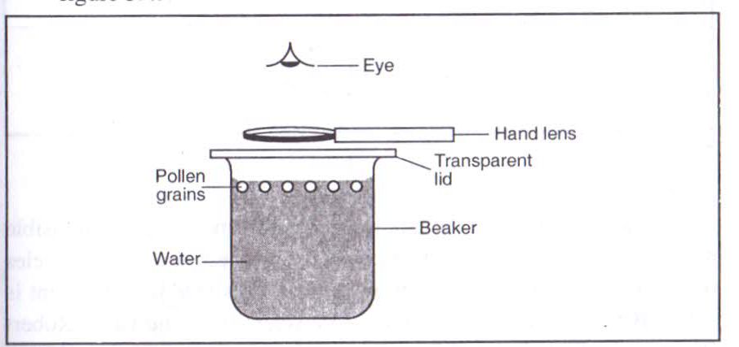In an experiment to determine Brownian motion in liquids pollen grains were suspended in water as shown in Figure 1.and its movement observed using a hand lens.

Figure1.

State and explain the motion of the pollen grains. (2marks) ………………………………………………………………………………………………………………………………………………………………………………………………………………...……………………………………………………………………………………

- Figure 2. Shows a simple form of a diving board

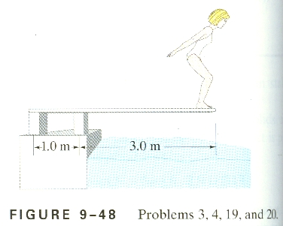
Figure 2.
A B
2.0m
Diving board
The diver has a mass of 40kg. Calculate the magnitude of force acting at A and B if the board is uniform and has a mass of 20 kg (4 marks)
………………………………………………………………………………………………………………………………………………………………………………………………………………………………………………………………………………………………………………………………………………………………………………………………………………………………………………………………………………………………
- Ice is heated from a temperature of -5⁰ C to water at 15⁰ C. Sketch a graph on the axes below to show the variation of its volume with temperature. (2 marks)
Volume (m³)

5 0 5 10 15
Temp.ºC

- A solid copper sphere will sink in water while a hollow copper sphere of the same mass may float. Explain this observation. (2 marks)
………………………………………………………………………………………………………………………………………………………………………………………………………………………………………………………………………………………………………………………………………………………………………………………………
- Figure 3. shows a Bunsen burner

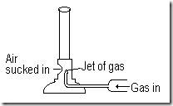
Figure 3.

Explain how air is drawn into the burner when the gas tap is opened. (2 marks)
………………………………………………………………………………………………………………………………………………………………………………………………………………………………………………………………………………………………………………………………………………………………………………………………………………………………………………………………………………………………………………………………………………………………………………………………………………………………………………………………………………………………………………………………………………………………………………………………………………………………………………………………………………………………………………………………………………………………………………………………………………………………………………………………………………………………………………………………………………………………………………………….

- A stone is thrown vertically upwards with a velocity u from the top of a cliff of height 20m falls to the ground below .Take the ground as the zero level, sketch a displacement-time graph in the axes below. (2 marks)

Displacement
(m)

Time (s)
- The figure 4. (a) below shows a spring fixed on a bench vertically. A mass of 0.5kg is placed on top as shown in Figure 4.(b).
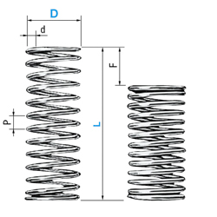
Fig. 4(a) Fig. 4(b)

h_{o}= 6 cm
h₁= 4cm
0.5kg
In (a) the height h_{o} of spring is 6cm while in (b), the height h₁= 4cm.Calculate the energy stored in the spring in (b). (3 marks) ………………………………………………………………………………………………………………………………………………………………………………………………………………………………………………………………………………………………………………………………...…………………………………………………………….

- The Figure 5.below shows a double-decker bus.
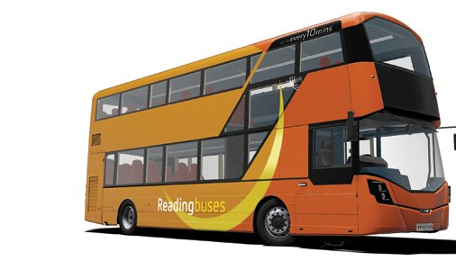

Figure 5.
Explain how the stability of the bus can be increased. (2 marks) ………………………………………………………………………………………………………………………………………………………………………………………………………………………………………………………………………………………………………………………………………………………………………………………………………………………………………………………………………………………………………………………………………………………………………………………………………………………………………………………………………………………………………………………………………………………………………………………………………………………………………………………………………………………………………………………………………………………………………………………………
- Define Mechanics as a branch of Physics. (1 mark)
………………………………………………………………………………………………………………………………………………………………………………………………………………………………………………………………………………………………………………………………………………………………………………………………………………………………………………………………………………………………

SECTION B (55 MARKS)
- a) A stone of mass 500g is attached a string of length 50cm and which will break when the tension on the string is 105 N. The stone is whirled in a vertical circle in anticlockwise direction. The axis of rotation is 175cm above the ground as shown in Figure 6.

50cm

175cm

Ground level

Figure 6.
The speed of rotation is slowly increased until the string breaks.
- Explain why the string is likely to break when it is passing the lowest point.
………………………………………………………………………………………………………………………(1mark) ……………………………………………………………………………………………………………………………………………………………………………………………………………………………………………………………………………………

- Calculate the linear velocity of the stone at the point where the string breaks.
- marks)
………………………………………………………………………………………………………………………………………………………………………………………………………………………………………………………………………………………………………………………………………………………………………………………………………………………………………………………………………………………………………………………………………………………………………………………………………………………………………………
(b) Below is a graph of r (m) against v (m/s). Given that v = rɷ

From the graph determine;

(i) Angular velocity, ɷ (2 marks)
……………………………………………………………………………………………………………………………………………………………………………………………………………………………………………………………………………………………………………………………………………………………………………………………
(ii) The periodic time, T (2 marks)
………………………………………………………………………………………………………………………………………………………………………………………………………………………………………………………………………………………………
- (a) Figure 7. Shows a set up of apparatus used to verify Charles Law.
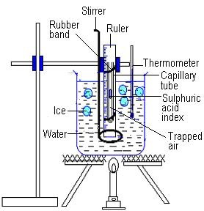
Figure 7.
- State one function of Sulphuric acid index (1 marks)
……………………………………………………………………………………………………………………………………………………………………………………………………………………………………………………………………….
- Briefly explain how the set up above is used to verify Charles Law. (4 marks)
…………………………………………………………………………………………………………………………………………………………………………………………………………………………………………………………………………………………………………………………………………………………………………………………………………………………………………………………………………………………………………………………………………………………………………………………………………………………………………………………………………………………………………………………………………………………………………………………………………………………………………………………………………………………………………………………………………………………………………………………………………………………………………………………………………………………………………………………………………………………………………………………………………………………………………………………………………………………………………………………………………………………………………………………………………………………………………………………….....

(b) A bicycle pump, with its exit hole closed, contains 80cm³ of air at 760 mmHg pressure and a temperature of 7ºC.When the air has been compressed to 38cm³ under 1720 mmHg pressure, its temperature rises. Calculate the rise in temperature. (3 marks) ………………………………………………………………………………………………………………………………………………………………………………………………………………………………………………………………………………………………………………………………………………………………………………………………………………………………………………………………………………………………………………………………………………………………………………………………………………………………………………………………………………………………
- (a) Define the term specific latent heat of vaporization of a substance. (1 mark)
………………………………………………………………………………………………………………………………………………………………………………………………………………………………………………………………………………………………………………………………………………………………………………………………………………………
(b) Water of mass 200g at a temperature of 5ºC was added into an insulated copper calorimeter of mass 60g.Steam at 100ºC was passed through the water for some time. When the calorimeter and its content were weighed again, the mass was found to be 266g.Given that specific heat capacity of water is 4200J/Kg K, specific heat capacity of Copper is 390J/Kg K, specific latent heat of vaporization of steam is 2.26 x 10⁶J/Kg and the final temperature of the mixture was Tº C.
(i) Determine the expression for the heat gained by water in the calorimeter in terms of T ⁰ C . (2marks)
………………………………………………………………………………………………………………………………………………………………………………………………………………………………………………………………………………………………………………………………………………………………………………………………………………………………………………………………………………………………
(ii) Determine the expression for the heat gained by the calorimeter. (2 marks)
………………………………………………………………………………………………………………………………………………………………………………………………………………………………………………………………………………………………………………………………………………………………………………………………………………………………………………………………………………………………………………………………………………………………………....................................
- Calculate the mass of steam which condenses to water. (1 mark)
………………………………………………………………………………………………………………………………………………………………………………………………………………………………………………………………………………………………………………………………………………………………………………………………………………………………
- Determine the expression for the heat lost by steam as it condenses to water at Tº C.
(3 marks) ………………………………………………………………………………………………………………………………………………………………………………………………………………………………………………………………………………………………………………………………………………………………………………………………………………………………………………………………………………………………
- Determine the final temperature, T attained. (3 marks)
………………………………………………………………………………………………………………………………………………………………………………………………………………………………………………………………………………………………………………………………………………………………………………………………………………………………………………………………………………………………………………………………………………………………………………………………
- (a) Draw a block and tackle pulley system with a velocity ratio 5. (1 mark)

(b) A block and tackle of V.R 5 is used to raise a load of 400N through a height of 10m.If the work done against friction is 1000J. Calculate;
(i) Work done by effort. (2 marks)
………………………………………………………………………………………………………………………………………………………………………………………………………………………………………………………………………………………………………………………………………………………………………………………………………………………………………………………………………………………………………………………………………………………………………………………………………………. (ii) The effort applied if the efficiency is 80%. (3 marks) …………………………………………………………………………………………………………………………………………………………………………………………………………………………………………………………………………………………………………………………………………………………………………………………………………………………………………………………………………………………………………………………………………………………………………………………………………………………………………………………………………………………………………………………………………………

(c) The Figure 8. shows part of a hydraulic press. The plunger is the position where effort is applied while the Ram piston is the position where the load is applied. The plunger has a radius r (m) while the Ram has a radius of R (m).When the plunger moves down a distance d, the ram piston moves up a distance D. 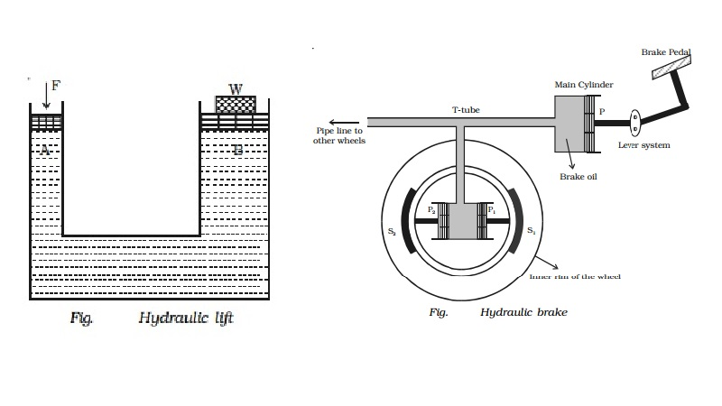
Figure 8.
Plunger of radius r
r
Ram piston of radius (R)
Derive an expression for the velocity ratio (V.R) in terms of R and r. (3 marks) ………………………………………………………………………………………………………………………………………………………………………………………………………………………………………………………………………………………………………………………………………………………………………………………………………………………………………………………………………………………………………………………………………………………………………………………………………………
- A railway truck of mass 2.4 tonnes travelling at a velocity of 4.7m/s collides with a stationary truck m on a level track. After collision the two trucks move together with common velocity of 1.2m/s. Calculate,
- The mass m of the stationary truck. (2 marks)
………………………………………………………………………………………………………………………………………………………………………………………………………………………………………………………………………………………………………………………………………………………………………………………………………………………………………………………………………………………………………………………………………………
- The original kinetic energy of the first truck (2 marks)
………………………………………………………………………………………………………………………………………………………………………………………………………………………………………………………………………………………………………………………………………………………………………………………………………………………………………………………………………………………………………………………………………………………………………………………………………………………………………………………………………………………………………………………………
- The total kinetic energy of both trucks after collision. Account for the apparent loss in kinetic energy. (3 marks)
……………………………………………………………………………………………………………………………………………………………………………………………………………………………………………………………………………………………………………………………………………………………………………………………………………………………………………………………………………………………………………………………………………………………………………………………………………………………………............................................................................................................................................................................................................................................................................
- (a) State Archimede’s Principle (1 mark)
………………………………………………………………………………………………………………………………………………………………………………………………
………………………………………………………………………………………….
(b) The figure 9. shows a wooden block of dimensions 50cm by 40cm by 20cm held in position 40cm below the surface of water, by a string attached to the bottom of a swimming pool. The density of the block is 600kg/m³ and density of water is 1g/cm³.
40cm 440cm40cm
20cm

50cm

Wooden block

40cm

Figure 9. String

(i) State the three forces acting on the block and write an equation linking them when the block is stationary (2mark) ………………………………………………………………………………………………………………………………………………………………………………………………………………………………………………………………………………………………………………………………………………………………………………………………………………………………………………………………………………………………………………………………………………………………………………………………
(ii) Calculate Upthrust on the block. (2 marks) ………………………………………………………………………………………………………………………………………………………………………………………………………………………………………………………………………………………………………………………………………………………………………………………………
(iii) Determine the Tension on the string. (2 marks) ………………………………………………………………………………………………………………………………………………………………………………………………………………………………………………………………………………………………………………………………………………………………………………………………………………………………………………………………………………………………
(c) Determine the pressure on the bottom surface of the block (2 marks)
………………………………………………………………………………………………………………………………………………………………………………………………………………………………………………………………………………………………………………………………………………………………………………………………(d) The figure 10. shows a diagram of a hydrometer which is suitable for measuring density of liquids varying between 0.8 and 1.2g/cm³.

Figure 10.
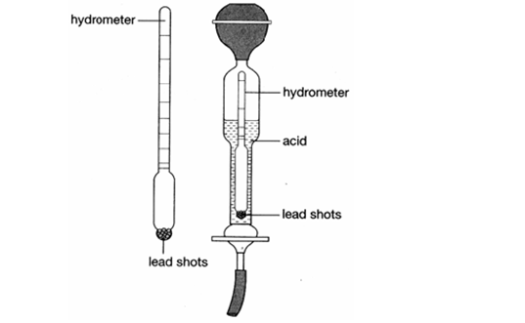
Air
Wide bulb
Stem
(i) Indicate on the diagram the label corresponding to 0.8 and 1.2 g/cm³. (1 mark)
(ii) State one function of lead shots (1 mark) ................................................................................................................................................................................................................................................................................................................................................................................................................................................

This is the last printed page

