Manyam Franchised Tests
MATHEMATICS | STD8 | 2HRS | KCPE 2007

Name…………..……………………..…………. School…………………….....………………Date…………

- Which one of the following is 1100000.001 written in words?
- One million one hundred thousand and one hundredth
- One million one thousand and one thousandth
- One million one hundred thousand one tenth
- One million one hundred thousand and one thousandth
- What is the place value of the digit 7 obtained after working out 0.2016+28?
- Tenths.
- Hundredths
- Thousandths
- Ten thousandths
- What is 6.0947 rounded off correct to two decimal places?
- 6.15
- 6.10
- 6.0947
- 6.09
- What is the value of 3$\frac{2}{5}+2\frac{1}{4}-1\frac{1}{3}+\frac{1}{6}of1\frac{5}{7}$?
- $5\frac{32}{35}$
- $1\frac{86}{105}$
- $\frac{24}{35}$
- $\frac{4}{35}$
- What is the volume of a cylindrical tank of diameter 5m and height 6m? (take $π=\frac{22}{7}$ )
- $471\frac{3}{7}m^{3}$
- $133\frac{4}{7}m^{3}$
- $117\frac{6}{7}m^{3}$
- $94\frac{2}{7}m^{3}$
- Auma and Maina shared the profit from the sale of fish in the ratio 3:4. If the profit was sh 8400, how much money did Auma get?
- Sh 3600
- Sh 4800
- Sh 6300
- Sh 11200
- Mariam bought the following items:
3kg flour @ sh 55
2kg packet of sugar for sh 115
2 bars of soap @ sh 42
3 litres of milk @ sh 25
1 ½ litres of kerosene @ sh 45

If she gave the shopkeeper a sh 1000 note, how much balance did she receive?
- Sh 378.50
- Sh 493.50
- Sh 718.00
- Sh 506.50
- A map is drawn to a scale of 1:20 000. What is the distance in kilometers of a road which is 25cm on the map?
- 5
- 50
- 500
- 5000
- By how much is the LCM of 40 and 60 more than their GCD?
- 20
- 100
- 120
- 140
- What is the value of$\frac{1.5+0.9 of 2.5-1.42}{0.4}$?
- 5.48
- 5.825
- 5.88
- 10.85
- Below is a net of a solid. The shaded parts are the flaps
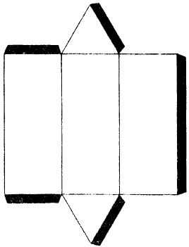
Which one of the following solids can be formed from the net?
- Rectangular prism
- Triangular pyramid
- Rectangular pyramid
- Triangular prism
- Which one of the following quadrilaterals has only one pair of parallel lines?
- Rhombus
- Trapezium
- Parallelogram
- Rectangle

- A fruit vendor prepared juice which filled eight 3-litre containers. He later put the juice in 2-decilitres bottles for sale. How many such bottles of juice did he get?
- 12
- 120
- 1200
- 12000
- A lawn is in the form of a rectangle and two semicircles. The rectangle is 22m long and 6m wide. The width of the rectangle are also the diameters of the semicircles
What is the area of the lawn in m²? (Take $π=\frac{22}{7}$ )
- 245$\frac{1}{7}$
- 188$\frac{1}{7}$
- 160$\frac{2}{7}$
- 28$\frac{2}{7}$
- Ali and Maingi sat for five subjects in an examination. The total marks for Maingi were 15 less than those of Ali. The mean mark for Ali was 65. What was the mean mark for Maingi?
- 50
- 62
- 68
- 310
- What is the next number in the pattern 16, 44, 82, 130, ……?
- 188
- 212
- 178
- 140
- In a certain village the total number of women and children was 34 603. The number of women and men was 18 623. If the number of men was 5984, what was the number of children in that village?
- 12639
- 15980
- 28619
- 21964
- The figure below shows angles formed by a pair of parallel lines and a transversal.
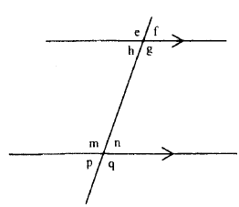
In which group below, are each of the angles equal to n?
- p,g,f
- p,m,f
- p,q,f
- p,h,f

- what is the value of $\sqrt{4.2849?}$
- 0.207
- 2.07
- 2.7
- 207
- In a certain school, the fractions of boys in classes 5, 6, 7 and 8 are as follows: class is $\frac{12}{16}$, class 6 is $\frac{13}{26}$, class 7 is $\frac{10}{25}$ and class 8 is $\frac{10}{18}$,
Which class has the least number of boys if all the classes have the same number of pupils?
- Class 5
- Class 6
- Class 7
- Class 8
- What is the value of $x$ in the equation $\frac{2x-3}{3}+2x=6?$
- $1\frac{1}{8}$
- $5\frac{7}{8}$
- $1\frac{7}{8}$
- $2\frac{5}{8}$
- The table below shows the number of vehicles that passed near a school in one week. The average number of vehicles per day was 116. The number of vehicles that passed near the school on Friday is not shown
Mon | Tues | Wed | Thur | Fri | Sat | Sun
125 | 75 | 112 | 100 | ….. | 148 | 112
How many more vehicles passed near the school on Friday than on Tuesday?
- 595
- 215
- 140
- 65
- A small aircraft took 6 hours 30 minutes to travel from Pretoria to Mombasa. It reached Mombasa at 04 00 h on Wednesday. At what time and day did it depart from Pretoria?
- 09 30 on Wednesday
- 09 30 h on Tuesday
- 21 30 on Wednesday
- 21 30 h on Tuesday
- The diagram below represents a flower garden
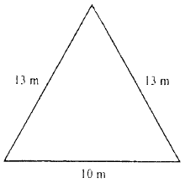
What is the area of the flower garden in m²?
- 36
- 60
- 65
- 120

- The diagram below represents a door which was painted on the outside.
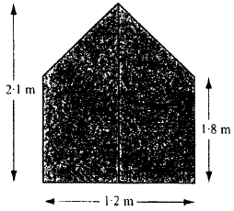
What was the area painted, in square metres?
- 1.17
- 2.16
- 2.34
- 2.52
- Which one of the following groups of measurements represents length of sides of a right angled triangle?
- 7cm, 12cm, 13cm
- 5cm, 4cm, 6cm
- 3cm, 4cm, 6cm
- 12cm, 16cm, 20cm
- A cylindrical container has an internal radius of 7cm and a height of 5cm. what is its capacity in litres? (Take $π=\frac{22}{7}$ )
- 0.77
- 7.7
- 77
- 770
- A farmer used $\frac{1}{2}$of her land for planting maize, $\frac{1}{5}$ for planting beans, $\frac{1}{3}$ of the remainder for grazing and the rest for horticulture. If the farmer used 10 ha for grazing, how much land does she have?
- 100 ha
- 33$\frac{1}{3}$ ha
- 30 ha
- 11$\frac{1}{30}$ ha
- Which one of the triangles below has two of its sides measuring 5cm and 7cm while one of its angles measures 75⁰?
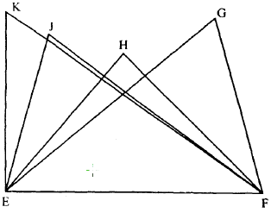
- Triangle KEF.
- Triangle JEF.
- Triangle HEF.
- Triangle GEF.

- In a certain company candidates G, K and L contested for a seat. The number of those who voted for K was 800, which was 0.25 of the total votes. Out of the remaining votes, L received 0.03 more than G. How many more votes than K did the winning candidate get?
- 72
- 364
- 436
- 448
- The table below shows the second class train fare from station M to P through station N. the Pupils paid fare as children.
DESCRIPTION | SECOND CLASS
STATION | FARE ONLY | FARE & BEDDING | ALL INCLUSIVE
M-P  ADULT  CHILD | 1000.00  500.00 | 1275.00  775.00 | 2275.00  1475.00
M-N  ADULT  CHILD | 695.00  350.00 | 970.00  625.00 | 1570.00  1045.00
Three teachers accompanied 45 pupils in the train. The pupils paid fair only, from station M to P. two of the teachers paid all inclusive rate from station M to P. one teacher who alighted at 0station N paid for fare and bedding. How much money did they pay altogether?
- Sh 25 195
- Sh 28 020
- Sh 28 325
- Sh 50 520
- The hire purchase price of a cupboard was 25% more than the marked price. Karani bought the cupboard on hire purchase terms.
He paid a deposit of sh 2000 and eight equal monthly installments of sh 650. What was the marked price of the cupboard?
- Sh 4 160
- Sh 5 400
- Sh 5 760
- Sh 9 000
- Construct a semi-circle whose diameter EF is given below. Construct a line from E to meet the semi-circle at G such that angle FEG is 30⁰. Construct a line from F to meet the semi-circle at H such that angle EFH is 20⁰. Join points E to H, H, H to G and G to F.

What is the length of line GH?
- 3.0cm
- 3.9cm
- 5.3cm
- 5.7cm

- A lorry has mass of 7.7 tonnes when loaded with 75 bags of rice. There are 33 bags each with mass of 85 kg and the rest have mass of 45 kg each. What is the mass of the lorry in tones, when empty?
- 3.005
- 4.695
- 4.850
- 12.895
- There were m men in a bus. The number of children in the bus was three times that of men but eleven more than that of women. The total number of women, men and children in the bus was 45. Which one of the equations below can be used to find the number of men that were in the bus?
- 5m-11=45
- 4m+11=45
- 7m+11=45
- 7m-11=45
- Four workers take 10 hours to complete a certain job. How many more workers would be hired in order that they do the same job in 2 hours?
- 20
- 24
- 16
- 1
- The pie-chart below shows how Kesenet spent her salary.
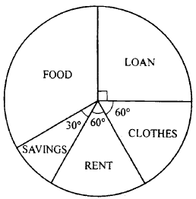
How much more did she spend on loan than on rent if she spent sh 4000 on food?
- Sh 5000 B. sh 3000 C. sh 2000 D. sh 1000
- Which two of the following statements are true about all triangles?
- All angles are equal
- Sum of interior angles is 180⁰
- One angle is 90⁰
- Sum of exterior angles is 360⁰
- i and ii
- i and iii
- iI and iv
- iii and iv
- There is a 25% loss when an article is sold at sh 2256. At what price should it be sold in order to make a profit of 5%?
A. Sh 315.00 B. sh 300.00
C. Sh 295.31 D. sh 236.25

- A playing field measured 50m by 30m. The measurements of the sides of the field were later increased to 80m by 60m. what was the percentage increase of the area of the field?
- 4800
- 3300
- 900
- 220
- How many more cube are needed to fill the box below?
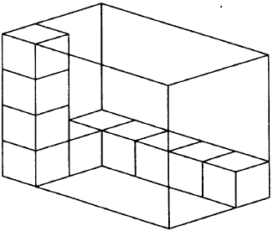
- 10
- 22
- 50
- 60
- The graph below shows part of the journey made by Chebet and Keya on the same road.

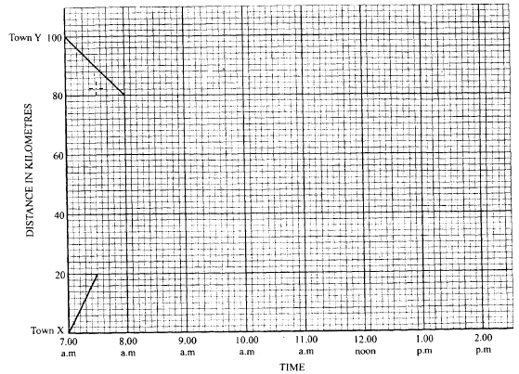
Chebet travelled from town Y to town X at a constant speed.
Keya travelled from town X to town Y. After covering 20 km he rested for 30 minutes. He then continued at an average speed of 40 km/h.
Complete the graphs of the journeys.
At what time did they meet?
A. 9.00 a.m. B. 8.40 a.m.
C. 9.10 a.m. D. 8.50 a.m.

- Line PQ below is the base of the parallelogram PQRS.
Complete the parallelogram in which angle QPS=60⁰ and line PS=4.5cm.

What is the height of the parallelogram in cm?
- 3.9
- 5.4
- 6.0
- 9.1
- Karim paid sh 950 for an item after getting a discount of 5%. What would have been the percentage discount, if Karim had paid sh 925 for the item?
- $2\frac{12}{19}\%$
- $7\frac{1}{2}\%$
- $7\frac{12}{19}\%$
- $8\frac{4}{37}\%$
- A motorist driving at 60km/h was expected to arrive on time in town A, 200 km away. After driving for one hour, the got a puncture and it took 20 minutes to change the wheel.
At what speed in km/h did he drive after repairing the puncture if he had to arrive at the expected time?
- 105
- 100
- 70
- 52$\frac{1}{2}$
- The figure below represents a plot of land bounded by three straight edges and a semi-circle. Three strands of wire are used to fence the plot
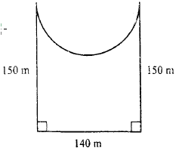
What is the length in metres, of the wire used? (Take $π=\frac{22}{7}$ )
- 660
- 1980
- 2640
- 24420

- Which one of the following expressions is the simplest form of $\frac{7\left(2r+3\right)+4r-3}{2(r+1)+4r+7}?$
A. $\frac{6r+6}{2r+3}$ C. $\frac{9r}{3r+4}$
B. $\frac{6r+8}{2r+3}$ D. $2\frac{1}{2}$

- The table below shows the rates of sending letters and postcards through a post office in year 2004

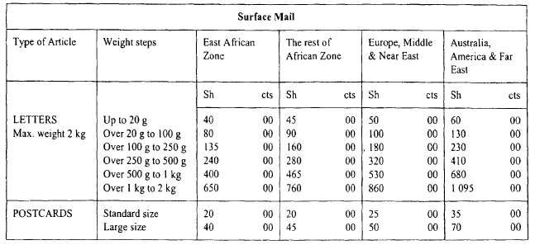
Makena sent the following letters and postcards. Two letters each weighing 21g; one to Australia, four letters each weighing 280g; one to Europe, two to America and one to Nigeria. Three large postcards; one to Australia, one to Far East and one to America
How much did she pay for postage altogether?
- Sh 1 840.00
- Sh 1 730.00
- Sh 1 820.00
- Sh 1 430.00
- The volume of an open rectangular tank is 24.m³. the tank has a square base. The height of the tank is 2.7 metres. What is the surface area of the tank in square metres?
- 32.4
- 41.4
- 50.4
- 178.2
- Janet borrowed some money at a simple interest of 12% p.a. After 18 months, she had paid a total interest of sh 5 400. How much money had she paid altogether?
- Sh 35 400
- Sh 30 000
- Sh 24 600
- Sh 7 90

