NAME........................................................................................................CLASS..........................
INDEX NO......................... DATE ........................SIGN................... ADM NO ………………..
231/1
BIOLOGY
PAPER 1
MARCH 2018
TIME: 2 HOURS

MOKASA EXAMINATIONS
(Kenya Certificate of Secondary Education)
BIOLOGY THEORY
Instructions
- Write your name, class and admission number in the space provided above.
- Write the date of the examination and sign in the space provided above.
- Answer all the questions in the spaces provided.
- You may be penalized for wrong spelling especially technical terms.

For Examiner’s Use Only
Question | Maximum Score | Candidate’s Score
1-32 | 80

This paper consists of 13 printed pages. Candidates should check the question paper to ascertain that all the pages are printed as indicated and no questions are missing

1. State two environmental problems that can be solved by studying biology. (2 marks)
………………………………………………………………………………………………………………………………………………………………………………………………………………………………………………………………………………………………………………………
2. Below is a photograph of an organism
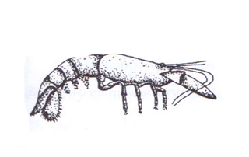
(i) Identify the class to which this organism belongs to. (1 mark)
………………………………………………………………………………………………………
(ii) Give reasons for your answer in (i) above. (2 marks)
………………………………………………………………………………………………………………………………………………………………………………………………………………………………………………………………………………………………………………………………………………………………………………………………………………………………
3. Aerobic break down of glucose yields 2880 kJ of energy whereas anaerobic breakdown yields 150 kJ. Give an explanation to account for this difference. (3 marks)
………………………………………………………………………………………………………………………………………………………………………………………………………………………………………………………………………………………………………………………………………………………………………………………………………………………………

4. The photograph illustrates an organism found in aquatic habitat.
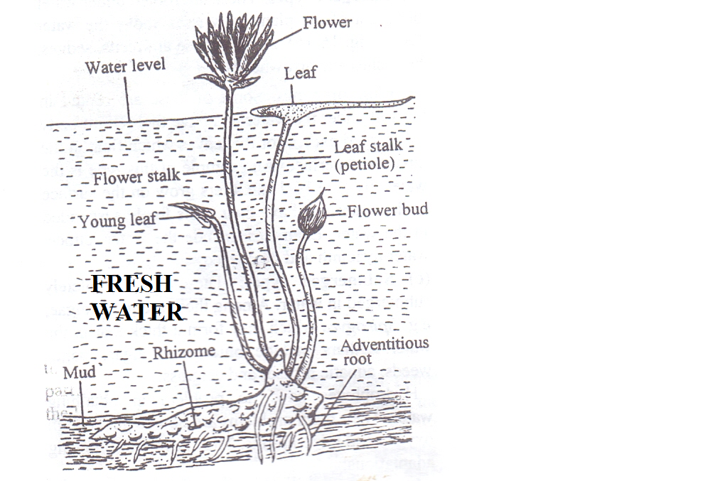
(a) Give the type of the plant. (1 mark)
………………………………………………………………………………………………………
(b) Describe three adaptation of the organism to its habitat. (3 marks)
………………………………………………………………………………………………………………………………………………………………………………………………………………………………………………………………………………………………………………………………………………………………………………………………………………………………………………………………………………………………………………………………………
5. Below is the basic functional unit of an organism
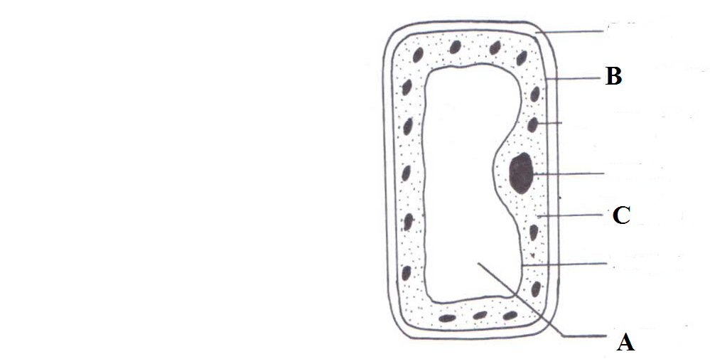
State the functions of the parts labeled:
(i) A…………………………..………………………………………………………….(1 mark)
(ii) B…………………………..…………………………………………………………(1 mark)
(iii) C……………………………….……………………………………………………(1 mark)

6. A student smeared the abdomen of a locust with Vaseline.
(a) What were the likely results after ten minutes? (1 mark)
………………………………………………………………………………………………………………………………………………………………………………………………………………
(b) Account for the results obtained above. ( 2marks)
……………………………………………………………………………………………………………………………………………………………………………………………………………………………………………………………………………………………………………………………………………………………………………………………………………………………
7. Use the illustration below to answer questions that follow.
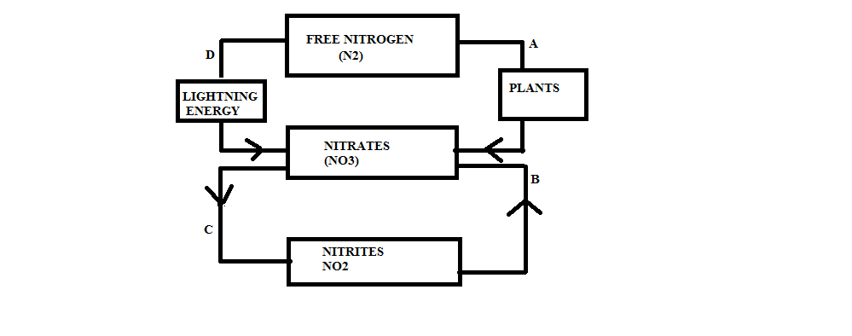
(a) Name the process labeled:
(i) B…………………………………………………………………………….………..(1 mark)
(ii) C………………………………………………………………………………..……..(1 mark)
(b) Name the site where process A occurs. (1 mark)
………………………………………………………………………………………………………
(c) Explain why process C is not beneficial to plants. (1 mark)
………………………………………………………………………………………………………

8. What is the significance of photolysis? (2 marks)
………………………………………………………………………………………………………………………………………………………………………………………………………………………………………………………………………………………………………………………
9. The following table shows the volume of gases carried by 100cm³ of blood.
Gas | Blood entering lungs | Blood leaving lungs
Nitrogen | 0.9 cm³ | 0.9 cm³
Oxygen | 10.6 cm³ | 19.0 cm³
Carbon (iv) oxide | 58.0 cm³ | 50.0 cm³
(a) Which blood has a higher content of carbon (IV) oxide? (1 mark) ………………………………………………………………………………………………………
(b) Explain the difference in the content of oxygen and carbon (IV) oxide in blood entering the lungs and that leaving the lungs. (2 marks) ………………………………………………………………………………………………………………………………………………………………………………………………………………………………………………………………………………………………………………………………………………………………………………………………………………………………………………………………………………………………………………………………………
10. State the function of the following apparatus;
(i) Specimen bottle. (1 mark) ………………………………………………………………………………………………………………………………………………………………………………………………………………
(ii) Bait trap. (1 mark) ………………………………………………………………………………………………………………………………………………………………………………………………………………
11. Name the causative agents of the following diseases:
(a) Cholera…………………………………………………………………………………(1 mark)
(b) Malaria …………………….…………………………………………………………..(1 mark)
12. Explain why young onion root tip is ideal for examining the stages of mitosis. (2 marks) ……………………………………………………………………………………………………………………………………………………………………………………………………………………………………………………………………………………………………………………………………………………………………………………………………………………………..
13. Below is a set up to investigate a certain phenomenon.
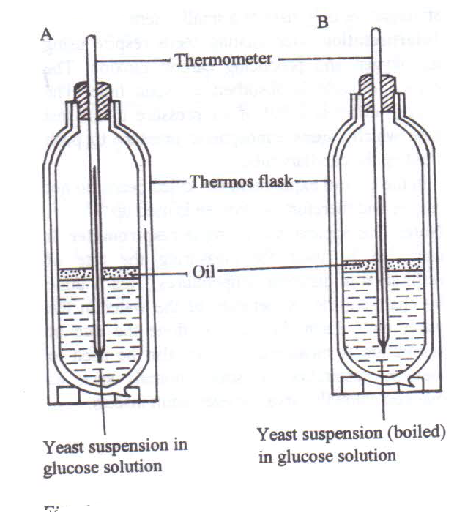
(a) State the aim of the experiment. (1 mark)
………………………………………………………………………………………………………
(b) Account for the observations made after 30 minutes in set-up A (2 marks)
………………………………………………………………………………………………………………………………………………………………………………………………………………………………………………………………………………………………………………………

14. Use the illustration below to answer questions.
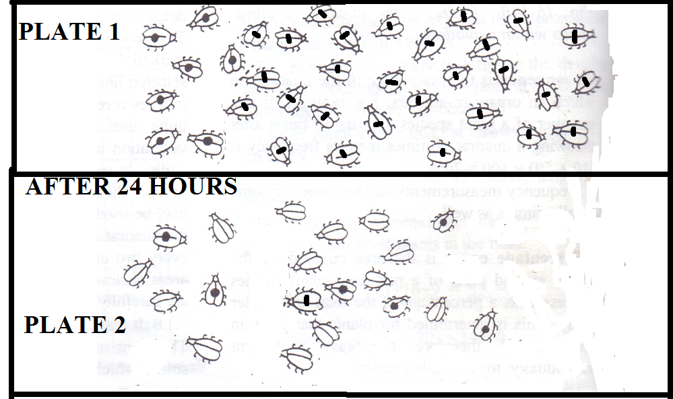
(a) Identify the method of population estimation shown above. (1 mark)
………………………………………………………………………………………………………
(b) Estimate the population of the beetles. (2 marks)

(c) State one limitation of this method. (1 mark)
………………………………………………………………………………………………………………………………………………………………………………………………………………………………………………………………………………………………………………………………………………………………………………………………………………………………………………………………………………………………………………………………………
15. An investigation was carried between 1994 and 2003 to study the changes of fish population in a certain small lake. Four species of fish A, B, C and D were found to live in this lake. In 1995, A factory was built near the lake raising temperatures from 25⁰ C to 30⁰ C. In 1997, Sewage and industrial waste was diverted into the lake. The population of fish during the period of investigation is shown in the table below.
Fish species | 1994 | 1996 | 1998 | 2000 | 2001 | 2002 | 2003
A | 6102 | 223 | 20 | 106 | 660 | 4071 | 7512
B | 208 | 30 | 11 | 22 | 63 | 311 | 405
C | 36 | 100 | 0 | 0 | 0 | 0 | 0
D | 4521 | 272 | 23 | 23 | 29 | 400 | 617

Explain two factors that could have brought the changes in the fish populations. (2 marks)
………………………………………………………………………………………………………………………………………………………………………………………………………………………………………………………………………………………………………………………………………………………………………………………………………………………………………………………………………………………………………………………………………
16. State the functions of the following parts of a light microscope.
(i) Coarse adjustment knob. (1 mark)
………………………………………………………………………………………………………………………………………………………………………………………………………………
(ii) Condenser. (1 mark)
………………………………………………………………………………………………………………………………………………………………………………………………………………

17. Below are photographs of fruits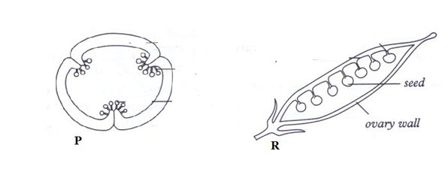
Identify the type of placentation shown above.
(i) P………………………………………………………………………………………. (1 mark)
(ii) R………………………………………………………………………..……………. (1 mark)
18. Use the diagram below to answer questions that follow.
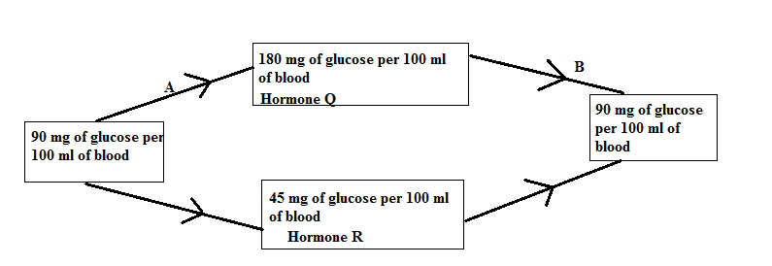(a) Name the feedback mechanism labeled B. (1 mark)
………………………………………………………………………………………………………
(b) Identify:
(ii) Hormone R………………………………………………………………………..…. (1 mark)

19. Show that you understand the terms below as used in describing flowers.
(i) Polypetalous. (1 mark)
………………………………………………………………………………………………………
(ii) Staminate flower. (1 mark)
………………………………………………………………………………………………………20. Study the illustration below and answer the questions that follow.
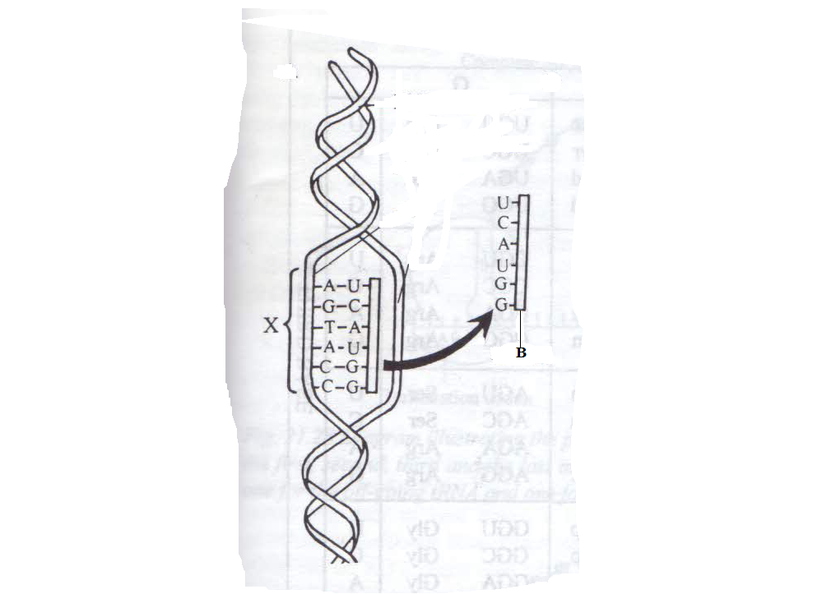
(a) (i) Identify the strand labeled B. (1 mark)
……………………………………………………………………………………………………… (ii) Give a reason for your answer in (a) (i) above. (1 mark) ……………………………………………………………………………………………………………………………………………………………………………………………………………
(b) If the cell was treated with colchicine prior to the process above, extra base will be added to the strand labeled X. Give the name of this type of mutation. (1 mark)
………………………………………………………………………………………………………………………………………………………………………………………………………………

21. Name three food substances acquired by herbivores feeding on green sprouting grass exposed to maximum sunlight during the day. (3 marks)
………………………………………………………………………………………………………………………………………………………………………………………………………………………………………………………………………………………………………………………………………………………………………………………………………………………………
22. A cross between a red - flowered plant and a white -flowered mirabilis plant produced only pink flowered F1 plants. Suggest a reason to explain why there were no red or white flowered F1 plants. (1 mark)
………………………………………………………………………………………………………………………………………………………………………………………………………………
23. Define the following concepts of ecology
(i) Ecological niche. (1 mark)
………………………………………………………………………………………………………………………………………………………………………………………………………………
(ii) Biomass. (1 mark)
………………………………………………………………………………………………………………………………………………………………………………………………………………
24. A certain animal has no incisors, no canines, 6 premolars and 6 molars in its upper jaw. In the lower jaw there are 6 incisors, 2 canines, 6 premolars and 6 molars.
(a) Write its dental formula. (1mark)

(b) Identify the mode of nutrition of the organism. (1 mark) ………………………………………………………………………………………………………………………………………………………………………………………………………………
(c) Give a reason for your answer in (b) above. (1 mark) ………………………………………………………………………………………………………………………………………………………………………………………………………………
25. The diagram below represents a stage in the development of human foetus.
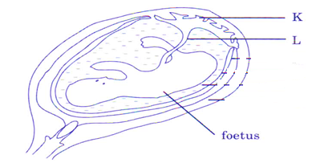
(a) Name the blood vessel in part labeled L that supplies nutrients to the foetus. (1 mark)
………………………………………………………………………………………………………
(b) Give two functions of part labeled K. (2 marks)
………………………………………………………………………………………………………………………………………………………………………………………………………………
26. The photograph below shows a skull of an organism
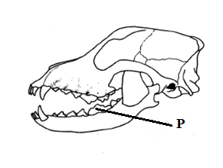

(i) Name the tooth labeled P and its function. (2 marks)
………………………………………………………………………………………………………………………………………………………………………………………………………………

27. State two roles of an acrosome. (2 marks)
………………………………………………………………………………………………………………………………………………………………………………………………………………………………………………………………………………………………………………………
28. Distinguish between the following terms:
(i) Cytology and entomology. (1 mark)
………………………………………………………………………………………………………………………………………………………………………………………………………………
(ii) Botany and zoology. (1 mark)
…….……......................................................................................................................................................................................................................................................................................................
29. Give the roles of the following hormones in males
(i) Follicle stimulating hormone. (1 mark)
………………………………………………………………………………………………………………………………………………………………………………………………………………
(ii) Luteinizing hormone. (1 mark)
……………………………………………………………………………………………………………………………………………………………………………………………………………
30. What is gestation period? (1 mark)
………………………………………………………………………………………………………………………………………………………………………………………………………………………………………………………………………………………………………………………………………………………………………………………………………………………………

31. Explain the importance of the following processes when making microscopic sections:
(i) Cutting very thin sections. (1 mark)
………………………………………………………………………………………………………………………………………………………………………………………………………………
(ii) Using a sharp scalpel to cut thin sections. (1 mark)
………………………………………………………………………………………………………………………………………………………………………………………………………………
32. Describe how the granum is adapted to its photosynthetic function. (2 marks) ………………………………………………………………………………………………………………………………………………………………………………………………………………………………………………………………………………………………………………………………………………………………………………………………………………………………
33. Below is a photograph of a fruit.
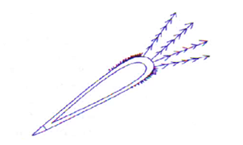
(a) State the agent of dispersal of the fruit. (1 mark) ………………………………………………………………………………………………………………………………………………………………………………………………………………
(b) Give a reason for your answer in (a) above. (1 mark)
………………………………………………………………………………………………………………………………………………………………………………………………………………

THE END

