MWAKICAN JOINT EXAMS
BIOLOGY END OF SECOND TERM 2017
FORM 1
MARKING SCHEME
1(a) Biology refers to (1mk)
The study of living organisms
b) State the name given to the study of :
(i) Chemical changes inside living organisms (1mk)
Biochemistry
(ii) Cells (1mk)
Cytology
2. Which three skills are acquired when one studies biology. (3mks)
Measuring,recording,observing,analyzing,identifying and everluating. (any three)
3 What is the importance of classification. (3mks)
- Facilitates identification of organism
- Helps arrange information about living organisms in an orderly manner
- Helps us understand the evolutionary relationships between organisms
- helps arrange organisms with similar characteristics together and seperates those with different characteristics. (any three)
4. Identify the following apparatus and state their used. (4mks)

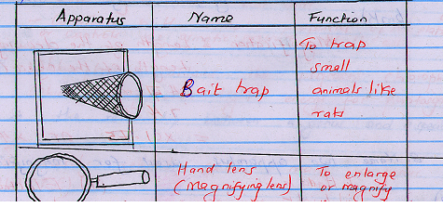

5 Which taxonomic unit:
(a) Comes before the germs. (1mk)
Family
(b) Has the largest number of different organisms. (1mk)
Kingdom
(c) Has organisms with very many similar characteristics. (1mk)
Species
6 A form one student wrote the scientific mane of the large round worm as ascaris Lumbricoides)
(a) Identify two mistakes made by the student. (2mks)
- He started the genus name with a small letter instead of a capital letter
-Started the species name with a capital letter instead of small letter
- did not underline the two name separately
(any two)
b. What do you call this system of naming living organisms. (1mk)
Binomial nomenclature
7 A student drew a 4cm long diagram of a Hibiscus flower. The actual flower was 7cm long. What was the linear magnification of the students drawing? (2mks)

Magnification = $\frac{length of the drawing}{length of the object(Actual length}$

= $\frac{4cm}{7cm}$
X 0.51 or x$\frac{4}{7}$
8 Name two apparatus used for magnification. (2mks)
i) Had lens
ii) Light microscope
iii) Electron microscope
(Any two)

9) Study the following diagram and answer the questions that follow:

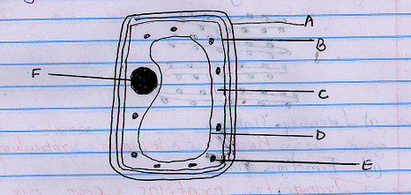
(a) Giving a reason state whether it is a plant or animal cell. (2mks)
Plant cell
Reason – it has a cell-wall
- It has chloroplasts
- It has a sap vacuole
(Any two)
b) A cell wall (4mks)
B cell membrane
C cytoplasm
F nucleus
c) State the functions of parts D and E. (2mks)

D - (sap vocoule)
- Store sugars and mineral salts
- contribute to the osmotic properties of the plant cell or controls the osmotic pressure of the cell.
E - Chloroplast – contains the pigment chlorophyll which traps the light energy for photosynthesis
10) What is the relationship between a genus and a species? (2mks)
Several closely related species make a genus (OWTTE)

11.(a) Identify the organelle shown below and state its functions in a cell.

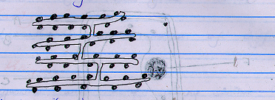

(i) Identity (2mks)
Rough endoplasmic reticulum

II) Function (1mk))
Transport proteins from one part of a cell to another.
b) Give a reason for your answer in (a)(i) above. (1mk)
This is the rough endoplasmic reticulum because it has ribosomes

12 The diagram below shows the changes in a plant cell when put in solution X

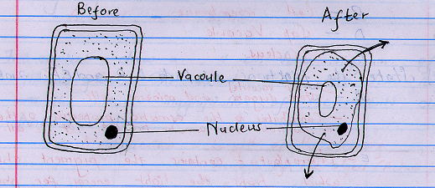

(a) Name solution X (1mk)
Hypertonic solution

b) Explain the abservation. (2mks)
The plant cell,when put in the hypertonic solution,salt water by osmosis and shrunk

c) Give a reason why a mature plant cell does not lose its shape even after losing water. (1mk)
it has a rigid or firm cell wall which does not allow it to change its shape.

13 State the importance of osmosis in plants. (3mks)
(a) Absorption of water from the soil
(b) Support of herbaceous plants,leaves and seedlings
(c) Opening and closing of stomata
(d) Feeding in insectivorous plants
14 Name the part of a light microscope which:
(a) Regulates the amount of light passing through the condenser. (1mk)

Diaphragm

(b) Hold the objective lens and eye piece lens. (1mk)
Body tube

c) Magnifies an object, (1mk)
Objective lens or eye piece lens. (Any one)

15 Define the term species. (2mks)
It is a group of organisms whose members can naturally interbreed giving rise to fertile offspring

16 What is the formular for calculating linear magnification of a specimen when using a hand lens? (2mks)
Magnification – $\frac{Lemgth of the drawing}{Length of actual specimen}$

17 Study the diagram of a cell organelle shown below and answer the questions that follow.

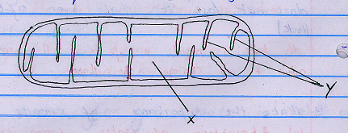

(a) Identify the organelle. (1mk)
Mitochendrian (reject mitochondria)

b) State its function. (1mk)
It is the site of energy produced/site of respiration

c) Name the parts labeled X and y. (1mk)
x = matrix
y = christae

18 a) i)cells that are structurally modified to perform a specific function (1mk)
ii) root hair cell, guard cell, palisade cell, sperm cell, red blood cell (2mks) any 2

(b) Arrange the following structures in the order of complexity; organ,organelle, tissue, organ system, cell, organism. (1mks)

c) What is a tissue? (1mks)
A tissue is a group of cells which perform the same specific function

19(a) Briefly describe how you would lift a microscope from your bench and take it to the teacher’s bench. (2mks)
Use both hands to carry the microscope. One hand holds the base to provide support while the other hand holds the limb or arm
Do not place the microscope close to the edge of the bench.

b) At which objective lens is the microscope stored. (1mk)
Low power objective lens.

c)What is the main advantage of using an electron microscope over a light microscope?(1mk)
The electron microscope has a higher resolution on resolving power than the light microscope. It is more powerful than the light microscope. Thus under the electron microscope more detail(more organelles) of a cell can be seen.

20(a) State four factor that affect the rate of diffusion. (4mks)
Temperature
Concentration gradient
Surface area to volume ratio
Thickness of membranes tissues or wall
Size of the molecules.
(Any three)

b) Distinguish between diffusion and active transport. (2mks)
Diffusion is movement of particles/molecules from their region of high concentration to their region of low concentration.
- No energy is needed
- In active transport molecules moves from a lowly concentration to their region of high concentration.
- Carriers and energy are necessary.

21(a) Examine the two cubes labeled A and B in the diagram below.

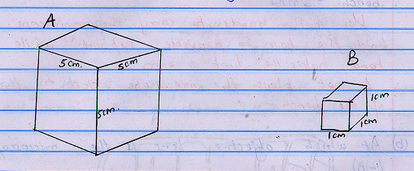

Calculate the surface area to volume ratio of each of the cubes. (4mks)
Cube A
Surface area = 6(5cm x 5cm) = 150cm²
Volume = 5 x 5 = 125cm³
Surface area to volume ratio = 6:1

b) If the cubes represented living organisms in which organism would diffusion take place at
(i) the slowest rate? Give a reason for your answer. (2mks)

Animal A
Reason – It has a small surface area to volume ratio.

(ii) The fastest rate, give a reason for your answer.
Animal B
Reason: It has large surface area to volume ratio

22 The diagram below is a transuerse section of a leaf.

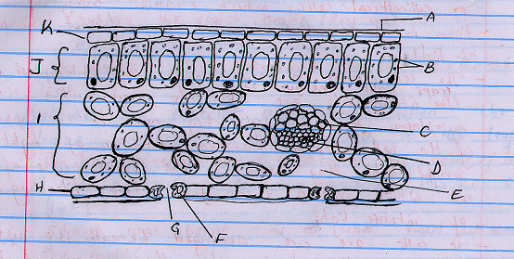

a) process by which green plants makes theirv own food using carbon iv oxide, water and energy from sunlight
b) Name the parts labeled A,C,F and J. (4mks)
A - Cuticle
C - Xylem
F - Guard cell
J - Palisade Mesophyll
c) i)Name the major pigment found in the structure labeled B. (1mk)
chlorophyll
ii) Traps light energy and converts it to chemical energy which is used to drive photosynthesis

d) Cuticle: It is waxy impervious to water and gase and therefore helps to reduce excessive loss of water by evaporation.
- Transparent therefore allows most of light to pass through
Spongy mesophyll - Its cells are irregularly shaped and loosely attached/arranged thus creating large intercellular air spaces which allow efficient diffusion of gases and water vapour between the leaf and the atmosphere.
- The cells have chloroplasts, which enable them to carry out photosynthesis
Palisade mesophyll – It has calumna or cylindrical cells, which enables many of them to be packed together for efficient absorption of light.
-the cells have a very numerous chloroplast which traps light energy.
-the chloroplasts are able to move to the upper parts of the cell allowing maximum absorption of light. In bright high they move to the lower parts of the cell which prefects them from the bleaching effects of intense light
-it cells are arranged beneath the upper epidermis of the leaf where they are exposed to abundant light
e) light stage ----grana/granum
dark stage----stroma

23 In an experiment, a leaf from a plant which had been kept in the dark overnight was boiled in water for a minute,boiled in alcohol in a hot water bath and washed in cold water. Iodine volution was then added to the leaf.
(a) Why was the leaf kept in the dark overnight? (1mk)

To destarch the leaf

b) Why was the leaf boiled in
(i) water (1mk)
To kill the cells; to stop the reactions; to rupture the starch grains.
(Any one)

(ii) alcohol. (1mk)

To remove the chlorophyll or to decolourise the leaf.

c)(i) Predict the expected observation when the iodine solution was added to the leaf. (1mk)
The leaf turned brown; or retained the colour of iodine

(ii) Give a reason for your answer in (i) above. (1mk)
Starch was absent as it had used up during the night.

d) Why was alcohol boiled indirectly over a hot water bath? (1mk)
In order to avoid igniting the highly flammable alcohol.

24(a) How does the study of biology help human beings in their day to day life? (3mks)
Choice of career; ways of avoiding and managing diseases like HIV//AIDS; Solving environmental problems; Acquiring some skills; Knowing the effects of drug and substance abuse to our health hence the need to avoid the practice.

b) How does movement in plants differ from that of animals. (1mk)
Movement in plants is localized ie move parts of their bodies while animals move their whole bodies (locomotion) or well part of their bodies.

