FORM ONE GEOGRAPGY MARKING SCHEME
1. a) -It is the description of the distribution of the natural features on the earth and their inter-relationship or it is the description of the distribution of the features due to human activities on earth. 1mk
b)The study of Geography helps learners to develop skills of studying ,observing ,analyzing and interpretation of maps ,charts,stastical data ,diagram & photography .
-It helps learners to be able to learn and explain the origin of earth, the solar system& the internal structure of the earth.
-Study of Geography encourages international awareness, interaction and cooperation.
- Geography creates awareness in the people on the significance of management and conservation of the environment and need to use resources sustainably.
-It helps learners to appreciate important social values such as time management.
-Geography leads to career development. 3mks
c) -Human geography
- Physical geography
-Practical geography 2mks
d) Mathematics principles and formulae are used in Geography to calculate distance, area and population density. 2mks
- (a)The solar system is the composition of the sun, the eight planets and other heavenly bodies like meteors, meteorites, asteroids, moon & comet. 1mk
b) -Nebula cloud theory
-Passing star theory 2mks
c)(i) x—inner core
Y-crust 2mks
(ii) z- Gutenberg discontinuity 1mk
d)- In the process of cooling after breaking away from the sun, the outer part of the earth cooled faster than interior therefore the interior retained much of its original heat.
-The weight of overlying burden /materials exerted pressure on the core resulting to high temperatures
-Radio activity taking place in the interior of the earth. 2mks
e) Photographs taken by satellite from space show that the earth is spherical.
-All planets appear round when viewed under the telescope .The earth being one of them is also spherical
-When a person stands at the horizons ,the others appear spherical.
-The shadow of the earth appears spherical during a lunar eclipse and only spherical bodies have spherical shapes
-The Earth rotates from west to east and the sun is seen first in the East. If the Earth was flat, the sun would be viewed at the same time.
One can sail or fly around the earth from one direction and come back to the same position where he started (circumnavigation) 2mks
f)(i)- causes day and night
-causes a difference of 1 hour for every 15⁰between meridians.
-causes falling and rising of ocean tides.
-causes deflection of winds and ocean currents
-causes variations in the speed of air masses between the equator and poles.
- causes pressure difference in different latitudes on the Earth surface. 2mks
(ii) -Causes lunar eclipse
-causes the four seasons
-causes changes in the positions of the mid-day sun on different times of the year.
-causes varying lengths of day and night at different times of the year. 2mks
(iii)Difference between longitudes is 47⁰.
1⁰- 4min
47⁰ - ? To the west you lose on time
= 47x4=188min Therefore 10.00am – 3hrs 08 min
1hr – 60 min = 6.52 am
? – 188min 2mks
= 188/60=3hrs 08 min
- a) -It is the condition of the atmosphere of a given place at a specific time or over a short period of time.
Or It’s the daily atmospheric changes of a particular time. 2mks

b) -Radiation
-Conduction
-Convention 3mks
c) Dew, mist, fog, frost, snow, sleet, Hail 2mks

d)(i) Usually formed over relief features when moist air rises.
-When this air rises, it expands, cools and on reaching the condensation level it forms clouds which fall as rain.
-This rain is received on the windward side and is usually heavy.
- Dry winds are forced to cross over to the leeward side of the mountain causing little or no rain. Text 4mks , well labeled diagram 2mks total 6mks.

(ii) Orographic rainfall 1mk

- a) It is a place where measurement reading and recording of weather elements are taken. 2mks

b) It should be away from tall buildings, vegetation and relief features.
-The place should be secured from the intruders
-It should be on a relatively flat area free from flooding.
-The area should be on an open ground to experience free flow of air. 2mks

c)(i) To reflect light and ensure there is no absorption of warmth as this would interfere with the temperature readings.
(ii)To allow free flow of air in and out of the box.
(iii) To prevent contact with direct radiation from the Earth surface,. 3mks

d) Highest Temperature – Maximum thermometer
Humidity -Hygrometer
Air pressure -Barometer 3mks

e) -Thermometer – minimum 2mks
- Maximum
-Hygrometer
- (a)-Primary 2mks
-Secondary
(b)(i)

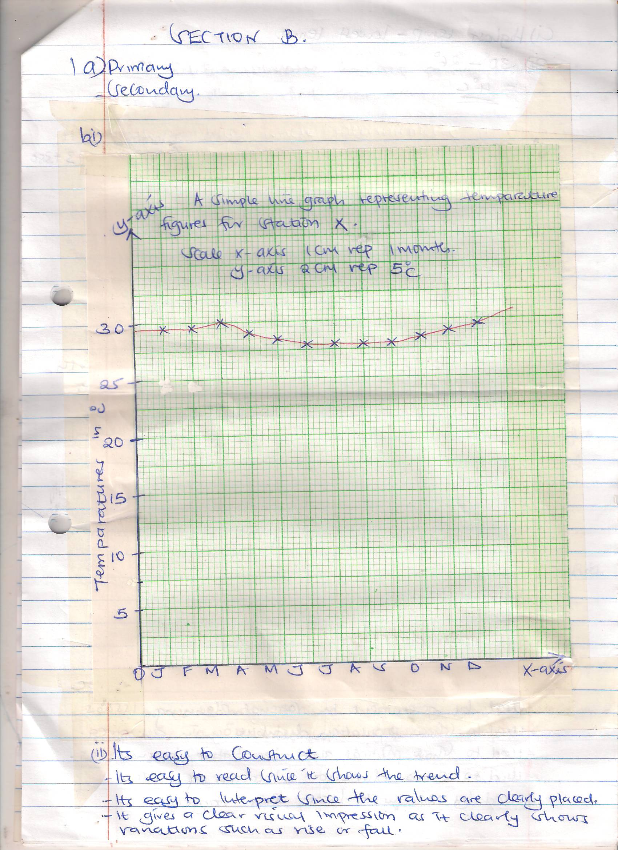
Distribution of marks
Trend 1mk
Title 1mk
Labeled axis 2mks
Well chosen scale 1mk (Total 5mks)

(ii) Its easy to construct
-Its easy to read since it shows the trend .
-It is easy to interpret since the values are clearly placed.
-It gives a clear visual impression as it clearly shows variations such as rise or fall.2mks

(i) Highest temp-lowest temperature
30⁰ - 26⁰ = 4⁰ 2mks

(ii) 25+ 38+ 99+ 140+ 277+ 439+ 277 + 69 + 100 + 273 + 380 + 200=2317mm 2mks

(iii) 26⁰ 1mk

d)Tabulation 1mk

- (a) It is the representation of part of the Earth or the whole earth on a piece of paper.2mks

(b)(i) Topographical map 1mk

(ii) Atlas maps
Sketch maps 2mks

(iii) map title 3mks
-map scale
-map key
-latitudes and longitudes
-compass direction.

(c)To show weather trends, climate, rainfall etc
-used by government in National planning issues
-Used to show population distribution in an area.
-Used to show political and administrative boundaries
-Used to show direction & location of a place
-Used by military to locate their targets
-Used to locate physical features e.g rivers, mountains 3mks
-Used by travelers to find their way

(d)(i) Statement scale
Representative fraction /ratio scale
Linear scale 2mks
ii) Used to estimate and calculate areas on maps
-used to calculate and measure distances on maps. 2mks
7. a)Layers of the atmosphere
- Troposphere
- Stratosphere
- Mesosphere
- Thermosphere 3x1= 3mks
b)i)Weather forecasting
It is the prediction of the weather situation for a given place within a short period of time.
ii) Importance of weather forecasting.
- It helps farmers to adjust their farming activities
- It helps determine mode of housing and dressing in different parts of the world.
- It helps determine time for sea and air travel
- It helps determine time when outdoor sporting activities can take place. 3x1 = 3mk
iii)Types of Local winds
- Sea breeze
- Land breeze
- Katabatic winds
- Anabatic winds (any 2x1 = 2mks
iv)Factors influencing temperatures
- Latitude - Aspect
- Altitude - Ocean currents
- Length of the day -cloud cover
- Distance from sea and large water body - winds (any 3x1=3mks)
c)Any two types of fog
- Advection
- hill
- Radiation
- Frontal (any 2x1 = 2mks)
d) i) State 3 methods of collecting statistical data.
- Direct observation
- Interviewing
- Administering Questionnaire
- Sampling
- Experimentation
- Taking measurements
ii)Any two methods of data analysis
- Calculation of percentages
- Measures of central tendency
- Measures of dispersion (range) (any 2x1 = 2mks)

