MWAKICAN JOINT EXAMINATION (MJET) - 2017
FORM ONE PHYSICS MARKING SCHEME
- V = 26 – 16 = 10cm³ ;
d ₌ m ₌ 125 = 12.5g/cm³ ;
V 10

- 5 or 5 x 0.000001 = 0.000005kg
1,000,000

- When the flask cools initially, it contracts; reducing in volume and forcing the water to rise. When the low temperature reaches the water inside, the water cools and contracts; reducing in volume and the water level falls steadily.

- Pressure applied at one part of a liquid is transmitted equally to all parts of the enclosed liquid.

- The wheels increase the area in contact with the ground and hence reduce the pressure exerted by the truck.

- p = hdg;
=0. 75 x 13600 x 10
= 102,000pa or 102,000N/m²

- The adhesive force between water and glass molecules is stronger than the cohesive force between water molecules;
The cohesive force between mercury molecules is stronger than the adhesive force between glass and mercury molecules;

- a) Volume of bottle = Volume of water = $\frac{m}{d}$ = $\frac{28-16}{1}$ = 12cm³
b) Density = Mass
Volume

= 31 – 16
12

= 15
12

= 1.25g/cm³

- a) m = $\frac{w}{g}$

= $\frac{320}{10}$ = 32kg

b) g = $\frac{w}{m}$
= $\frac{192}{32}$ = 6N/kg

- -Expand and contract uniformly.
-have a wide range of temperature
- Do not stick to the inside of the tube/does not wet the tube
- Can be easily seen/visible
- Does not vaporize and distil onto the upper parts of the tube.
Any two

- -73 + 273 = 200K

- (a) The force which causes the surface of a liquid to behave like a stretched elastic skin.
(b) Presence of Impurities
Change in Temperature

- a) i) To show movement of air molecules
ii) To focus the light into the smoke cell
iii) To magnify the smoke particles
b) i) Bright specks/smoke particles are seen moving randomly in all directions

ii) Smoke particles are being hit/knocked/bombarded by the invisible air molecules which are in constant random motion.

iii) The Brownian motion of the particles increase

c) In solids, the molecules vibrate to and fro in their fixed positions; In gases molecules are
free and move randomly in all directions.

- a) Pressure is the force acting perpendicularly per unit area;
b) i) m = d x v
= 2.5 x 20 x 10 x 5
= 2,500g or 2.5kg

ii)
F= mg = 2.5 x 10 = 25N
A = 0.1 x 0.05 = 0.005m²

p = $\frac{F}{A}$

= $\frac{25}{0.005}$
= 5,000N/m²

c) i) p = $\frac{F}{A}$

= $\frac{20}{0.02}$ = 1,000N/m²

ii) F = P x A

= 1000 X 0.4
= 400N
OR

F2 = $\frac{F1A2}{A1}$ = $\frac{20 X 0.4}{0.02}$

= 400N
- a) Temperature is the degree of coldness or hotness of a body
b) – Does not wet glass
- It is a better heat conductor
- It is opaque and easily seen
- Does not vaporize onto the upper parts of the tube
- Thread has no tendency to break
Any three correct

c) To break the mercury thread when the temperature is falling enabling the temperature to be read

d) It would break since water boils at 100ºC whereas it measures up to a maximum of about 43ºC
e) Length of 100ºC = 5.5 – 0.5 = 5cm ;
Length within 100ºC = 3 – 0.5 = 2.5cm
Temperature = $\frac{100 x 2.5}{5}$ ;
= 50ºC

- a) - causes breakage of pipes when it freezes in them;
- causes marine accidents due to icebergs

b)
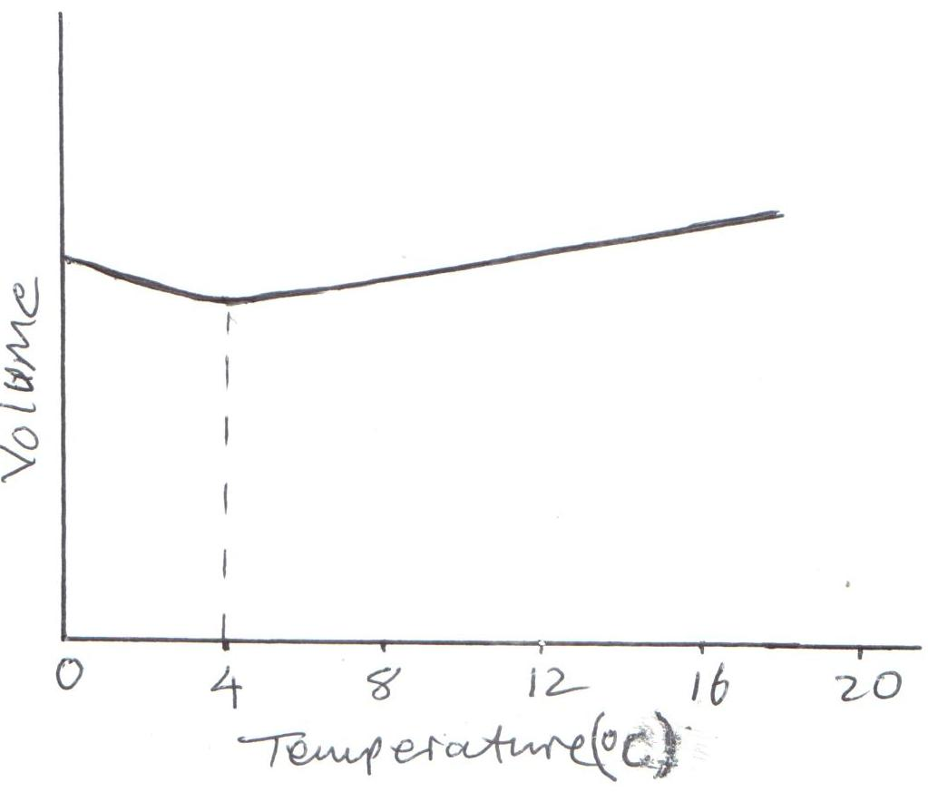
Correct labeling
Correct X-scale
Minimum volume at 4ºC
c) - Riveting metal plates
- Joining wheel and axle
- Bimetallic thermometer
- Thermostat
- Any other suitable application
Any two correct
d) ice being less dense than water floats on the water. It insulate the water below against heat losses to the cold air above

- (a) A scalar quantity is a quantity that has magnitude only and no direction
E.g. mass, time, distance, speed.
A vector quantity is a quantity that has both magnitude and direction.
e.g. displacement, velocity, force, acceleration.
(b) MASS WEIGHT
- Quantity of matter in a body Pull of gravity on a body
- Measured in kilograms Measured in Newtons
- Constant Changes from place to place
- Measured using abeam balance Measured using a spring balance
- A scalar quantity A vector quantity

C) The end rubbed with soap reduces the surface tension on that end. The matchstick moves towards the end with greater surface tension.

d) F=5-2
=3N

