Name………………………………………Admission number…………………………
Date……………………………………….
Mwackan exam second term 2017
Agriculture form one.
Instructions
(a) Write your name and admission number in the spaces provided above
(b)Answer all questions in the spaces provided in section A, B &C
(c)Write the date in the space provided above
- Do not remove any page from this booklet

MWAKICAN FORM 1 2017
AGRICULTURE
SECTION A 30 MRKS
- State four factors that makes agriculture to be termed as an art. 4mkks

- Define the following terms as used in agriculture.(5mks
(a)Crop pathology

(b)Entomology

(c) Pomology

(d)Organic farming

(e)Agro forestry

3. State four benefit of high level of education and techinology in agriculture.2mks

4. Give three effect of high temperature on crops. 3mks

5. Give four constituents of soil.2mks

6. State three forms in which soil water exist.1½mks

7. State the functions of the following farm tolls and equipments.
(a)Garden trowels. 1mks

(b)Dibber. 1mks

(c)Pruning shears.1mks

(d)Strip cup.1mks

(e)Wool shears.1mks

(f)Bolus gun.1mks

(g)Trocar and canula.1mks

(h)Stock and die.1mks

(i)pipe cutter.1mks

8. State three types of surface irrigation.1½mks

9. State four factors considered when choosing type of irrigation to use in a farm.2mks

Section B 30mks
10. (a)Give 6 importance of drainage as a land reclamation.3mks
(b)Name five methods drainage.2½mks
11. The diagram below shows a method of irrigation. Use it to answers the questions that follow.

(a)Identify the method of irrigation illustrated above.1mks

(b)Give any four advantage of the method of irrigation illustrated above.4mks

12. State the six stage of water treatments.6mks

13. The diagram below illustrates water harvesting process. Use it to answer the questions that follow.
(i)Label the parts marked a-h 3½mks
a-
b-
c-
d-
e-
f-
g-
(ii)Apart from the method illustrated above name any other two methods used in water collection.2mks
14. Below are diagrams of different types of spanners. Use them to answer the questions that follow.

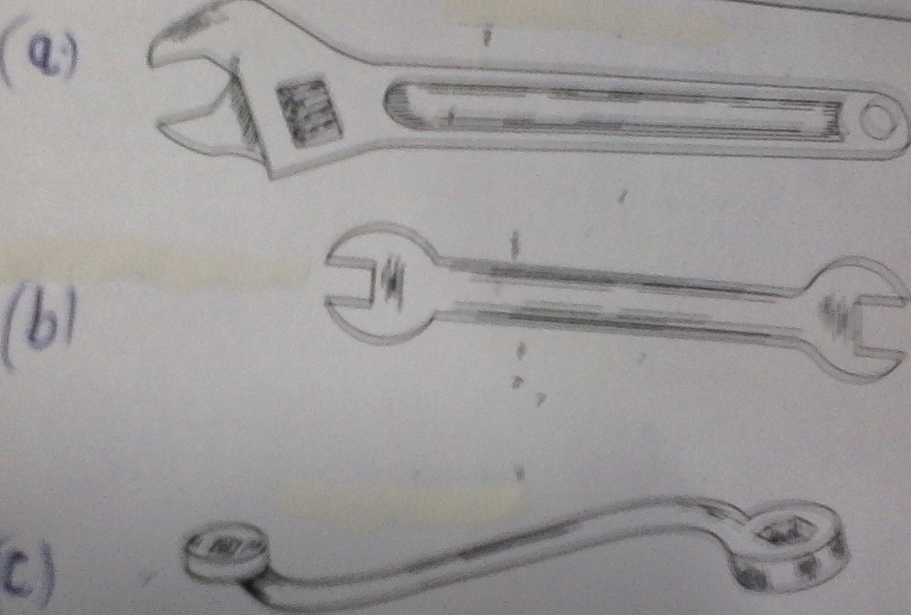

(i)Identify the tools marked. a- 1mk
b- 1mk
c- 1mk
(ii)Give one advantage of the tool marked a as compared to the tool marked b.1mk

15.(a) Identify the part marked a and b in the structure drawn below

- 1mk

b. 1mk
(b) State two advantage of the above structure in tuber crop growing.2mks

SECTION C 40mks (answer all the questions)
16.(a) Outline five reasons for carrying out minimum tillage.5x2=10mks

(b)Outline five importance of water in the farm.5mks

(c)State five importance of primary cultivation.5mks

17.(a)Give seven maintenance practices of saws in the farm.7mks

(b)Explain four importance of water treatment in the farm.4mks

(c)Name any four types of soil structures.4mks

(d)Name any five branches of agriculture. 5mks

