NAME…………………………………………………….ADMNO…………CLASS………..
MWAKICAN JOINT EXAMS
BIOLOGY END OF SECOND TERM 2017

FORM 1

TIME : 2 HOURS

INSTRUCTIONS
Answer all the questions in the spaces provided

1(a) Biology refers to (1mk)

b) State the name given to the study of :
(i) Chemical changes inside living organisms (1mk)

(ii) Cells (1 mk)

2. Which three skills are acquired when one studies biology. (3mks)

3 What is the importance of classification. (3mks)

4. Identify the following apparatus and state their uses. (4mks)

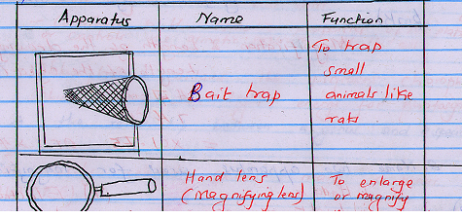

5 Which taxonomic unit:
(a) Comes before the genus. (1mk)

(b) Has the largest number of different organisms. (1mk)

(c) Has organisms with very many similar characteristics. (1mk)

6 A form one student wrote the scientific name of the large round worm as ascaris Lumbricoides
(a) Identify two mistakes made by the student. (2mks)

b. What do you call this system of naming living organisms. (1mk)

7 A student drew a 4cm long diagram of a Hibiscus flower. The actual flower was 7cm long. What was the linear magnification of the students drawing? (2mks)

8 Name two apparatus used for magnification. (2mks)

9) Study the following diagram and answer the questions that follow:

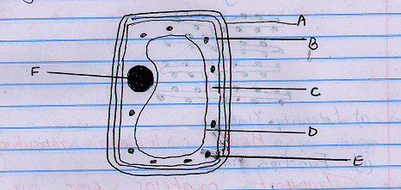

(a) i) Identify the cell (1mk)

ii) Give a reason for your answer in a (i) above (1mk)
b) Label the parts A,B,C and F (4mks)
A
B
C
F
c) State the functions of parts D and E. (2mks)

D

E

10) What is the relationship between a genus and a species? (2mks)

11.(a) Identify the organelle shown below and state its functions in a cell.

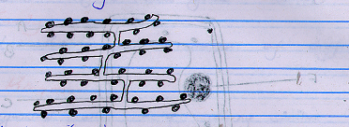

(i) Identity (1mk)

ii) Function (1mk))

b) Give a reason for your answer in (a)(i) above. (1mk)

12 The diagram below shows the changes in a plant cell when put in solution X

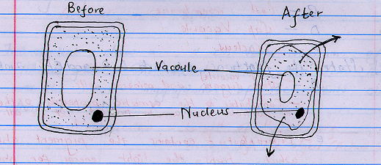

(a) Name solution X (1mk)

b) Explain the observation. (2mks)

c) Give a reason why a mature plant cell does not lose its shape even after losing water. (1mk)

13 State three importances of osmosis in plants. (3mks)

14 Name the part of a light microscope which:
(a) Regulates the amount of light passing through the condenser. (1mk)

(b) Hold the objective lens and eye piece lens. (1mk)

c) Magnifies an object, (1mk)

15 Define the term species. (2mks)

16 What is the formular for calculating linear magnification of a specimen when using a hand lens? (2mks)

17 Study the diagram of a cell organelle shown below and answer the questions that follow.

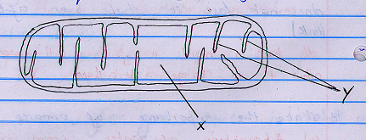

(a) Identify the organelle. (1mk)
b) State its function. (1mk)

c) Name the parts labeled X and y. (1mk)

18 a) i) Define cell specialization (1mk)

ii) Give two examples of specialized cells (2mks)

(b) Arrange the following structures in the order of complexity; organ, organelle, tissue, organ system, cell, organism. (1mks)

c) What is a tissue? (1mks)

19(a) Briefly describe how you would lift a microscope from your bench and take it to the teacher’s bench. (2mks)

b) At which objective lens is the microscope stored. (1mk)

c) What is the main advantage of using an electron microscope over a light microscope?
(1mk)

20 (a) State four factor that affect the rate of diffusion. (4mks)

b) Distinguish between diffusion and active transport. (2mks)

21(a) Examine the two cubes labeled A and B in the diagram below.

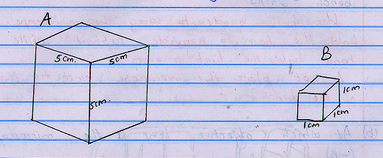

Calculate the surface area to volume ratio of cube A and B. (4mks)

b) If the cubes represented living organisms in which organism would diffusion take place at
(i) the slowest rate? Give a reason for your answer. (2mks)

(ii) The fastest rate, give a reason for your answer. (2mks)

22 The diagram below is a transuerse section of a leaf.

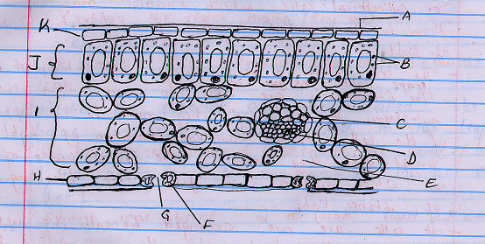

- Define photosynthesis (1mk)

b) Name the parts labeled A,C,F and J. (4mks)
A -
C -
F -
J -

- i) Name the major pigment found in the structure labeled B (1mk)

ii) What is the role of the pigment you have mentioned in c (i)above (1mk)

- State three adaptations of a leaf to photosynthesis (3mks)

- State two stages of photosynthesis and list where they occur (4mks)

23 In an experiment, a leaf from a plant which had been kept in the dark overnight was boiled in water for a minute, boiled in alcohol in a hot water bath and washed in cold water. Iodine solution was then added to the leaf.
(a) Why was the leaf kept in the dark overnight? (1mk)

b) Why was the leaf boiled in
(i) water (1mk)

(ii) alcohol. (1mk)

c)(i) Predict the expected observation when the iodine solution was added to the leaf. (1mk)

(ii) Give a reason for your answer in (i) above. (1mk)

d) Why was alcohol boiled indirectly over a hot water bath? (1mk)

24(a) How does the study of biology help human beings in their day to day life? (3mks)

b) How does movement in plants differ from that of animals. (1mk)

