Name_______________________________________________________Adm. No._________________
Date _____________________

FORM ONE
CHEMISTRY
TIME: 2 Hours

MWAKICAN JOINT EXAMINATION TEAM (MJET) TERM II 2017

Instructions to Candidates

(a) Write your name and admission number.
(b) Answer ALL the questions in this question paper.
(c) All your answers must be written in the spaces provided in this question paper.
(d) Students must answer all questions in English

FOR EXAMINER’S USE ONLY
QUESTIONS | MAXIMUM SCORE | CANDIDATES SCORE
1-25

INSTRUCTIONS
- Answer all the questions in the spaces provided

1. The table below shows the pH value of solutions J to N
Solution | J | K | L | M | N
pH | 5 | 13 | 2 | 10 | 7
a) Which solution is:
i) Neutral (1mk

ii) Strongly acidic (1mk

iii) Weak base (1mk

b) State the colours of the following acid-base indicators when added to the indicated solution (2mks
Indicator | Solution | Colour
Methyl Orange | L
Phenolphthalein | K

2. Classify the following processes as either chemical or physical (3mks
Process | Type of change
a) Heating of copper (II) sulphate crystals
b) Obtaining Kerosene from crude oil
c) Heating of zinc oxide

3. The diagram below represents set-up that can be used to prepare and collect oxygen gas
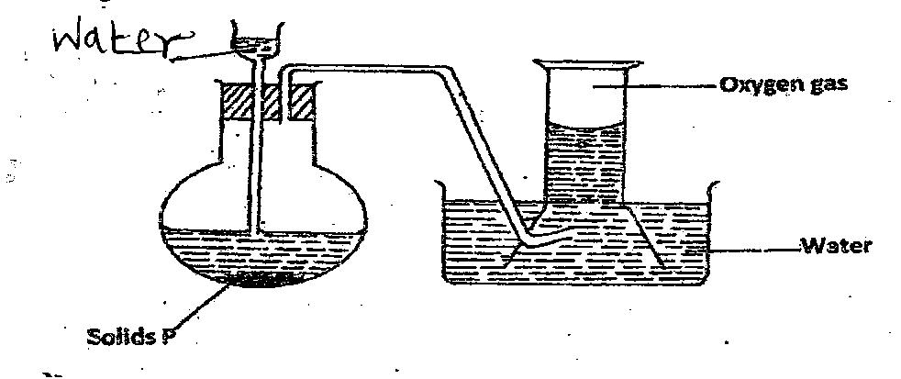
a) Name solid P (1mk

b) What property of oxygen makes it possible for its collection as indicated by the diagram (1mk

c) Explain why it is important not to collect any gas for the first few seconds of the experiment (1mk

4. The diagram below shows a Bunsen burner when in use
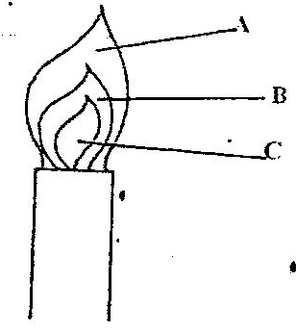
a) What type of a flame is it? (1mk

b) Which of the labeled parts is used for heating? Give a reason (2mks

c) Give two reasons why the flame you stated is suitable for heating (2mks

5a) What is the chemical name of rust? (1mk

b) Painting and oiling are methods of rust prevention.
i) Explain the similarity of these methods in the way they prevent rusting (1mk

ii) Explain why cars in Mombasa rust faster than cars in Nairobi (2mks

6. Filtration is carried out in the apparatus shown
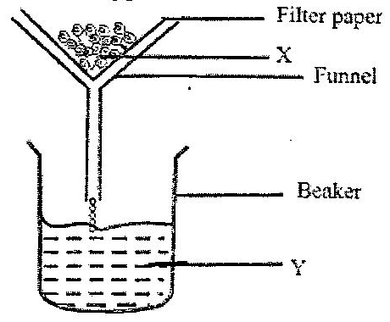
Name
i) X ________________________________ (1mk

ii) Y _______________________________ (1mk
7. Iron is mixed with Sulphur and heated
a) State the observation made when the mixture is heated (1mk

b) Explain how a mixture of Iron and Sulphur can be separated (2mks

8a) A student in form one placed a thermometer in molten naphthalene at 85ºC and recorded the temperature
and time until the naphthalene solidified from the values obtained, the figure below was drawn

85
Temperature (ºc)
Time (minutes)
D
C
B
A

i) What name is given to such a figure? (1mk

ii) Which part of the figure represents the change of state of naphthalene? (1mk

iii) Is naphthalene pure or impure? Explain (2mks

b) What will be the physical state of naphthalene at part C – D (1mk

9. Give the names of the following processes used to: (4mks
a) Obtain oil from sunflower seeds _____________________________________
b) Separate pure pigments from a mixture of dyes _______________________________
c) Separate a mixture of Iodine and Common salt ____________________________
d) Water from salt solution ____________________________________________________
10. The diagram below is a set up used to investigate the effect of heat on hydrated copper (II) Sulphate. Study
the diagram and answer the questions that follow
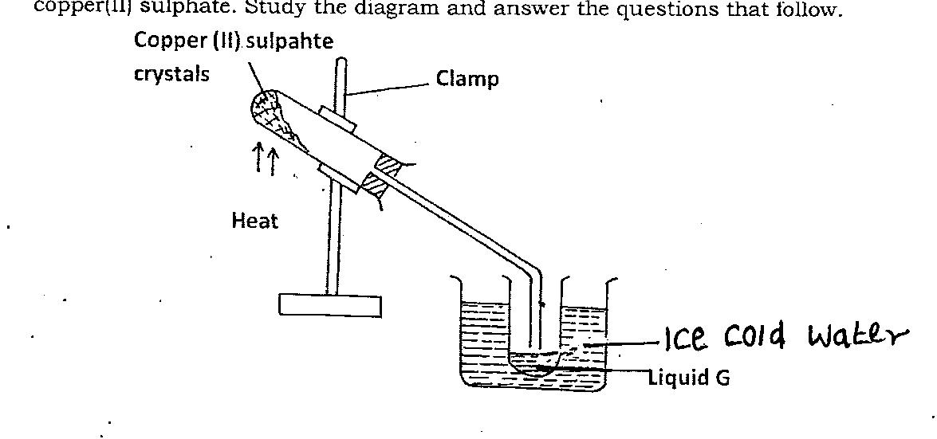

a) Why is boiling tube slanted as shown? (1mk

b) What is observed in the boiling tube? (1mk

c) Identify liquid G (1mk

d) What is the purpose of the ice cold water (1mk

11. Name the most suitable apparatus for carrying out the functions stated below:
a) Crushing solid substances (1mk

b) Storing bench reagents (1mk

c) Delivering liquids drop wise (1mk

12a) Most of the apparatus in the chemistry laboratory are made of glass. Give two reasons for this (2mks

b) Name two apparatus used for measuring volume accurately (2mks

13a) Name the solution and the catalyst used in preparation of oxygen in the laboratory (2mks
Solution _______________________________________ (1mk)

Catalyst _______________________________________ (1mk)

b) Give a word equation for the reaction above (1mk

c) In an experiment to determine the proportion of oxygen in air, copper turnings were packed in excess in a
long combustion tube connected to two syringes of 120cm³ each in volume. Syringe R contained 120cm³
of air while syringe S was closed and empty as shown.

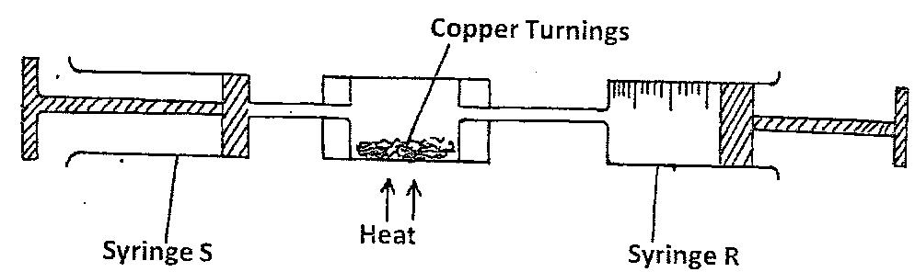
Air was passed over heated copper turnings slowly and repeatedly until there was no further change in
volume. 95.5cm³ of air remained in syringe R
i) Why was copper packed in excess? (1mk

ii) Account for the change in volume of air in the syringes (1mk

iii) State one observation made in the combustion tube during the experiment (1mk

iv) Give a word equation for the reaction that took place in combustion tube (1mk

v) Determine the percentage of oxygen used up during the experiment (2mks

vi) Give two commercial uses of commercial oxygen (2mks

14. A mixture of kerosene and water was shaken and left to separate out as shown in the diagram below:-
- Identify liquids A and B (2mks
A _____________________________________

B _____________________________________
- Apart from density, state one other property that makes it possible to separate them using the set-up above? (1mk

- Identify the apparatus used above (1mk

15. Suplhur (IV) oxide and nitrogen (IV) Oxide are some of the gases released from car exhaust pipes. State how
these gases affect the environment. (2mks

16. Three brands of inks M,N and O were suspected to be contaminated with substance P. The result is shown
below;

i) Which ink was contaminated with substance P (1mk

ii) Name the ink which was pure (1mk

iii) Identify the other ink which was not pure (1mk

17. The diagram below shows a set-up of apparatus used to separate miscible liquids
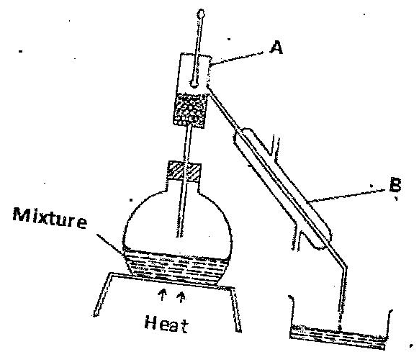
- Name the parts labeled A and B and state their functions (4mks
A_____________________________________________

B _____________________________________________
b) State the property of the mixture that makes it suitable to be separated by the method above (1mk

18. The set up below was used to investigate a chemical property of carbon. Study it and answer the questions
that follow
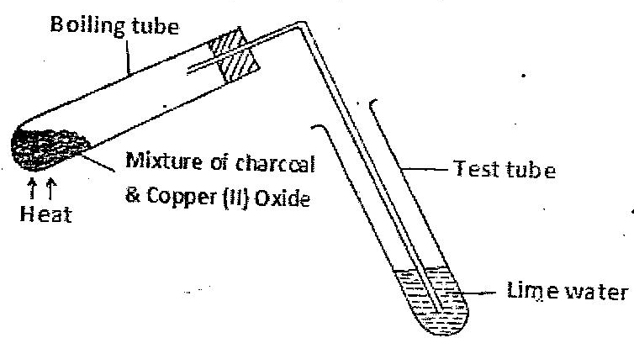
- What observations were made on the heating the mixture? (2mks

- What is the industrial application in terms of property investigated above (1mk

19. Complete the table below (6mks
Element | Latin Name | Symbol
Lead
Copper
Potassium

20a) Name the parts A,,C,D and F (4mks
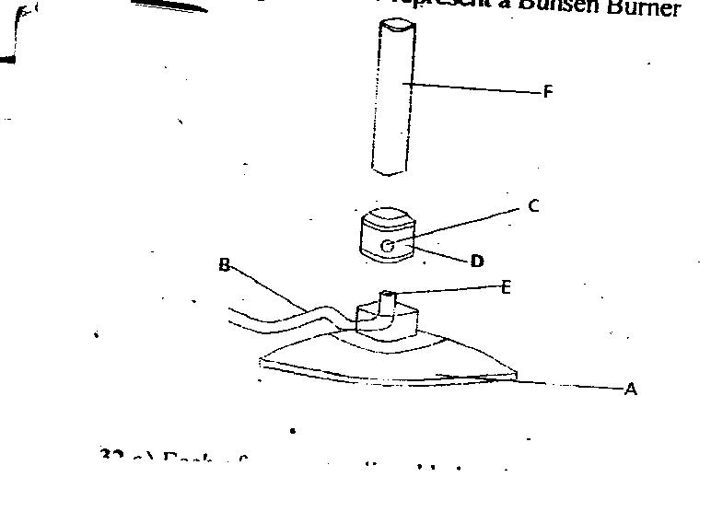
A ___________________________

C ___________________________
D ____________________________
F _______________________________
- State the functions of part C and E (2mks

C _________________________________
E __________________________________
21. State the functions of the following apparatus in the chemistry laboratory. (2mks
a) Stop watch

b) Top pan balance

22. Matter exists in three states which can be related as shown in the diagram below
Name processes:
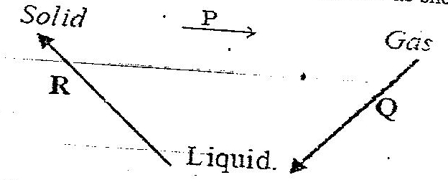

i) P: ____________________________________________ (1mk
ii) R: ___________________________________________ (1mk
iii) Q: __________________________________________ (1mk
23a) what is melting point? (1mk

b) State the difference between matter in the solid state and matter in liquid state according to kinetic theory
of matter (2mks

24a) What is the name given to the smallest particles of the following substances? (2mks
Substance | Particle
Water
Copper

b) Identify the elements present in the following substances (3mks
i) Sodium hydroxide

ii) Calcium nitrate

25. a) State the observation made when dilute hydrochloric acid is added to calcium carbonate. (1mk)

- Write a word equation for the reaction in (a) above. (1mk)

THIS IS THE LAST PRINTED PAGE

