NAME…………………………..……DATE ………………ADM NO. ……….…

312
GEOGRAPHY
END OF TERM 2 2017

FORM 1 GEOGRAPHY

MWAKICAN JOINT EXAMINATION TEST (MJET)

INSTRUCTIONS TO CANDIDATES
- Write your name and admission number in the spaces provided above.
- This paper has TWO sections: A and B.
- Answer ALL the questions in section A and section B .

- a) Define the term Geography. 1mk
……………………………………………………………………………………………………………………………………………………………………………………………………………………………………..
b) Give three reasons why it is important to study Geography. (3mks)
……………………………………………………………………………………………………………………………………………………………………………………………………………………………………..
……………………………………………………………………………………………………………………………………………………………………………………………………………………………………..

c) State any two branches of Geography. 2mks
……………………………………………………………………………………………………………………………………………………………………………………………………………………………………..

d) What is the relationship between Geography and Mathematics. 2mks
……………………………………………………………………………………………………………………………………………………………………………………………………………………………………..
……………………………………………………………………………………………………………………………………………………………………………………………………………………………………..
- a) What is the solar system. 1mk
……………………………………………………………………………………………………………………………………………………………………………………………………………………………………..
b) State two theories that explain the origin of the solar system. 2mks
……………………………………………………………………………………………………………………………………………………………………………………………………………………………………..
…………………………………………………………………………………………………………………………………………………………………………………………………………………………………….
c) The diagram below shows the structure of the Earth .Use it to answer the questions that follow:-

- Identify the parts marked. 2mks
X-
Y
- Name the layer of discontinuity marked z. 1mk
……………………………………………………………………………………………………………………
d) State two reasons why the interior of the Earth is still hot. 2mks
……………………………………………………………………………………………………………………………………………………………………………………………………………………………………..
e) State any two proofs that are put forward to prove that the earth is spherical. 2mks
……………………………………………………………………………………………………………………………………………………………………………………………………………………………………..
……………………………………………………………………………………………………………………………………………………………………………………………………………………………………..
f) State any two effects of the following:-
i. Rotation of the Earth. 2mks
……………………………………………………………………………………………………………………………………………………………………………………………………………………………………..
- Revolution of the Earth . 2mks
……………………………………………………………………………………………………………………………………………………………………………………………………………………
- If the local time in Nairobi at longitude 37˚ E is 10.00 am. What will the time be at Buchanan in Liberia at longitude 10˚w. 2mks
…………………………………………………………………………………………………………………………………………………………………………………………………………………….
……………………………………………………………………………………………………………………………………………………………………………………………………………………………………..
- a) Define weather. 2mks
……………………………………………………………………………………………………………………………………………………………………………………………………………………………………..
……………………………………………………………………………………………………………………………………………………………………………………………………………………………………..
b) State three ways in which the atmospheres is heated. 3mks
……………………………………………………………………………………………………………………………………………………………………………………………………………………………………..
……………………………………………………………………………………………………………………………………………………………………………………………………………………………………..
c) State any other 2 forms of precipitation apart from rainfall. 2mks
……………………………………………………………………………………………………………………………………………………………………………………………………………………………………..

d)(i) Using a well labeled diagram ,explain how relief rainfall is formed. 6mks

(ii) What is the other name given to the above type of rainfall.(1mk)
……………………………………………………………………………………………………………………………………………………………………………………………………………………………………..

- a) What is a weather station? 2mks
……………………………………………………………………………………………………………………………………………………………………………………………………………………………………..

b) State two factors to consider when citing a weather station.(2mks)
……………………………………………………………………………………………………………………………………………………………………………………………………………………………………..
……………………………………………………………………………………………………………………………………………………………………………………………………………………………………..

c) Explain why a Stevenson’s, screen is:-
i. Painted white (1mk)
……………………………………………………………………………………………………………………………………………………………………………………………………………………………………..
ii.Louvred (1mk)
……………………………………………………………………………………………………………………………………………………………………………………………………………………………………..
- Is placed 121cm above the ground (1mk)
……………………………………………………………………………………………………………………………………………………………………………………………………………………………………..
d) Which instrument is used to measure the following elements of weather.
Highest Temperature…………………………………………………
Humidity …………………………………………………………
Air pressure ………………………………………………… 3mks
e) Name two weather recording instruments kept in a Stevenson’s screen .(2mks)
……………………………………………………………………………………………………………………………………………………………………………………………………………………………………..
- (a) Name two types of data.(2mks)
…………………………………………………………………………………………………………………………………………………………………………………………………………………………………..
b)Use the table below to answer the questions that follow.
Month | Jan | Feb | Mar | Apr | May | Jun | Jul | Aug | Sept | Oct | Nov | Dec
Temp˚ c | 29 | 29 | 30 | 28 | 27 | 26 | 26 | 26 | 26 | 26 | 28 | 29
Rainfall (mm) | 25 | 38 | 99 | 140 | 277 | 439 | 277 | 69 | 100 | 273 | 380 | 200

i)On the graph provided draw a simple line graph to represent the temperature figures. 5mks

ii)What is the advantages of using a simple line graph .(2mks)
………………………………………………………………………………………………………………………………………………………………………………………………………………………………………………………………………………………………………………………………..
c)(i) Calculate the annual range of temperature for the station.(2mks)
……………………………………………………………………………………………………………………………………………………………………………………………………………………………………..
………………………………………………………………………………………………………………………………………………………………………………………………………………………………………………………………………………………………………………………………………………………………
……………………………………………………………………………………………………..

ii) Calculate the total rainfall (2mks)
……………………………………………………………………………………………………………………………………………………………………………………………………………………………………..
……………………………………………………………………………………………………………………………………………………………………………………………………………………………………..
……………………………………………………………………………………………………………………………………………………………………………………………………………………………………..
……………………………………………………………………………………………………………………………………………………………………………………………………………………………………..
iii)What is the mode of temperature for the above station. 1mk
……………………………………………………………………………………………………………………………………………………………………………………………………………………………………..
……………………………………………………………………………………………………………………………………………………………………………………………………………………………………..
d) What name is given to the above method of data presentation? 1mk
……………………………………………………………………………………………………………………………………………………………………………………………………………………………………..

Use the map below to answer question number 6

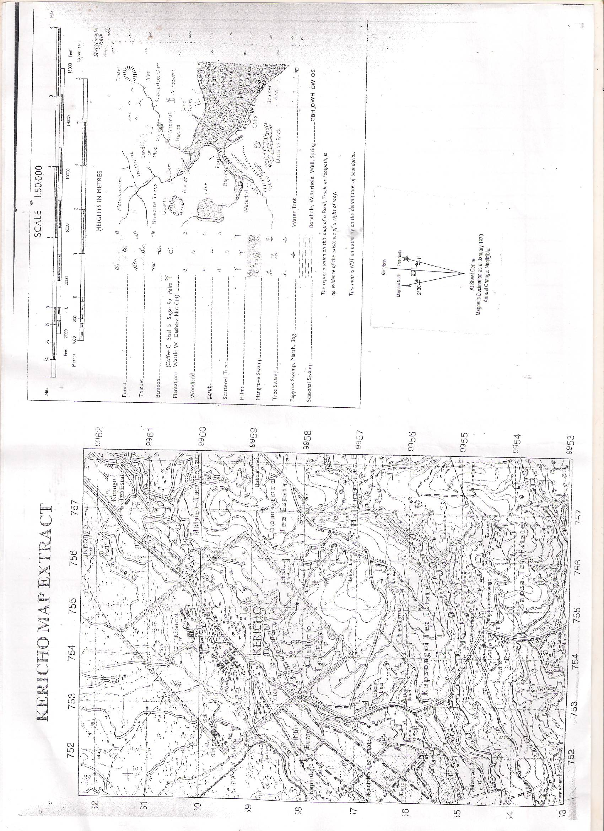

- (a) What is a map. 2mks
……………………………………………………………………………………………………………………………………………………………………………………………………………………………………..
……………………………………………………………………………………………………………………………………………………………………………………………………………………………………..
b)(i) Identify the type of map above. 1mk
……………………………………………………………………………………………………………………………………………………………………………………………………………………………………..
(ii) List any two other types of maps. 2mks
…………………………………………………………………………………………………………………………………………………………………………………………………………………………………….

(iii) Using the above map extract, state any three marginal information that can be seen. 3mks
……………………………………………………………………………………………………………………………………………………………………………………………………………………………………..
……………………………………………………………………………………………………………………………………………………………………………………………………………………………………..
……………………………………………………………………………………………………………………………………………………………………………………………………………………………………..
……………………………………………………………………………………………………………………………………………………………………………………………………………………………………..
……………………………………………………………………………………………………………………………………………………………………………………………………………………………………..
c) State any three uses of maps. 3mks
……………………………………………………………………………………………………………………………………………………………………………………………………………………………………..
……………………………………………………………………………………………………………………………………………………………………………………………………………………………………..
……………………………………………………………………………………………………………………………………………………………………………………………………………………………………..
……………………………………………………………………………………………………………………………………………………………………………………………………………………………………..
d) (i) Identify any two scales that are used in the drawing of maps. 2mks
……………………………………………………………………………………………………………………………………………………………………………………………………………………………………..
……………………………………………………………………………………………………………………………………………………………………………………………………………………………………..
(ii) Identity two uses of scales on map. 2mks
……………………………………………………………………………………………………………………………………………………………………………………………………………………………………..
……………………………………………………………………………………………………………………………………………………………………………………………………………………………………..
- a)Name three layers of the atmosphere. (3mks)
……………………………………………………………………………………………………………………………………………………………………………………………………………………………………………………………………………………………………………………………………………………………………………………………………………………………………………………………………………………

b) i) Define weather forecasting. (2mks)
………………………………………………………………………………………………………………………………………………………………………………………………………………………………………………………………………………………………………………………………………………………….......

ii)State three importances of weather forecasting (3mks)
……………………………………………………………………………………………………………………………………………………………………………………………………………………………………………………………………………………………………………………………………………………………………………………………………………………………………………………………………………………
iii)Name two types of local winds. (2mks)
………………………………………………………………………………………………………………………………………………………………………………………………………………………………………………………………………………………………………………………………………………………………

iv)List three factors that influence temperature. (3mks)
…………………………………………………………………………………………………………………………………………………………………………………………………………………………………………………………………………………………………………………………………………………………………………………………………………………………………………………………………………………..
c)List two types of fogs. (2mks)
………………………………………………………………………………………………………………………………………………………………………………………………………………………………………………………………………………………………………………………………………………………………………………………
d) i)State three methods of collecting statistical data (3mks)
………………………………………………………………………………………………………………….
…………………………………………………………………………………………………………………..
…………………………………………………………………………………………………………………..
ii)State any two methods of Data analysis. (2mks)
……………………………………………………………………………………………………………………………………………………………………………………………………………………………………………………………………………………………………………………………………………………………………………………………………………………………………………………………………………………

