NAME………………………………………………ADM.NO……………CLASS:……….

MWAKICAN JOINT EXAMINATION (MJET) - 2017

FORM ONE PHYSICS TERM II 2017
TIME: 2 HRS.

INSTRUCTION TO CANDIDATE’S:
- Write your name, Admission number and class in the spaces provided above.
- This paper consists of TWO Sections; Section A and Section B.
- Answer ALL the questions in both Section A and B in the spaces provided.
- ALL working MUST be clearly shown.
- Candidates should check the question paper to ascertain that all the 9 pages are printed as indicated and that no questions are missing.
- Candidates should answer the questions in English.

Where necessary, take:
g = 10N/kg
Density of water = 1000kg/m³

Section | Question | Maximum score | Candidates score
A | Q1- 12 | 30
B | 13  14  15  16  17 | 9  12  9  9  11
TOTAL |  | 80

SECTION A(30 MARKS)
- The figure below shows the volume of water in a measuring cylinder before and after immersing a stone of mass 125g.
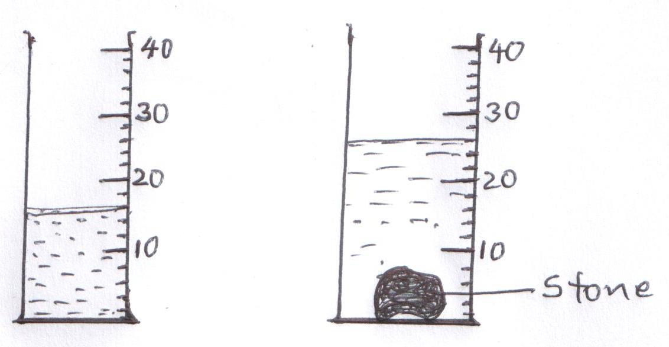
Determine the density of the stone (3mks)

- A drug manufacturer gives the mass of an active ingredient in a tablet as 5mg. Express this quantity in kilogrammes. (1mk)

- The figure below shows a flask filled with water. The flask is fitted with a cork through which a tube is inserted. When the flask is cooled, the water level rises slightly then falls steadily.
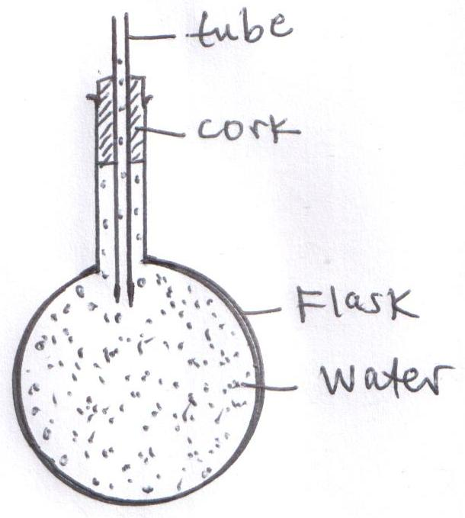
Explain this observation (3mks)

- State the Pascal’s principle of transmission of pressure in fluids. (1mk)

- A transport truck has many wheels. Explain this observation. (2mks)

- The atmospheric pressure at Nairobi is 750mmHg. Express this pressure in Pascal’s. (Density of mercury is 13600kg/m³) (3mks)

- Explain why water clings on the surface of a clean glass plate whereas mercury does not. (2mks)

- An empty density bottle weighs 16g. It weighs 28g when full of water and 31g when full of another liquid. Determine:(Take the density of water =1g/cm³)
- The volume of the density bottle. (2mks)

- The density of the liquid (3mks)

- A girl weighs 320N on the surface of the earth and 192N on the surface of the moon. If the gravitational field strength on earth is 10N/kg, determine
- The mass of the girl (2mks)

- The gravitational field strength on the surface of the moon (2mks)

- Give two properties of a liquid that make it suitable as a thermometric liquid. (2mks)

- Convert -73ºC to Kelvin scale (1mk)

- (a) What is meant by surface tension? (1mk)

(b) Give two factors that affect surface tension. (2mks)

SECTION B(50 MARKS)
- Brownian motion of smoke particles can be studied by using the apparatus shown below. To observe the motion, some smoke is trapped in the smoke cell and then observed through a microscope.
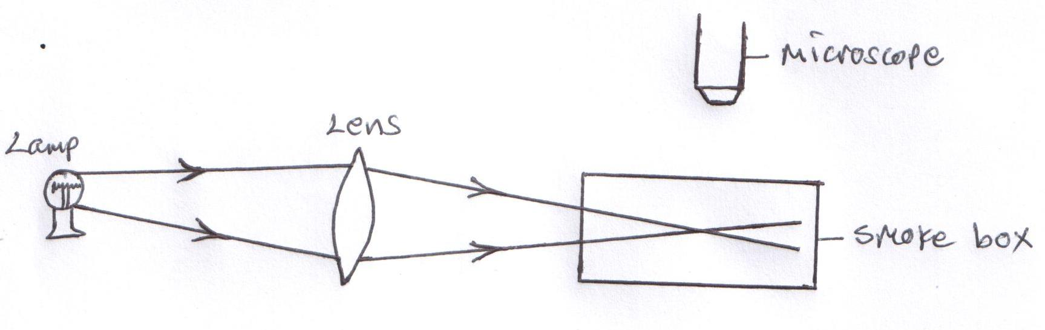
- Explain the role of smoke particles, lens and microscope in the experiment (3mks)
- Smoke particles

- Lens

- Microscope

- i) State what is observed in the smoke cell (1mk)

ii) Explain your answer to b(i) above (2mks)

iii) State what will be observed about the motion of the smoke particles if the temperature
surrounding the smoke cell is raised slightly (1mk)

- Describe the difference between solids and gases in terms of the movement of the molecules.
(2mks)

- a) Define Pressure (1mk)

- The figure below shows the measurements of a solid of density 2.5g/cm³
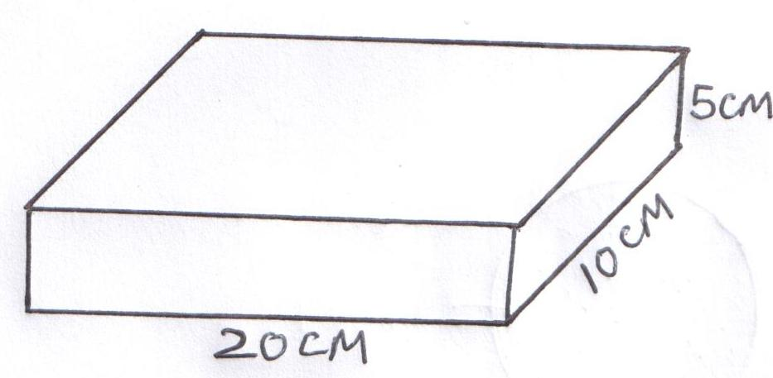
Determine:
- The mass of the solid (3mks)

- The maximum pressure it can exert on a flat surface (3mks)

- The diagram below shows a simple hydraulic lift.
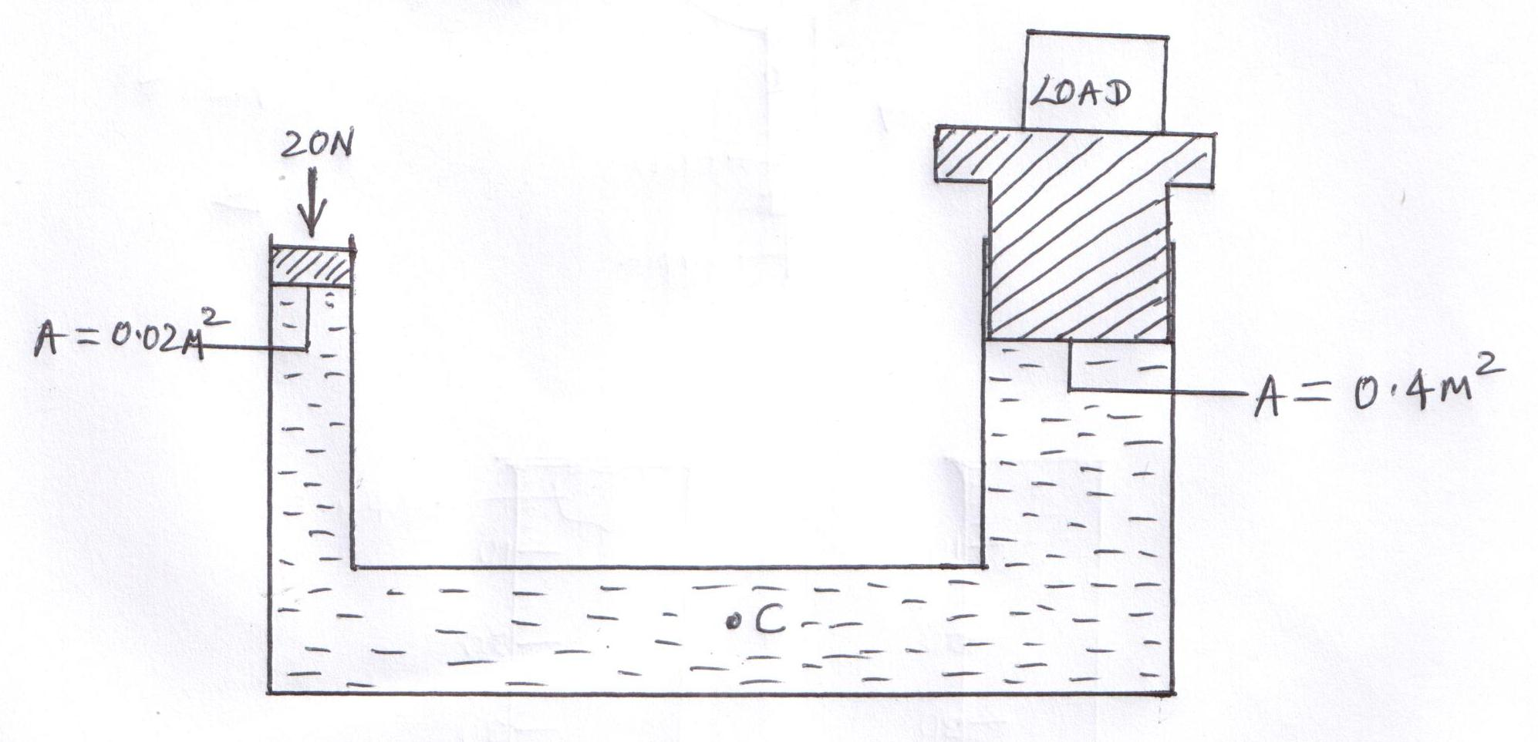
An effort of 20N is applied on the small piston. Determine:
- The pressure at point C (2mks)

- The load lifted (3mks)

- a) What is temperature? (1mk)

- Give three reasons why mercury would be preferred to alcohol as a thermometric liquid.
(3mks)

- What is the purpose of a constriction in a clinical thermometer? (1mk)

- Why is a clinical thermometer not sterilized using boiling water? (1mk)

- When marking the fixed points on a thermometer, it is observed that at 0ºC, the mercury thread is of length 0.5cm and 5.5cm at 100ºC. What temperature would correspond to a length of 3cm? (3mks)

- a) State two disadvantages of anomalous expansion of water. (2mks)

- Sketch a graph of volume (y-axis) against temperature, when water is heated from 0ºC to 20ºC
(3mks)

- State two applications of thermal expansion in solids (2mks)

- Give a reason why aquatic life is able to survive under frozen water (2mks)

- (a) Differentiate between a scalar quantity and a vector quantity and give an example for each (4mks)

(b) Give four differences between mass and weight (4mks)

(c)A matchstick rubbed at one end with soap starts moving immediately in one direction when placed on the surface of water. Explain (2 marks)

(d) Two forces acts on a body as shown below

2N 5N

Find the resultant force on the object (1 mk)

