MWAKICAN JOINT EXAMINATION
FORM 2 GEOGRAPHY
MAKING SCHEME
TERM II 2017
- (a) 21st March and 23rd September. 2 x 1 = 2mks

(b) Effects of revolution
- causes seasons
- causes changes in position of the mid-day Sun
- causes varying lengths of day and night at different times of the year
- causes lunar eclipse
- causes changes in the position of the mid-day Sun at different times of the year
2 x 1 = 2mks

- (a) (i) Components of the Solar System
- The Sun
- Planets
- Asteroids
- Meteors
- Comets 2 x 1 = 2mks

(ii) Diagram of the Lunar eclipse
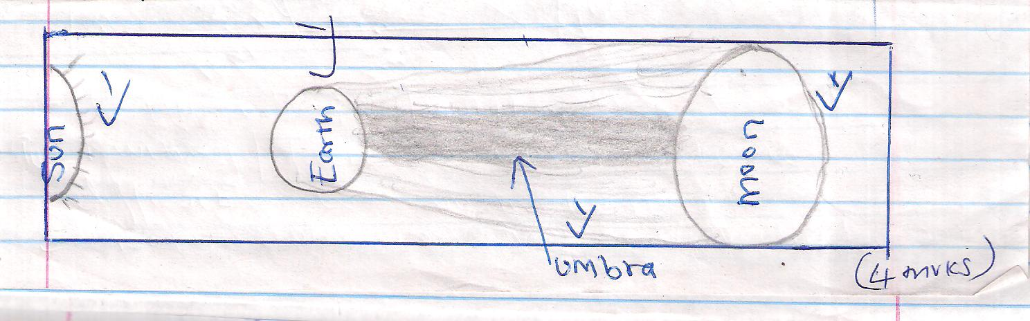

3(a) (i) Stratosphere 1 x 1 = 1mk
(b) Characteristics of the troposphere layer
- Temperature decrease with an increase in height/normal lapse rate
- Pressure falls with increase in height
- The speed of the atmosphere increases with an increase in height
- It contains most of the atmospheric water vapour/cloud
3 x 1 = 3mks

4(a) (i) Characteristics of I.T.C.Z.
- Experiences high temperatures
- Zone of low pressure
- Zone where N.E trade winds and S.E. trade winds coverage
- Zone found within the tropics
- It migrates to the South and the North with apparent movement of the Sun
- Its associated with convectional rain and thunderstorms
3 x 1 = 3mks
(ii) Formation of relief rainfall
- Water body is heated causing evaporation of water
- Moist air from the sea is forced to ascend up a hill/mountain side
- As air ascends it cools and it condenses to form clouds.
- Rain falls on the windward side of the mountain
- Descending air warms up the leeward side of the mountain

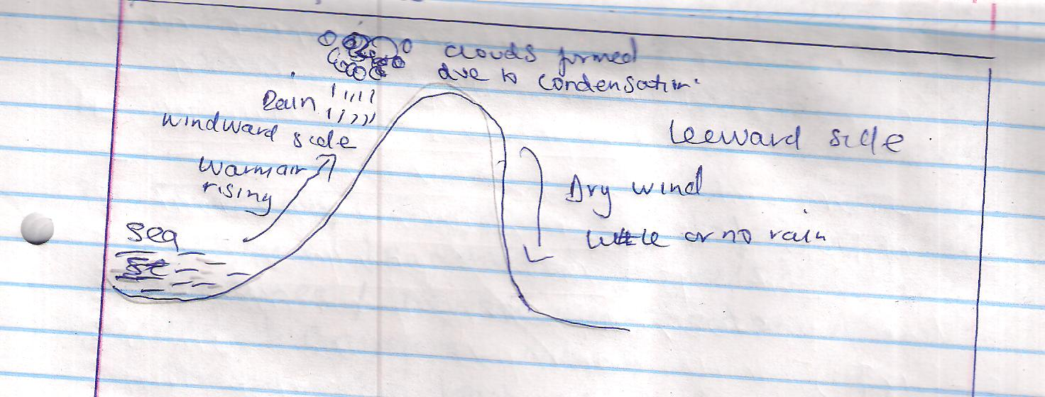
text 3mks
well labeled diagram 3mks (Total 5mks)

5(a) Minimum Thermometer 1 x 1 = 1mk

(b) (i) Diurnal range of temperature on Tuesday 27⁰C - 18⁰C = 9⁰C
(Show calculations) (1mk)
(ii) Mean temperature for Saturday
29⁰C + 21⁰C = 50⁰C
50⁰C = 25⁰C
2
Mean temperature is 25⁰C (1mk)
(show calculations)
6. (a) (i) A rock is any naturally formed solid mineral aggregate or a naturally occurring solid material composed of one or more minerals forming part of the earth’s crust
1x 2 = 2mks
(ii) Characteristics of Sedimentary rocks
- Some contain fossils
- have cleavage or are foliated or have planes
- have horizontal layers or stratified
- most are non – crystalline
3 x 1 = 3mks

(b) (i) Secondary sources of information
- Text books / pamphlets / journals / periodicals / magazines / newspaper / handouts.
- Maps / Geological maps
Photographs / pictures / video apes / slides / film
Data recorded information
3 x 1 = 3mks
(ii) Activities to be carried out
- Drawing sketches
- Observation
- Collecting rock samples
- Making notes
- Taking photographs

- asking / answering questions
- study geographical map
3 x 1 = 3mks
(iii) Problems likely to be experienced
- inability to identify rocks
- inability to access the rocks
- accidents or slipping
- difficulties in climbing or descending steep rocks
- hindrance by poor weather conditions
- attack by wild animals 3 x 1 = 3mks

7(a) (i) Types of boundaries according to plate tectonic theory
- Extension boundary/divergent/constructive
- Compressional boundary/convergent/destructive
- Conservative boundary/transform
2 x 1 = 2mks

(ii) Effects of movements of tectonic plates
- They cause earthquakes
- Can lead to formation of fold mountains
- Can lead to formation of new oceanic crust
- May lead to formation of submarine islands/volcanic islands
2 x 1= 2mks
8. (a)(i) Fold mountains
Asia - Himalayas
North America - Rockies and Appalachians
South America - the Andes 3 x 1 = 3
(ii) Apart form fold mountains other features include:-
- Cuestas’
- Escapments
- Intermontane basins or depressions
- Synclinal valleys
- Rolling plains
- Valley and ridge landscape
- Plateaus
3 x 1 = 3mks
(b) (i) Effects of fold mountains on human activities
- Fold mountains protect water catchment areas
- They trap rainfall which feed rivers that provide water for domestic use and irrigation or industrial use or hydro-electric power production.
- the windward slopes receive heavy precipitation which enhance agricultural activities or forestry.
- some fold mountains are important tourist attractions or show covered slopes encourage sporting activities.
- fold can lead to exposing of valuable minerals which can be exploited.
- fold mountains may act as barriers to transport and communication or make the construction of transport and communication lines difficult or expensive.
- the topographical nature of the landscape may encourage or discourage settlement or agriculture.
2 x 2 = 4mks
b) (ii) How students would prepare
- Divide themselves into groups
- Identify methods of data collection or presentation
- Conduct a pre-unit or reconnaissance of the area under study
- Formulate study objectives and hypothesis for the study.
- Prepare working schedule of activities for the study.
- Seek permission from relevant authorities
- Drawing a route map
- Assembling relevant stationery
- Hold class discussions
- Assembling relevant stationery
2 x 1 = 2mks
(iii) Advantages of studying landforms through field work
- Enable students to get first hand information on different landforms.
- Enable students develop various skills or apply skills learnt
- Enable students to acquire appropriate attitudes towards the environment
- It breaks the classroom monotony for the students and teachers
- Students are able to relate or apply knowledge gained to real situations.
2 x 1 = 2mks
9. (a) Types of faults
- reverse fault
- normal fault
- Tear / shear / slip fault
- thrust fault
- An anticlinal fault
3 x 1 = 3mks
(ii) Formation of rift valley through tensional forces
- Layers of rocks are subjected to tensional forces

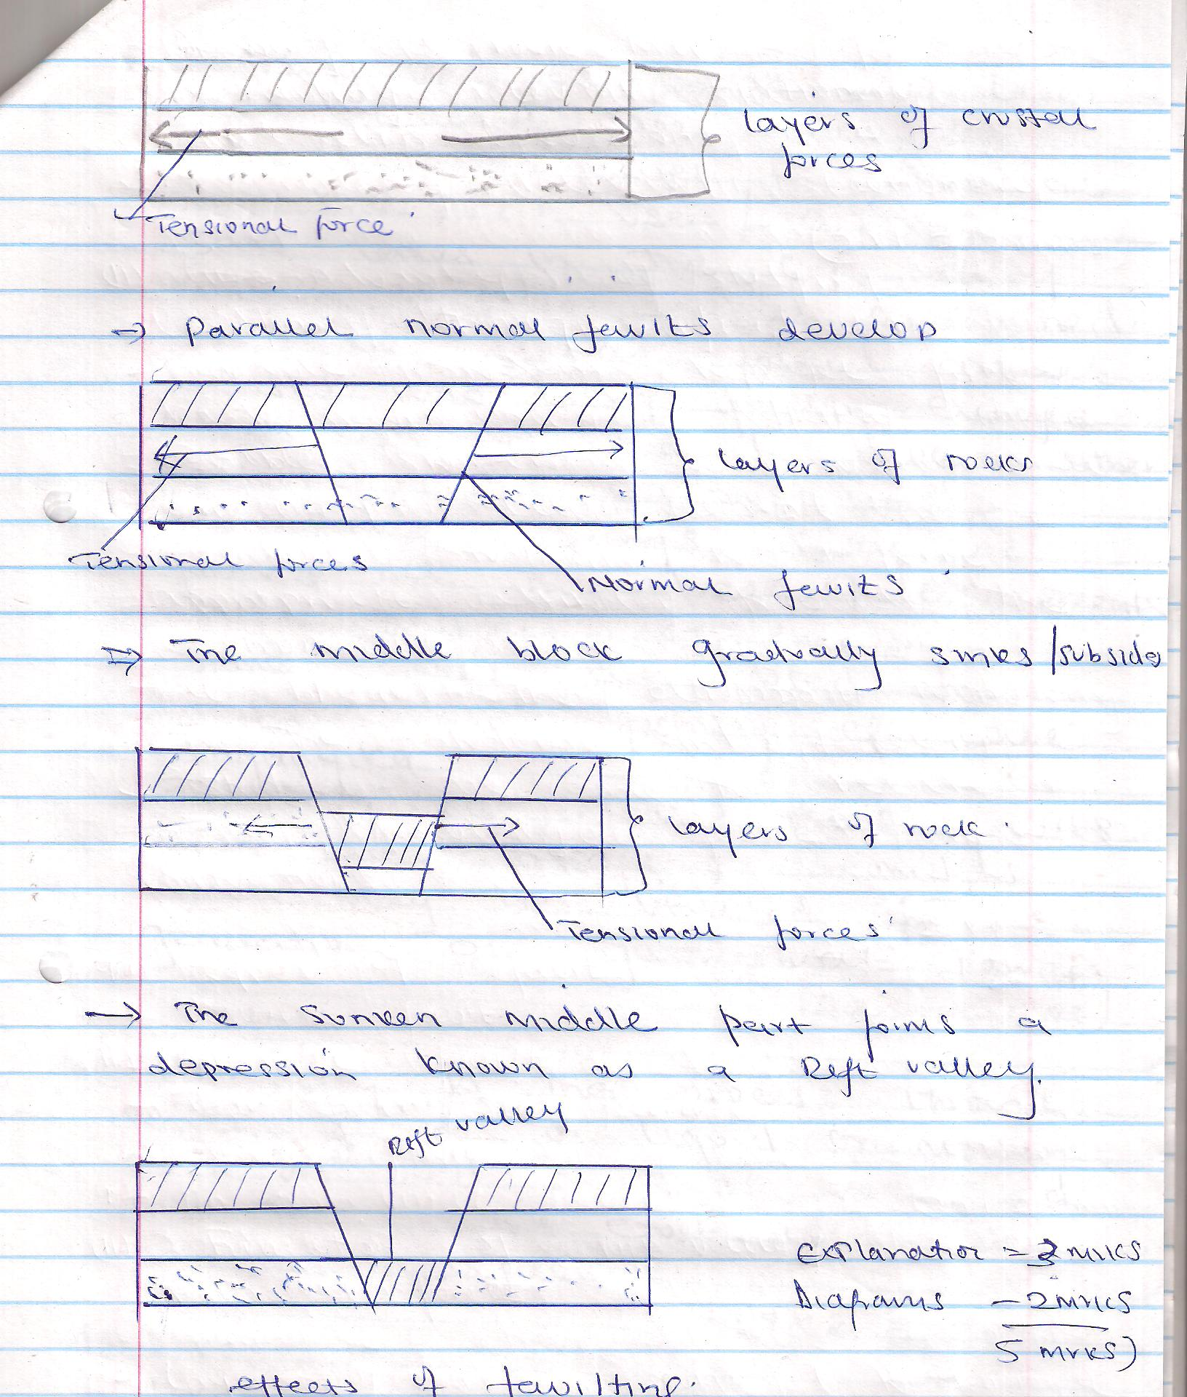

9 (iii) Faulting / fault scarps make it difficult to construct roads
- Faulting leads to formation of lakes e.glakeNaivasha which provide water for domestic and industrial uses / irrigation.
- Some lakes in the Rift Valley contain minerals which are mined
- Some features formed attract tourists who bring foreign exchange which can be used to develop other sectors of the economy.
- Sometimes springs may be formed at the base of escarpments which attract settlement
- Some lakes are used for transport and fishing e.g Lake Tanganyika
- Faulting has created deep faults which are passage of steam sets which may be utilized for generation of geothermal power.
2 x 3 = 6mks

10. (a) Vulcanicity is the process through which gaseous or liquid or molten rock or sound materials are forced into the earth’s crust or elected onto the surface.
2 x 1 = 2mks
(b) (i) Dyke
- batholith
- lapolith
- laccolith
3 x 1 = 3mks
11. (a) Earthquakes are sudden earth movements which cause vibrations within the crust
2 x 1 = 2mks
(b) Types of earthquake waves
- primary waves - P waves
- secondary waves - S waves
- long waves - L waves
2 x 1 = 2mks
12. (i) X – Desert climate

Y – Modified tropical climate of the highland
2 x 1 = 2mks
(ii) Characteristics of climate Z
- Means annual range of temperature is small / 4⁰C
- Rainfall is received throughout the year no dry season
- It experiences moderate to high temp.
- Mean annual temperature is high
- Humidity is high throughout the year
- Double maxima rainfall regime
- Rainfall is usually convectional accompanied by thunder and lightening
3 x 1 = 3mks

13. (a) A photograph is an image of an object, person of scene inform of a print or slide recorded by Camera or a film and latter transferred onto a specially prepared paper
2 x 1 = 2mks
(ii) Parts of a Photograph
Background

Middle ground

Foreground

3 x 1 = 3mks
Position of the
Camera
NB(Position of camera should be indicated)
14. (a) Negative effects of mining
- the dumping of rock waste has led to the loss of biodiversity/destruction of natural vegetation.
- dereliction of land due to dumping of waste materials is an eye sure / destroys the natural beauty of the land.
- pollution of the areas by noise/blasts smoke and water pools are all health hazards.
- Mining disrupts the water table which may lead to water shortage.
- Mining takes up that would have been used for agriculture thus interfering with food production
- Mining displaces human settlements thus disrupting people and necessitating expensive resettlement processes.
2 x 1 = 2mks
(ii) Ways, minerals occur
- Veins and lodes
- Beds and seams
- Weathering products
- Alluvial or placer deposits
2 x 1 = 2mks
Answer for question 15 (a) on the graph paper attached (6mks)

