MARKING SCHEME FORM TWO PHYSICS SECOND TERM 2017
1.)Diameter, d= 7.0 + 0.39
= 7.39 mm + 0.03 mm
r=
= 3.71 mm
2). Uniformity of expansion of liquid
-Liquid expansion in comparison to that of glass.
-Thermal conductivity
-Wide temperature range (any two 2mks)
3). Concrete mixture and steel have approximately he same linear expansivity.

4. )
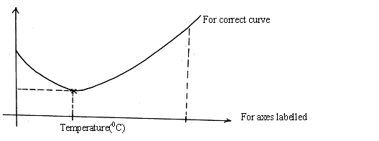

5.Wx5=4x20√
W=$\frac{80}{5}=16N$√
6.) Carrying the goods in the carrier raises the C.O.G hence unstable,goods in the boot lowers the C.O.G hence stable.
7).Diameter of wire $\frac{20}{15}$ = 1.33
Radius of wire 1.33÷21
=0.67cm1

8.Impurities reduces the surface tension hence the needle sinks.
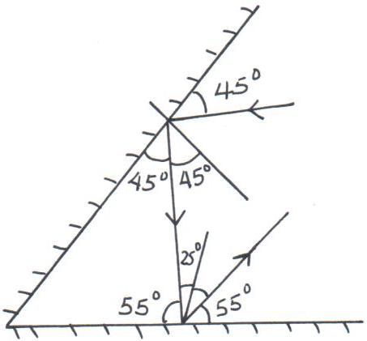
9.)

10.)Thermometer A will record a higher temperature than B because black surfaces absorb radiant heat while shiny surfaces reflect heat.
11). i)Other than L₁, state the lamp that will light when S1 and S₂ are closed.
L₃ (1 mark)
ii)How does the brightness in L1 in i) above compare with its brightness when all the
switches are close
L₁ is brighter (1 mark)
- Explain the observation in ii) above. (1 mark)
When the switches are all closed the total resistance is less
.

12 ). Ƥg = Ƥa - Ƥhg
= 100,000- 13,600 x 0.2
= 100,000- 2 + 200
= 72,800 N/m²

13) a)Introduce the oil drop on the water surface.1The surface tension of water reduces and the net force1 of the surrounding water pulls oil molecules outwards hence spreading.1

b)
- Ah=volume1
2
π$x\left( \frac{{21}^{}}{2}\right)h=$π$x\frac{4}{3}{(0.028)}^{3}$1
h=$\frac{2.92693}{110.25}=2.655x{10}^{-7}m$2
- Oil patch is a perfect circle, a monolayer1
Oil drop is perfect sphere1
Oil does not evaporate

c) To make boundary of oil patch visible1

d) i) Smoke particle - For visibility of air movement 1
ii)Lens - focus light to a point in the smoke cell 1
iii)Microscope. -magnification of smoke particles 1
e) Smoke particles observed moving at random 1
the smoke particles move at random due to the bombardment by air molecules which are in random motion 1(Brownian motion)
f) The random motion of smoke particle increases 1.

14(a) when a system is in equilibrium the sum of clockwise moments about a point is equal to the sum of anticlockwise moments about the same point.
(b) (i) Clockwise moment = 0.45 x 40
Anticlockwise moments = 10 x w
10w = 0.45 x 40
w = 1.8
m = 180g
d = $\frac{m}{v}$ = $\frac{180}{2.5 x 0.5 x 100}$
= 1.44g/ cm³
(ii) Sum of upward forces = Sum of downward forces
T = 0.45 + 1.8
T = 2.25N

c) Clockwise moments = Anticlockwise
f x 0.7 = 1.4 x 0.3
f = 0.6N

15.) (i)

√ Both rays √ Virtual image
(ii) Magnification = image height= 2.8√ = 2.545√
Object height 1.1
NB: Image and object heights must be measured accurately.
(b) i)When v= 45cm, magnification = 3.5 √ from the graph
But magnification = v/u
∴ u = 45
3.5
= 12.85cm.√
(ii) Slope = 3.5 – 0 √
45 -10
= 3.5 = 0.1cm⁻¹
35

16)a---Increasing the number of turns of the coil.
----winding the coil on a soft iron core
------(any other correct answer)

b) P: South Pole

Q: North Pole
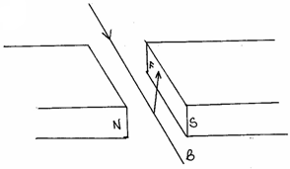
c)i)

ii) - Direction of magnetic field. (1mk)
-Direction of current (1mk)

d)magnetic relay
electric motor
electric bell
moving coil meter

17a)For a helical spring or other elastic material,the extension is directly proportional to the stretching force ,provided the elastic limit is not exceeded.

b)

c) ----Diameter of the coils making the spring .
-------Thickness of the wire
---------Length of the spring
------Number of turns per unit length

d) 75 N=K× 0.25
K = 75 ÷O.25
= 300N/M.
e)i) Spring constant =slope
= $\frac{2.5-0}{10-0}$
=0.25 N/M
ii)F =2Ke₁
= 2×0.25×0.1
=0.05 N

