NAME ...................................................................................... ADM NO ...........
DATE:………………

FORM II CHEMISTRY
TERM II 2017
TIME: 2 HOURS

MWAKICAN JOINT EXAM
CHEMISTRY

Instructions to students.

(a) Write your name and admission number.
(b) Answer ALL the questions in this question paper.
(c) All your answers must be written in the spaces provided in this question paper.
(d) Students must answer all questions in English

FOR EXAMINER’S USE ONLY
QUESTIONS | MAXIMUM SCORE | CANDIDATES SCORE
1-29

Answer all the questions in the spaces provided
1. a) State the function of glass beads during fractional distillation in
i. Boiling flask (1 mark)

ii. Fractionating column (1 mark)

b). Give two industrial applications of solvent extraction (2 marks)

2. The diagram below shows a Bunsen burner when in use.
A
B
Bunsen burner

i. Identify the type of the flame (1 mark)

ii. Name the regions labeled A and B (2 marks)
A
B
3. The following is a cooling curve of a certain gas.
B
A
Time (min)
Temp
(⁰C)

i) Is this a pure or impure substance? Explain (2 marks)

ii) Explain using kinetic theory what happens in region A (2 marks)

4. i. Distinguishing between weak and strong alkali (2 marks)

ii. The following is a list of pH values of some substance:
Substance | M | N | V | X | Z
pH | 10.6 | 7.0 | 13.2 | 5.9 | 1.5

Identify:
a) Strong acid (1 mark)
b) Weak base (1 mark)
5. A sample of urine from three athletes F,G and H in the recently concluded world championships athletics in Beijing China suspected to have taken illegal drugs were spotted onto a chromatography paper alongside two from illegal drugs X and Y. A chromatogram was run using methanol. The figure below shows the chromatogram.

•
x
x
x
x
x
X
Y
F
G
H
•
•
•
•
•
•
•

i. Identify the student who had used an illegal drug (1 mark)
ii. Which drug is less soluble in methanol (1 mark)
- Indicate on the diagram, the baseline and the solvent front (2 marks)

- Define the term chromatography (1 mark)
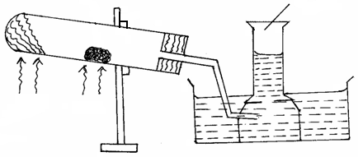 6. The set-up below was used to prepare and collect gas X. During the experiment cleaned magnesium ribbon was strongly heated before heating the wet glass wool.
Heat
Heat
Reaction tube
Magnesium ribbon
Gas X
Wet glass wool

i. Name gas X (1 mark
ii. Why is magnesium ribbon cleaned before it is used? (1 mark)

iii. State one observation that would be noted in the reaction tube. (1 mark)

iv. Write the chemical equation for the reaction in the reaction tube. (1 mark)

v. State one industrial use of the solid product formed in the reaction tube. (1 mark)

vi. What precaution should be taken at the end of experiment? Explain. (2 marks)

7. Distinguish between drug abuse and drug dependency (2 marks)

8. Name the method or process that can be used to separate each of the following mixture
- Water and motor oil (1 mark)
- Iron filings and sulphur powder (1 mark)
- Iodine and sand (1 mark)
- Water and ethanol (1 mark)

9.Give 4differences between permanent chemical changes and temporary chemical changes (4 marks)

10. The diagram below represents the apparatus used to prepare and collect dry oxygen.
Hydrogen
Peroxide

Solid Q
Solid P

- Complete the diagram to show how oxygen gas is collected. (1 marks)
- Name solids P and Q (2 marks)

iii. Write the chemical equation to show the reaction that produces oxygen gas. (1 mark)

iv. Briefly describe how oxygen is extracted from the air on large scale. (3 marks)

v. State two uses of oxygen gas. (2 marks)

11. State any three reasons why laboratory apparatus are made of glass (3 marks)

12. Both chlorine and iodine are halogens
(a) What are halogens (1 mark)

(b) In terms of structure and bonding, explain why the boiling point of chlorine is lower than that of iodine (2 marks)

13. Using dots (.) and crosses (x) to represent electrons, show bonding in the compounds formed when the following elements react ( Si = 14, Na = 11 and Cl = 17)
(a) Sodium and chlorine (1 mark)

(b) Silicon and chlorine (1 mark)

14. Use the information in the table below to answer the questions that follow. (The letters do not represent the actual symbol of the elements)
Element | A | B | C | D | E
Atomic number | 18 | 5 | 3 | 5 | 20
Mass number | 40 | 10 | 7 | 11 | 40

(a) Which two letters represent the same element? Give a reason. (2 marks)

(b) Give the number of neutrons in an atom of element C (1 mark)

15. When hydrogen gas is passed over heated lead (II) oxide, a reaction occurs. The diagram below shows a set up that could be used for this reaction
Hydrogen
Burning

Lead (ii) Oxide
Heat
Dry
Hydrogen

What observations would be made in the combustion tube? (2 marks)
16. Both molten lead (II) chloride and graphite conduct electricity. State how each of the substances conduct
electricity.
(i) Graphite (1 mark)

(ii) Molten lead (II) chloride (2 marks)

17. Substances J, K, L and M have the following properties.
Substance | M.P. | Solubility in water | Electrical conductivity
 |  |  | Solid state | Liquid state
J | Low | Soluble | Does not | Does not
K | High | Soluble | Does not | Conducts
L | High | Soluble | Conducts | Conducts
M | High | Insoluble | Does not | Does not
Select the letter which represents a substance which is suitable for making kettle handles. (1 mark)

(ii) Which letter represents a substance which is likely to be sodium chloride? (1 mark)
(iii) Name the structure and bond type likely to be in J.
a) Structure. (1 mark)
b) Bond type. (1 mark)
18. Ethanol and pentane are miscible liquids. Explain how water can be used to separate a mixture of
ethanol and pentane (3 marks)

19. The figure below shows part of sodium chloride crystal lattice.
•
•
•
•

- Which ion are represented in
(i) Larger circles (Ο) (1 mark)

(ii) Smaller circle (•) (1 mark)
(b) Sodium chloride has a higher melting point than hydrogen chloride, explain. (2 marks)

20. Elements X and Y have the atomic masses of 39 and 23 respectively.
(a) Complete the table below by filling the blank spaces (2 marks)
Elements | X | Y
Atomic mass | 39 | 23
Number of neutrons | 20 | 12
Electronic configuration

(b) Which element has a higher ionization energy? (1 mark)

(c) Explain your answer in (b) above. (2 marks)

Air
Concentrated potassium hydroxide solution
Excess hot copper turnings
Excess heated magnesium powder
Escaping gases
21. Air was passed through several reagents as shown in the flow chart below.

- Write an equation for the reaction that took place in the chamber with the magnesium powder.
(1 mark)
- Name one gas that escapes from the chamber containing magnesium powder. Give a reason for your answer. (2 marks)

22. When the air-hole is fully opened, the Bunsen burner produces a non-luminous flame. Explain. (1 mark)

23. Element T consists of two isotopes ⁶²T and ⁶⁴T in the ratio 7 : 3 respectively. Calculate the relative
atomic mass of element T. (3 marks)

24. Briefly explain the following:
(a) Alkaline earth metals are generally less reactive than-alkali metals. (2 marks)

(b) Though sodium and aluminum are in the same period and are both metals, aluminum is a better
conductor of electricity. (2 marks)

25. Identify and state the use of the apparatus represented below. (2 marks)
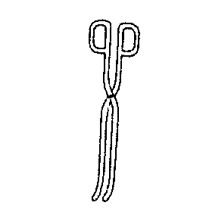
26. Starting with copper metal, describe how to prepare solid copper (II) carbonate. (3 marks)

27. The set-up represented below can be used to separate ethanol from its mixture with water.

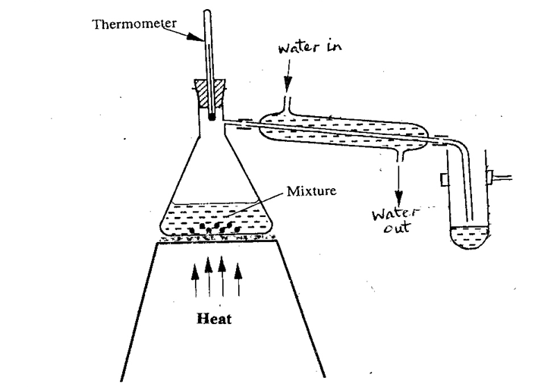

(a) Identify an error in the set-up. (1 mark)

(b) Name this method of separation. (1 mark)

(c) What properties make it possible to separate ethanol from water by this method? (2 marks)

28. A certain element Y has atomic number 15 and mass number of 31.
(a) Calculate the number of neutrons in the element. (1mk)

(b) Write the electron arrangement of the ion formed by element Y. (1mk)

- How would the atomic size of the above element compare with another atom X whose atomic number is 11 and mass number 23? Explain. (1mk)

29. The table below shows the first ionisation energies of elements P and Q.
Element | 1st Ionisation energy kJ/mole
P  Q | 494  418
a)What do these values suggest about the reactivity of P compared to that of Q? Explain. (2 marks)

- State two factors that influence ionization energy. (2 mark)

