Name: ………………………………………………. Adm. No ……………. Class…………

GEOGRAPHY EXAMINATION
TIME: 2 HOURS

MWAKICAN JOINT EXAM (MJET)
FORM 2 TERM II 2017

INSTRUCTIONS TO CANDIDATES
- Write your name and admission in the spaces provided at the top of this page.

- Answer all questions in this question paper.

- All the answers must be written in the spaces provided in this question paper.

ANSWER ALL QUESTIONS ON THE SPACE PROVIDED
- (a) Give the two dates in a year when the length of the day and night are equal (2mks)

(b) State two effects of the earth revolution (2mks)

- (a) (i) Name two components of the solar system (2mks)

(ii) Draw a diagram of the Lunar eclipse and on it mark the following features (4mks)
- Sun
- Moon
- Umbra
- Earth

- (a) O zone layer is found in which layer of the atmosphere (1mk)

(b) State three characteristics of the Troposphere layer (3mks)

- (a) State three characteristics of the Inter-tropical convergence zone (3mks)

(b) With aid of a well labeled diagram describe how relief rainfall is formed (5mks)

- (a) Name the instrument used to measure minimum temperature in a weather station (1mk)

(b) The table below shows temperature readings at a weather station for one week
Temp/Day | MON | TUE | WED | THUR | FRI | SAT | SUN
Max ⁰C | 28 | 27 | 28 | 26 | 29 | 29 | 26
Min. ⁰C | 18 | 18 | 20 | 16 | 22 | 21 | 19

Calculate the following:-
- The diurnal range of temperature for Tuesday (1mk)

- The mean temperature for Saturday (1mk)

- (a) (i) What’s a rock (2mks)

(ii) State three characteristics of Sedimentary rocks (3mks)
(b) Suppose you were to carry out a field study of rocks within the vicinity of your school.
(i) Name three secondary sources of information you would use to prepare for the field study (3mks)

(ii) State three activities you would carry out during the field study (3mks)

(iii) State three problems you are likely to experience during the study (3mks)

- (a)(i) Name two types of boundaries according to the plate tectonic theory (2mks)

- Give two effects of the movement of tectonic plates (3mks)

- (a) (i) Name one fold mountain in:-
Asia (1mk)

North America (1mk)

South America (1mk)

(ii) Apart from fold Mountains name other three features resulting from folding
(3mks)

(b) (i) Explain two effects of fold mountains on human activities (4mks)

(ii) Students are planning to carry out a field study on land forms in their District
- State two ways in which the students would prepare themselves for the field study (2mks)

- Give two advantages of studying landforms through field work (2mks)

- (i) Name three types of faults (3mks)

(ii) With the aid of a well labeled diagram, describe how a rift valley is formed by tensional forces (5mks)

(iii) Explain three effects of faulting (6mks)

10 (a) What is vulcanicity (2mks)

(b) Apart from a sill, name three other intrusive volcanic features (3mks)
11. (a) Define earthquakes (2mks)

(b) Name types of earthquake waves (2mks)

12. The Map below shows climatic regions of Kenya. Use it to answer questions which follows:-
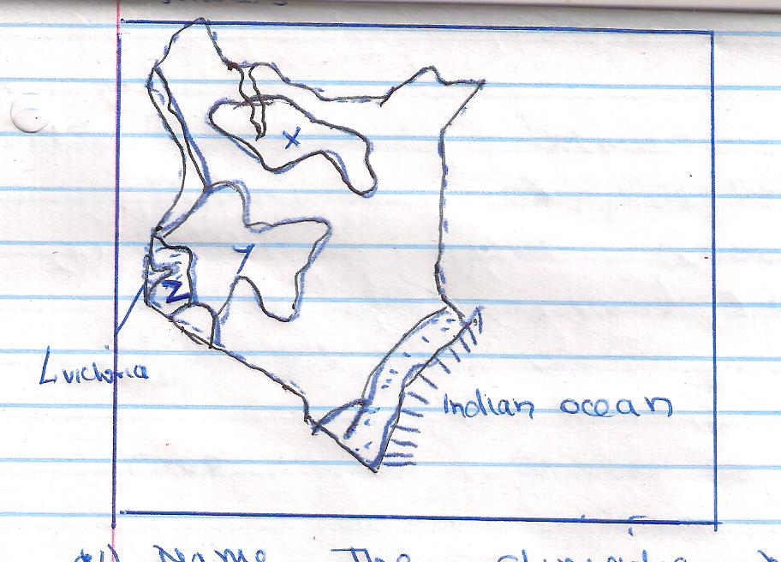

- Name the climatic regions marked X and Y (2mks)

- State three characteristics of the climatic region marked Z (3mks)

13. (a) (i) Define Photograph (2mks)

(ii) Draw a table showing the major parts of a photograph (3mks)

14. (a) State two negative effects of mining to the environment (2mks)

(b) Name two ways in which minerals occur (2mks)

15. (a) The table below shows four main principal crops produced in Kenya in the years 2000 and 2001. Use it to answer questions which follows:-

Crop | Amount in Metric Tons
 | 2000 | 2001
wheat | 70000 | 130000
Maize | 200000 | 320000
Coffee | 98000 | 35000
Tea | 240000 | 295000

- Using scale of 1cm represent 50000 metric tons, draw a comparative bar graph using the above information (6mks)

