FORM 3 MWAKICAN
MARKING SCHEME BIOLOGY PP2
1. (a)Green plant- Grasshoppers Lizard-snake (2 mks)

Green plants- mouse snake Hawk
(b)Mouse 1mk

(c )Lizard, domestic cat, hawk, snake 2 mks

(d)-The green plants will dry up 3mks
-Grasshoppers will die
-Mouse will die and others migrate
-Domestic cat will reduce in number
-Death and migration of hawks

2. (a)A-Epidermal cell 2mks
B-Guard cell

(b)C-Gaseous exchange/ controls water loss 2mks
D-Carry out photosynthesis

(c )(i)It will close 1 mk

(ii)Guard cells will lose water by osmosis; and become flaccid, its walls then will draw towards each other closing the stomata. 3mks

3. (a) N=nxM
m

374x400=1870 crabs 2mks
80

(b)-No crabs migrated in or out of the pond
-The marked animals mixed freely with the others
-The mark does not harm the animal or alter the behaviour of the crab or make vulnerable to attack
-The population does not vary during the study period 3mks

(c )Capture –recapture method 1mk

(d)Direct counting 2mks
-Quadrat method
-Belt transect method
-Line transect method

4.(a)A-Bowman’s capsule 3mks
D-Proximal convoluted tubule
F-Glomerulus

(b)(i)Blood in vessel x flows at high pressure while Blood in vessel Y flows at a lower pressure1mk

(ii)Blood at F contains plasma protein /Blood cells which are absent at D. 1mks
(c )(i)Mineral salts 1mk
(ii)Metabolic energy /ATP 1mk

(d)Less water would be reabsorbed /large quantity of dilute urine would be produced 1mk

5.(a)A-AnimalsB- Saprophytic bacteria /fungi2( for two correct answers)

(ii)C-NitritesD-Nitrates 2mks

(iii)1. Nitrification 3mks
2. Denitrification
3. Absorption

(b)-Allows nitrogen in air to enter into the living tissues of organisms 1mk
-Source of energy from decomposers
-Enriches soil with nitrates which is important for healthy growth of crops
-Regulates the percentage of atmospheric nitrogen 4 mks

6. a) 7 marks
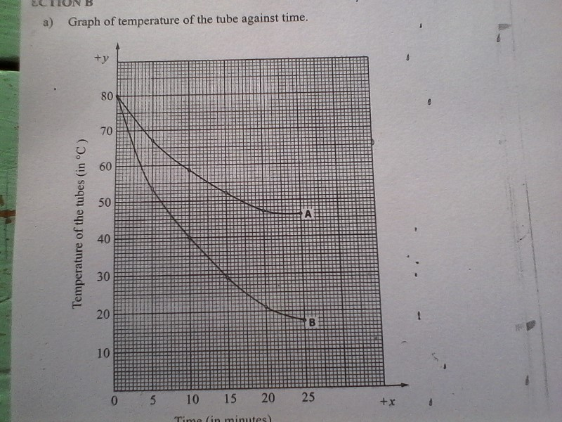

(b)80-18/25 2mks
62/25=2.48c//minute

(c )Control experiment 1mk

(d)Rate was faster in tube A because its surface was being wiped with cotton wool containing methylated spirit. The spirit absorbed latent heat of vaporization from the tube, releasing it to the air therefore, facilitating the cooling of the tube content 3mks

(e)-conduction-Radiation 2mks

(f)Would have low rate loss 1mk

(g)(i)Feathers 1mk

(ii)Fur 1mk

(h)(i)Receptors in the skin 1mk
(ii)Hypothalamus 1mk

7. a) light, temperature, humidity, atmospheric pressure, salinity, ph, wind. Any 4
b)
- some have leaves modified into thorns to reduce SA for transpiration
- some plants shed their leaves during dry season to reduce SA for for transpiration
- have leaves with thick waxy cuticle to reduce the rate of transpiration
- some fold their leaves hence exposing few stomata to reduce the rate of transpiration
- some have sunken stomata with moisture accumulating within the sub-stomatal air chamber to reduce rate of transpiration
- some have reversed stomata rhythm to reduce rate of transpiration
- some are deep rooted inorder to absorb water
- others have superficial rooting system to trap water from occational rain
- some have needle like leaves to reduce the SA for transpiration
- some have succulent stems or leaves which store water. (OWTTE)

8. The heart has cardiac muscles which are myogenic. The muscles initiate their own contractions without nervous stimulation. The cardiac muscle fibres are interconnected due to presence of intercalated discs to enable the waves of contraction to travel throughout the organ. Cardiac muscles have special muscle fibres to enable it to contract and relax rhythmically without fatigue. The heart is enclosed by a translucent membrane called pericardium whose purpose is to keep the heart in position and check on over dilation of the heart during pumping. The pericardium also secrets pericardial fluid that acts as a lubricant to reduce friction in the walls during pumping action. The heart is connected to vagus and sympathetic nerves of the autonomous nervous system that control the rate of heart beat depending on the body’s physiological requirements. Sympathetic nerves increases the rate of heart beat while vagus slows down the rate of heart beat. The cardiac muscle fibres have their own blood supply through coronary artery which supplies nutrients and oxygen while coronary vein removes metabolic wastes from cardiac muscle fibres. The outer part of the heart has a layer of fat that acts as a shock absorber protecting the heart against mechanical damage. The cardiac muscles has a specialized small area in the wall on the right auricle called sino atrio node (SAN)or pacemaker. Its spontaneous rhythmical activity initiates and maintains contractions of the heart. The cardiac muscle also contains specialized tissues namely atro-ventricular node (right ventricle) and purkinje tissues at the junction of the ventricle and atria tha sends impulses down making the ventricles contract. The ventricles are divided into two by a thick muscular wall called atrio-ventricular septum which prevents mixing of oxygenated and deoxygenated blood. Between the atrium and the ventricle is an atro-ventricular valve namely bicuspid on the left and tricuspid on the right. These valves prevent back flow of blood into the relaxed auricles when ventricle muscles contract. The valves are supported by valve tendons which are attached to the wall of the ventricle on each side. The tendons prevent valves from turning inside out when under pressure as the ventricles contract.

