MWAKICAN
FORM 3 BIOLOGY PAPER 3 MARKING SCHEME

- You are provided with an unknown mixture labeled J.
You are also provided with Benedict’s solution, dilute hydrochloric acid solution, iodine solution, dichlorophenol-indophenol (DCPIP) solution, sodium hydrogen-carbonate solution, means of heating, test tubes, test tube holder and a test tube rack.
- Using the reagents provided only, test for the food substances in mixture J. Record in the table below the food substance tested, the procedure of the test, your observations and conclusions. (8mks)
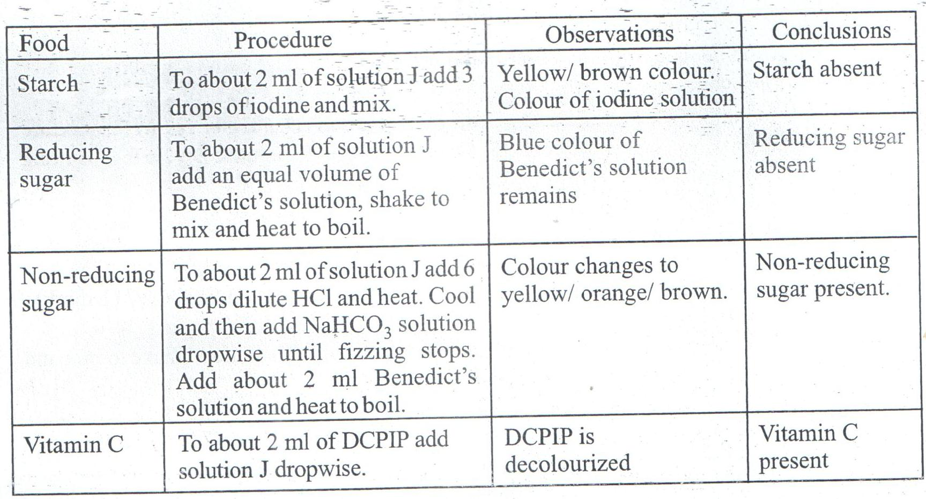
- Which of the components of mixture J does not undergo digestion in the mammalian digestive system? (1mk)
Vitamin C
- Name a common carbohydrate that could be present in mixture J (1mk)

Sucrose

- State the role of hydrochloric acid and sodium hydrogen carbonate in the experiment (2mks)
Hydrochloric acid hydrolyzes non-reducing sugar(s) into simple
sugars/monosacharides/reducing sugars;
Sodium hydrogen carbonate neutralizes the hydrochloric acid.

- (i) Name a deficiency disease that may result from a deficiency of one of the substances present in mixture J (1mk)
Scurvy

(ii) Give one common symptom of the disease you have stated in (e)(i) above (1mk)
Bleeding gums
- Examine the photographs of the leaves labelled K1, K2, K3, K4, K5, K6, K7, K8 and K9 shown below and the incomplete dichotomous key shown.
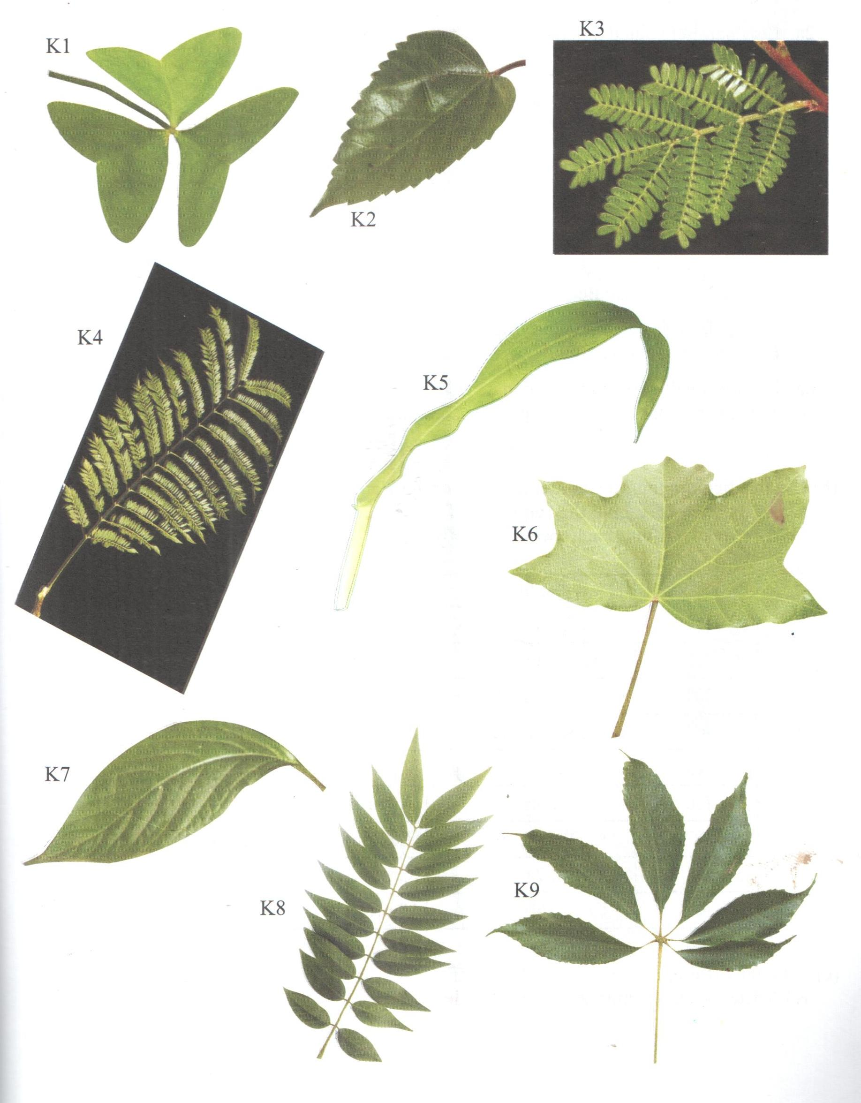

- Complete the dichotomous key shown below (4mks)
1a. Leaf simple ………………………………………….go to 2
b. Leaf compound ……………………………………… go to 5

2a. Leaf parallel veined ………………………………… Zea
b. Leaf net-veined ……………………………………… go to 3

3a. Leaf lobed …………………………………………..Aleurites
b. Leaf not lobed ……………………………………… go to 4

4a. Leaf margin smooth ………………………………..Achyranthes
b. Leaf magin serrated………..……………………….Hibiscus

5a. Leaf palmately compound ………………………… go to 6
b. Leaf pinnately compound ………………………… go to 7

6a. Leaf trifoliately compound ………………………..Oxalis
b. Leaf with more than three leaflets…………………..Chorisia

7a. Leaf unipinnately compound ……………………..Cassia
b. Leaf bipinnately compound ………………………go to 8

8a. Has terminal leaflets/imparipinnate …………….. Jacaranda
b. Has no terminal leaflets/paripinnate ……………….Acacia

- Use the dichotomous key to identify each of the plant specimens in the photographs to their genus. In each case give the sequence of steps, e.g. 1(a), 2(b), 4c and so on which you followed in identifying each specimen (9mks)
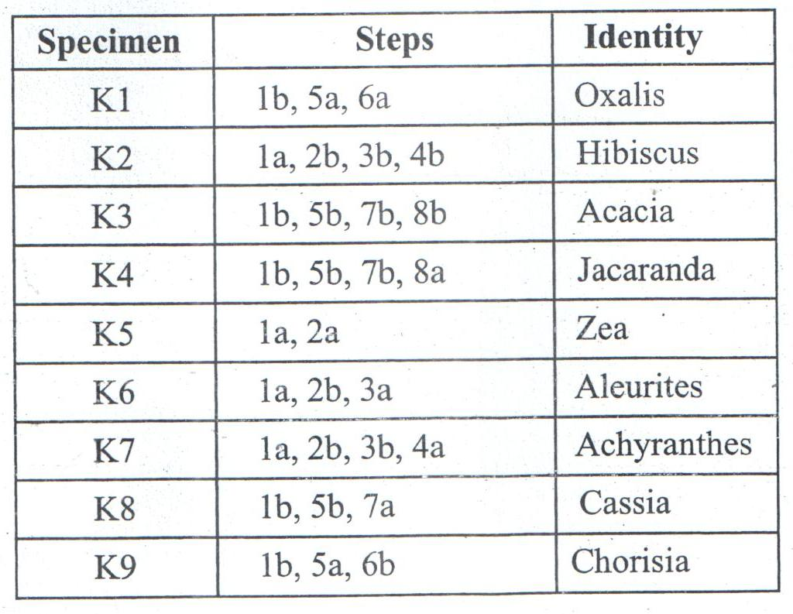

- State the difference in the apex of the leaflet of K1 and leaf K2 (2mks)
K1 leaflet has an emarginated/broad apex while leaf K2 has an acute/pointed apex

- The three organisms shown in the photographs below are often found in the same ecosystem. Examine them.
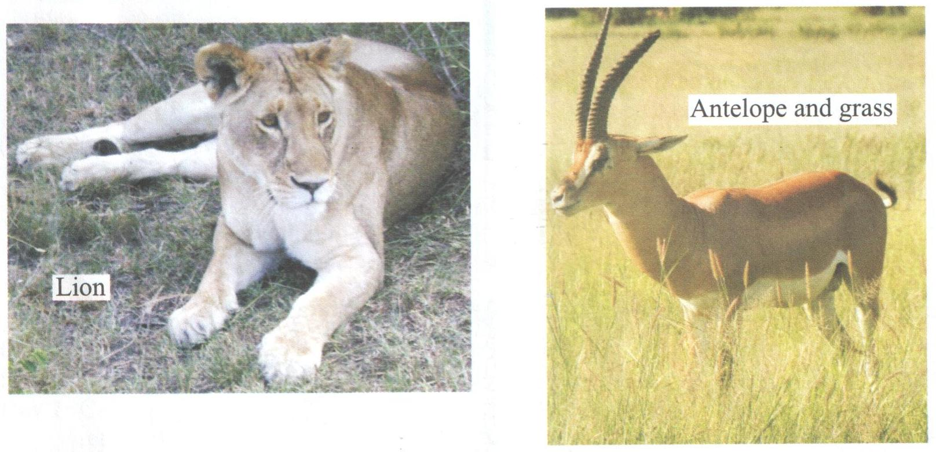
- (i) Name the trophic level occupied by the antelope (1mk)

Primary consumer
(ii) Give a reason for your answer in (a) (i) above (1mk)
It feeds on grass

- (i) Draw a pyramid of biomass for the three organisms in the ecosystem (3mks)
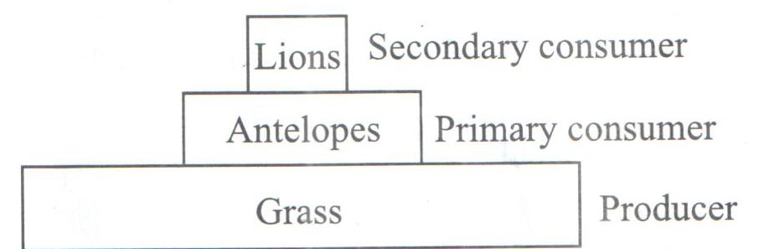

(ii) Explain the differences between the biomass of lions and antelopes in the ecosystem (4mks)
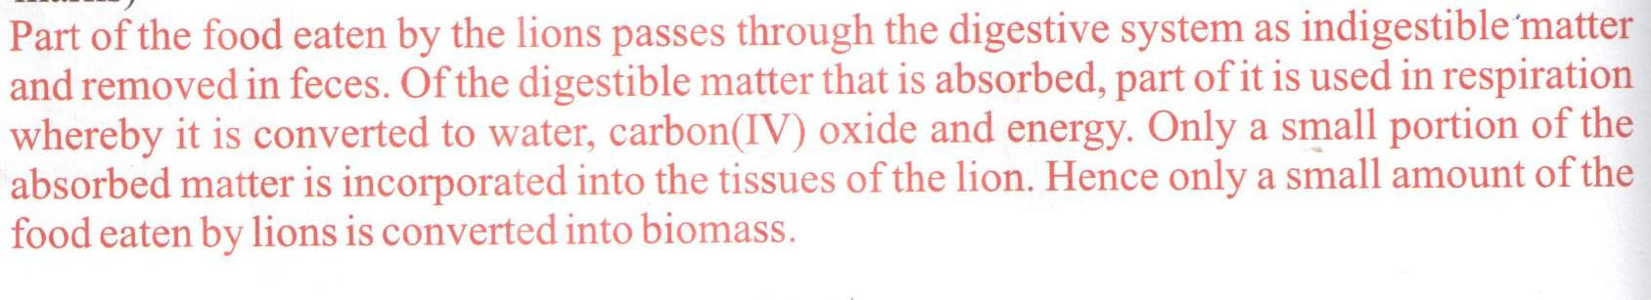

- (i) Hyenas are also often found in this ecosystem. Name the trophic level(s) that they occupy. (1mk)

Secondary and tertiary consumers

(ii) Give a reason for your answer in (c) (ii) above (1mk)

They feed on the flesh of other animals, both herbivores and carnivores

