MWAKICAN JOINT EXAM TEAM (MJET)
FORM 3 END TERM 2, 2017
GEOGRAPHY (Marking Scheme)
PAPER 1
SECTION A
- Name three effects of revolution of the earth. (3 mks)
  - Causes four seasons - spring, summer ,autumn and winter.
  - Causes varying lengths of day and night at different times of the year.
  - Causes changes in the position of the midday sun at different times of the year.
b) Difference in longitude(2marks)
10º + 37ºE = 47º
15º - 1 hr =47 x 4 = 47 = 3 hrs 8 mins
47º - ? 60 15
10.00 am
3.02
6.52 am
2. a) State three natural causes of earth quakes (3 marks)
- Tectonic causes
- Magma movement within the earth crust
- Gratitative pressure
- Isostatic adjustments
- Energy release in the mantle.
b) Give two effects of earth quakes in built up areas (2 marks)
- Earth quakes causes sea waves called Tsunamis which causes flood which drown buildings neighbouring the coast.
- Causes landslides which bury people alive
- Causes big cracks in buildings.
- When earthquakes occur in densely populated areas they cause alot of damage to property.
3. a) State three reasons why wind action is more effective in the hot desert. (3 marks)
- The presence of loose unconsolidated dry masses of soil.
- The occurrence of strong, tropical storms.
- The absence of vegetation cover
b) Name three features resulting from wind erosion in the desert areas. (3 marks)
- Rock pedestals
- Mushroom blocks
- Zeugen
- Yardangs
- Deflation hollows and oasis

4. a) Name two sources of underground water. (2 marks)
- Rain water
- Melt water
- Water bodies
- Magmatic water
b) state three conditions necessary for the development of karst scenary. (3 marks)
- The rock below the surface should be limestone, dolomite or chalk
- Rocks should be hard and well jointed
- Water table should be deep below the surface
- Hot and humid climate to accelerate chemical weathering
5. a) What is mass wasting (2 mks)
- Downward movement of weathered materials down slope under influence of gravity
b) Differentiate solifluction and earth flow (2 mks)
- Solifluction is flow of viscous soil, gravel and weathered rock material over saturated with water moving over a
permanently frozen ground on a gentle slope due to influence of gravity while earth flow is rapid movement of material oversaturated with water down a hill slope under the influence of gravity.
accumulate in layers.

SECTION B
Answer question 6 and any other two questions from this section
Study the map of Kitale (sheet 75/3, Scale 1:50,000) provided and answer the questions that follow.
6. What is the longitudinal extent of the area covered by the map. (2mks)
35⁰00’E and 35⁰15⁰E
b) Give the six figure grid reference of the top most part of Rogurr hill (2mks)
463241 or 462241
c) Measure the length of the all-weather road from the junction at grid reference
239286 towards the Southern part heading to Kitale, give your answer in Kilometers.(2mks)
Distance in kilometers
6.1+ 0.1km
d) What is the bearing of Kipsain club at grid reference 3121 from the Dip at grid reference 2826. (2 mks)
Direction of kipsain club from Dip = 90⁰+ 60⁰ = 150⁰ + 1⁰

(e) (i) Draw a frame of dimensions 14cm by 10cm to represent the area bound by the eastings23 and 30 and the northings 11 and 16. (1mk)
(ii) On the frame, mark and name:
- railway line:
- Papyrus swamp;
- All weather loose surface road C 641. (3mks)

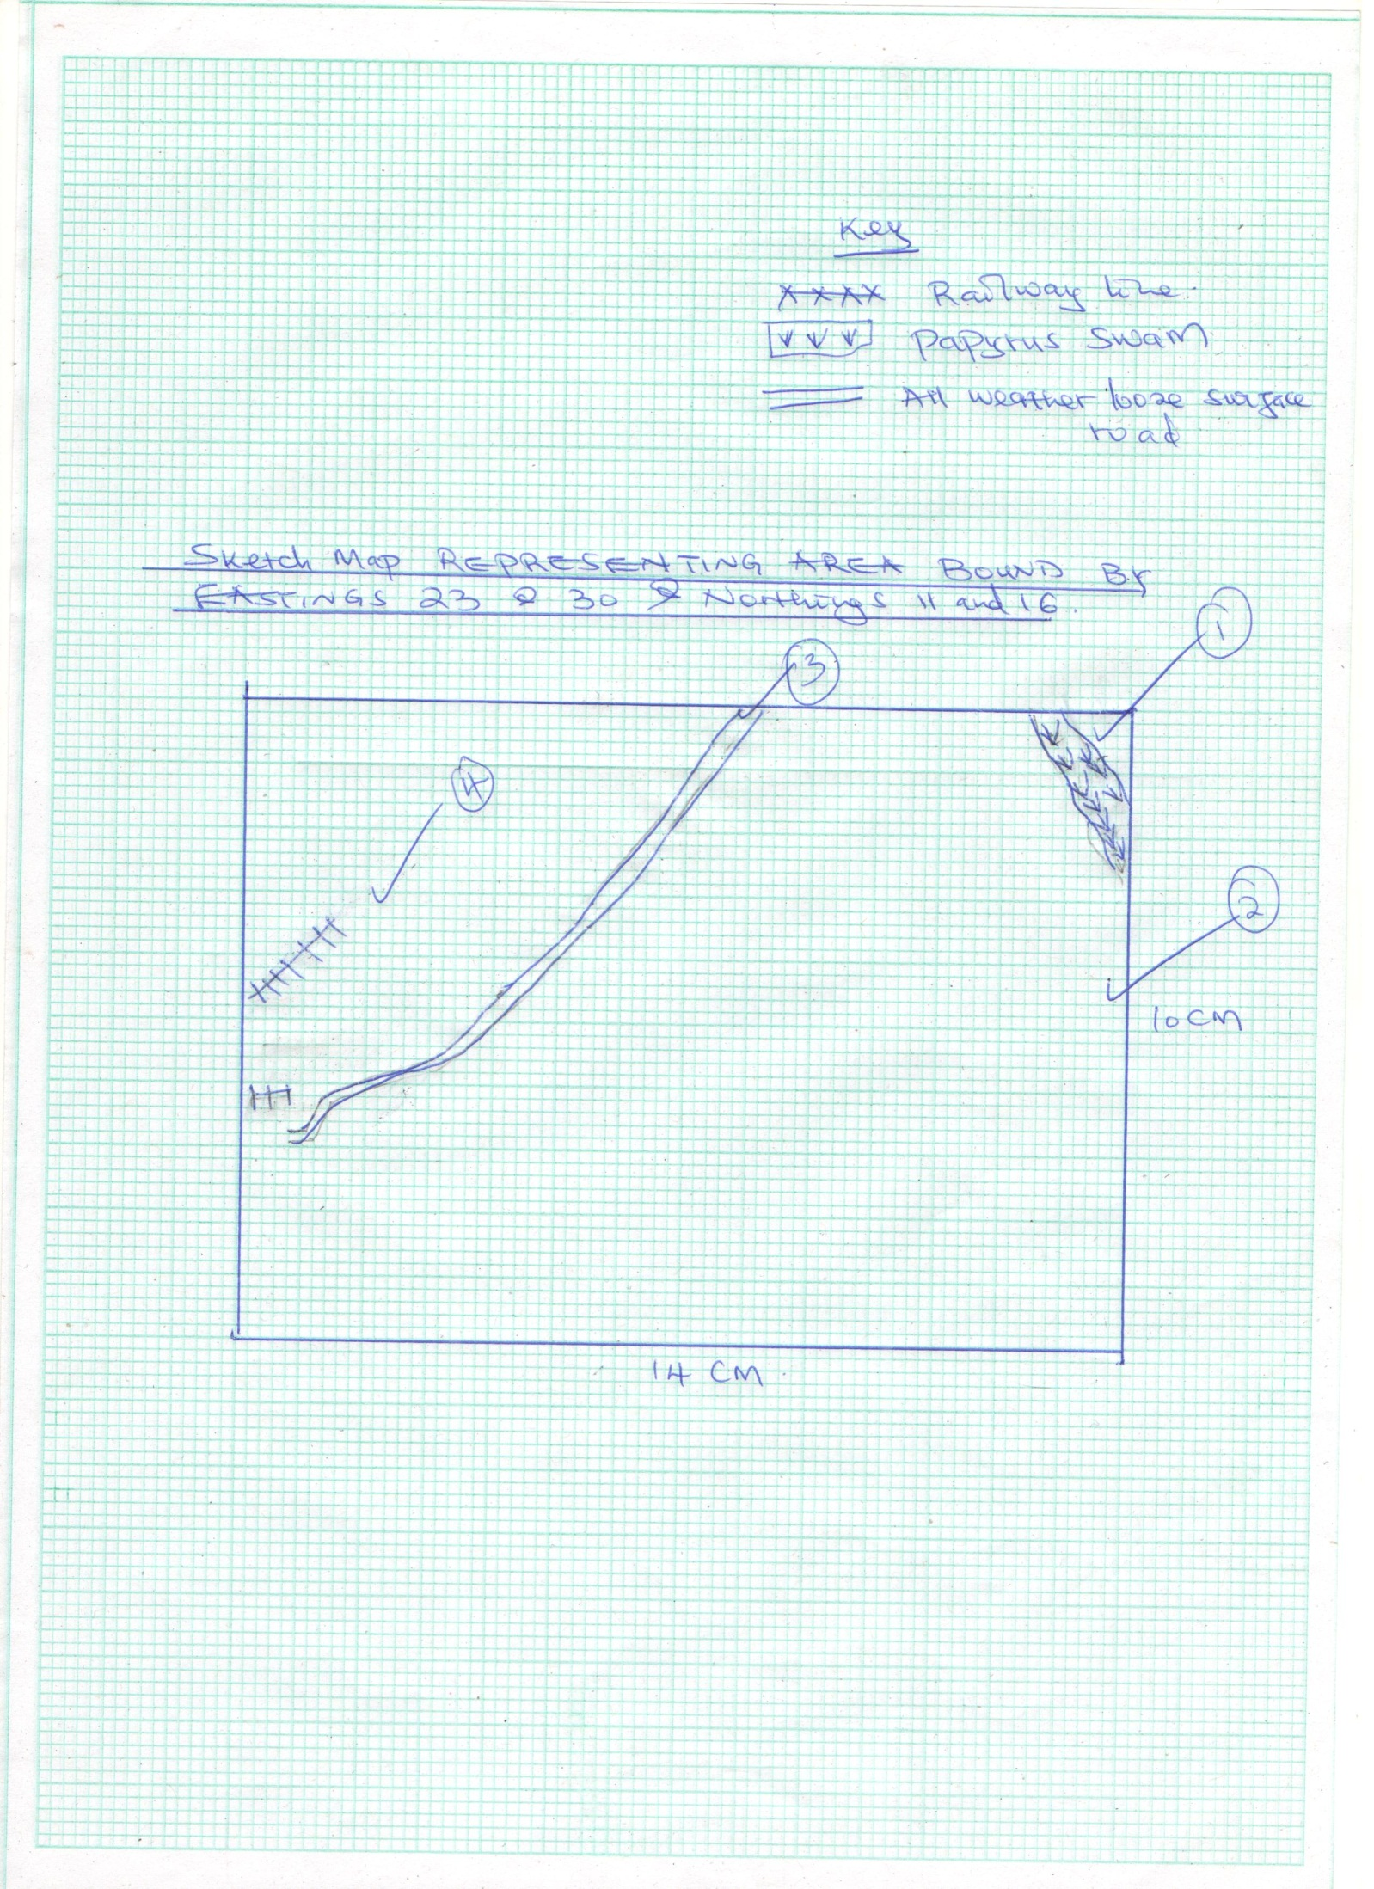
Distibution of marks
Frame 1mk
Title 1mk
Features 3mks (total 5mks)

(f) Students from a school in grid square 2614 conducted a field study of Kitale township.
(i) Citing evidence from the map, state three functions of Kitale Township they are likely to
identify. (3mks)
- Educational centre- presence of schools
- Religious centre-presence of church
- Trade centre-presence of market
- Transport centre –presence of roads
- Health / medical centre – presence of a hospital

(ii) State two physical problems they could have encountered during the study. (2mks)

- Inaccessibility
- Attack by wild animals
- Vehicle break down
- Students falling sick
- Uncooperating respondent
- Health /medical centre – presence of a hospital

g) Examine the factors influencing settlement in the area covered by the map (4mks)
i) Drainage – The area covered by the seasonal swamps eg on the western part of the map is
completely inhibited.
ii) Transport routes – most settlements are located long transport and communication routes eg roads, other tracks and foot paths.
iii) Government facilities – is evidenced by a concentrated settlement at the ministry of work camp at
grid reference 2817 and 3514.
iv) Relief, the western part of the map has high density of settlement compared to N.Eastern part because it is generally flat as evidenced by evenly spaced contours
v) The North Eastern part of the map is completely inoccupied by settlements possibly because of
government policy as it is a forest (Kaptaberr forest)
vi) Social facilities the area around Kitale municipality has a concentrated settlement most likely
because the presence of social facilities eg the Golf course, Kitale club, show ground
( 2 x 2)

h) Show Three characteristics of drainage in the area covered by the map (3mks)

i) Kitale has many seasonal swamps as indicated by blue marked lines on the south and western part of the map
ii) There are several man made drainage features for example the water tank in Kitale municipality and dams eg on grid square 3911.
iii) Some of the rivers exhibit dentritic drainage pattern for example River Noigameget is joined by its tributaries at an acute angle.
iv) The most common drainage feature is rivers which are well distributed on the map eg. Suwerwa,
Kapolet and Koitbio
v) The Rivers exhibit a parallel drainage pattern as they flow the north towards the south eg Rivers
Koitabos and Noigameget and Koitobos.
vi) Rivers Koitobos and Noigameget are permanent rivers as indicated by continous blue line
vii) There are disappearing rivers for example river Saiwa which disappears into the sitatunga swamp.
(3 x 1 = 3mks)

7. (a) climatic regions marked a,b and c. (3 marks)
- A-Equitorial climate
- B-Tropical desert climate
- C-Mediterenean climate
b) climatic characteristics of
- A (4 marks)
- High temperatures throughout the year 24-27⁰c with a small annual range of 3⁰c
- Diurnal mean temperatures of approximate 26⁰c all year with diurnal range of below 8⁰c
- Mean annual rainfall 1500mm well distributed throughout the year
- Receives double maxima of rainfall
- High relative humidity over 80% throughout the year
- Plenty of sunshine
- Thick cloud cover allthe year around
- Low atmospheric pressure all the year around
- Rainfall is mainly conventional accompanied by thunderstorms (4×1=4 marks)
- C (4 marks)
- Hot summers with temperatures of approximately 21⁰c and mild winters of temperatures approximately 10⁰c
- Moderate annual range of temperatures approximately 10⁰c
- Mean annual rainfall of between 500-900-mm
- Cyclonic rainfall caused by depressions falls in showers in winter
- Offshore trade winds in summer causes a dry season
- Hot and cold local winds are common (4×1=4 marks)
(c) Explain how the following factors influence climate
(i) Altitude (4 marks)
- Lowlands are usually warmer than highlands because the atmosphere becomes thinner as the ground looses heat faster
- Atmospheric pressure decreases with increases in altitude. This is due to the weight of the atmospheric air which is less above highlands than inlowlands
- Highlands tend to be wetter than lowlands (2×2=4 marks)
(ii) Distance from the sea (4 marks)
- During hot seasons coastal lowlands are relatively colder than inland areas on the same latitude due to effect of sea breezes which bring cold air to the land.
- In winter land loses heat gained in summer faster than the sea. Sea breezes carry warmer air to the land making areas closer to the sea warmer than inland areas.
- Coastal lands receive more rainfall than the interior of continents .This is because the coasts receive moist winds from the sea and by the time the winds reach inland areas they are usually dry. (2×2=4 marks)
(d) (i)suitable site for a weather station. (2 marks)
- The site should be flat and free from flooding
- It should be open with a free flow of air
- It should not be near obstacles such as tall trees ,buildings or other structures
- It should be secure and free from intruders. (2×1=2 marks)
(ii) Why a Stevenson’s screen is:
Painted white (2 marks)
- To help in reflecting heat from the sun to avoid interfering with temperature readings (1×2=2 marks)
Has louvers (2 marks)
To allow free circulation of air and keep the screen well ventilated. (1×2=2 marks)

8. (a) (i) Name the features marked S and T
- S - Ox - bow lake
- T - alluvial deposits (1 mark each) (2mks)
(ii) State three that are necessary for the formation of the feature marked S.
- Presence of pronounced meanders in the flood plain.
- Heavy load being carried by the river.
- A reduction in the river gradient/reduction in the river energy to erode vertically/low velocity.
- Lateral erosion on the outer side of the river banks.
- Deposition on the inner side of the river banks.
- Periodic flooding (to cut off the neck to pronounced meanders). (Any first 3, 1 mark)

(b) (i) Outline two factors that influence the development of a drainage pattern.
- Direction of the slope of the land.
- Difference in rock resistance/hardness.
- The arrangement of rock layers/ structure. (2 x 1 = 2mks)
(ii) Outline five characteristics of a river in its youthful stage.
- The river has a steep river gradient.
- The river channel is narrow.
- The river has deep steep - sided V-shaped valley/gorges.
- The river flows at a high speed/high stream velocity.
- The vertical erosion/down cutting is dorminant.
- The river channel is generally widing.
- The type of flow is torrential.
- The river has a small volume of water.
- The river has a small load. (Any 5 x 1 = 5mks)
(c) (i) State three reasons why it would be necessary to pre-visit the area of study.
- Helps to access suitability of the area of study.
- Helps to draw up objectives/hypothesis of the study.
- Helps to prepare a route map.
- It helps to design a working schedule.
- It helps to identify the probable problems and how to solve them.
- It helps to estimate the cost of the field study.
- It helps to identify suitable data collection methods.
- It helps to identify appropriate equipment to be used during the field study. (Any 3x 1 = 3mks)
(ii) State four activities you would carry out todetermine why deposition occurs at thisstage.
- Measuring of the gradient.
- Finding out the nature of the load.
- Finding out the amount of the load.
- Establishing the velocity of the river.
- Observing obstacles in the stream channel or distributaries.
- Measuring of the width of the river.
(d) (i) Explain three negative effects of rivers to the human environment
- When rivers flood, they destroy a lot of property/crops and may lead to loss of human life.
- Wide/deep rivers are a barrier to transport especially where bridge has not been constructed.
- River water can be a medium of spreading water-borne diseases since flood waters may spread chemicals from
farms/human waste which contaminates sources of water.
- Some rivers are habitat to dangerous animals which may attack human beings/destroys crops. (Any 3 x 2 = 6mks)

9. (a) (i) Causes of submergence of Coasts
- Rise in the sea level.
- Depression of the Coastlands or subsidence of Coastal lands.
- Flooding along the Coast (Any 2 x 1 = 2mks)
(ii) Name two features that form as a result of submergence of Coasts.
- Fjords - Rias or creeks
- Islands - Estuaries
- Broad continent shelf (Any 2 x 1 = 2mks)
(b) (i) Conditions that favour the growth of coral.
- Warm water about 200 - 300c
- Water that is clear from silt/mud
- Water should be saline
- Plenty supply of plankton microscopic plant food.
- Water should be well oxygenated. (Any 4 x 1 = 4mks)
(ii) Formation of a stack.
- Waves attack both sides of a headland at right angle.

Stage I
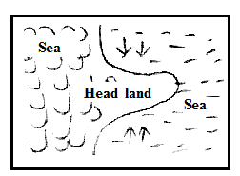

Stage II
The wave erode through abrasion and hydraulic action, forming caves on both sides of the headland

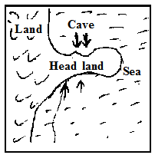

Stage III
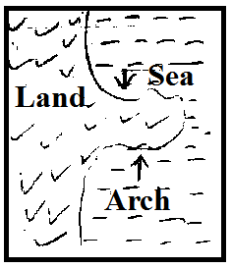
Continued wave erosion and weathering leads to the merging of caves. The merging of the caves leads to formation of an arch.

Stage IV
The roof of the arch collapses leading to isolation of part of the headland on the seaward side. The isolation headland is the stack.
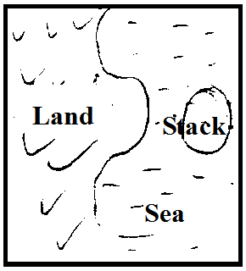
Distribution of marks
Diagram 2mks
Text 2mks (total 4mks)

(4x1= 4mks)
(iii) Explain two ways in which coral contribute to the economy of Kenya.
- Coral stones are extracted and sold as ornaments.
- Coral features attract tourists who bring foreign exchange in the country.
- Coral reefs provide breeding grounds for fish. This has promoted fishing industry
- Provide limestones; cement (Any 2 x 2 = 4mks)
(c) (i) What are tides?
- Tides are the periodic rise and fall in the level of ocean or sea or other water bodies as a result of the gravitational
attraction of the sun and the moon. (2mks)
(ii) Name the three ocean currents along the Western Coast of Africa.
- Benguela
- Guinea
- Canary (Any 3 x 1 = 3mks)
(d) State four significance of coast and coastal features (4 mks)
- Formation of fertile soils for farming
- Deep well sheltered harbours
- Features attract tourists
- Breeding regions for fish
- Corals are raw materials for cement manufacturing
- Habitats for marine life

10. a)i)What is a lake ?
- It is an extensive body of water in a depression on the earth surface (2mks)
ii) Three sources of water found in lakes
- rain water
- rivers
- underground water
- glacial melt water ( 3x 1 = 3mks)

b) Describe formation of the following lakes
i) Tarn lake
- snow accumulate in a pre-existing depression on the mountain side
- snow get compacted into ice forming a cirque glacier
- frost action / freeze thaw action enlarges the hollow
- abrasion by ice deepens the hollow
- plucking process steepens the backwall
- eventually a deep arm chair shaped depression known as corrie is formed
- when the corrie fills up with melt water is forms a corrie / tarn lake (4mks)
ii) Crater lake
- vent eruption emit acid lava to form a volcanic cone
- subsequent eruption may blow the top of the cone to form a crater at the top
- the top of the cone can also subside to form a crater at the top
- if the crater is occupied by rain water / melt water / underground water it forms a crater lake (3mks)
c) Name the lakes marked
X - Baringo
Y - Rukwa
Z – Mobutu (3mks)
d) i)Four reasons why some Rift valley lakes have fresh water
- some have surface outlets through which excess salts deposits are carried away
- some have subterranean outlets which drain the salts that accumulate in the lake bed
- the lakes have regular inflow of fresh water from rivers which dilutes the salts keeping the water fresh
- some are situated in areas of low temperature thus low rate of evaporation
- some are situated in areas of high rainfall which keeps the water freshany 4 x 1 = 4mks
ii) Three negative effects of human activities on lakes
- defforestation exposes soil which is eroded and carried out into the lake causing siltation
- defforestation destroys catchment areas which reduces water fed into the lakes by rivers
- industrialization - establishment of industries has led to disposal of waste / pollution / contamination of lakes
- establishment of industries has led to increased water use which has lowered water levels in lakes
- emergence of water weeds has chocked the lakes hindering effective exploitation of lake resources
- emergence of water weeds has hindered transport in lakes
- when the weeds rot they affect the habitat of aquatic life. (any 3 well explained 3x2= 6mks)

