FORM 3 GEO PP2MWAKICAN TERM 2 2017 MARKING SCHEME
1 a) Name two areas where gold is mined in South Africa (2mks)
-Witwatersrand
-Lydenburg
-ogendaalrus
b) State three uses of diamond (3mks)
For making jewellery
For cutting instruments
For grinding metals
As grilling bits
2 a). What is forestry? (2mks)
- Is science of planting caring and using trees/forests and their associated resources?
- The practice of managing and using trees/forests and their associated resources.
b) State three problems facing the growth of softwood forests in canada. (3mks
- Periodic forest fires destroy large areas
- The harsh, cold conditions do not allow trees to mature quickly
-The northern parts are in accessible in winter
3a) Name two oil producing countries in Middle East (2mks)
-Saudi Arabia -kuwait
-Iran - united Arabs emirates
-Iraq
b) Give three by-products obtained when crude oil is refined (3mks)
-War - bitumen/ peat/ asphalt
-Grease/ lubricants
-Resin/ petrol chemicals

4 (a) List two main types of sampling. (2 mks)
- Random
- Systematic
- Stratified 2 x 1 = 2mks

(b) Name the methods that are used to analyse statistical data. (3 mks)
- Calculation of percentages
- Measures of central tendencies
- Measures of dispersion. 3 x 1 = 3mks
N
. 5. (a) Differentiate between a reconnaissance and a working schedule? (2mks)
A reconnaissance is a short visit conducted before the actual day of study while a working schedule is a timetable of activities to be followed on the day of study
(b). Give three importance’s of a working schedule (3mks)

- To ensure proper time managent and reduce the tendency of wasting time.
- To ensure that no important area will be inadequately covered or forgotten
- It ensures that the one carrying out the study remains on course i.e does not deviate to irrevant areas.
- It is a pointer of how much time will be required for the study.

6 a) The table below shows the distribution of minerals in a country in tones. Study it carefully and answer the questions that follow.
Mineral/year | 2012 | 2013 | 2014 | 2015 | 2016
Trona | 40 | 50 | 45 | 35 | 30
Gold | 10 | 15 | 5 | 10 | 15
Oil | 8 | 13 | 15 | 8 | 10
Diamond | 4 | 10 | 8 | 6 | 5
Copper | 2 | 7 | 3 | 4 | 7

- Draw a compound bar graph to represent the data above using a scale of 1cm to rep 10 tonnes (9mks)
Calculations

Mineral/year | 2012 | C.T | 2013 | C.T | 2014 | C.T | 2015 | C.T | 2016 | C.T
Trona | 40 | 40 | 50 | 50 | 45 | 45 | 35 | 35 | 30 | 30
Gold | 10 | 50 | 15 | 65 | 5 | 50 | 10 | 45 | 15 | 45
Oil | 8 | 58 | 13 | 78 | 15 | 65 | 8 | 53 | 10 | 55
Diamond | 4 | 62 | 10 | 88 | 8 | 73 | 6 | 59 | 5 | 60
Copper | 2 | 64 | 7 | 95 | 3 | 76 | 4 | 63 | 7 | 67

NB/
Calculation of cumulative totals 2mks
Title ½ mk
Y-axis labeling ½ mk
X-axis labeling ½ mk
Correct use of vertical scale ½ mk
Correctly drawn bars 5mks
TOTAL 9MKS

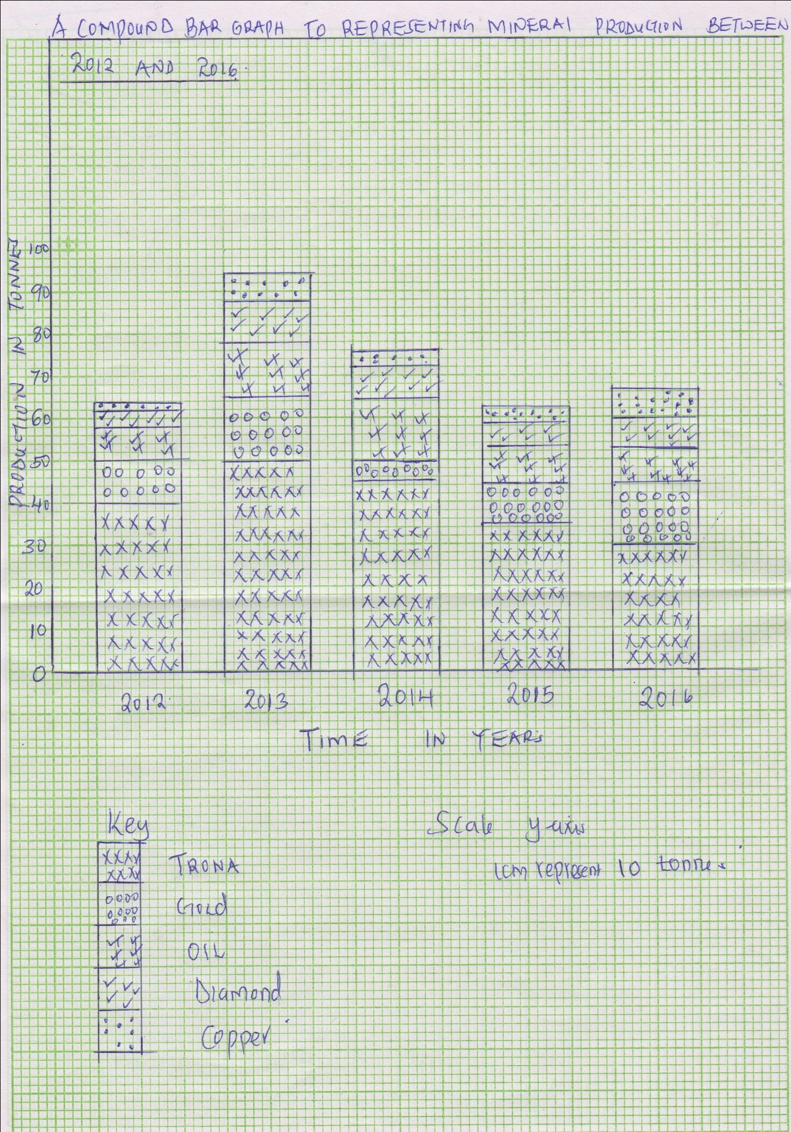

- State two advantages of using compound bar graphs to represent the data (2mks)
- Easy to construct and read
- -Easy to compare similar components
- -differences in quantities between bars in each set are easier to see than when lines are used.
- -has a greater impression of the totality of the individual contribution
b) Explain four short comings of using the shaft method of mining (8mks)
-Inhaling poisonous gases that can lead to choking and finally death
-inhaling dust that can lead to respiratory diseases
-collapsing of the mines leading to injuries and sometimes death
-the shaft may be filled with water from rain and other sources and this can lead to flooding and related diseases such as cholera, bilharzias, and malaria
c) Explain three significance of mining to the economy of South Africa (6mks)
-Mining has created employment opportunities in s. Africa like some people are employed in the diamond and gold mines hence raising their living standards
-Mining in s. Africa has led to development of transport network as some of the roads have been put up connecting diamond and gold mines
-mining has led to creation of settlements in the areas because some people concentrate in certain areas
-mining has created trading activities since Gold is major exports making the country earn a lot of income from trade.

7(a) (i) What is reafforestation?
This is the planting of trees in areas where forests have been cleared / deforestation has taken place. (2 x 1 = (2mks)
(ii) Four reasons why afforestation should be encouraged in Kenya.
      - To ensure continuous supply of wood fuel (timber) / herbal medicine / raw materials for paper making.
      - To protect water catchment areas / create micro-climates to maintain hydrological cycle.
      - To create scenic beauty.
      - To expand the habitat for wildlife / conservation of wildlife.
      - To create employment opportunities.
      - To reduce importation of forest products / foreign exchange. (4 x 1 = (4mks)
- (i) Main exotic softwood trees grown in Kenya.
        - Cypress
        - Pine
        - wattle (2 x 1 = (2mks)
(ii) Characteristics of softwood forests in Canada.
        - The trees are conical in shape.
        - Trees occur in pure stands.
        - Trees are tall.
        - Trees have straight trunks.
        - Trees bear cones.
        - The forests have no undergrowth.
        - The trees have thick barks.
        - Trees have shallow roots. (5 x 1 = (5mks)
- Problems which hinder the Kenya government effort to manage and conserve forests.
        - Rapid increase in population has led to encroachment into forest land hence destruction of trees.
        - Occurrence of forest fires which have led to destruction of large areas under forest.
        - Illegal logging / indiscriminate cutting of trees thereby reducing / depleting indigenous species.
        - Attacks by pests / diseases lead to destruction of trees.
        - Some wild animals damage trees through uprooting / trampling debarking.
        - Prolonged drought leads to drying of some trees. (3 x 2 = (6mks)
- Comparison between forestry in Kenya and Canada.
- Transportation of logs
      - In Canada, logs are transported using melt water rivers while in Kenya transportation is by road.
      - In Canada, logs are transported using melt water / Rivers while in Kenya transportation is by road. (2 x 1 = (2mks)
(ii) Felling trees
      - In Canada felling is done in winter while in Kenya it takes place throughout he year.
      - In Canada harvesting is done through clear cutting while in Kenya it is selective cutting.
      - In both countries, commercial logging is mechanized. (2 x 1 = (2mks)
(iii) Tree species
      - In both countries some tree species are similar e.g. pine.
      - In Canada softwood tree species are indigenous while in Kenya they are both exotic / indigenous. (2 x 1 = (2mks)
8 a) I) Identify the two types of photographs (2mks)
-Ground photographs
-Aerial photographs
ii) State three advantages of using photographs as a technique of recording data (3mks)
-Photographs are easy to take
-Photographs are less time consuming in that one only needs to focus on the object being photographed
-Photographs shows physical features such as the appearance of a landscape or economic activities taking place
-Photographs are easily accessible

iii) With reference to ground photographs explain the meaning of
Dead ground (2mks)
The area hidden or blocked from the lens of the camera by other objects
Fore ground (2mks)
The part of the photograph nearest to the camera
Back ground (2mks)
It’s the part of photograph furthest from the camera

b) Study the photograph below and use it to answer the questions that follow

I) Name the type of photograph shown (1mk)
- Ground general view photograph

ii) Describe the characteristics of the forest shown on the photographs (7mks)
- The trees are thin
- The trees have straight stems
- The forest has tall trees
- The trees are conical shaped
- The trees are composed of the same species
- The trees are almost of the same height
- The trees are close to each other
- The undergrowth is composed of crops

c) Name the kind of farming activity in the photograph (1mk)
-Agro forestry

d) Name the type of trees shown in the photograph (1mk)
-cypress
e) Compare tree harvesting in Kenya and Canada (4mks)
-In Kenya there is less mechanization while in Canada lumbering is more mechanized.
-In Kenya logging takes place throughout the year while in Canada it is done in winter
-In Kenya cutting of trees is selective while in Canada harvesting is done through clear cutting.

9 a) Define the term mineral (2mks)
-A mineral is a naturally crystalline inorganic substance with a definite chemical composition and physical properties
b) I) Name two areas in South Africa where diamond is mined (2mks)
Kimberly
-Orange free state
-pretoria
ii) Give four ways in which minerals occur (4mks)
-veins and lodes
-beds and seams
weathering products
Alluvial deposits
c) I) Explain Three negative effects of mining on the environment (6mks)
-Waste of agricultural land- mines and their associated tip-heaps may occupy land otherwise suitable for farming
-Waste of industrial land – where derelict land is in or near towns it may occupy industrial land which could be used for industries
-Open cast mines may be filled with water and create deep pools thus accidents are likely to occur. Such pools are also breeding grounds for mosquitoes and other water borne diseases
-Pollution- during mining toxic gases may be emitted from the mimes leading to air pollution
ii) Identify any two methods of mining (2mks)
-Open cast mining
-Underground mining
-Alluvial mining/ placer method
Iii) Name a port through which minerals in East Africa are exported (1mk)
Mombasa; Dar-es-salam
d) Explain four ways in which soda ash contributes to the economy of Kenya (8mks)
-it has led to the growth of magadi township
-it has led to the development of social amenities such as hospitals, schools, social clubs, electricity that have benefited the local maasai community
-it has stimulated the development of infrastructure. For example the 110km tarmac road and railway line from konza to magadi in an otherwise remote region.
-The company provides employment to many Kenyans improving their living standards
-Through exports of soda ash the country earns a substantial amount of foreign exchange. (4x2=8mks)

10 . a) (i) List three types of fieldwork. (3mks
• Field excursions
• Field study
• Field research
ii) State three importances of field work. (3mks)
• Breaks classrooms monotony.
• Make study of geography real.
• Helps learner to acquire skills.
• Encourages students to appreciate the environment.
• Enables learners to get first hand information from the field.
• Improves visual memory through observation.
• Enhances what has been learnt in class.
b). You are supposed to carry out a field study on the uses of vegetation in the area around your school.
(i) State three reasons why it would be necessary to visit the area before the day of the study. (3mks)
• To design appropriate research method.
• To prepare the working schedule.
• To be able to identify relevant equipment for data collection.
• To identify suitable areas for study/ to familiarize with people who will provide information
• To seek permission from owners of the land.

(ii) Givethree uses of vegetation you are likely to identify during the study (3mks)
Use as fodder.
• Use for providing fruits/roots/vegetables as food.
• Providing wood fuel.
• Controlling soil erosion
• Use of ornaments/beauty, aesthetics.

(c) Give three reasons Why it is necessary to sample part of the forest for the study? (3mks)
• In order to do a detailed study
• To reduce cost of study
• To save time
• The whole forest is too large to cover within a day.
• It would be less boring to study a small area.
• Some parts may inaccessible
• To reduce bias

d)(i) State three follow up activities you would be involved in (3mks)
Analyzing data
• Writing report
• Giving relevant advice to the stake holders
• Discussing the findings
• Displaying photography, sketches from the study area.

- State two ways in which information collected during the field study would be useful to the local community. 2mks
• The information on rainfall can be used by farmers to plan their calendar of activities.
• The information on humidity can be used in improving storage of produce e.g. Cereals.
• The findings can be used to plan suitable time for drying farm produce.

(e) Formulate five suitable objectives for field study on a visit to a forest. (5mks)
• To know the type of forest.
• To determine the factors which have favoured growth of forest?
• To know the type of trees found in the forest.
• To find out the problems faced by the forest.
• To find out the economic significance of the forest.
NB: must start wit to followed by a verb.
Accept any relevant objective.

