MATHEMATHEMATICS FORM 3
MARKING SCHEME PAPER 2
No.
1. | a = 2  r = 5  L = 1250  S_{n} = a$\left(\frac{r^{n}-1}{r-1}\right)$  T_{n} = a$r^{n-1}$  1250 = 2 x $5^{n-1}$  125 x 10 = 2 x $5^{n-1}$  $5^{3}$ x $5^{1}$ = $5^{n-1}$  $5^{4}$ = $5^{n-1}$  ⇒ 4 = n – 1  5 = n  S₅ = 2 $\left(\frac{5^{5}-1}{5-1}\right)$  = 2$\left(\frac{3125-1}{4}\right)$  = 2 x $\frac{3124}{4}$  = 1562 | M1  A1
2 | $$P=KQR^{2}$$  $$P=K\left(2Q\right)({\left(\frac{1}{2}R\right)}^{2}$$  $$P=2×\frac{1}{4} P$$  $$P=\frac{1}{2} P$$  P decrease by 50% | M1  M1  A1
3. | QU x RU = SU x TU  SU = $\frac{QU x RU}{TU}$  = $\frac{11 x 6 }{4}$  = 16.5cm | M1  M1  A1
4. | Det = 6 + 25 = 31  M⁻¹ = $\frac{1}{31}\left[\begin{matrix}2 & 5 \\ -5 & 3\end{matrix}\right]$  $\left[\begin{matrix}X \\ Y\end{matrix}\right]$ = $\frac{1}{31}\left[\begin{matrix}2 & 5 \\ -5 & 3\end{matrix}\right]\left[\begin{matrix}-9 \\ 16\end{matrix}\right]$ = $\frac{1}{31}\left[\begin{matrix}62 \\ 93\end{matrix}\right]$  $\left[\begin{matrix}X \\ Y\end{matrix}\right]$ = $\left[\begin{matrix}2 \\ 3\end{matrix}\right]$ | B1  M1  M1  A1
5. | (3X –Y)(X-Y)  9X² – Y² = (3X –Y)(3X+Y)  $$\frac{(3X –Y)(X-Y)}{\left(3X-Y\right)(3X+Y)}$$  $$\frac{X-Y}{3X+Y}$$ | M1  M1  A1
6. | h = $\frac{5\sqrt{3}}{2Sin60}$ = 5cm  Arc length = $\frac{120}{360}$ x 2 x 3.142 x5  = 10.5cm
7. | $\frac{2\sqrt{3}}{\left(\sqrt{3}+\sqrt{2}\right)}$ $\frac{(\sqrt{3}-\sqrt{2)}}{(\sqrt{3}-\sqrt{2)}}$  = $\frac{2\sqrt{3}x\sqrt{3}-2\sqrt{3}x\sqrt{2}}{{\left(\sqrt{3}\right)}^{2}-{\left(\sqrt{2}\right)}^{2}}$  = $\frac{2x3-2\sqrt{6}}{3-2}$  = $\frac{6-2\sqrt{6}}{1}$  = 6 - 2$\sqrt{6}$ | M1  M1  A1
8. | Mean – of six  $\frac{n}{2}$, $\frac{n}{2}+1$  32, x  Median 36 = $\frac{32+x}{2}$  72 = 32 + x  72 - 32 = x  40 = x  Mean mark  = 24 + 28 + 32 + 40 + 48 + 50  6  x = 37 | M1  M1  A1
 |  | 3 Marks
9. | Absolute error  = $\frac{Max-Working+Working-Min}{2}$  = $\frac{20.05x 25.05-19.95 x 24.95}{2}$  = $\frac{4.5}{2}$  2.25  % error = $\frac{Absolute}{Actual}$ x 100  = $\frac{2.25}{20.0 x 25.0}$ x 100  = 0.45% | M1
10. | $\frac{9.2}{Sin C}$ = $\frac{7.9}{Sin 48}$  Sin C = $\frac{9.2 Sin 48}{7.9}$  Sin C = 0.8654  C = 59.93  = 59.9 A1 | M1
11. | $$\frac{5X+75}{9}=2X-9$$  $$5X+75=18X-81$$  $$13X=156$$  $$X=12$$ | M1  M1  A1
12. | 2x – 3y = -6  -3y = -2x – 6  y = $\frac{2}{3}$x + 2  Gradient = $\frac{2}{3}$  Tan x = $\frac{2}{3}$ = 0.6667  x = 33.7⁰  θ = 180 – 33.7⁰  = 146.3⁰ | B1  B1  B1
13. | $\sqrt{q}$ = r$\sqrt{1-as^{2}}$  q = r² (1 – as²)  q = r² – r²as²  r²as² = r² – q  = $\frac{r^{2}-q}{r^{2}-a}$  S = ± $\sqrt{\frac{r^{2}- q}{r^{2}a}}$ | M1  M1  A1
14. | 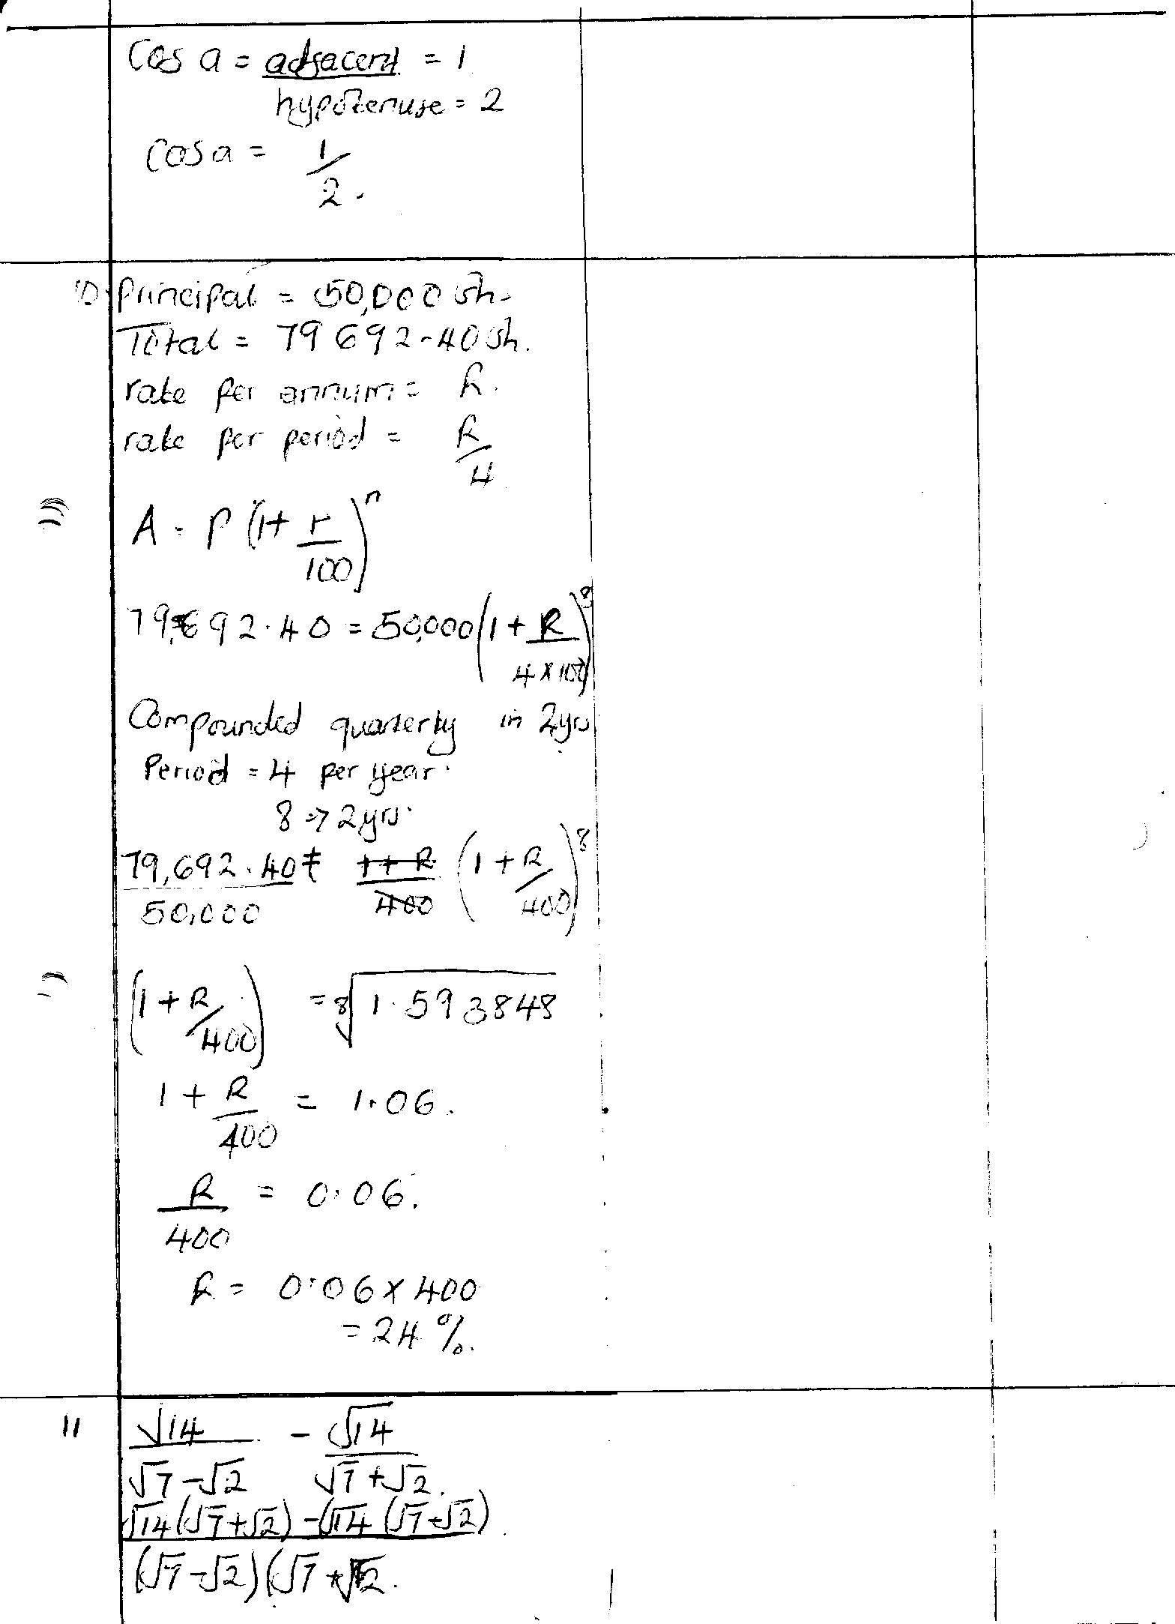  14 | B1  B1  B1
 | 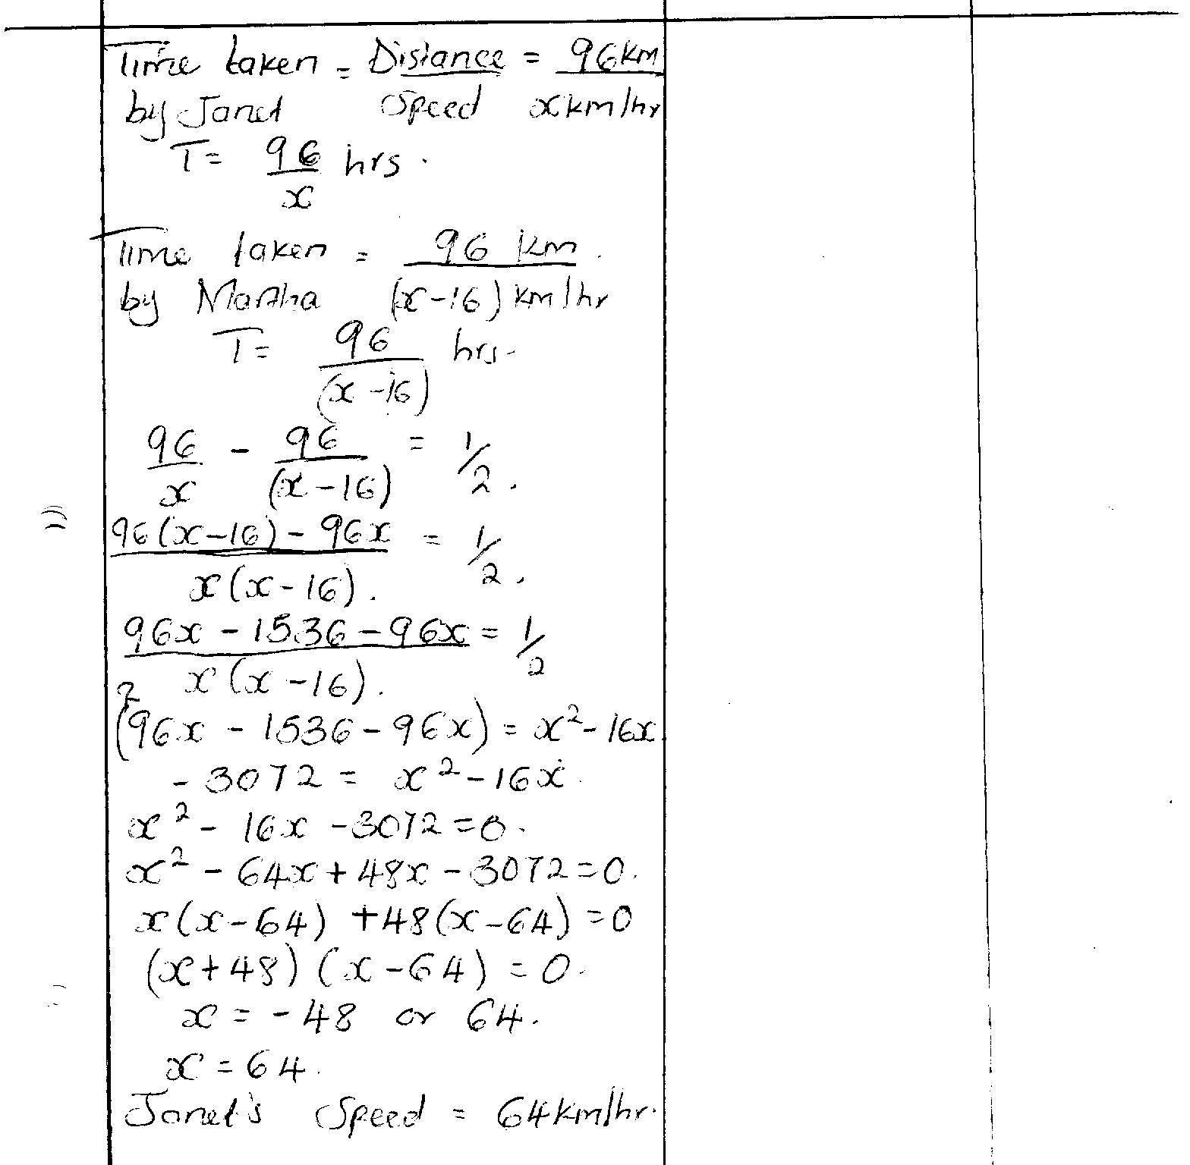
16. | Ext.angle = $\frac{360}{5}$  ∠BTC = 180 – (72 + 72)  = 36⁰ | M1  A1
SECTION 2
17. | (a) Modal : 16 – 200  (b)  Mass (kg) f Mid pts (x) Fx Cf  1-5 2 3 6 2  6-10 3 8 24 5  11-15 6 13 78 11  16-20 8 18 144 19  21-25 3 23 69 22  26-30 2 28 56 24  31-35 1 33 33 25  Σf=25 Σfx= 410  Mean = $\frac{410}{25}$= 16.4  - Cf2,5,11,19,22,24,25  13th – Class 16 – 20  Median = 15.5 + $\frac{2}{8}$ x 5  = 16.75 | B1  M1  M1  A1  M1  A1  B1  B1  M1  A1 | Mid points  fx  Σfx  May be implied  Median class
 |  | 10
18.  6⁰  θ  A  B  153.2  Tower  h 21.02  Tan θ = $\frac{21.02}{153.2}$  θ = Tan⁻¹ 0.1372  = = 7.812⁰ or (7⁰,49’)  6⁰  6⁰  A  B  200  h Tower  h (tower) = 200 tan6⁰  = 200 x 0.1051  = 21.02 | (a)  B  A  C  D  200  200  50⁰  310⁰  65⁰  65⁰  Bearing 180⁰ + 65⁰ = 245⁰  $\frac{BC}{Sin 50}$ = $\frac{200}{Sin {65}^{0}}$  BC = $\frac{200 X 0.766}{0.9063}$  = 169.0m  (b) $\frac{BD}{200}$ = Sin50⁰  BD = 200 x 0.766  = 153.2 | B1  B1  M1  A1  M1  A1  M1  A1  M1  A1 | Sketch
 |  | 10
19. | (a) Distance covered by car = 500km  Time = $\frac{500}{100}$ hrs  = 5 hours  Arrival time ⇒ 9.30 + 5 hours  = 2.30 p.m  (b) Lorry took ⇒ 6 hrs 15 mins  Lorry’s speed = $\frac{250}{6.25}$ km/hr  40 km/hr  Relative speed ⇒ 100 – 40  = 60 km/hr  (c) Lorry’s Distance  ⇒ (12.5 – 8.15) x 40km/hr  = 160km  Car’s distance  = (12.5 – 9.30) x 100km/h  = 275km  Distance btn = 160 – 25  = 135km | M1  A1  M1  A1  M1  A1  B1  B1  M1  A1 | Accept 1430h
20. | . a) T6 = p + 5c  T5 = p + 4d B1  p + 4d = p + 5c M1  4d = 5c  d = 5/4c A1  b) p + 3d - (p + 3c) = 11/2 M1  3d - 3c = 11/2  15/4c - 3c = 11/2  3/4c = 3/2 = c = 2 A1  d = 21/2 B1 accept 5/2  c) S5 = 6/2 (24 + 5 x 2) M1  S5 = 1/2n(2p + 10) = 2.5(2p + 10)  = 5p + 25  (6p + 30) - (5p + 25) = 10 M1  p + 5 = 10  p = 5 A1
21.

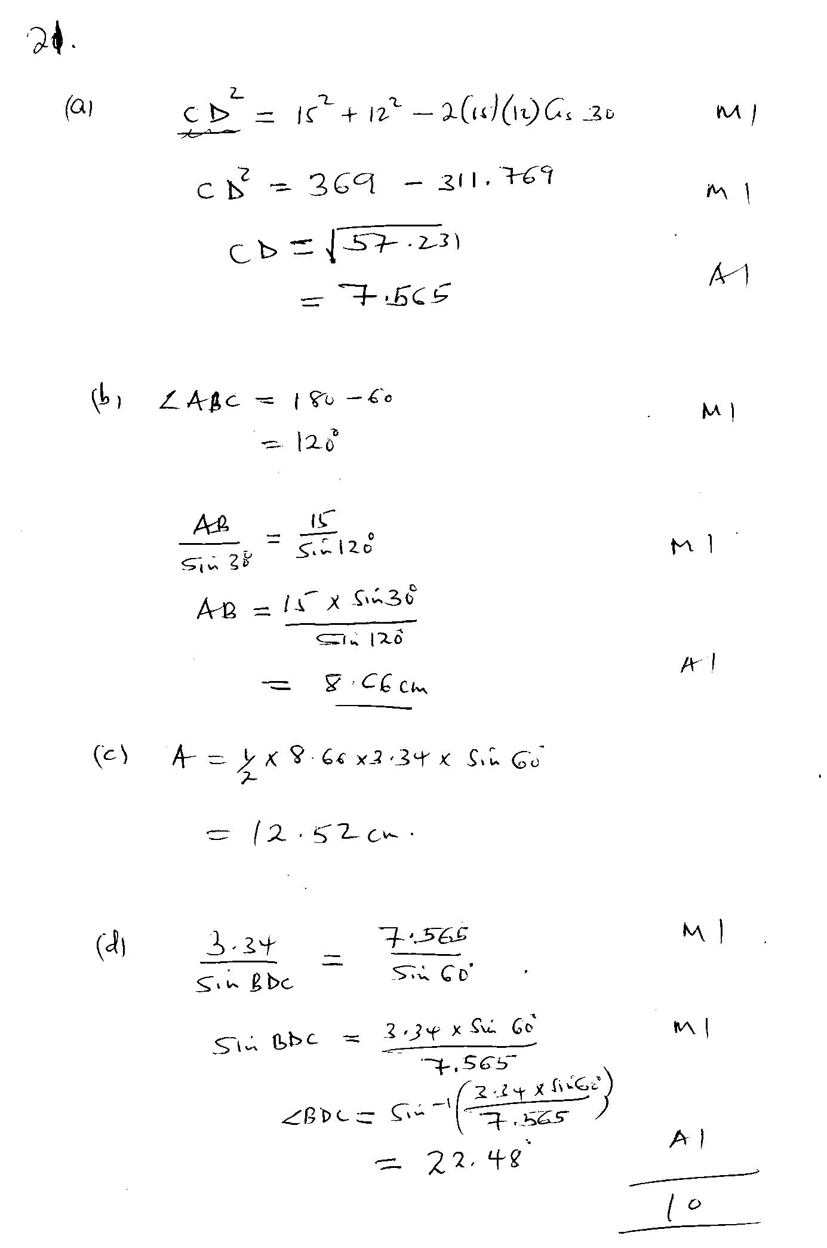

22. | (a) = 38000 + 14000 + 8500 + 3300  = 62800  $\frac{62800 x 12}{20}$  K£ 37680 p.a.  (b) 1st K£ 600 6000 x 2 = 12000  Next £6000 6000 x 3 = 18000  Next £6000 6000 x4 = 24000  Next £6000 6000 x 5 = 30000  Next £6000 6000 x 6 = 36000  Next £6000 6000 x 7 = 42000  Rem. £ 1680 1680 x 8 = 13440  Tax due p.a. = Sh. 175440  Less relief Sh. 18000  Tax paid = Sh. 157440  (c) (i) Tax paid per month = $\frac{157440}{12}$  = 13,120  Total deductions  = 13120 + 320 + 1000 + 2000 + 500  = 23940  (ii) Net salary = 62800  - 23900  38,900 | M1  A1  M1  M1  M1  A1  M1  A1 | Taxable income in Sh/m  (can be implied in accuracy mark)  Values in just 4 slabs  Subtracting relief  Addition  Ans
23. | Let the No. of goats be x  Let the No. of bulls be y  $\frac{2000}{1000}x$ + $\frac{15000}{1000}y$ = $\frac{190000}{1000}$  2x + 15y = 190………(i)  2(2000x) + (y – 3)15000 = 190,000-5000  4000x + 15000y – 45600 = 185,000  $\frac{4000}{1000}x$+ $\frac{15000}{100}y$ = $\frac{230,000}{100}$  4x + 15y = 230 ………………………….(ii)  4x + 15y = 230 (Elimination substitution  2x + 15y = 190  2x = 40  x = 20  2x + 15y = 190 but x = 20  2(20) + 15y = 190  15y = 190 – 40  15y = 150  15 15  y = 10  ∴x = 20 goats and y = 10 bulls  (b) Profit per goat $\frac{25}{100}$ x 2000 = 500  Profit per bull $\frac{30}{100}$ x 15000 = 4,500  Goat 20 x 500 = 10,000  Bulls 10 x 4500 = 45,000  Total profit = 10,000 + 45,000  = 55,000/= | M1  M1  A1  M1  M1  M1  M1  M1  A1
24. | (a) y = 2x² – 3x – 5  x -2 -1 0 1 2 3  2x² 8 2 0 2 8 18  -3x 6 3 0 -3 -6 -9  -5 -5 -5 -5 -5 -5 -5  y 9 0 -5 -6 -3 4  (b) (i) Roots = -1 and 2.5  (ii) 2x² – x – 3 = 0  2x² – 3x – 5 = y  -2x – 2 = y  Line = y = -2x – 2  Roots x = -1 and 1.5 ± 0.1 | B2  S1  P1  C1  B1  M1  A1  B1  B1 | Table  Scale  Plotting  Smooth curve  Line drawn  For both
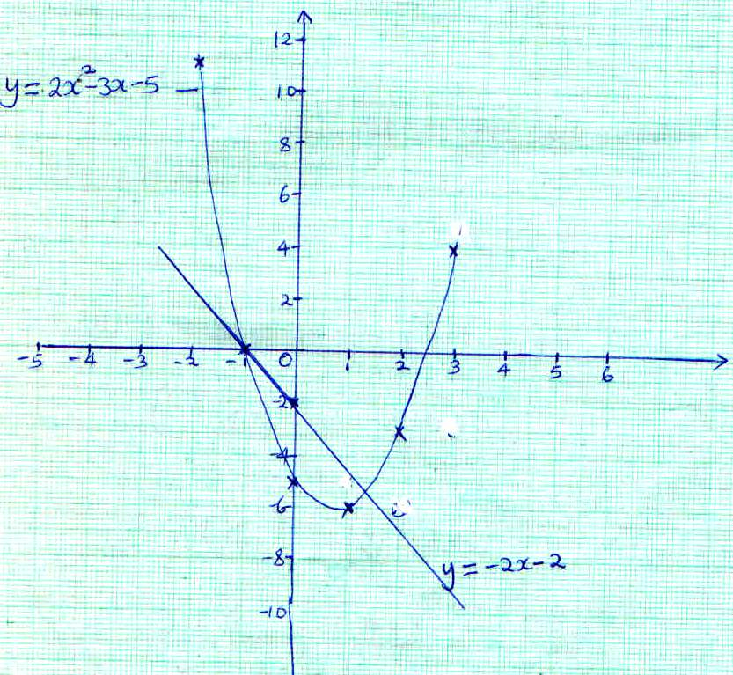
X
Y

