MWAKICAN JOINT EXAM TEAM (MJET)
FORM 3 JOINT EXAMINATION – 2017 TERM 2
232/1
MARKING SCHEME

SECTION A:25MKS – Answer all the questions in this section

- Figure 1 shows a measuring cylinder containing some water
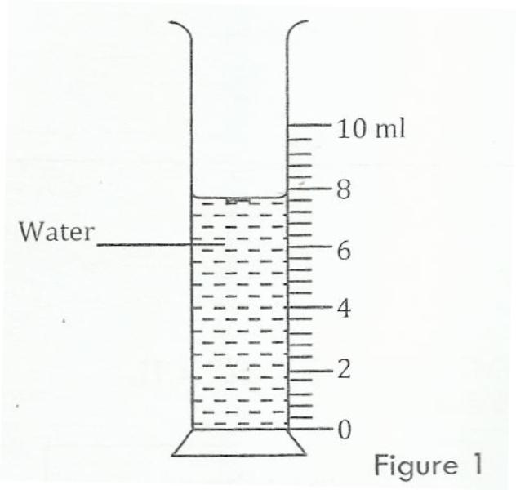

Determine the reading on the measuring cylinder, after three drops of water each of volume 0.6cm³ are added. (2 marks)
$Initial reading = 7.6ml1$
$Final reading 7.6cm3 + (0.6×3)$
$= 9.4cm3$
- Figure below shows parts A, B and C of a glass tube.
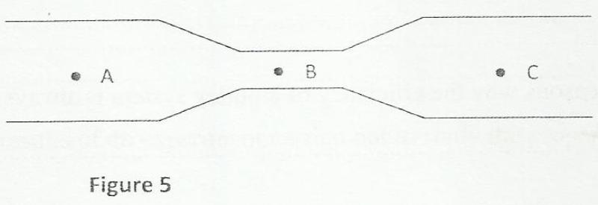

State with a reason the part of the tube in which the pressure will be lowest when air is blown through
the tube from A towards C. (2 marks)

- B
- Air moves with the highest velocity hence lowest pressure
- A uniform rod of length 4m and mass 4 kg is pivoted at 3.6m mark. The rod is held horizontally with a vertical rope at 4m mark as shown below
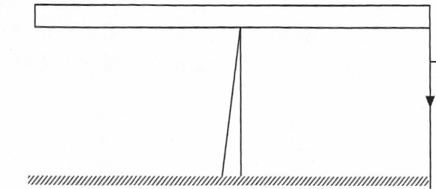
3.6m
4m
rope
T

Calculate tension T in the rope (Take g=10N/kg) (3mks)

$W×1.6=T ×0.4 m$
$40×1.6=0.4 T$
$T=\frac{64}{0.4}$
$T=160N$

- State one factor that determines the height to which water rises in a capillary tube in a given place. (1mark)
- Atmospheric pressure
- Diameter of the capillary tube
- The figure below shows two aluminum metal rods A and B of equal length held over a Bunsen flame.

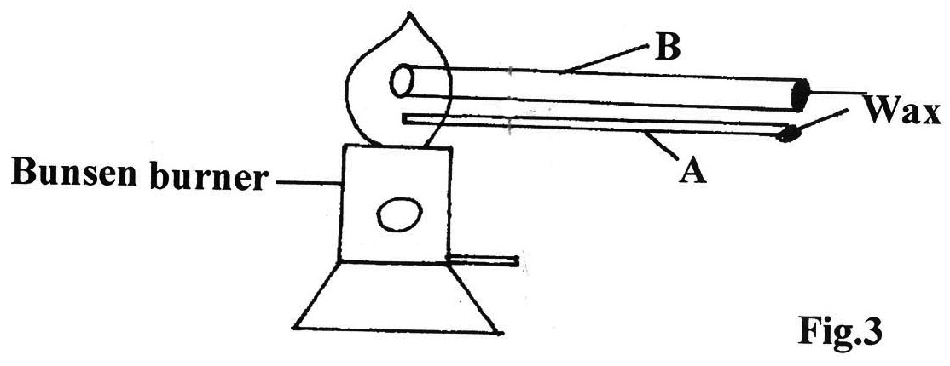

If it is observed that the wax in rod B melts faster. Give a reason for this observation. (2mks)
- B has a wider cross sectional area
- Rate of conduction is higher in B than A
- Draw a vernier callipers whose reading is 0.06cm. (1mk)
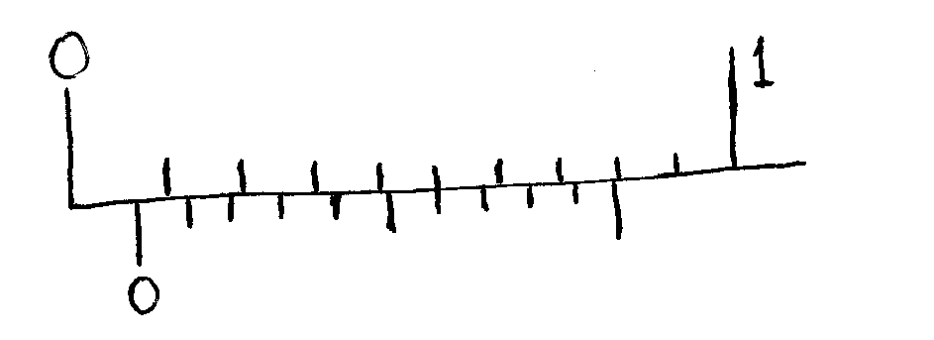

- The figure below shows a block of ice placed inside a beaker.

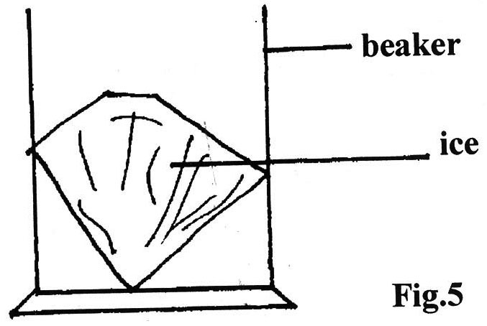

State and explain the effect on stability of a beaker when the ice has melted. (2mks)
- Stability increases
- Position of C.O.G is lowered as the liquid melts
- A student pulls a block of wood of mass 4kg along a horizontal surface by applying a constant force of 15N. Calculate the co- efficient of friction between the surface and the block.. (3mks)
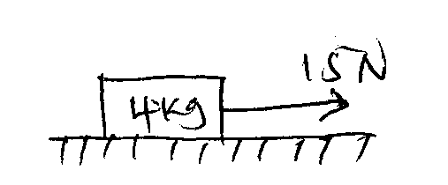
$μ=\frac{F}{R}$
$μ=\frac{15N}{40N}$
$μ=0.375$

- Two identical blocks of mass $m kg$ each travel towards each other on a frictionless air track at speeds of 60cm/s and 40cm /s. They stick together on impact.

40cm/s
60cm/s

What is the common velocity of the masses after impact? (3 mks)
$$m_{1 }u_{1}+m_{2 }u_{2}=\left(m_{1 }u_{2}\right)V$$
$$\left(60cm/s×m\right)-\left(40cm/s ×m\right)=2mV$$
$$60m-40m=2mV$$
$$20m=2mV$$
$$2V=20$$
$$V=10cm/s$$

- In a vacuum flask the walls enclosing the vacuum are silvered on the inside. State the reason for this. (1mk)
- To minimize heat loss through radiation
- Explain why brakes fail in a hydraulic braking system when air gets into the system. (2mks)
- Air is compressible hence the pressure transmission is reduced
- The forces acting on a trolley are as shown below.
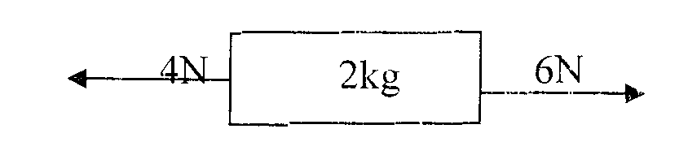
Find the acceleration of the trolley. (3 mks)

$Net force = 6-4 = 2N$
$2N =2kg×a$
$a=\frac{2}{2} = 1m/s^{2}$

SECTION B: 55Mks- Answer all the questions in this section
- In an experiment to estimate the size of an oil molecule, an oil drop of diameter 0.05cm spreads over water to form a circular patch whose diameter is 15cm.
(a) Explain why the oil spreads over water. (1mk)
$It acts as an impurity and breaks the surface tension of water$
(b) Determine:

(i) Volume of the drop. (3mks)
$volume of drop=\frac{4}{3}πr^{3}$
$=\frac{4}{3}×3.142×({0.025)}^{3}=6.55×{10}^{-5}{cm}^{3}$

(ii) Area of the patch (3mks)
$Area=πr^{2}$
$3.142×({7.5cm)}^{2}$
$=1.767×{10}^{2}{cm}^{2}$
(iii) Size of the oil molecule (3mks)
$T=\frac{volume of drop}{area of patch}=\frac{6.55×{10}^{-5}}{1.767{×10}^{2}}$
$T=3.706×{10}^{-7}cm$

(c) State two assumption made in b (iii) above (2mks)
- The oil drop is spherical
- The patch is a mono layer
- Brownian motion of smoke particles can be studied by using the apparatus shown below. To observe the motion, some smoke is closed in the smoke cell and then observed through the Microscope.

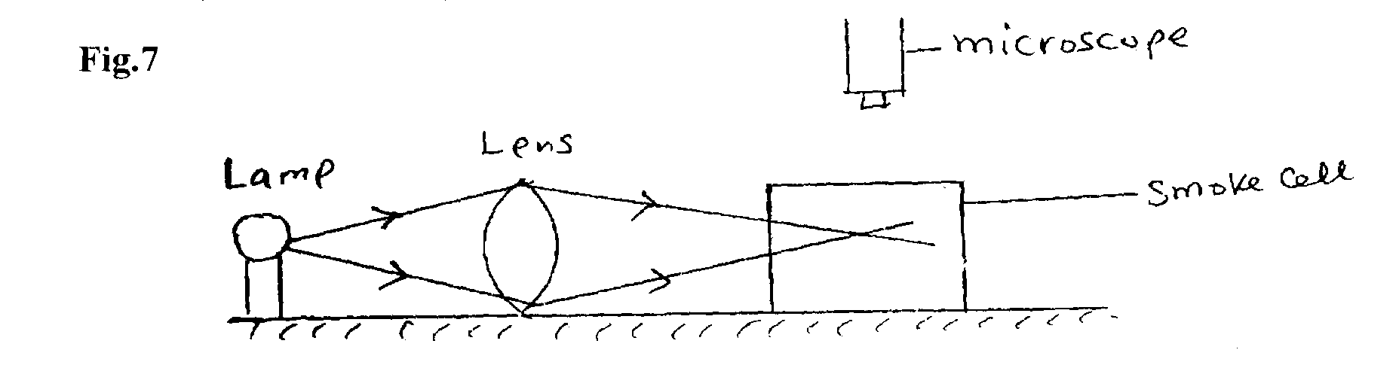

(a) Explain the role of the smoke particles, lens and microscope in the experiment.
(i) Smoke particles. (1 mk)
- To show random motion of air particles
(ii) Lens (1 mk)
- To focus the light into the smoke cell
(iii) Microscope (lmk)
- To view the motion of the smoke particles (magnify the smoke particles)
(b) State and explain the nature of the observed motion of the smoke particles. (2mks)
- Random motion
- The smoke particles move in random motion because they are continually hit by the invisible air particles.
(c) State what will be observed about the motion of the smoke particles if the temperature surrounding the smoke cell is raised slightly. (1 mk)
- The motion becomes faster
- (a) The figure below shows an inclined plane, a trolley of mass 30kg is pulled up a slope by a force of
100N, parallel to the slope. The trolley moves so that the centre of mass C travels from points A to B.
•
A
C
100N
B
10m
15º

Determine
- Mechanical advantage of the trolley (2 mks)

$$MA=\frac{L}{E}$$
$$\frac{300N}{100N}=3$$

(ii) The work done by the force in moving the trolley from A to B. (2 mks)

$$work done=100N×distance$$
$$\sin{15=\frac{10}{d}}$$
$$d=\frac{10}{\sin{15 }}=38.64$$
$$work done=10N×38.64$$
$$W=3,864J$$
(iii) The work done against gravity (2 mks)
$$W.d=mgh$$
$$=30kg×10×10$$
$$=3000J$$
(iv)The work done in overcoming the frictional force. (1mk)
$$W.d=3864-3000$$
$$=864J$$
(iv) The efficiency of the system. (3 mks)
$$Eff=\frac{3000J}{3864}×100\%=77.64\%$$

(b) The figure shows a simple pendulum of mass 400g oscillating between Y and Z.

Support
Thin cord
Pendulum bob
y
x
z
Ground

State the type of energy the body possesses at
(i) Position y (1 Mark)
- Potential
(ii) Position x (1 Mark)
- Kinetic
(a) Differentiate between distance and displacement (1 mk)
- Distance is the length of a path covered by a body while displacement is the length of a path covered by a body in a specified direction.

(b) The figure below shows dots which were made by a ticker tape-timer attached to a trolley. The trolley was
moving in the direction shown.

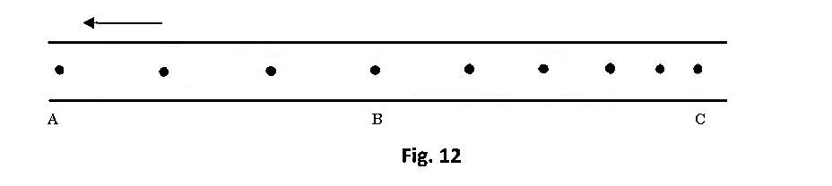

12cm 7.2cm
If the frequency used was 50 Hz, distance A$B=12cm and BC=7.2cm,$ determine
i) The velocities between AB and BC (2marks)

$$VAB=\frac{12cm}{3×0.02}$$
$$VAB=200cm /s$$
$$VBC=\frac{7.2}{5×0.02}=72cm /s$$
ii) the acceleration of the trolley. (2marks)
$$a=\frac{72cm /s -200cm/s}{7×0.02}$$
$$a=\frac{-128}{0.14}$$
$$a=-914.29{cm/s}^{2} (-9.14 m{/s}^{2})$$
(b) An object is released to fall vertically from height of 100m. At the same time another object is projected vertically upward with velocity of 40m/s.
(i) Calculate the time taken before the objects meet (3 marks)

$free fall$
$$100-x=\frac{1}{2}×10×t^{2}$$
$or 100-x=\frac{1}{2}{gt}^{2}$
100-x
$$vertical projection$$
$$x=40t-\frac{1}{2}×10×t^{2}$$
$$or x=40t-\frac{1}{2}{gt}^{2}$$
$x=40t-\left(100-x\right)$
x
$$40t=100$$
$$t=2.5seconds$$
(ii) At what height do the objects meet? (2marks)
$$h=\frac{1}{2}10×{2.5}^{2}$$
$$h=31.25m$$
$$at 68.75m from the ground$$

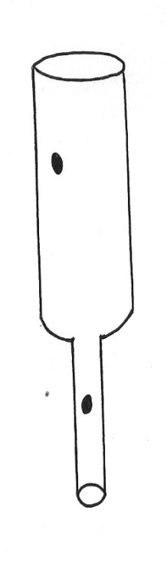
- (c) The figure below shows parts A and B of a glass tube

B
A

(i) State the part of the tube in which the pressure will be lowest when air is blown through the
tube to from A to B (1mk)
B
(ii) Compare the velocity of air at A and at B (2mks)
V_{B} is higher tha V_{A}
(iii) What is the relationship between the velocity of the air and its pressure at any point along
the tube AB (2mks)
- When velocity increases, pressure decreases and vice versa.
(d) Water flows a horizontal pipe of cross-section area 35cm² and constriction of cross section
area 5cm². If the speed of water at the constriction is 2m/s, calculate
(i) Rate of flow (2 mks)
$$Rate of flow=Area ×Velocity$$
$$R=200 cm/s ×{5cm}^{2}$$
$$=10{00cm}^{3}/s$$
(ii) The speed in the wide section (2mks)
$$A_{1}V_{1}=A_{2}V_{2}$$
$$35×V_{1}=5×2m/s$$
$$V_{1}=\frac{5×2}{35}=0.285m/s$$
- (a) State Hooke’s law (1mk)
- For a helical spring or any other elastic material, then extension is directly proportional to the force applied, provided elastic limit is not exceeded

(b) The graph provided is of force (y-axis) against extension.

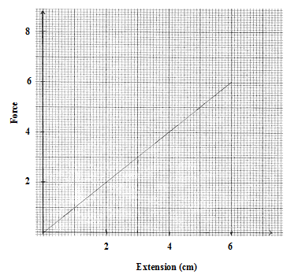

(i) From the graph determine the work done in stretching spring by 3cm (3mks)

$$W.d=\frac{1}{2}×Fxe$$
$$=\frac{1}{2}×3N×0.03m$$
$$W.d=0.045J$$

(ii) Use the graph to determine the spring constant. Give your answer in SI units (3 mks)

$$K=gradient$$
$$K=\frac{3-0}{3-0}$$
$K=\frac{3}{3}$=1$N/cm$
$$=100N/m$$

