MWAKICAN FORM THREE COMMON EXAMINATION
PHYSICS PRACTICAL, 232/3
MARKING SCHEME
QUESTION ONE
- h= 6.0cm
- Table
X cm | h cm | X² cm² | X²/h cm
20 | 6.0 | 400 | 66.67
25 | 8.0 | 625 | 78.13
30 | 11.0 | 900 | 81.82
35 | 14.0 | 1225 | 87.50
40 | 19.0 | 1600 | 84.21
45 | 23.0 | 2025 | 88.05

Use students own values award
-3 marks for correct values of h,
-One mark for x²
-and one mark for x²/h
Award ½ a mark for every entry made within range shown in the table.
d) Graph
- Axes-٧1mk (both axes labeled with units and quantity.
- Scale-٧1mk (simple and uniform)
- Plotting -٧2mks (1/2 mark for max of 4 values)
- Best line of fit-٧1mk
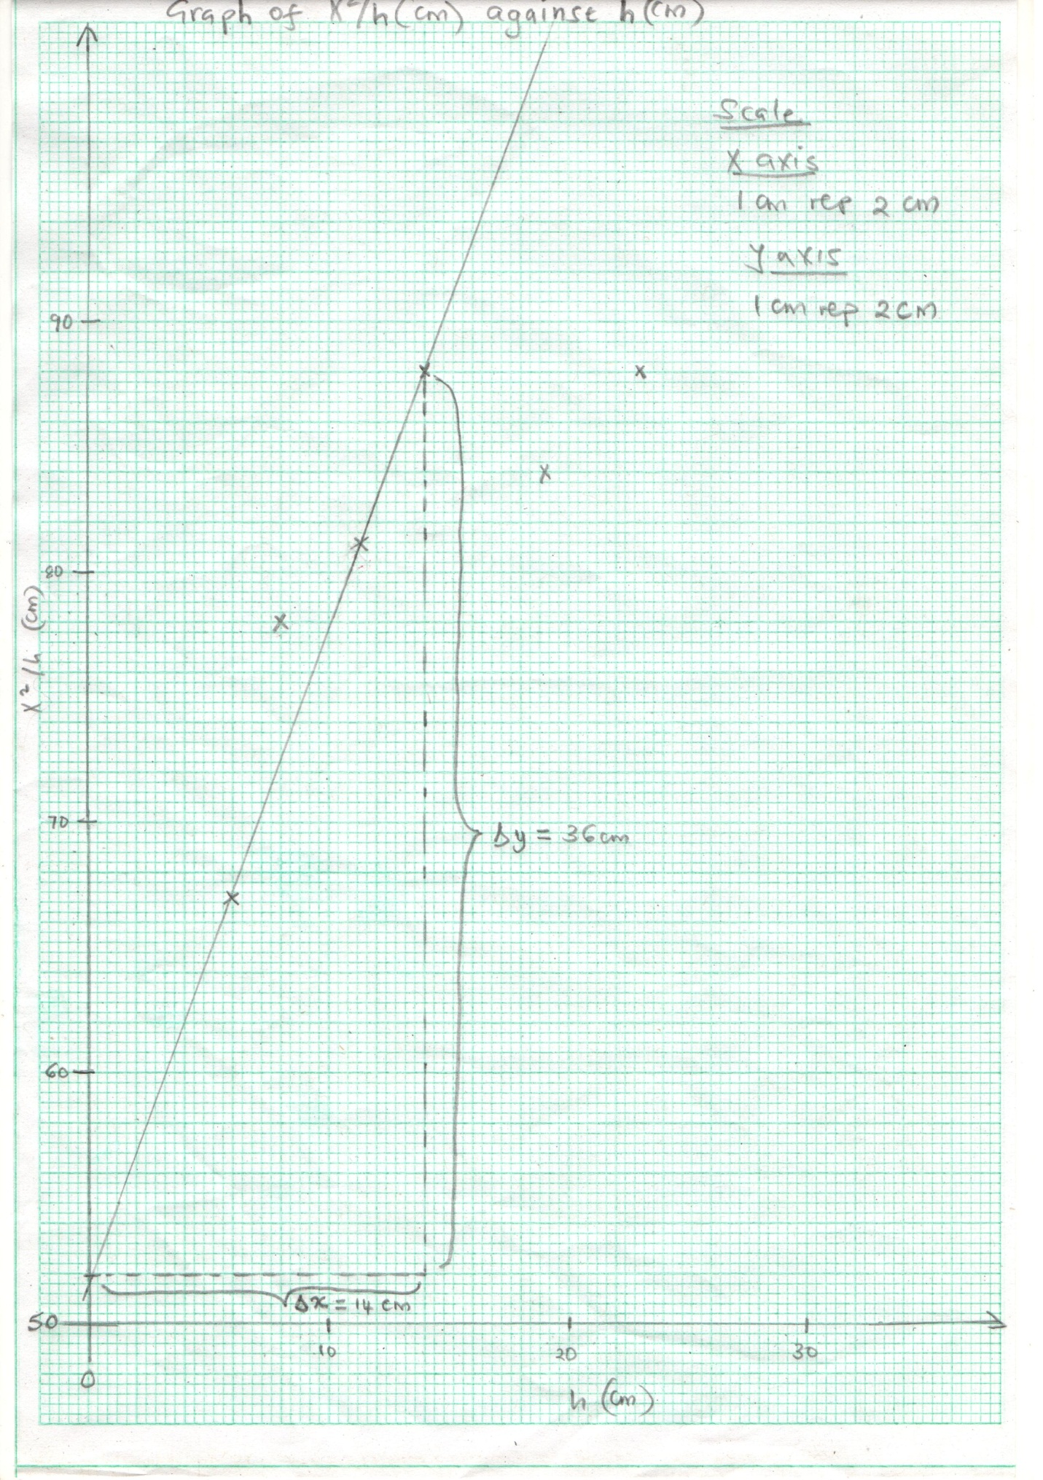
e) Should be computed from the graph
88-52 = 2.571 (with no units)
14-0
- ٧1mk for showing on the graph
- ٧1mk for substitution and accuracy
- Read from students graph X ٧(1mk)
=52 cm (the y-intercept)
- Time for 20 oscillations (1mk)
= 30.0 sec
- Period (T) = time for 20 oscillations
20
= 30/20
= 1.5 sec ٧ (1mk)
(ii) P= T²g = 0.57m ٧ (4mk)
4π
(2mks for correct substitution and arithmetic)

QUESTION TWO
- G=50.0 cm ٧ (1mk)
- Check students table and mark accordingly (5mks)
m (g) | d₁ (cm) | d₂ (cm) | d₁/d₂ | md2(g/cm)
20 | 8.0 | 41.0 | 0.1951 | 820
40 | 13.5 | 35.5 | 0.3803 | 1420
50 | 15.5 | 33.5 | 0.4627 | 1675
60 | 17.0 | 32.0 | 0.5313 | 1920
80 | 20.5 | 28.5 | 0.7193 | 2280
100 | 23.5 | 25.5 | 0.9257 | 2550
Each value of d₁ and d₂ (_{1/2} mark)max 2mks each
- Straight line graph ٧(5mks)

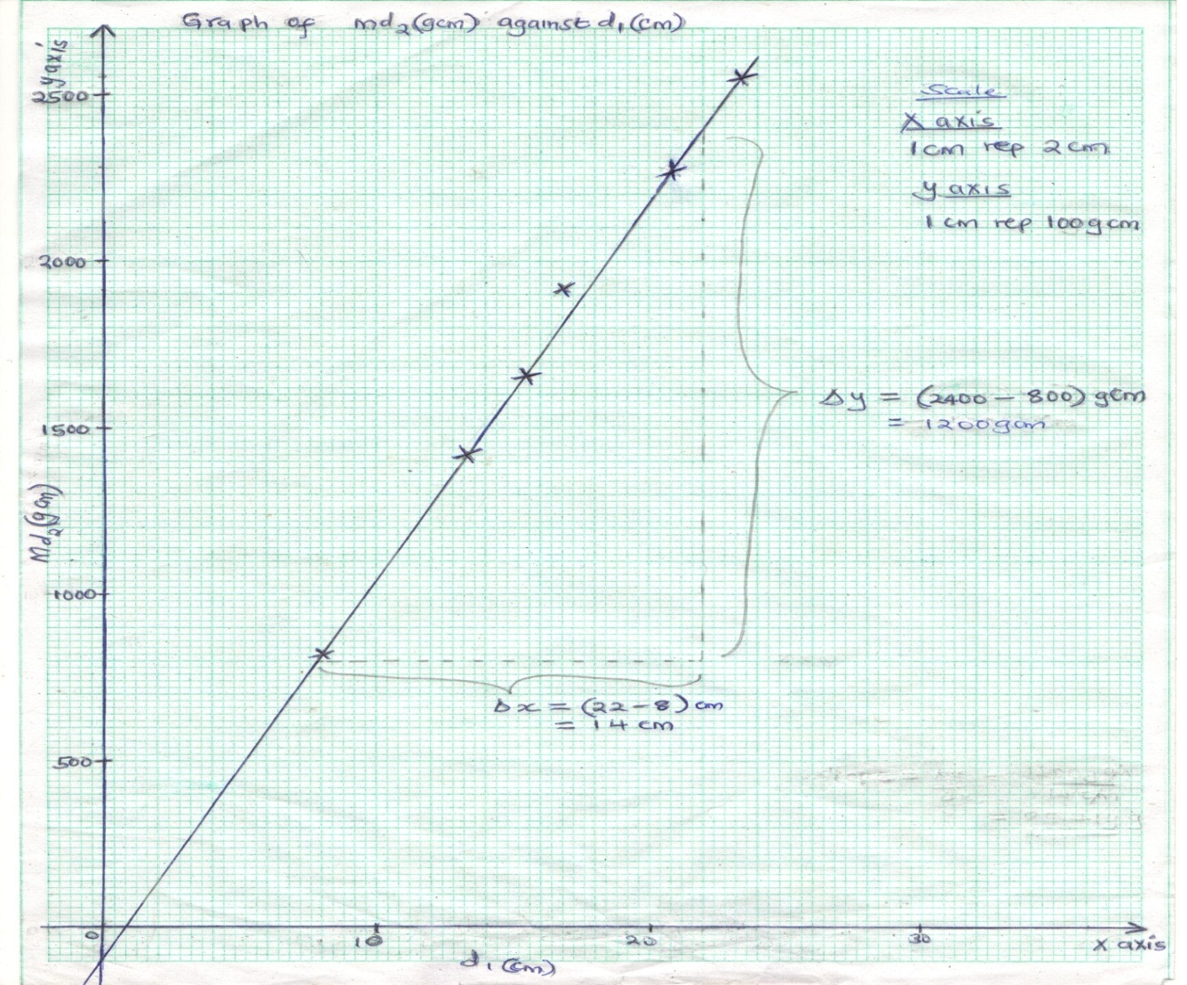
- Correct labeling withj units 1mk
- Scale 1 mk
- Plotting all pointe correctly 2mks
- Line / curve 1mk
- Slope to be derived from the graph ٧(2mks)
2400-800 = 85.714g
22-8
- Slope represents mass of the metre rule ٧(1mk)
The units are in grammes (g)
- Check the accuracy for values of thickness t and width b
(Values should be correct to 2d.p) each ٧(1mk)
t= 0.77 cm
b= 2.85cm
- Check correct substitution for P ٧(2mks)
85.714 = 0.3906 g/cm³
100x0.77x2.85

