NAME___________________________________________ ADM NO._______________
DATE:___________________
SIGNATURE:____________

AGRICULTURE
PAPER 2
MWAKICAN JOINT EXAM TERM 2 -2017
2 HOURS

INSTRUCTIONS
- Write your Name and Adm Number in the Spaces Provided.
- This Paper Consists of Three Sections A, B and C.
- Answer ALL the Questions in Sections A and B and TWO Questions in Section C.

For Examiner’s Use Only
Section | Questions | Maximum Marks | Candidate’s Score
A | 1-17 | 30
B | 18-21 | 20
C | 22-24 | 40
TOTAL SCORE |  | 90

SECTION A: 30 MARKS
Answer All questions in this Section

- State four factors that influence the quality of bricks. (2 Marks)
__________________________________________________________________________
__________________________________________________________________________
__________________________________________________________________________
__________________________________________________________________________

- Give four functions of vitamins in livestock production. (2 Marks)
__________________________________________________________________________
__________________________________________________________________________
__________________________________________________________________________
__________________________________________________________________________

- Give two characteristics of a good creep feed. (1 Mark)
__________________________________________________________________________
__________________________________________________________________________
__________________________________________________________________________
__________________________________________________________________________

- State two uses of pick axe. (1 Mark)
__________________________________________________________________________
__________________________________________________________________________

- Give two reasons of holding animals for a short period in the outlet crush after dipping.
(1 Marks)
__________________________________________________________________________
__________________________________________________________________________
__________________________________________________________________________
__________________________________________________________________________

- i) State two reasons for culling breeding sow. (1 Mark)
__________________________________________________________________________
__________________________________________________________________________
ii) Differentiate between ringing and crutching in sheep production. (1 Mark)
__________________________________________________________________________
__________________________________________________________________________
__________________________________________________________________________
__________________________________________________________________________

- What is the functional difference between cold chisel and wood chisel? (2 Marks)
__________________________________________________________________________
__________________________________________________________________________
__________________________________________________________________________
__________________________________________________________________________

- State three characteristics of goats that make them adaptable to arid-areas of Kenya.
(1 ½ Marks)
__________________________________________________________________________
__________________________________________________________________________
__________________________________________________________________________

- Name two methods of harvesting fish. (1 Mark)
__________________________________________________________________________
__________________________________________________________________________
__________________________________________________________________________

- List two tools you would require when smoothening concrete walls during plastering.
(1 Mark)
__________________________________________________________________________
__________________________________________________________________________
- List four farm structures that would assist in control of livestock parasites. (2 Marks)
__________________________________________________________________________
__________________________________________________________________________
__________________________________________________________________________
__________________________________________________________________________

- State six desirable characteristics to be considered when a heifer is being selected for milk production. (3 Marks)
__________________________________________________________________________
__________________________________________________________________________
__________________________________________________________________________
__________________________________________________________________________
__________________________________________________________________________
__________________________________________________________________________
__________________________________________________________________________
__________________________________________________________________________
__________________________________________________________________________

- Distinguish between inbreeding and out crossing in livestock production. (2 Marks)
__________________________________________________________________________
__________________________________________________________________________
__________________________________________________________________________
__________________________________________________________________________
__________________________________________________________________________

- a) Mention six reasons why bees swarm. (3 Marks)
__________________________________________________________________________
__________________________________________________________________________
__________________________________________________________________________
__________________________________________________________________________
__________________________________________________________________________
__________________________________________________________________________
__________________________________________________________________________
__________________________________________________________________________

b) State two methods to stock bee hives. (1 Mark)
__________________________________________________________________________
__________________________________________________________________________

- State four reasons for castrating a male cattle. (2 Marks)
__________________________________________________________________________
__________________________________________________________________________
__________________________________________________________________________
__________________________________________________________________________
__________________________________________________________________________
__________________________________________________________________________

- Give two reasons for steaming up in dairy cattle management. (1 Mark)
__________________________________________________________________________
__________________________________________________________________________
__________________________________________________________________________
__________________________________________________________________________

- Give three reasons why honey harvesting should be discouraged at night. (1 ½ Marks)
__________________________________________________________________________
__________________________________________________________________________
__________________________________________________________________________
__________________________________________________________________________
__________________________________________________________________________
__________________________________________________________________________
__________________________________________________________________________
__________________________________________________________________________
SECTION B: 20 MARKS
Answer All Questions in this Section

- Diagram M illustrates chicks suffering from some essential feed nutrients. Study the diagrams and answer the questions that follow.

- Outline the deficient nutrient in M and N. (2 Marks)
M__________________________________________________________________________
__________________________________________________________________________
N_________________________________________________________________________
__________________________________________________________________________

- i) Outline one method in each case to control the conditions in M and N. (2 Marks)
M_________________________________________________________________________
__________________________________________________________________________
N________________________________________________________________________
__________________________________________________________________________
__________________________________________________________________________

ii) Name two sources of deficient nutrient in N apart from commercial feeds. (2 Marks)
______________________________________________________________________
__________________________________________________________________________
__________________________________________________________________________
__________________________________________________________________________
__________________________________________________________________________

- Below is the diagram of a digestive system, use it to answer questions that follow.
- Which farm animal has a digestive system similar to the above system? (1 Mark)
__________________________________________________________________________
- Name the parts labeled S, T and W. (3 Marks)
__________________________________________________________________________
__________________________________________________________________________
- Explain the work of the parts S and T. (2 Marks)
__________________________________________________________________________
__________________________________________________________________________
__________________________________________________________________________
__________________________________________________________________________
__________________________________________________________________________
__________________________________________________________________________

- Study the diagram below and answer questions that follow.
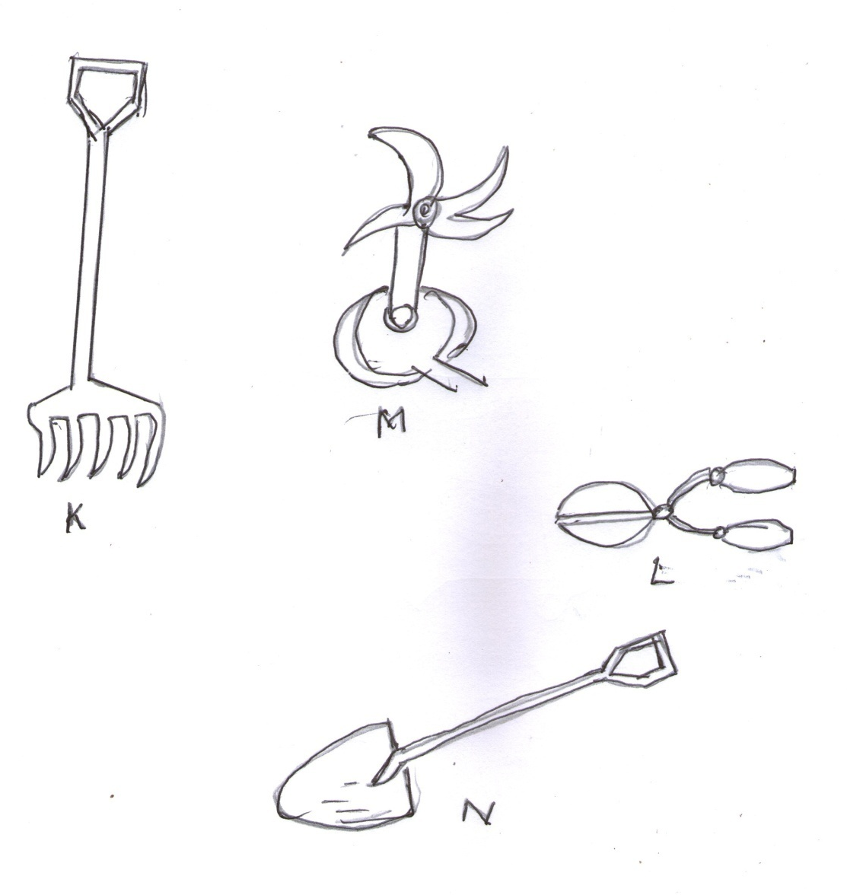

- Identify the tools K, L, M and N. (2 Marks)
K__________________________________________________________________________
L__________________________________________________________________________
M__________________________________________________________________________
N__________________________________________________________________________
- Give the use of K and L. (2 Marks)
K__________________________________________________________________________
__________________________________________________________________________
L_________________________________________________________________________
- The diagram below illustrates a breeding management practice.
- Identify the practice. (1 Mark)
__________________________________________________________________________

- Outline three reasons for carrying out the practice. (3Marks)
__________________________________________________________________________
__________________________________________________________________________
__________________________________________________________________________
__________________________________________________________________________
__________________________________________________________________________
__________________________________________________________________________
__________________________________________________________________________

SECTION C: 40 MARKS
Answer any TWO Questions in this Section.
- a) Describe the factors to be considered before si ting a cattle dip. (4 Marks)

b) Name any six essential parts of a spray race and describe their functions. (6 Marks)

c) Describe five disadvantages of using a spray race. (5 Marks)

d) Give five advantages of Kenya Top Bee Hive. (5 Marks)

- a)Describe the management practices carried out on sheep from preparation for mating to weaning of lambs. (12 Marks)
b)State and explain the methods of maintaining farm tools and equipments. (8 Marks)

- a) Describe the life cycle of a three host tick. (8 Marks)
b) Discuss the methods adapted to control livestock diseases. (12 Marks)
________________________________________________________________________
__________________________________________________________________________
__________________________________________________________________________
__________________________________________________________________________
__________________________________________________________________________
__________________________________________________________________________
__________________________________________________________________________
__________________________________________________________________________
__________________________________________________________________________
__________________________________________________________________________
__________________________________________________________________________
__________________________________________________________________________
__________________________________________________________________________
__________________________________________________________________________
__________________________________________________________________________
__________________________________________________________________________
__________________________________________________________________________
__________________________________________________________________________
__________________________________________________________________________
__________________________________________________________________________
__________________________________________________________________________
__________________________________________________________________________
__________________________________________________________________________
__________________________________________________________________________
__________________________________________________________________________
__________________________________________________________________________
__________________________________________________________________________
__________________________________________________________________________
__________________________________________________________________________
__________________________________________________________________________
__________________________________________________________________________
__________________________________________________________________________
__________________________________________________________________________
__________________________________________________________________________
__________________________________________________________________________
__________________________________________________________________________
__________________________________________________________________________
__________________________________________________________________________
__________________________________________________________________________
__________________________________________________________________________
__________________________________________________________________________
__________________________________________________________________________
__________________________________________________________________________
__________________________________________________________________________
__________________________________________________________________________
__________________________________________________________________________
__________________________________________________________________________
__________________________________________________________________________
__________________________________________________________________________
__________________________________________________________________________
__________________________________________________________________________
__________________________________________________________________________
__________________________________________________________________________
__________________________________________________________________________
__________________________________________________________________________
__________________________________________________________________________
__________________________________________________________________________
__________________________________________________________________________
__________________________________________________________________________
__________________________________________________________________________
__________________________________________________________________________
__________________________________________________________________________
__________________________________________________________________________
__________________________________________________________________________
__________________________________________________________________________
__________________________________________________________________________
__________________________________________________________________________
__________________________________________________________________________
__________________________________________________________________________
__________________________________________________________________________
__________________________________________________________________________
__________________________________________________________________________
__________________________________________________________________________
__________________________________________________________________________
__________________________________________________________________________
__________________________________________________________________________
__________________________________________________________________________
__________________________________________________________________________
__________________________________________________________________________
__________________________________________________________________________
__________________________________________________________________________
__________________________________________________________________________
__________________________________________________________________________
__________________________________________________________________________
__________________________________________________________________________
__________________________________________________________________________
__________________________________________________________________________
__________________________________________________________________________
__________________________________________________________________________
__________________________________________________________________________
__________________________________________________________________________
__________________________________________________________________________
__________________________________________________________________________
__________________________________________________________________________
__________________________________________________________________________
__________________________________________________________________________
__________________________________________________________________________
__________________________________________________________________________
__________________________________________________________________________
__________________________________________________________________________
__________________________________________________________________________
__________________________________________________________________________
__________________________________________________________________________
__________________________________________________________________________
__________________________________________________________________________
__________________________________________________________________________
__________________________________________________________________________
__________________________________________________________________________
__________________________________________________________________________
__________________________________________________________________________
__________________________________________________________________________
__________________________________________________________________________
__________________________________________________________________________
__________________________________________________________________________
__________________________________________________________________________
__________________________________________________________________________
__________________________________________________________________________
__________________________________________________________________________
__________________________________________________________________________
__________________________________________________________________________
__________________________________________________________________________
__________________________________________________________________________
__________________________________________________________________________
__________________________________________________________________________
__________________________________________________________________________
__________________________________________________________________________
__________________________________________________________________________
__________________________________________________________________________
__________________________________________________________________________
__________________________________________________________________________
__________________________________________________________________________
__________________________________________________________________________
__________________________________________________________________________
__________________________________________________________________________
__________________________________________________________________________
__________________________________________________________________________
__________________________________________________________________________
__________________________________________________________________________
__________________________________________________________________________
__________________________________________________________________________
__________________________________________________________________________
__________________________________________________________________________
__________________________________________________________________________
__________________________________________________________________________
__________________________________________________________________________
__________________________________________________________________________
__________________________________________________________________________
__________________________________________________________________________
__________________________________________________________________________
__________________________________________________________________________
__________________________________________________________________________
__________________________________________________________________________
__________________________________________________________________________
__________________________________________________________________________
__________________________________________________________________________
__________________________________________________________________________
__________________________________________________________________________
__________________________________________________________________________
__________________________________________________________________________
__________________________________________________________________________
__________________________________________________________________________
__________________________________________________________________________
__________________________________________________________________________
__________________________________________________________________________
__________________________________________________________________________
__________________________________________________________________________
__________________________________________________________________________
__________________________________________________________________________
__________________________________________________________________________

