NAME……………………………………………………ADMNO………….CLASS…………..

231/2 DATE…………………………..

BIOLOGY PAPER 2

TIME: 2HRS

MWAKICAN FORM3 JOINT EXAMINATION END TERM 11 -2017

Instruction to candidates
-Write your name and Adm No. in spaces provided above.
-This paper consists of two sections A and B
-Answer all questions in section A in the spaces provided
-In section B answer question 6 (COMPULSORY) and either question 7 or 8.

SECTION | QUESTIONS | MAXIMUM SCORE | CANDIDATES SCORE
A | 1 | 8
 | 2 | 8
 | 3 | 8
 | 4 | 8
 | 5 | 8
B | 6 | 20
 | 7 | 20
 | 8 | 20
 | TOTAL | 80

1 .The chart below shows a feeding relationship in a certain ecosystem
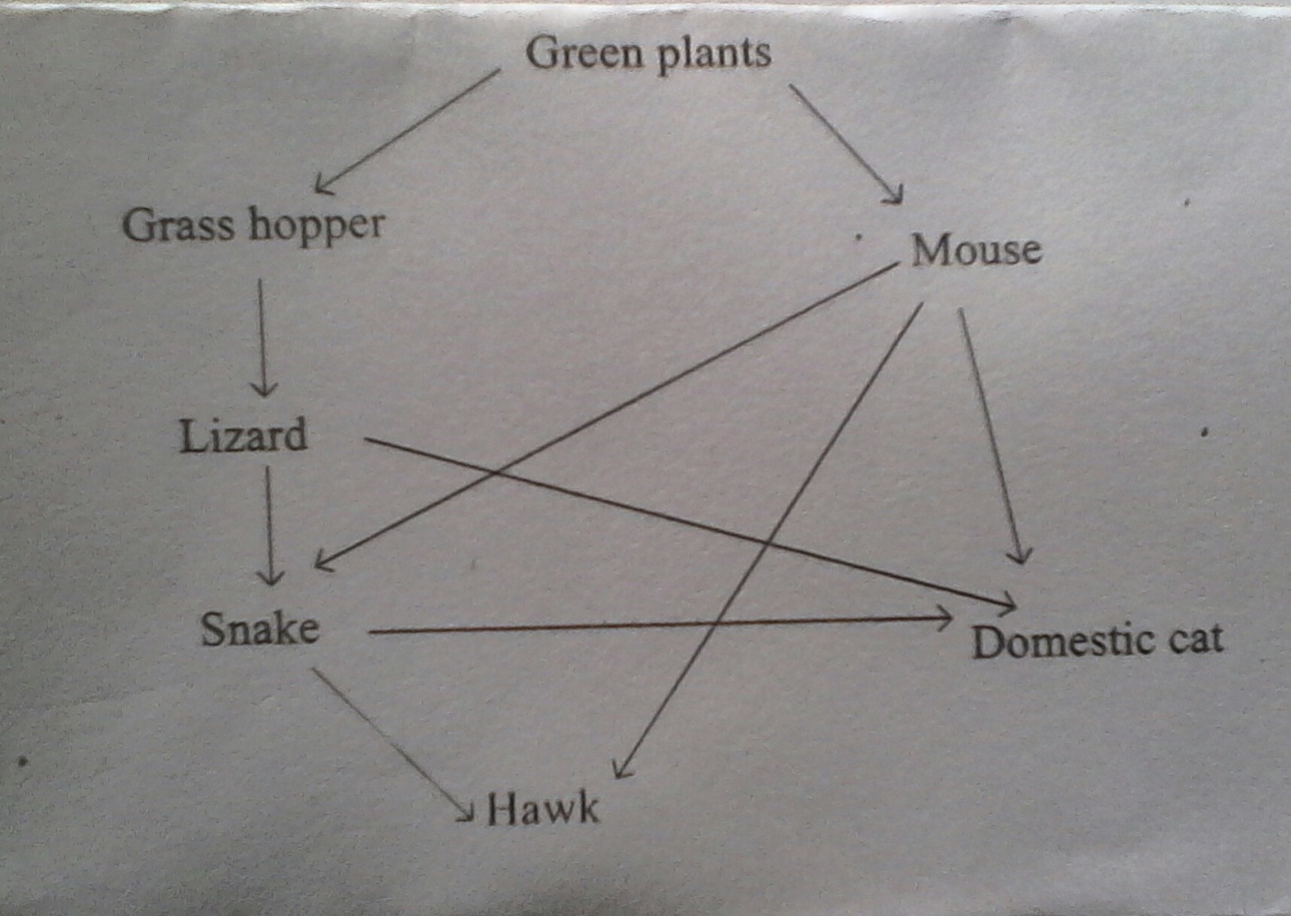

- Construct two food chains ending with tertiary consumer in each case (2marks)

- Which organism has the largest variety of predator in the food web? (1 mark)

- Name two secondary consumers in the food web (2 marks)

- Suggest three ways in which the ecosystem would be affected if there was a prolonged drought
(3 marks)

2. The diagram below shows a portion of a leaf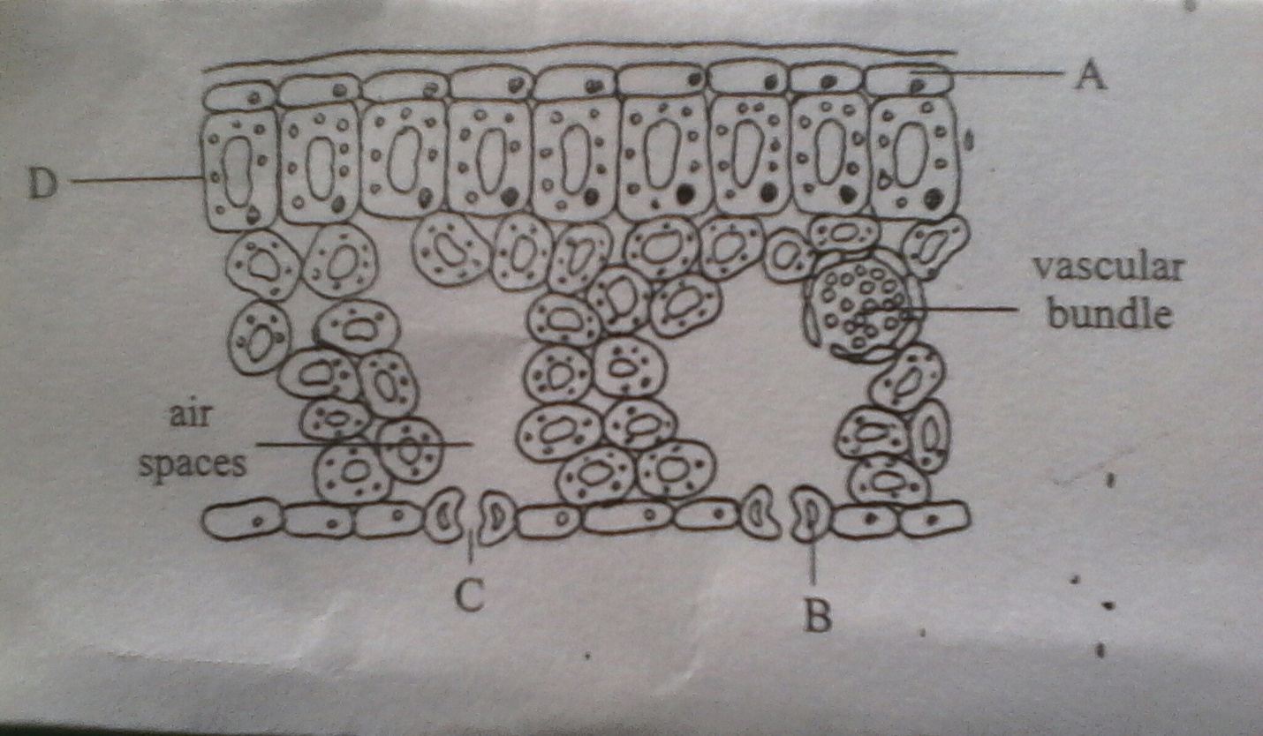

- Name the cells labeled A B (2 marks)

- State the functions of each of the structures labeled c and D (2marks)

- (i) what would happen to structure C if the epidermal tissue was placed in a concentrated solution of sugar for one hour ? (1 mark)

(ii) Give reasons for your answers in 2c above (3 marks)

3. To estimate the population size of crabs in a certain pond, traps were laid at random. 400 crabs were caught, marked and released back in the pond. Four days later, traps were laid and 374 crabs were captured. Out of 374 crabs captured 80 in figures were found to have been marked
- using the formula below
N= n X M
m N-Total population of crabs in the pond
n- Total number of crabs in the second catch
M- Number of marked crabs during the first catch
m- Number of marked crabs during the second catches

Calculate the population size of the crabs in the pond (2 marks)

- State three assumptions that were made during the investigation (3 marks)

- What name is given to this method of estimating the population size (1 mark)

- Name two other methods that can be used to estimate the number of organism in a given habitat
( 2 marks)

4 The figure below represents a kidney nephron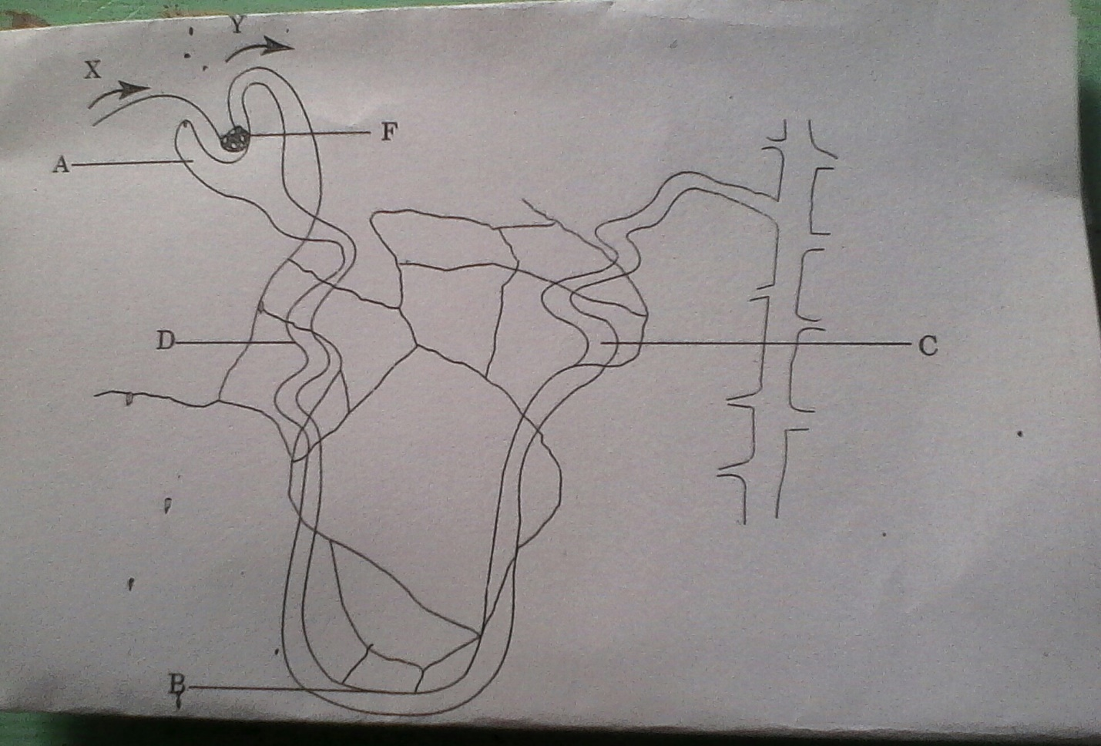

- Name the parts labeled A, D, F (3 marks)

- State the difference between the following
(i) Blood in vessel X and Y (1mk)

(ii) Substances in parts labeled F and part labeled D (2mks)

- (i) State the main substance that is reabsorbed in the part labeled B (1mk)

(ii) Give one requirement for the reabsorption of the substance named c(i) (1mk)

5. Examine the diagram shown below which is part of a cycle in nature.

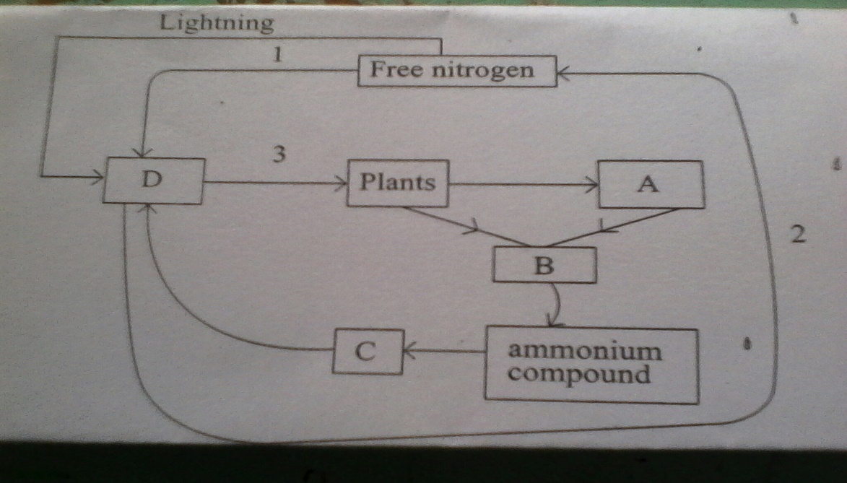

(i)Name organism A and B (2mks)
A

B

(ii)Name the compounds Cand D (2mks)
C

D

(iii)State the processes 1, 2 and 3 (3mks)

(b)State one benefits of this cycle in nature (1mks)

SECTION B (40MARKS)

6. Some students used a model to demonstrate the effect of sweating on human body temperature. Two boiling tubes A and B were filled with hot water. The surface of the tube A was continuously wiped with a piece of cotton wool soaked in methylated spirit. The temperature of water in the tubes was taken at the start of the experiment and then at 5 min interval. The results obtained are as shown in the table below.
TIME (MINUTES) | TEMPERATURE (C ) IN TUBES | TEMPERATURE (C ) IN TUBE
 | A | B
0 | 80 | 80
5 | 54 | 67
10 | 40 | 59
15 | 29 | 52
20 | 21 | 47
25 | 18 | 46

(a)On the same axis plot a graph of temperature of water in the tubes against time (7mks)

(b)At what rate was the water cooling in A ? (2mk)

(c )Why was tube b included in the set up? (1mk)

(d)Account for the rate of cooling in tube A (3mks)

(e)State two processes of heat loss in tube B (2mks)

-
(f)What would be the expected results if tube B was insulated (1mk?)

(g)What would the insulation be comparable to in
(i)Birds (1mk)

(Ii)Mammals (1mk)

(h)Name the structures in human body that detect
(I)External temperature changes (1mk)

(i)Internal temperature changes (1mk)

7. a) State four abiotic factors in an ecosystem (4mks)
b) Describe how xerophytes are adapted to their habitats (16 mks)
8.Describe the adaptations of the heart to their functions (20mks)

