NAME …………………………………………………ADM. NO ………….CLASS……….

DATE………………
231/3
BIOLOGY
PAPER 3
(PRACTICAL)
JULY/AUGUST
TIME: 1³/₄HRS

KENYA CERTIFICATE OF SECONDARY EDUCATION MWAKICAN FORM 3 JOINT EXAMINATION - 2017

Instruction to Candidates
- Write your name, Adm No. and class in the spaces provided at the top of this page.
- Answer all the questions in the spaces provided.
- You are required to spend the first 15 minutes of the 1³/₄ hours allowed for this paper reading the whole paper carefully before commencing your work.
- Answers must be written in the spaces provided in the question paper.
- Additional pages must not be inserted.
- The paper consists of 7 printed pages.

QUESTION | MAXIMUM SCORE | CANDIDATES SCORE
1  2  3 | 14  15  11
TOTAL SCORE | 40

Candidates should check the question paper to ascertain that all the pages are printed as indicated and no questions are missing.
- You are provided with an unknown mixture labeled J.
You are also provided with Benedict’s solution, dilute hydrochloric acid solution, iodine solution, dichlorophenol-indophenol (DCPIP) solution, sodium hydrogen-carbonate solution, means of heating, test tubes, test tube holder and a test tube rack.
- Using the reagents provided only, test for the food substances in mixture J. Record in the table below the food substance tested, the procedure of the test, your observations and conclusions. (8mks)
Food | Procedure | Observations | Conclusions

- Which of the components of mixture J does not undergo digestion in the mammalian digestive system? (1mk)

- Name a common carbohydrate that could be present in mixture J (1mk)

- State the role of hydrochloric acid and sodium hydrogen carbonate in the experiment (2mks)

- (i) Name a deficiency disease that may result from a deficiency of one of the substances present in mixture J (1mk)

(ii) Give one common symptom of the disease you have stated in (e)(i) above (1mk)

- Examine the photographs of the leaves labelled K1, K2, K3, K4, K5, K6, K7, K8 and K9 shown below and the incomplete dichotomous key shown.
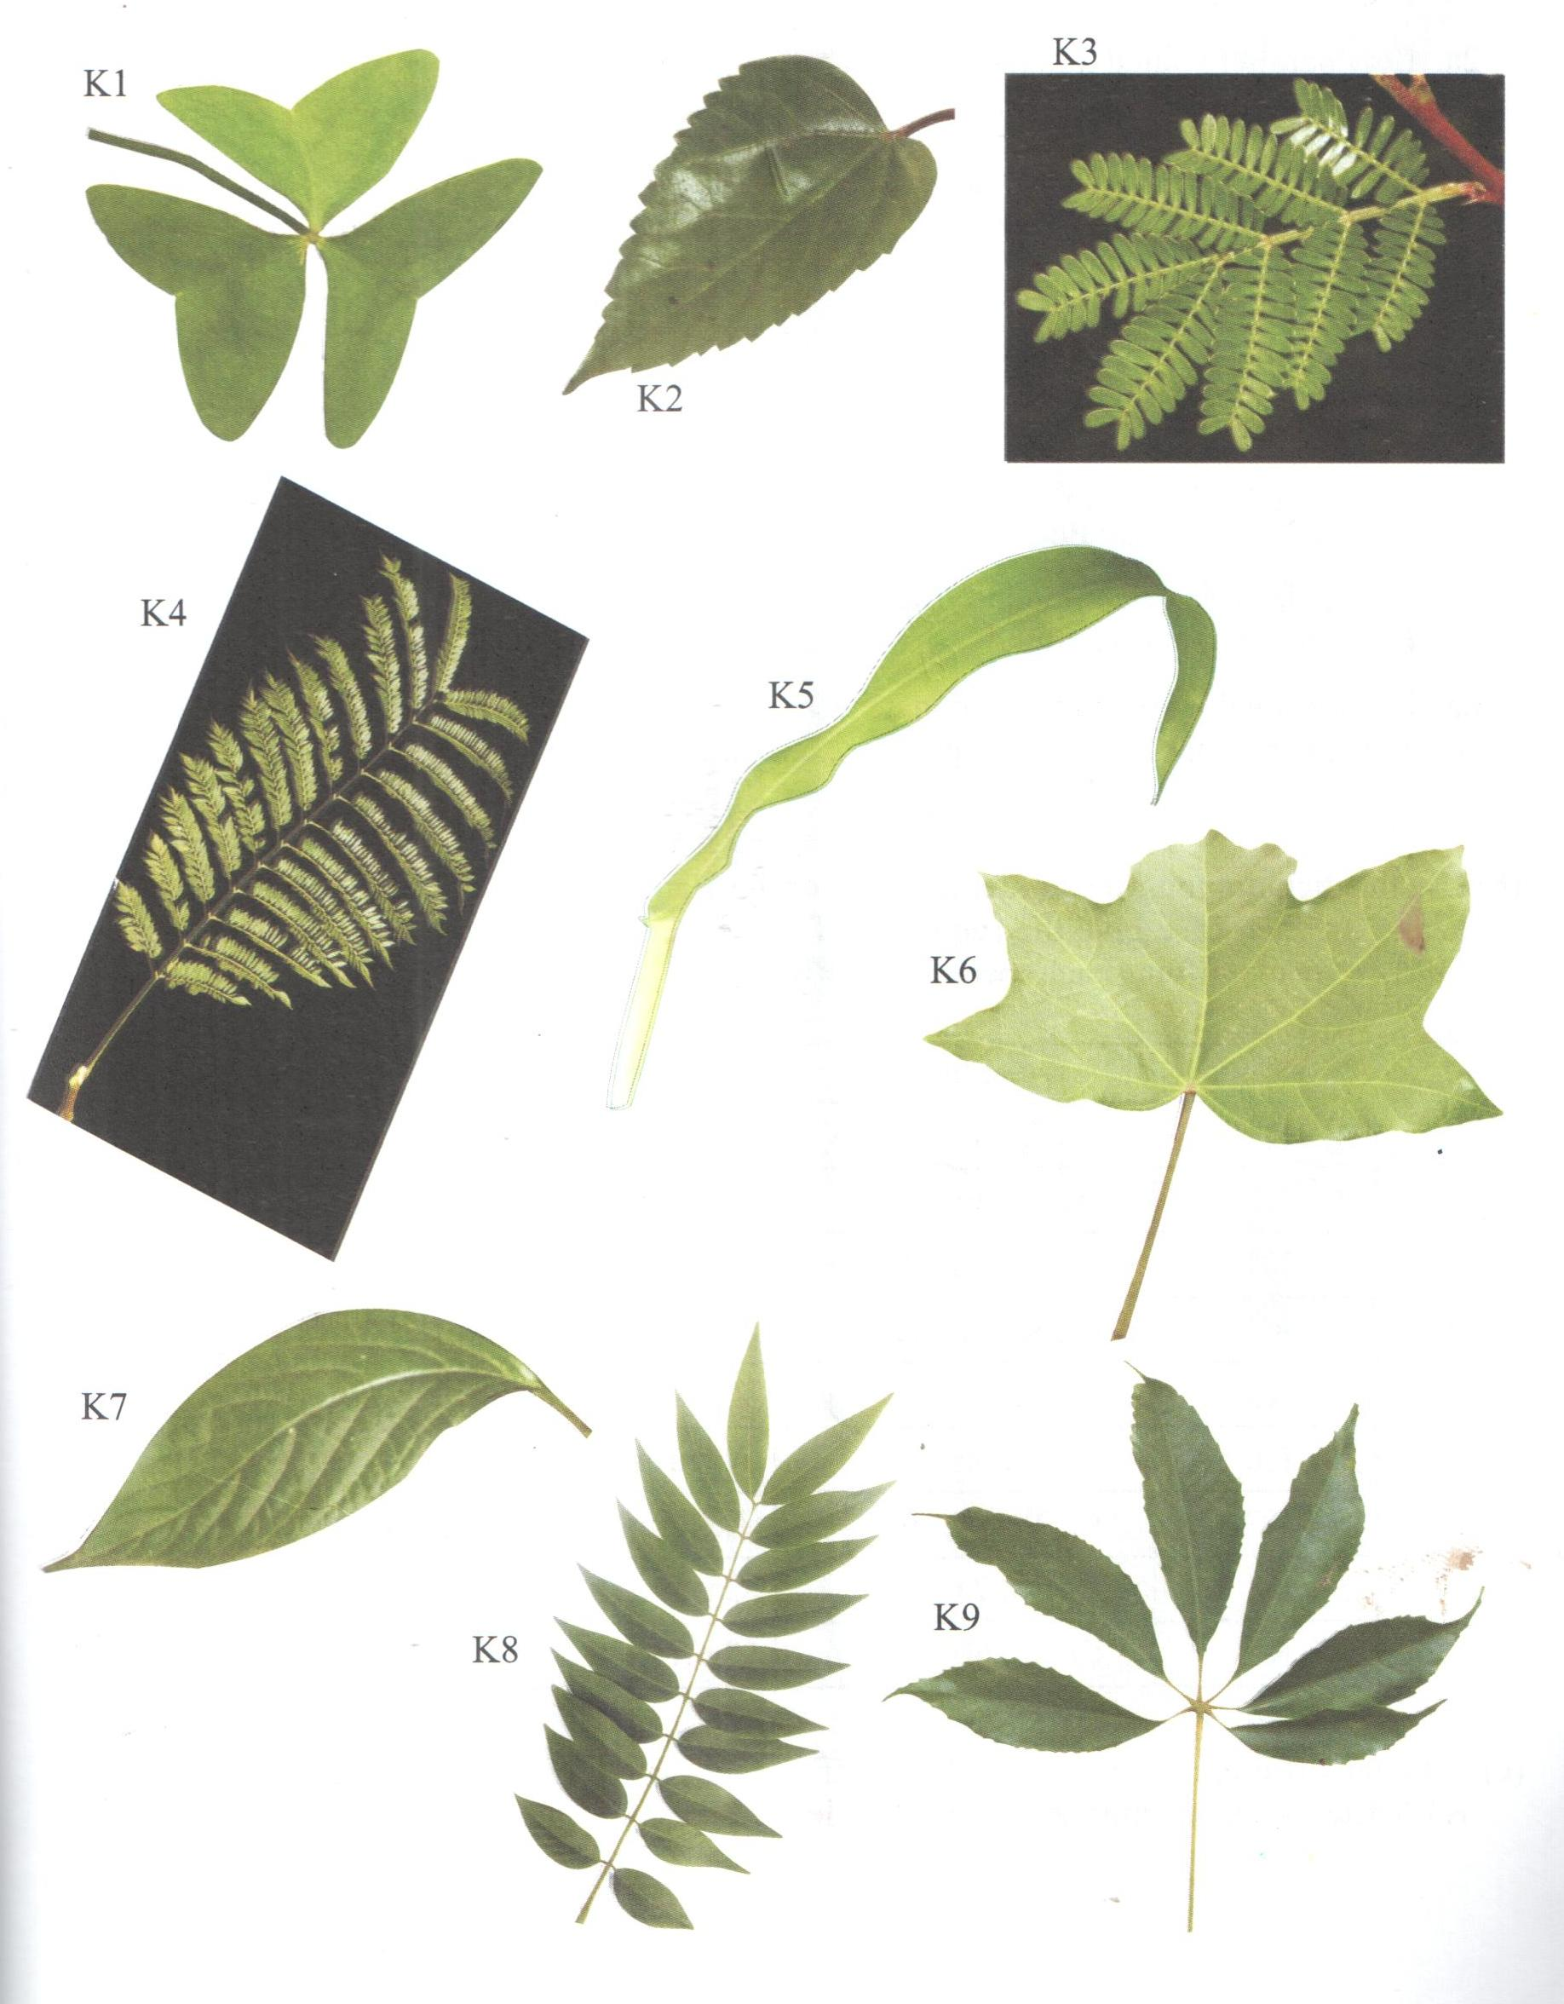
- Complete the dichotomous key shown below (4mks)
1a. Leaf simple ………………………………………….go to 2
b. Leaf compound ……………………………………… go to 5

2a. Leaf parallel veined ………………………………… Zea
b. Leaf net-veined ……………………………………… go to 3

3a. Leaf lobed …………………………………………..Aleurites
b. Leaf not lobed ……………………………………… go to 4

4a. Leaf margin smooth ………………………………..Achyranthes
b. ……………………………………………………….Hibiscus

5a. Leaf palmately compound ………………………… go to 6
b. ……………………………………………………… go to 7

6a. Leaf trifoliately compound ………………………..Oxalis
b. Leaf with more than three leaflets…………………..Chorisia

7a. Leaf unipinnately compound ……………………..Cassia
b. ………………………………………………………go to 8

8a. …………………………………………………….. Jacaranda
b. Has no terminal leaflets/paripinnate ……………….Acacia

- Use the dichotomous key to identify each of the plant specimens in the photographs to their genus. In each case give the sequence of steps, e.g. 1(a), 2(b), 4c and so on which you followed in identifying each specimen (9mks)

Specimen | Steps | Identify
K1
K2
K3
K4
K5
K6
K7
K8
K9

- State the difference in the apex of the leaflet of K1 and leaf K2 (2mks)

- The three organisms shown in the photographs below are often found in the same ecosystem. Examine them.
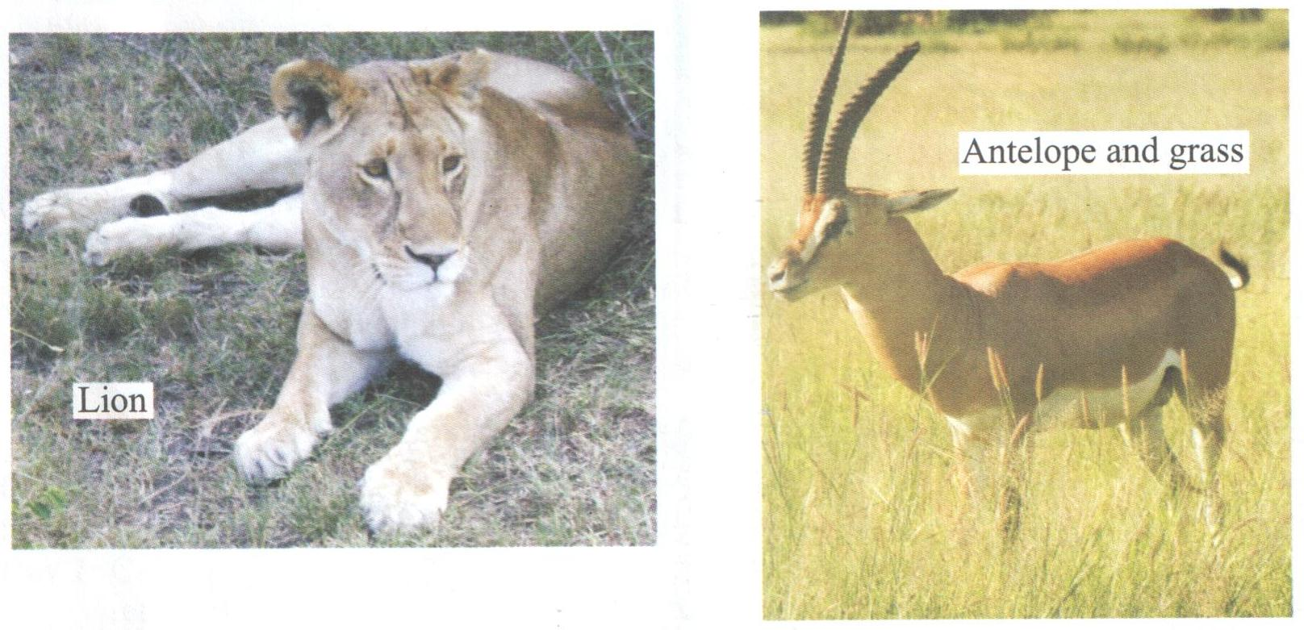
- (i) Name the trophic level occupied by the antelope (1mk)

(ii) Give a reason for your answer in (a) (i) above (1mk)

- (i) Draw a pyramid of biomass for the three organisms in the ecosystem (3mks)

(ii) Explain the differences between the biomass of lions and antelopes in the ecosystem (4mks)

- (i) Hyenas are also often found in this ecosystem. Name the trophic level(s) that they occupy. (1mk)

(ii) Give a reason for your answer in (c) (ii) above (1mk)

