312/1
GEOGRAPHY
PAPER 1
JULY 2017
TIME: 2¾ HOURS

MWAKICAN JOINT EXAM TEAM (MJET)
FORM 3 END TERM 2, 2017
GEOGRAPHY
PAPER 1
TIME: 2¾ HOURS

INSTRUCTIONS TO CANDIDATES
- This paper consists of two sections; section A and section B.
- Answer all questions in section A. In section B answer question 6 and any other two questions.
- All answers must be written in the answer booklet provided.
- This paper consists of 4 printed pages.
- Candidates should check to ascertain that all pages are indicated and that no question are missing

SECTION A

Answer all the questions in this section
1. a) State three effects of the revolution of the earth. (3 marks)
b) The local time of town Y at 37º is 10.00a.m. What will be the time at town X longitude 10ºW. (2 marks)
2 a) State three natural causes of earthquakes. (3 marks)
b) Give two effects of earthquakes in built up areas. (2 marks)
3. a) State three reasons why wind action is more effective in the hot desert (3 marks)
b) Name three features resulting from wind erosion in desert areas. (3 marks)

4. a) Name two sources of underground water. (2 marks)

b) state three conditions necessary for the development of karst scenary. (3 marks)
5. 5. a) What is mass wasting (2marks)
b) Differentiate between solifluction and earth flow (2 marks)

SECTION B
Answer question 6 and any other two questions from this section
6. Study the map of Kitale (sheet 75/3, Scale 1:50,000) provided and answer the questions that follow.
a) What is the longitudinal extent of the area covered by the map. (2mks)
b) Give the six figure grid reference of the top most part of Rogurr hill (2mks)
c) Measure the length of the all-weather road from the junction at grid reference
239286 towards the Southern part heading to Kitale, give your answer in
Kilometers. (2mks)
d) What is the bearing of kipsain club at grid reference 3121 from the dip at grip reference
2826. (2mks)
(e) (i) Draw a frame of dimensions 14cm by 10cm to represent the area bound by the eastings
23 and 30 and the northings 11 and 16. (1mk)
(ii) On the frame, mark and name:
- railway line:
- Papyrus swamp;
- All weather loose surface road C 641. (3mks)
(iii) State the scale of the sketch drawn in (b)(i) above. (1mk)

(f) Students from a school in grid square 2614 conducted a field study of Kitale township.
(i) Citing evidence from the map, state three functions of Kitale Township they are likely to identify. (3mks)
(ii) State two physical problems they could have encountered during the study. (2 mks)

g)Examine two factors influencing settlement in the area covered by the map. (4mks)

h) Show 3 characteristics of drainage in the area covered by the map. (3mks)
7. Below is a map of Africa representing climatic regions .Use it to answer the questions that follow.
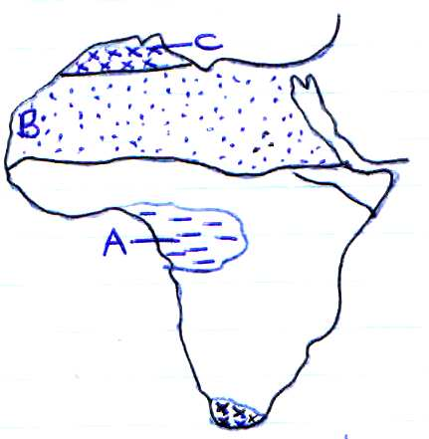

(a) Identify the climatic regions marked a, b and c. (3 marks)
(b) Outline the climatic characteristics of the regions marked:
- A (4 marks)
- C (4 marks)
(c) Explain how the following factors influence climate
(i) Altitude (4 marks)
(ii) Distance from the sea (4 marks)

(d)
(i) Describe a suitable site where you would locate a weather station. (2 marks)
(ii) Give reasons why a Stevenson’s screen is:
- Painted white (2 marks)
- Has louvers (2 marks)

8. The diagram below shows a section of a river. Use it to answer the questions that follow.
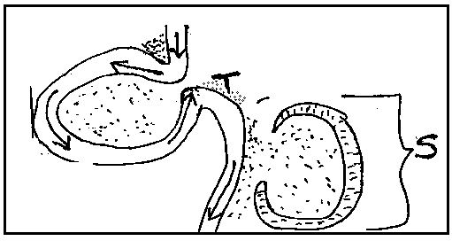

(a) (i) Name the features marked S and T (2mks)
(ii) State three conditions that are necessary for the formation of the feature marked S. (3mks)
(b) (i) Outline two factors that influence the development of a drainage pattern. (2mks)
(ii) Outline five characteristics of a river in its youthful stage. (5mks)
(c) Your class is planning to carry out a field study of a river in its old stage.
(i) State three reasons why it would be necessary to pre-visit the area of study. (3mks)
(ii) State four activities you would carry out to determine why deposition occurs at this
stage. (4mks)
(d) Explain three negative effects of rivers to the human environment. (6mks)
9. (a) (i) State two causes of submergence of Coasts. (2mks)
(ii) Name two features that form as a result of submergence of Coasts. (2mks)
(b) (i) State four conditions that favour the growth of coral polyps. (4mks)

(ii) With the aid of labelled diagrams, describe the process through which a stack is formed. (4mks)
(iii) Explain two ways in which coral contribute to the economy of Kenya. (4mks)
(c) (i) What are tides? (2mks)
(ii) Name the three ocean currents along the Western Coast of Africa. (3mks)

(d) State four significance of coast and coastal features (4 mks)

10. a) i) What is a lake ? (2 marks)
ii) State three sources of water found in a lake. (3 marks)
b) Describe how the following lakes are formed
i) Tarn lakes (4 marks)
ii) Crater lakes (3 marks)

c) The map below shows some lakes formed by faulting.
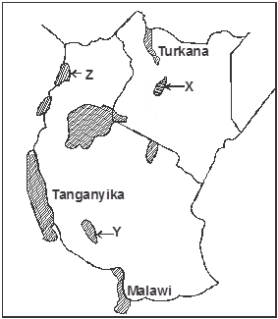

Name the lakes marked X, Y and Z. (3 marks)
d) i) Give four reasons why some Rift Valley lakes have fresh water. (4 marks)
ii) Explain three negative effects of human activities on lakes. (6 marks)

