NAME: ADM NO:
CLASS: DATE:

MWAKICAN FORM 3 JOINT EXAMINATION
TERM II 2017
GEOGRAPHY
PAPER 2
FORM 3
AUGUST 2017
TIME: 2 ½ HOURS

INSTRUCTIONS TO CANDIDATES
THIS PAPER CONSISTS OF TWO SECTONS: A AND B
ANSWER ALL QUESTIONS IN SECTION A
IN SECTION B, ANSWER QUESTION 6 AND ANY OTHER TWO

SECTION A: 25 MARKS

1 a) Name two places in south Africa where gold is mined (2mks)
b) State three uses of diamond (3mks)
2 a) what is forestry? (2mks)
b) State three problems facing the growth of softwood forests in Canada. (3mks)
3. a) Name two oil producing countries in Middle East (2mks)
b) Give three by-products obtained when crude oil is refined (3mks
4. a) List two main types of sampling techniques (3mks)
(b) Name three methods that are used to analyze statistical data. (3mks)

5. (a) Differentiate between a reconnaissance and a working schedule? (2mks)

(b). Give three importance’s of a working schedule (3mks)

SECTION B: 75 MARKS
ANSWER QUESTION SIX AND ANY OTHER TWO QUESTIONS FROM THIS SECTION

6 a) the table below shows the distribution of minerals in a country in tones. Study it carefully and answer the questions that follow.
Mineral/year | 2012 | 2013 | 2014 | 2015 | 2016
Trona | 40 | 50 | 45 | 35 | 30
Gold | 10 | 15 | 5 | 10 | 15
Oil | 8 | 13 | 15 | 8 | 10
Diamond | 4 | 10 | 8 | 6 | 5
Copper | 2 | 7 | 3 | 4 | 7

- Draw a compound bar graph to represent the data above using a scale of 1cm rep 10 tonnes. (9mks)

- State two advantages of using compound bar graphs to represent the data (2mks)
b) Explain four short comings of using the shaft method of mining (8mks)
c) Explain three significance of mining to the economy of South Africa (6mks)
7. (a) (i) What is reafforestation? (2 marks)
- State four reasons why afforestation should be encouraged in Kenya. (4 marks)

(b) (i) Name two main exotic softwood trees grown in Kenya. (2 marks)
(ii) State five characteristics of softwood forests in Canada. (5 marks)
(C) Explain three problems which hinder the Kenya government’s effort to manage and conserve her forests. (6 marks)

(d) Compare forestry in Kenya and Canada under the following headings:-
(i) Transportation of the logs. (2mks)
(ii) Felling of tree (2mks)
(iii) Tree species. (2mks)
8 a) i) Identify the two types of photographs (2mks)
ii) State three advantages of using photographs as a technique of recording data (3mks)
iii) With reference to ground photographs explain the meaning of
Dead ground (2mks)
Fore ground (2mks)
Back ground (2mks)
b) Study the photograph below and use it to answer the questions that follow

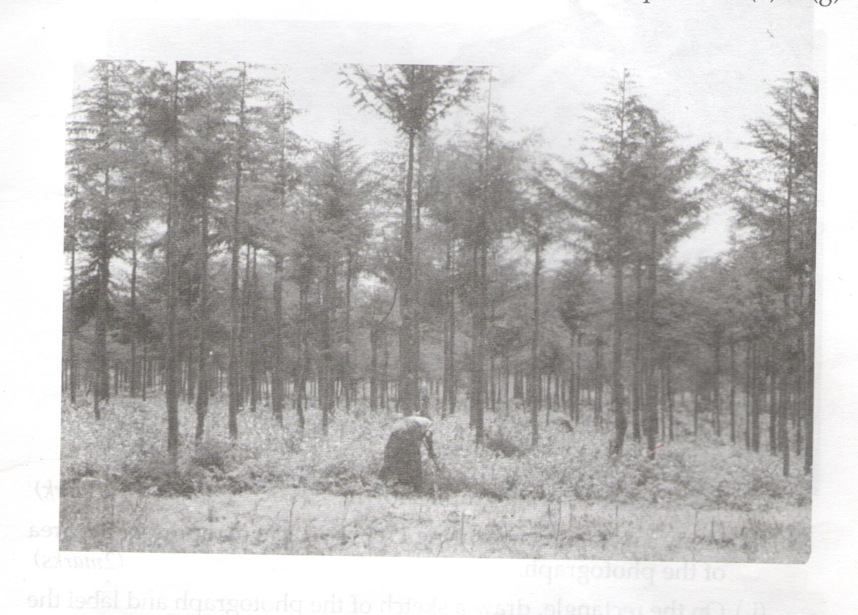

i) Name the type of photograph shown (1mk)
i)Name the type of photograph shown (1mk)
ii) Describe the characteristics of the forest shown on the photographs (7mks)
c) Name the kind of farming activity in the photograph (1mk)
d) Name the type of trees shown in the photograph (1mk)
e) Compare tree harvesting in Kenya and Canada (4mks)

9 a) Define the term mineral (2mks)
b) I) Name two areas in South Africa where diamond is mined (2mks)
ii) Give four ways in which minerals occur (4mks)
c) I) Explain Three negative effects of mining on the environment (6mks)
ii) Identify any two methods of mining (2mks)
(ii) Name a port through which minerals in East Africa are exported (1mk)
d) Explain four ways in which soda ash contributes to the economy of Kenya (8mks)

10. a) . (i) List three types of fieldwork. (3mks
ii) List three importance’s of field work. (3mks)
b). you are supposed to carry out a field study on the uses of vegetation in the area around your school.
(i) State three reasons why it would be necessary to visit the area before the day of the study. (3mks)
(ii) Give four uses of vegetation you are likely to identify during the study (4mks)
- Why is it necessary to sample part of the forest for the study? (2mks)
- (i) State three follow up activities you would be involved in (3mks)
- State two ways in which information collected during the field study would be useful to the local community. 2mks

(e) Formulate five suitable objectives for field study on a visit to a forest. (5mks)

