NAME:………………………………………………….. INDEX NO:………………………………
CANDIDATE’S SIGNATURE:…………… DATE:………………………………………
443/1
AGRICULTURE
JULY, 2019
PAPER1
TIME: 2 HOURS

BUURI EAST STANDARDS
Kenya Certificate of Secondary Education
AGRICULTURE 443/1
2 Hours

Instructions to Candidates:

- Write your name and index number in the spaces provided above.
- Sign and write the date of examination in space provided.
- This paper consists of three sections; A, B and C.
- Answer all the questions in section A and B.
- Answer any two questions in section C.
- All answers should be written in spaces provided in question paper.

FOR EXAMINER’S USE ONLY

SECTION | Question | Maximum score | Candidates score
A | 1 - 15 | 30
B | 16 - 19 | 20
C |  | 20
 |  | 20
 | Total score 90

SECTION A: (30MKS)

Answer all the questions in this section.

1. State four advantages of intensive system of farming. (2mks)

2. Give four conditions likely to facilitate land fragmentation. (2mks)

3. a) List four post harvest practices done on crops. (2mks)

b) What is earthing up in crop production. (1mk)

4. Give four reasons as to why burning as a method of bush clearing is not recommended. (2mks)

5. a) Give the form in which the following elements are available to plants (1mk)

i) Nitrogen

ii) Sulphur

b) State two liming elements in crop production. (1mk)

6. State four effects of ill – health and HIV /AIDs in agricultural production (2mks)

7. State the functions of the following components in a compost heap. (2mks)

i) Ash

ii) Garden soil

iii) Organic manure

iv) Stick

8. State four factors that can enhance rooting in a stem cuttings. (2mks)

9. Outline four reasons a farmer should have breeding records in livestock production. (2mks)

10. Give four ways of treating water for use in the farm. (2mks)

11. Name four methods of harvesting trees. (2mks)

12. Give two methods of conserving forage. (1mk)

13. State four roles of young farmers clubs in Kenya. (2mks)

14. a) Distinguish between farm planning and farm budgeting. (1mk)

b) Name two sources of capital in the farm. (1mk)

15. State four advantages of budding. (2mks)

SECTION B: (20MKS)

Answer all questions in this section.

16. The diagrams below show an experiment that was carried out by Mwatate agriculture students. Study it carefully and answer the questions that follow.

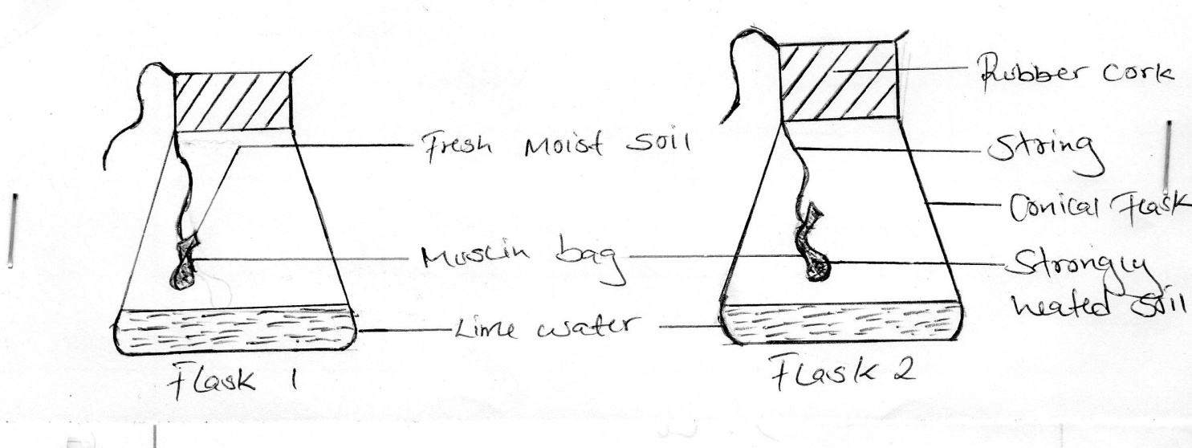

a) What was the aim of the experiment. (1mk)

b) What observation did the students make in the two flasks at the end of the experiment. (2mks)

Flask 1……………..

Flask 2……………..

c) Give a reason for the observation made in flask 1 (1mk)

d) Why did the students heat the garden soil in flask 2 strongly? (1mk)

17. The diagram below illustrate materials, and a method of vegetative propagation. Study it and answer the questions that follow.

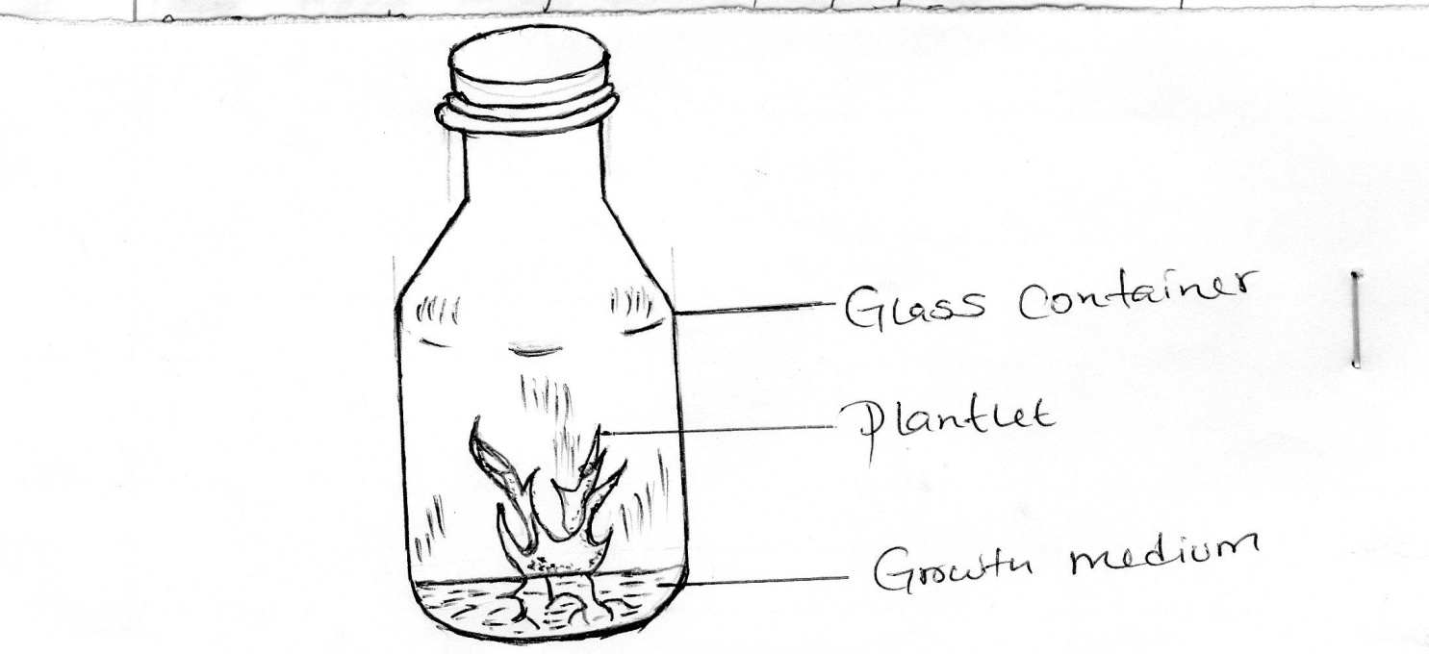

i) Identify the method of propagation illustrated above. (1mk)

ii) Name a common crop propagated through the method. (1mk)

iii) Give three disadvantages of this method of propagation. (3mks)

18. The diagram below shows a bird which is a field crop. Study it and answer the question that follow.

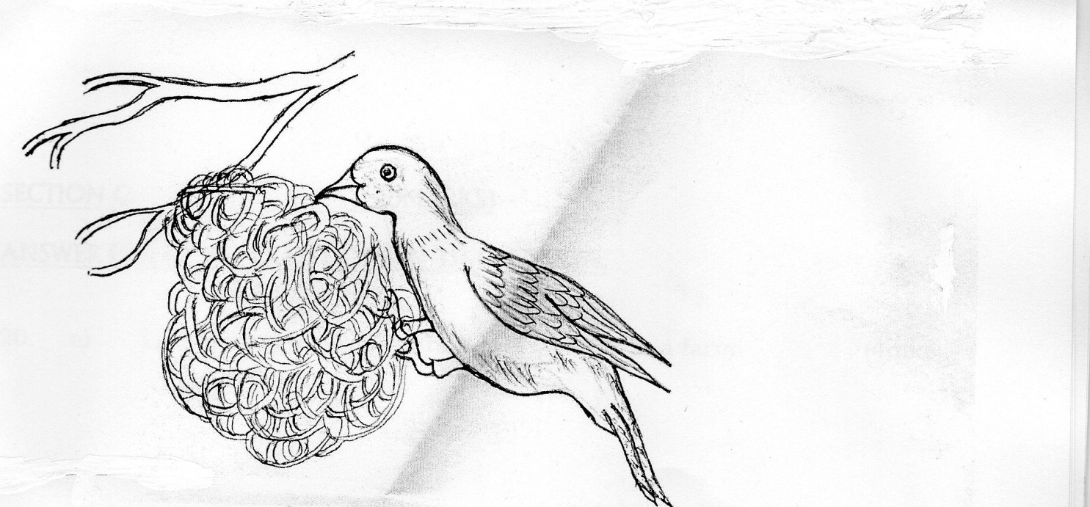

a) Identify the pest (1mk)

b) State two damages caused to crops by the pest. (2mks)

c) Give two methods which can be used to control the pest. (2mks)

19. a) Given that the spacing of coffee is 2.7m by 2.7m, calculate the plant population in 1 hectare (Ha) of land (2mks)

b) Give three reasons why crops should be planted at the correct spacing (3mks)

SECTION C: (40MARKS)

ANSWER ONLY TWO QUESTIONS IN THIS SECTION.

20. a) List various methods of harvesting water in a farm. (4mks)

b) Outline farming activities which may encourage soil erosion. (6mks)

c) Explain five farming practices that would help to conserve soil. (10mks)

21. Describe the field production of tomato under the following sub – headings

i) Seedbed preparation (3mks)

ii) Transplanting (5mks)

iii) Fertilizer application (2mks)

iv) Pruning (2mks)

b) Explain how various field practices carried out in crop production would help to control diseases. (6mks)

22. Maboya farm started the year on and as at 31/12/2018 had following transactions.
Sale of poultry 5,000.00
Opening valuation 10,000.00
Purchase of seeds 2,800.00
Purchase of fertilizer 2,000.00
Sale of beans 1,200.00
Sale of vegetables 500.00
Closing valuations 15,000.00
Casual labourers (wages) 2,500.00
Depreciation (tractors) 500.00
Interest (borrowed laon) 400.00
Purchase of day old chicks 800.00
Sale of milk 6,000.00
Purchase of calves 10,000.00
Miscellaneous expenses 1,000.00

a) Prepare a profit and loss account for Maboga farm. (10mks)

b) Did the farm qualify for credit? Give one reason for your answer. (2mks)

c) Explain four roles of agriculture in national development (8mks)

<<< E N D >>>

