231/1
BIOLOGY
JULY, 2019
PAPER 1
Marking scheme

BUURI EAST STANDARDS
Kenya Certificate of Secondary Education
BIOLOGY 231/1

1. a) Pitfall trap (1mk)

b) Returning live millipedes to the habitat after study (1mk)

2. a) Nucleolus (1mk)

b) Nuclear membrane pore (1mk)

3. a) Nuclear material/genetic materials is not surrounded by a membrane/lack nuclear membrane/prokaryotic;

b) Lacks most of the cell organelles. Acc lack mitochondria; ribosomes
small in size;

(any two 2 x 1 = 2mks

b) Smallest unit of classification whose organism have hereditary distinction from other groups and can naturally interbreed to produce viable offspring; (1mk)

4. a) Scelerenchyma; xylem vessels/xylem tracheid; (2mks)

b) cell take in water and became turgid; (1mk)

5. a) Osmosis involves movement of water molecules/solvent molecules active transport involves movement of solute molecules; osmosis
Does not require energy, active transport requires energy; in osmosis molecules move along a concentration gradient in active transport molecules move against a concentration gradient; (3mks)

b) Shrinking of redblood cells/animal cell as a result of loss of water by osmosis (when placed in hypertonic solution; (1mk)

6. a) Q - Antipodal cell; (1mks)

R - Polar nucleus /body (1mk)

S - Functional egg cell (1mk)

b) Pathway through which male nuclei reach embryo sac/improves efficiency of fertilization; it’s tip produces lytic enzyme which dissolves the embryo sac wall to allow entry of male nuclei; (1mk)

7. a) Epigeal – cotyledon are brought above ground surface; (1mk)

Hypogeal – cotyledon remains below surface; (1mk)

b) required in aerobic respiration / oxidation; to release energy from food reserve for germination; (reject oxidation of starch) (2mks)

8. A mouse has a large surface area to volume ratio than dog; hence losses more energy per unit body weight /mouse losses heat faster than a dog; (2mks)

9. Food stored is used up ( mobilized) for respiration and growth; (1mk)

10. Adaptive radition/divergent evolution; (1mk)

11. i) Food web (1mk)
ii) three (1mk)
iii) sun (1mk)

12. a) Lactic acid; (1mk)

b) Anaerobes are introduced into a septic tank and they break down the human refuse anaerobilcally; (1mk)

13. a) - Most enzymes in the body function within a narrow range of temperature;
- High temperatures denatures enzymes; low temperatures inactivates enzymes; (2mk)

b) Sugar is raw material for respiration therefore less sugar leads to low rate of respiration hence less energy available to body/low rate of metabolism (2mks)

14. Vibrio cholera (1mk)

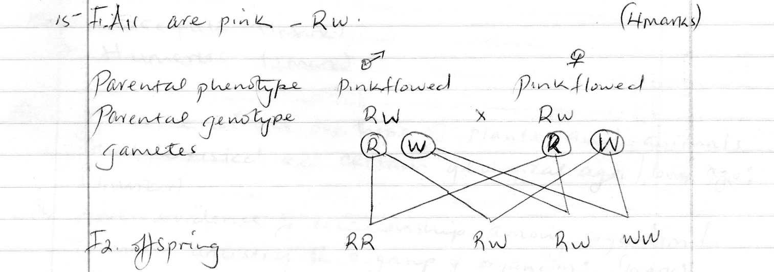

or

16. A - Synaptic cleft (1mk)

B - Mitochondria (1mk)

b) Contains the transmitter substance/Acetychlone; (1mk)

17. - Secret sebum which keeps hair and epidermal flexible and water proof;

- Sebum contains antiseptic substance for protection against bacteria; (any one)

18. a) Enable plant roots to grow deep into the soil thus offing (firm) anchorage to plants; for absorption of water and mineral salts; (1mk)

b) Enables pollen tube to grow towards the embryo sac to effect fertilization / sperm moving toward ovum/ antheridia towards the archegonia in ferns to effect fertilization (1mk)

19. a) Scapula (1mk)

b) Humerus (1mk)

20. i) Give evidence on type of plants and animals that existed at certain geological age/long ago;

ii) Gives evidence of relationship among organism/common ancestry of a group of organism; (1mk)

21. a) Increased breathing rate;/increased rate of heart beat; (1mk)

b) Mitochondria (1mk)

22. a) Allergy (1mk)

b) Pollen grains contained proteins that act as antigen when the farmer inhaled an antigen antibody reaction occurred on cell surface the cells released histamine which causes the irritation, itching and stimulated nasal discharge (2mks)

23. a) it reduces the rate of transpiration of plants thus conserving water;

b) Water absorption does not involve active transport that requires energy from respiration facilitated enzyme hence no metabolic inhibition involved (1mk)

24. a) A - condensation (1mk)

B - Hydrolysis (1mk)

b) Sucrose (1mk)

c) glycosidic bond (1mk)

25. a) Herbivorous (1mk)

b) Structural -tooth J is narrow/sharp/chisel like while tooth L is broad/ridged; (1mk)
Functional – tooth J is used for cutting and bitting while tooth L is used for grinding and crushing; (1mk)
26. a) Rhizombium bacteria (1mk)

b) Symbiosis (1mk)

27. a) Pancreatic juice containing digestive enzyme is prevented from reaching
Food ; insulin and glucagon hormones which regulates sugar are
Released directly into blood stream; (2mks)

b) i 0 c 0 pm 3 m 3 ; (1mk)
3 1 3 3

c) Slice through fresh/shearing (1mk)

28. a) Taxonomy scientific study of classification (1mk)

Taxon – a unit of classification

b) Class diplopoda (1mk)

sharp hooked strong beaks for killing/ripping off fresh from bones; sharp claws for grabbing holding prey; (2mks)

29. a) Placenta takes over the role of the ovary of producing the hormone progesterone; which maintains pregnancy; (2mks)

b) Production of male gametes/spermatozoa;
production of androgens i.e testosterone hormone which influences secondary sexual characteristics; (2mks)

30. a) Abo blood group (1mk)

b) To increase the surface area of gaseous exchange. (1mk)

c) To dissolve respiratory gases before they diffuse across. )(1mk)

<<<< E N D >>>

