NAME:………………………………………………….. INDEX NO:………………………………

CANDIDATE’S SIGNATURE:…………………………DATE…………………………………….

231/1
BIOLOGY ( Theory)
JULY, 2019
PAPER 1
TIME: 2 Hours

BUURI EAST STANDARDS
Kenya Certificate of Secondary Education
BIOLOGY 231/1
2 Hours

Instructions to candidates.

1. Answer all questions in this paper in the spaces provided after each question.
2. Candidates should answer the questions in English.

FOR EXAMINER’S USE ONLY

Total Marks | Candidate’s score
80

1. Your teacher has allowed you to carry out a study on millipedes in the school compound.

a) Name the apparatus you would use to collect the specimens. (1mk)

b) What precaution will you observe to maintain ecological balance during your study. (1mk)

2. Give the structure of the cell that perform the following functions.

a) Synthesis of ribosomes. (1mk)

b) Regulate exchange of substances in and out of the nucleus. (1mk)

3. a) State two characteristics of the kingdom monera that are not found in other kingdom. (2mks)

b) Define the term species. (1mk)

4. a) Name two tissues in plants which are thickened with lignin. (2mks)

b) How is support attained in herbaceous plants. (1mk)

5. a) State three differences between osmosis and active transport. (3mks)

b) What is meant by the term crenation. (1mk)

6. The diagram below shows a stage during fertilization in flowering plants.
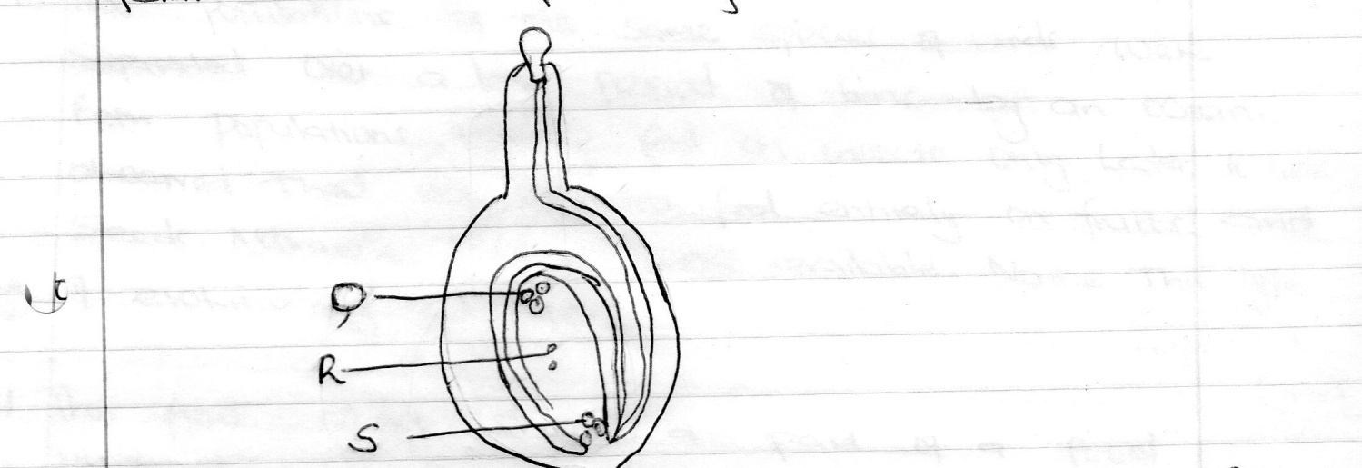

a) Name the parts labelled Q, R, S (3mks)

Q
R

S

b) State the function of the pollen tube. (1mk)

7. a) Distinguish between epigeal and hypogeal germination. (1mk)

b) Why is oxygen necessary in the germination of seeds. (2mks)

8. A dog weighing 15.2kg requires 216kJ while a mouse weighing 50g requires 273kJ per day. Explain. (2mks)

9. Account for the loss of dry weight of cotyledons in a germinating bean seeds. (1mk)

10. Two populations of the same species of birds were separated over a long period of time by an ocean. Both populations initially fed on insects only. Later it was observed that one population fed entirely on fruits and seeds. Although insects were available. Name this type of evolutionary change. (1mk)

11. The flow chart shows a part of a food relationship in an ecosystem.

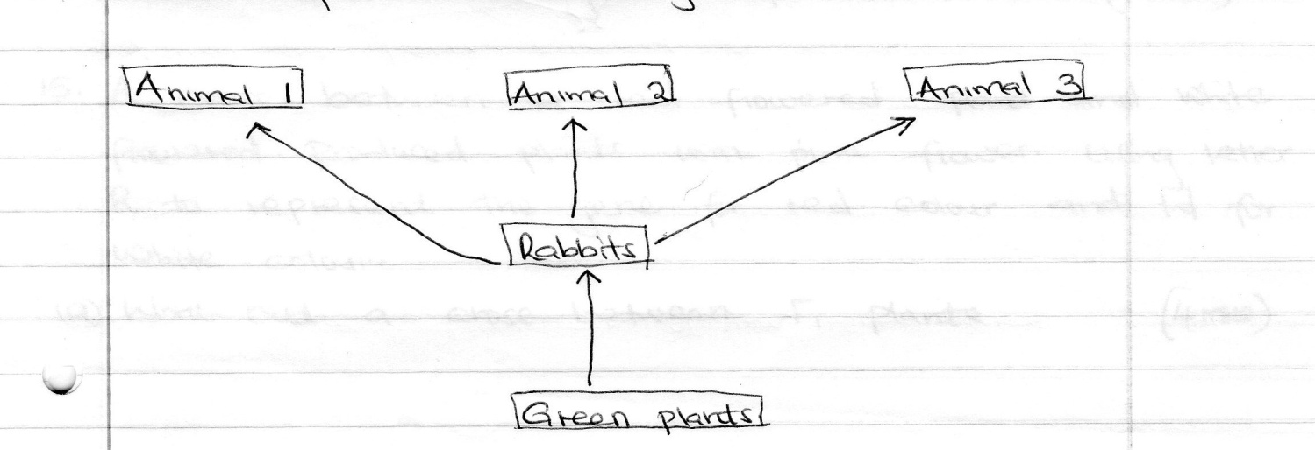

i) Name the food relationship shown (1mk)

ii) How many trophic levels are shown in the ecosystem. (1mk)

iii) What is the main source of energy in the ecosystem. (1mk)

12. a) What is the end – product of respiration in animals when there is insufficient oxygen supply? (1mk)

b) Explain how anaerobic respiration is applied in sewage treatment. (1mk)

13. give reasons for each of the following.

a) Constant body temperature is maintained in mammals. (2mks)

b) Low blood sugar is harmful to the body. (2mks)

14. Name causative agents of cholera. ( 1 mks)

15. A cross between a red flowered plant and white flowered produced plants with pink flowers. Using letter R to represent the gene for red colour and W for white colour.

a) Work out a cross between F.1 plants (4mks)

16. The following diagram shows parts of a synapse observe and answer the questions that follows.

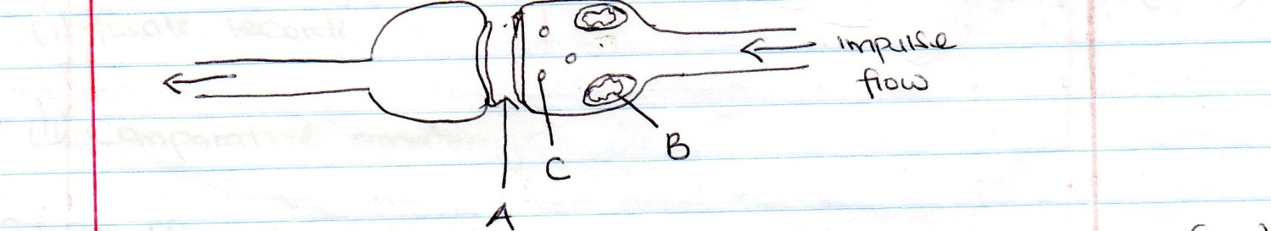

a) Name the parts labelled A and B (2mks)

A

B

b) What is the role of part labelled C. (1mk)

17. What is the importance of sebaceous glands in the human skin. (1mk)

18. Give the survival value of the following trophic responses.

a) Geotropism (1mk)

b) Chemotropism (1mk)

19. The diagram below represents a bone obtained from a mammal.
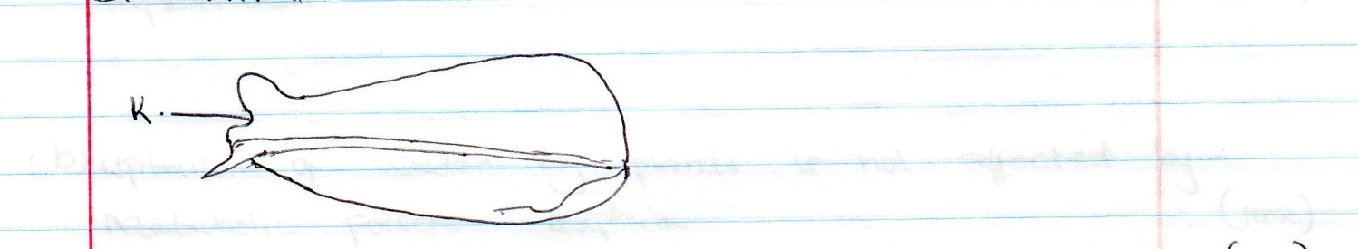

a) Name the bone (1mk)

b) Name the bone which articulates with the bone named in (a) above at the cavity labelled K. (1mk)

20. Give a reason why each of the following is important in the study of evolution today. (2mk)
i) Fossils records

ii) Comparative anatomy

21. a) Outline two physiological changes that occur in the body to lower the level of carbon (iv) oxide after vigorous physical exercise. (1mk)

b) Name the site of respiration in a cell. (1mk)

22. A farmer walked through his plantation when the plants were flowering. Immediately he developed severe itching and irritation of nasal lining with nasal discharged and sneezing due to pollen inhalation.

a) State the name of this body reaction to pollen grains. (1mk)

b) Explain how the body reaction occurs. (2mks)

23. a) Why is wilting important to plants on a hot sunny afternoon. (1mk)

b) Uptake of water by plants is not affected by metabolic poisons. Explain (1mk)

24. Study the reaction below and answer the questions that follow.

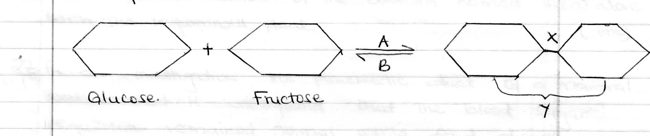

a) What biological process are represented by A and B (2mks)

A

B

b) Identify the product Y (1mk)

c) State the bond represented by X (1mk)

\

25. The diagram below represents the lower jaw of a mammal.

a) Name the mode of nutrition of the mammal whose jaw is shown. (1mk)

b) State one structural and one functional difference between the teeth labelled J and L (2mks)

Structural

Functional

26. a) Name the bacterial found in the root nodules of leguminous plant (1mk)

b) State the association of the bacteria named in (a) above with the leguminous plant. (1mk)

27. a) In an investigation, the pancreatic duct of a mammal was blocked. It was found that the blood sugar regulation remained normal while food digestion was impaired. Explain these observation. (2mks)

b) A certain animal has no incisors, no canines, 6 premolars and 6 molars in its upper jaw. In the lower jaw there are 6 incisors, 2 canines, 6 premolars and 6 molars. Write its dental formula. (1mk)

c) What is the function of carnassials teeth. (1mk)

28. a) Distinguish between Taxonomy and Taxon. (1mk)

b) An organism with an exoskeleton, segmented body, two pairs of legs per segment, a pair of eyes and a pair of short antennae belongs to which class. (1mk)

c) Explain how birds of prey are adapted to obtaining their food. (2mks)

29. a) Pregnancy continues if the ovary of an expectant mother is removed after the 4th Month. Explain (2mks)

b) What is the role of the testis in the mammalian reproductive system. (2mks)

30. a) Name a characteristic of humans, which is controlled by multiple gene (1mk)

b) Why is the skin of amphibians like frogs highly folded? (1mk)

c) The trachea have a liquid at the endings. State one reason for this (1mk)

*** E N D ***

