NAME:………………………………………………….. INDEX NO:………………………………

CANDIDATE’S SIGNATURE:…………………………DATE…………………………………….

231/2
BIOLOGY ( Theory)
JULY, 2019
PAPER 2
TIME: 2 Hours

BUURI EAST STANDARDS
Kenya Certificate of Secondary Education
BIOLOGY 231/2
2 Hours

1. Answer all questions in section A.

2. In section B answer question 6 (Compulsory) and either question 7 or 8 in the spaces Provided after question 8.

FOR EXAMINER’S USE ONLY

SECTION | Question | Candidates score
A | 1 | 8
 | 2 | 8
 | 3 | 8
 | 4 | 8
 | 5 | 8
B | 6 | 20
 | 7 | 20
 | 8 | 20
Total |  | 80

SECTION A:

Answer all questions

1. a) The diagram below represent a stage in cell division. Study it and answer the questions that follow.

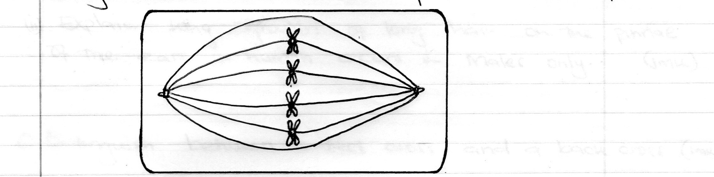

i) Identify the stage of cell division. (1mk)

ii) Give a reason for your answer. (1mk)

b) Give the role of the following parts of the male reproductive system. (2mks)

i) Epididymis

ii) Prostrate gland

c) i) Name two mechanisms that prevent self pollination in flowers that have both male and female parts. (2mks)

ii) State two disadvantages of self pollination. (2mks)

2. a) Mwiti and Karimi who are siblings are both normal but their parents have a haemophilic son. Using letter H, give the genotype of their parents. (2mks)

b) i) What are sex – linked genes. (1mk)

ii) Explain why growth of long hair on the pinnae of the ears in human occurs in males only. (1mk)

c) Distinguish between a test cross and a back cross. (1mk)

d) Part of one strand of a DNA molecule was found to have the following base sequence.

G – T – C – A – G – T

i) What is the sequence on m-RNA strand copied from this DNA portion. (1mk)

ii) State two role of DNA molecule. (2mks)

3. The diagram below represent set up to investigate the conditions necessary for seed germination. The set up was left for 5 days.
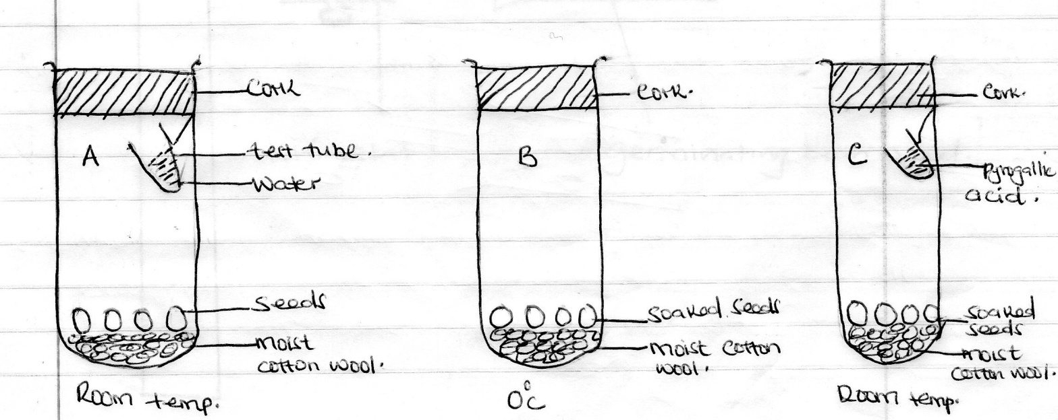

i) What conditions were being investigated in the experiment. (2mks)

ii) Explain the role of water during seed germination. (2mks)

iii) State observation made in jar A and C after five days. (2mks)

iv) Account for the results obtained in set up A and C after five days. (2mks)

4. In an experiment to investigate a plant response the set up shown in the diagram below was used.
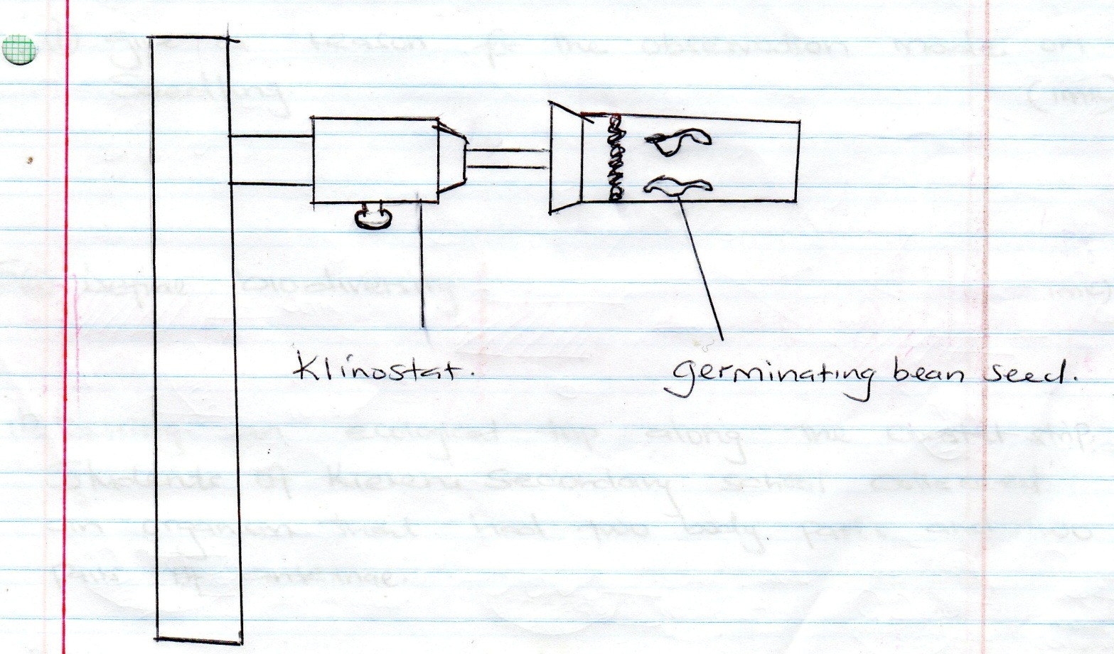

a) Name the type of response that was being investigated. (1mk)

b) If the klinostat was not rotating

i) State the observation that would be made on seedling after three days. (2mks)

ii) Explain the observation in (b) (i) above (3mks)

c) If the experiment was repeated with the Klinostat rotating.

i) State the observation that was made on the seedling after three days. (1mks)

ii) Give a reason for the observation made on seedling. (1mk)

5. a) Define bio diversity. (1mk)

b) During an ecological trip along the coastal strip. Students of Kiereni Secondary school collected an organism that had two body parts and two pairs of antennae.

i) Name the class to which this organism belonged. (1mk)

ii) Predict the number of legs the organism most likely to have. (1mk)

iii) All the observed members of this specials were found to hide under rocks and leaves. Suggests the benefits that this behavior confers to the organisms. (2mks)

c) Declining population of insects world wide should be a great concern to the human population. Explain. (3mks)

SECTION B:

Answer question 6 and either question 7 or 8.

6. Form one students of St Moses carried out an experiment to determine the percentage change in weight of two tender stems of two different plants when placed in two different sucrose solutions of different concentrations.

Sucrose concentration (Mg/ml) | 0 | 5 | 10 | 15 | 20 | 25 | 30 | 35
Percentage change in weight for plant N | 7.0 | 6.6 | 5.0 | 3.6 | 1.6 | -0.8 | -2.3 | -2.8
Percentage change in weight for plant D | 3.2 | 2.2 | 0.8 | -0.6 | -1.4 | -2.2 | -2.8 | -3.4

a) On the same axes, in the graph provided below, plot a graph of percentage weight change of the plant stem tissues against sucrose concentration. (8mks)
b) Account for the results obtained for the plant tissues at 15mg/ml sucrose concentration. (2mks)

c) From the graph, determine the concentrations of the cells saps of the two plants. (2mks)
Plant N

Plant D

d) i) Identify the plant that was most likely obtained from a more saline environment? (1mk)

ii) Explain your answer above. (1mks)

e) Describe the effect of high osmotic pressure of body fluids on urine formation. (4mks)

f) Outline two roles of active transport in human body. (2mks)

7. a) Describe the process of absorption of water from the soil to the leaves.
(10mks)
b) How is mammalian heart adapted to its function. (10mks)
8. a) Define
i) chemical evolution (2mks)
ii) organic evolution (2mks)

b) i) What are vestigial organs. (1mk)

ii) Give an example of vestigial organs in human beings. (1mk)

c) Giving example give and account for any five pieces of evidence for organic evolution. (14mks)
……………………………………………………………………………………………………………………………………………………………………………………………………………………………………………………………………………………………………………………………………………………………………………………………………………………
……………………………………………………………………………………………………………………………………………………………………………………………………………………………………………………………………………………………………………………………………………………………………………………………………………………
………………………………………………………………………………………………………………………………………………………………………………………………………………………………………………………………………………………………………………………………………………………………………………………………………………………………
………………………………………………………………………………………………………………………………………………………………………………………………………………………………………………………………………………………………………………………………………………………………………………………………………………………………
……………………………………………………………………………………………………………………………………………………………………………………………………………………………………………………………………………………………………………………………………………………………………………………………………………………………..

…………………………………………………………………………………………………………………………………………………………………………………………………………………………………………………………………………………………………………………………………………………………………………………………………………………………….
……………………………………………………………………………………………………………………………………………………………………………………………………………………………………………………………………………………………………………………………………………………………………………………………………………………………..
…………………………………………………………………………………………………………………………………………………………………………………………………………………………………………………………………………………………………………………………………………………………………………………………………………………………….
……………………………………………………………………………………………………………………………………………………………………………………………………………………………………………………………………………………………………………………………………………………………………………………………………………………
…………………………………………………………………………………………………………………………………………………………………………………………………………………………………………………………………………………………………………………………………………………………………………………………………………………………….
……………………………………………………………………………………………………………………………………………………………………………………………………………………………………………………………………………………………………………………………………………………………………………………………………………………
……………………………………………………………………………………………………………………………………………………………………………………………………………………………………………………………………………………………………………………………………………………………………………………………………………………

<<<< E N D >>>

