NAME:………………………………………………….. INDEX NO:………………………………
CANDIDATE’S SIGNATURE:…………… DATE:………………………………………
233/1
CHEMISTRY
JULY, 2018
PAPER 1
TIME: 2 HOURS

BUURI EAST STANDARDS
Kenya Certificate of Secondary Education
CHEMISTRY 233/1
2 Hours

Instructions to Candidates:

- Write your name and index number in the spaces provided above.
- Sign and write the date of examination in the spaces provided above.
- Answer all the questions in the spaces provided in the question paper.
- All working must be clearly shown where necessary.
- KNEC mathematical tables and silent electronic calculators may be used.
- Candidates should check the question paper to ascertain that all the pages are printed as indicated and that no questions are missing.
- Candidates should answer the questions in English.

FOR EXAMINER’S USE ONLY

Question | Maximum Score | Candidates score
1 - 32 | 80
Total | 80

1. Study the diagram below and answer the questions that follow.

a) Name the apparatus drawn above. (1mk)

b) State its use (1mk)

2. A student set up the experiment below to collect gas K. The glass wool was heated before heating magnesium ribbon.

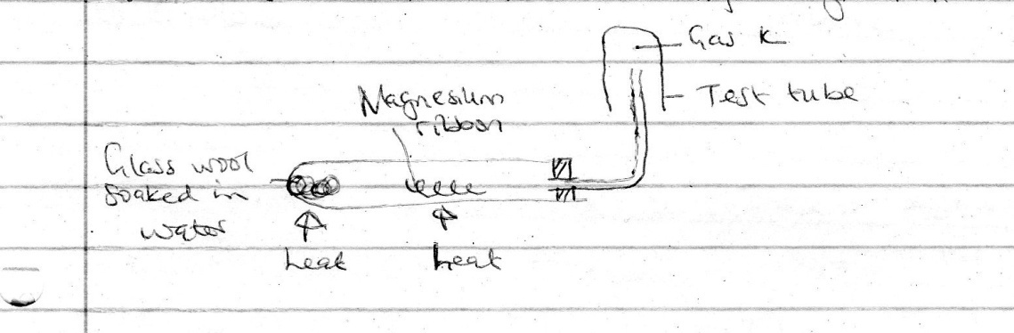

a) Why was it necessary to heat moist glass wool before heating magnesium ribbon. (1mk)

b) What would happen if the magnesium ribbon was heated before heating glass wool. (1mk)

3. A given volume of sulphur (iv) oxide (SO₂) diffused from a certain apparatus in 96 seconds. Calculate the time taken by an equal volume of carbon (iv) oxide (CO₂) to diffuse under the same conditions ( C = 12, O = 16, S = 32)
(3mks)

4. A student investigated the effect of electric current by passing it through some substances. The student used inert electrodes and connected a bulb to the circuit. The table below shows the substances used and their states.

Experiment | Substance | State
1 | Potassium carbonate | Molten
2 | Copper (ii) Sulphate | Solution
3 | Sugar | Solution
4 | Lead (ii) Bromide | Solid

a) In which experiment did the bulb not light. (1mk)

b) Explain your answer in (a) above. (2mks)

5. Using dots (.) and crosses (x) to represent electrons, draw a diagram to show bonding in sodium chloride (NaCl) ( Atomic number of Na = 11, Cl = 17) (2mks)

6. The table below shows some properties of substances K, L and M. Study it and answer the questions that follow.

Substances | Mp(⁰ C) | Solubility in water | Electrical conductivity
 |  |  | Solid state | Molten State
K | -40 | Insoluble | Poor | Poor
L | 1510 | Insoluble | Poor | Poor
M | 810 | Soluble | Poor | Good

Select a substance:

a) With a molecular structure (1mk)

b) That is not likely to be an element. (1mk)

7. State and explain the observation that would be made when a few drops of concentrated sulphuric (vi) acid are added to a small sample of hydrated copper (ii) sulphate (2mks)

8. In the equation below, identify the reagent that acts as an acid, Give a reason
(2mks)

H₂O_{2(l)} + H₂O _{(l)} H₃O⁺_{(aq)} + HO₂⁻ _{(aq)}

9. Study the flow chart below and answer the questions that follow.

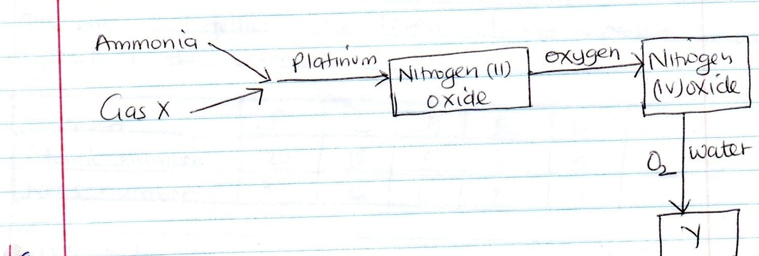

a) Identify

i) Gas X (1mk)

ii) Compound Y (1mk)

b) What is the purpose of platinum (1mk)

10. Use the information given in the table below to answer the questions that
Follow. The letters do not represent actual symbols of the elements.

Element | B | C | D | E | F
Atomic number | 20 | 18 | 5 | 3 | 5
Mass number | 40 | 40 | 10 | 7 | 11

a) Which two letters represent the same element? Give a reason.(1mk)

b) Give the number of neutrons in an atom of E. (1mk)

11. Study the equilibrium below then answer the question that follow.

2Q_{2(g)} + R_{2(g)} 2Q₂ R(g) $∆$ H = -197kJmol⁻¹
$$Type equation here.$$
$Type equation here.$
On the grid below, sketch a labelled energy level diagram for the reverse reaction. (2mks)

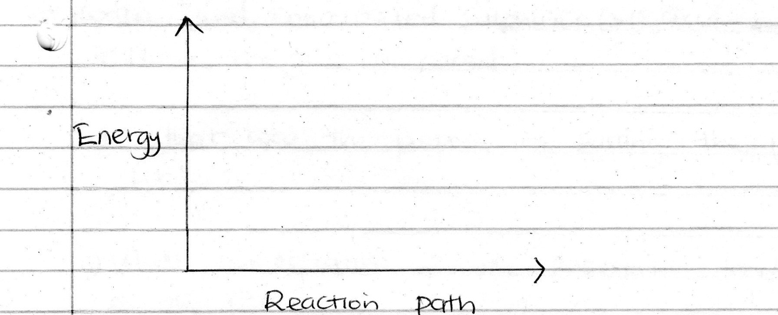

12. a) A radioactive cobalt ₂₇⁶¹Co undergoes decay by emitting a beta particle and forms a nickel (Ni) atom. Write a decay equation for the above change. (1mk)

b) The table below gives the rate of decay for a radioactive element S.

Number of days | Mass (g)
0 | 12.8
280 | 0.8

Determine the half-life of the radioactive element. (2mks)

13. An oxide of element F has the formula F₂ O₅.

a) Determine the oxidation number of F. (1mk)

b) In which group of the periodic table is element F. (1mk)

14. In an attempt to prepare a certain gas, a student added concentrated hydrochloric acid to manganese (iv) oxide and heated the mixture. The products were then passed through water and concentrated sulphuric (vi)
acid separately.

a) Name the gas prepared (1mk)

b) What was the purpose of passing the products through water? (1mk)

c) Write an equation for the reaction leading to production of the gas. (1mk)

15. The reaction between sodium carbonate is faster in hot hydrochloric acid
than with cold acid. Explain. (2mks)

16. Iron is extracted from its ore by the blast furnace.

a) Name one ore from which iron is extracted. (1mk)

b) One of the impurities in iron is removed in the from of calcium silicate. Write an equation for the reaction in which calcium silicate is produced. (1mk)

17. Use the scheme below to answer the questions that follow.

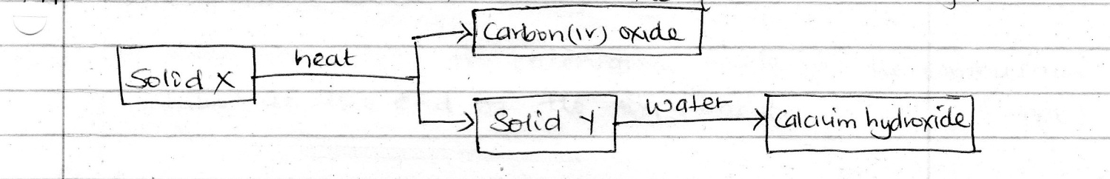

a) Identify solids. (1mk)
i) X

ii) Y

b) Describe how solid X can be prepared in the laboratory. (2mks)

18. In an experiment, a few drops of concentrated nitric (v) acid were added to aqueous iron (ii) sulphate in a test tube. Excess sodium hydroxide solution was then added to the mixture.

a) State the observation made when

i) concentrated nitric ( v) acid was added to aqueous iron (ii) sulphate. (1mk)

ii) Excess sodium hydroxide was added to the mixture. (1mk)_

b) Write an ionic equation for the reaction which occurred in (a) (ii) above. (1mk)

19. Study the diagram below and answer the questions that follow.

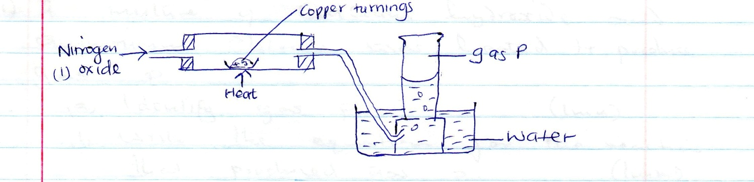

a) Name gas P (1mk)

b) State the observation made in the combustion tube at the end of the experiment. (1mk)

20. a) Define enthalpy of formation of a compound. (1mk)

b) Given that

$∆$H_{f} (CO₂) = - 394kJmol⁻¹

$∆$H_{f} (H₂)) = - 286kJmol⁻¹

$∆$H_{c}(C₄ H₁₀) = -2881kJmol ⁻¹

Calculate the molar heat of formation of butane. (C₄H₁₀) (3mks)

21. A mixture of calcium hydroxide and ammonium chloride was heated to produce gas P.

a) Identify gas P (1mk)

b) Write the equation for the reaction that produced gas P. (1mk)

c) Draw a diagram to show how gas P can be collected. (1mk)

22. Name the method that can be used to extract the following.

a) Common salt from a salt solution. (1mk)

b) paraffin from crude oil (1mk)

23. a) Draw the structural formulae of the following compounds.

i) 2 – methylpropane (1mk)

ii) But – 2 – ene (1mk)

O

b) Name the compound shown below CH₃ – C – O – CH₂ CH₃ (1mk)

24. The diagram below shows electrolysis of copper (ii) sulphate solution using coper electrodes.
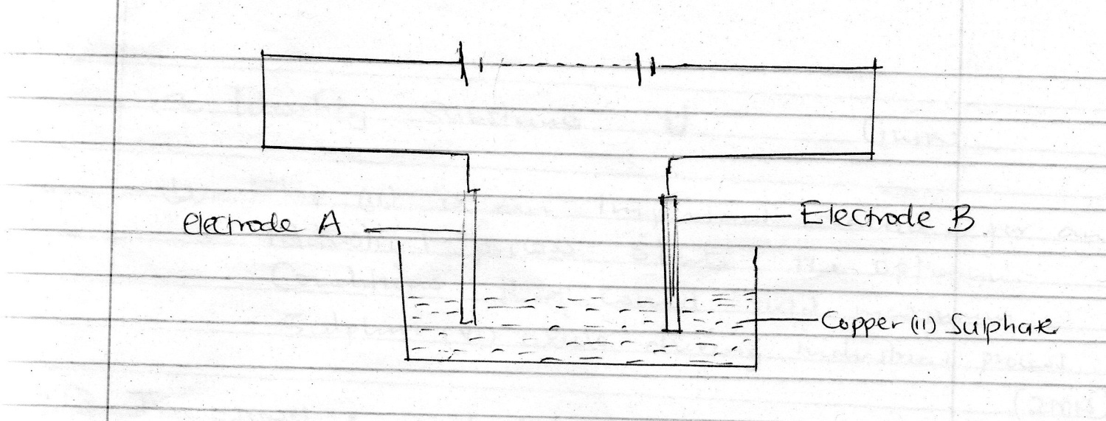

a) Which electrode loses mass and what is its polarity. (1mk)

b) What happens to the concentration of copper (ii) sulphate electrolyte with time? Explain (1mk)

c) Write down the equation for the reaction taking place at the cathode (1mk)

25. Oxygen gas can be prepared in the laboratory by decomposition of hydrogen peroxide.

i) State a suitable catalyst. (1mk)

ii) Give one use of oxygen. (1mk)

26. The flow chart below shows some reactions involving sulphur.

a) Identify substance U (1mk)

b) Step (ii) is an important reaction for an industrial process. State the optimum conditions that would yield maximum sulphur (vi) oxide during the industrial process. (2mks)

27. Two gases X₂ and Y₂ reacts to from gaseous products XY₃ according to the following equation.

X_{2(g)} + 3Y₂(_{g)} 2XY₃(g) ∆H = -44kJ

a) State two ways in which the yield of XY₃ can be increased. (2mks)

28. Calculate the volume of 0.2M hydrochloric acid that will completely neutralize 23cm³ of 0.25M sodium hydroxide. (2mks)

29. 9.12g of a gaseous compound Q contain 8g of silicon while the rest is hydrogen . Determine the empirical formula of the compound (Si = 28, H=1)
(3mks)

30. The following are half reaction for some half cells and their respective reduction potentials.

Zn²⁺ _{(aq)} + 2e- Zn_{(s)} -0.76V
Pb²⁺_{(aq)} + 2e- Pb_{(s)} -0.13V
Ag⁺_{(aq)} + e- Ag_{(s)} +0.80V
Cu²⁺_{(aq)} + 2e- Cu_{(s)} +0.34V

a) Write the overall cell equations for two electrodes which will give the highest e.m.f (1mk)

b) Calculate the e.m.f of the cell in (a) above. (2mks)

31. The set up below was used to study the effect of carbon (ii) oxide on hot
copper ( ii) oxide.
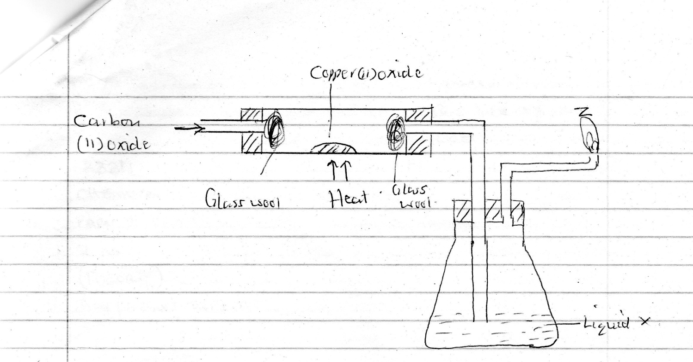

a) Give the identity of substance burning at Z. (1mk)

b) What is the purpose of liquid X. (1mk)

c) Write an equation for the burning of substance in (a) above. (1mk)

32. Element T belongs to period 3 and group vii of the period table.

a) Suggest the family name that T belongs. (1mk)

b) Determine its atomic number. (1mk)

<<< E N D >>>

