233/2
CHEMISTRY
JULY, 2018
PAPER 2
Marking scheme

BUURI EAST STANDARDS
Kenya Certificate of Secondary Education
CHEMISTRY 233/2

1. a) B/G ; it belongs to group II hence loses 2 electrons to form an ion.

b) Giant ionic

c) E is more reactive than H This is because E has smaller atomic radius hence gains an electron more readily.
(OWTTE)

d) i) Atomic radius of F is bigger than that of G

ii) P^{H} of the oxide of B is higher than that of the oxide of D

e) i) D/H

ii) a) 2.8

b) DE₃/DE₅

c) Acidic

d) Used in light bulbs
used in arch welding

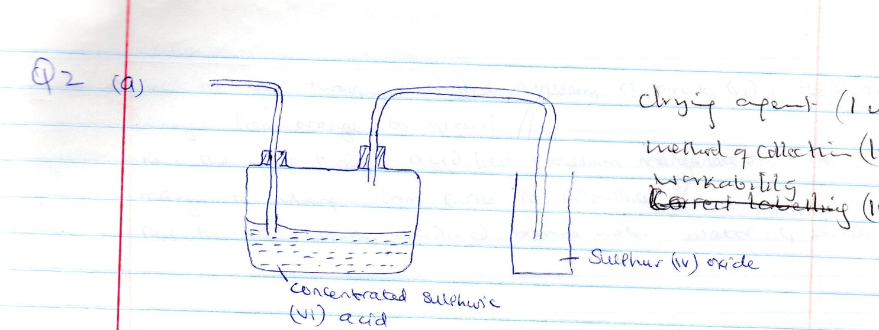

Drying agent (1mk)

Method of collection (1mk)

Workability (1mk)

b) i) Dilute hydrochloric acid// concentrated sulphuric (vi) acid

ii) Sodium sulphite / copper turnings /zinc

NB: i) Dil acid should much with a sulphate
ii) Conc. H₂SO₄ acid to match with Cu/Zn

c) Na₂SO_{3(s)} + 2HCl_{(aq)} 2NaCl_{(aq)} + SO_{2(g)} + H₂O(i) or

Cu(s) + 2H₂ SO_{4(l)} CuSO_{4(aq)} + 2H₂O_{(i)} + SO_{2(g)}

d) Magnesium ribbon continues to burn to form a white solid ( 1) and yellow solid; heat produced by burning magnesium decomposes sulphur (iv) oxide to sulpur and oxygen that reacts with magnesium to form magnesium oxide. (1)

e) Pass the gas through acidified potassium chromate (vi) the chromate changes from orange to green
pass the gas through acidified potassium manganate (vii): the manganate changes from purple to colourless
pass the gas through acidified bromine water; bromine water is decolourised.

f) As a fumigant/preservative in jam and fruit juices/making of calcium hydrogen sulphite to bleach wood pulp for manufacture of paper.

3. a) Cracking

b) Alkanes

c) Reagent : water
Condition: concentrated sulphuric (vi) acid

d) C₂H₄ and C₂H₆ are passed separately through acidified potassium chromate (vi).

C₂ H₄ changes the colour of acidified potassium chromate (vi) from orange to green.

C₂ H₆ has no effect on the colour of acidified potassium chromate (vi)

e) Hardening of oils to fats/manufacture of margarine.

f) C₂H₆ + Cl₂ Cl – CH₂ – CH₂ – Cl + 2HCl

g) Make plastic bags/film wrappers/flexible bottles/electrical wire insulators/water pipes

h) i) Soapy detergent

4. a) The process of decomposing an electrolyte by passing an electric current through it.

b) 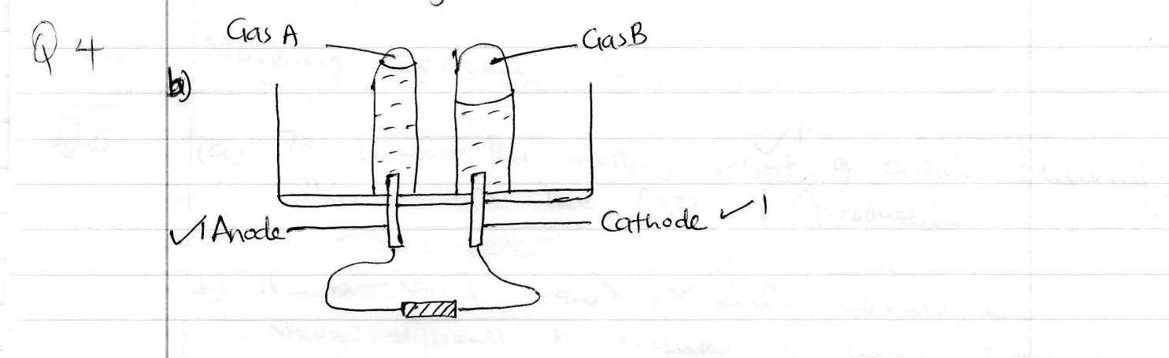

c) Oxygen

d) 4OH⁻ _{(aq)} O_{2(g)} + 2H₂ O_{(l)} + 4e⁻

e) Gas A is slightly soluble in water, some of it dissolves.

f) Dilute sulphuric (vi) acid/magnesium sulphate solution / dilute sodium chloride solution / acidified water

g) Q = 1 t ( ½ )

= 2 x 15 x 60 ( ½ )

= 1800C

2 H⁺_{(aq)} + 2e⁻ _________ H_{2(g)}

24dm³ requires 2 x 96500c ( ½ )

Xdm³ requires 1800C

X = 24 x 1800 ( ½ )
2 x 96 500

= 0.2238dm³ ( ½ )

NB: Award full mark even if the equation is missing but correctly applied.

5. a) To lower the melting point (1) of sodium chloride: this lowers the cost of production. (1)

b) it is very reactive (1 ) and would be very difficult to reduce it using common reducing agents. (1 )

c) i) Rock salt ( any two for ( 2mks)

ii) Salt petre

iii) Trona

d) The steel diaphragm separates chlorine gas from sodium and this prevents the two elements from recombining.

e) x – chlorine gas (1 )

2Cl⁻_{(s)} Cl_{2(g)} + 2e

f) Na⁺_{(l)} + e- Na_{(l)} (1)

g) - Sodium vapour used in street lamps which give yellow light.
- Manufacture of sodium cyanide (NaCN) used in extraction of gold
- An alloy of sodium and potassium is used as a coolant in nuclear reactors.

Any two for ( 2mks)

6. a) the energy changes in converting reactants to products is the same regardless of the rout by which the chemical change occurs.

b) I - 34.65⁰C $±$ 0.1⁰C

II – Acid = 22cm³ (1) base

III) ∆H = MC ∆T

M = d$×$ v = 50g ( ½ )

∆T = 34.65 - 25 = 9.65K ½

∆H = 50 x 4.2 x 9.65 ( ½ )= 2026.5J ( ½ )

c) Ammonia solution ionizes partially and hence during neutralization some energy is used to ionize its molecules fully hence lowers molar enthalpy of neutralization unlike sodium hydroxide that ionizes fully in solution.

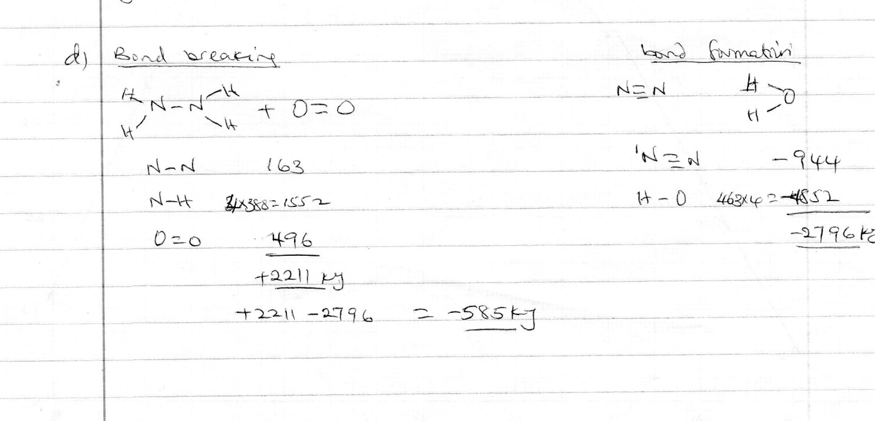

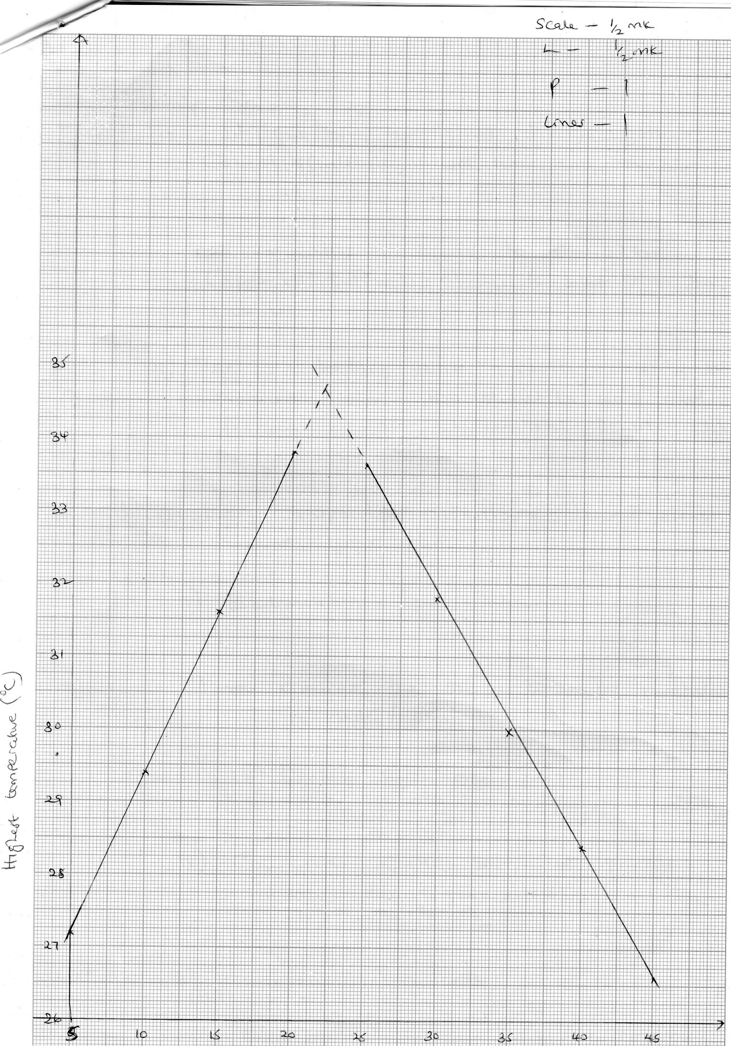

7. a) i) Add one drop of liquid to anhydrous cobalt (ii) chloride, it will turn pink from blue

Or

Add one drop of liquid to anhydrous copper (ii) sulphate change to blue colour from white.

ii) Test the boiling points of water, density or refractive index. Bp should be 100⁰C and freezes at 0⁰C at sea level. Density = 1g/cm³.

b) i) large suspended particles e.g leaves, stones sand, gravel/grit

ii) Sedimentation/precipitation

iii) a) Causes the small suspended particles to settle/precipitates.

b) Destroy micro – organisms

iv) Combines with suspended particles making them to precipitate

v) a) Permanent hardness

b) Addition of Na₂CO₃ to precipitate Mg²⁺ ions as MgCO₃

- Use distillation and residue MgSO₄ is left behind
- Use ion exchange resins which will remove Mg²⁺ _{(aq)} ions

vi) HCO₃⁻ / hydrogencarbonates

<<<< E N D >>>>

