312/1
GEOGRAPHY
JULY, 2019
PAPER 1
Marking scheme

BUURI EAST STANDARDS
Kenya Certificate of Secondary Education
GEOGRAPHY 312/1

SECTION A: (25MARKS)

1. a) Name two branches of geography (2mks)

Physical geography
Human geography
Practical geography

b) Give three reasons why it is important to study geography. (3mks)

- Geography is a career subject it provides a firm foundation for advanced studies in specialized fields like engineering, remote sensing, urban planning etc.
- Study of geography enables one to acquire basic skills and knowledge which contribute to local, regional and national development.
- Through the study of fieldwork, geography teaches one on how to manage time properly by drawing a time schedule and adhering to it.
- Geography focuses on physical study of the earth. We are therefore able to learn and explain the origin of the earth and the solar system.
- Geography enables the learners to understand and appreciate different environmental influences at work on different societies.
- Geography creates awareness in the people on the significance of management and conservation of the environment.

2. a) What is solar insolation? (2mks)

Solar insolation is the amount of sunshine reaching the surface of the earth.

b) Outline three importance of moisture in the atmosphere (3mks)

- Source of precipitation, especially rain.
- Regulating temperature on the earths surface.
- Influencing weather conditions.

3. a) State two effects of the rotation of the earth on its axis. (2mks)

- Causes day and night
- It causes deflection of ocean currents/winds.
- It causes falling and rising of the ocean tides.
- It causes different of 1 hour between 15⁰ meridian.

b) The local time at manual 60⁰W is 11.30 what is the time in Nairobi 37⁰E? (3mks)

Difference in degrees 60⁰ + 37⁰ = 97⁰

97⁰ x 4 = 388 minutes

1 hour = 60 minutes

Thus 388 ÷ 60 = 6 hours 28 minutes

Nairobi is 6 hours 28 minutes East of manual the time is 11.30 am + 6 hours 28 minutes.

= 17.58 hours or 5: 58 pm

4. a) What is an ice sheet ? (2mks)

An ice sheet is a continuous mass of ice covering a large area /surface.

b) State three positive effects of glaciations in lowland areas. (3mks)

- Glacial till provide fertile soils.
- Outwash plains have sand/gravels for building.
- Ice melts into rivers for domestic/industrial use.
- Glaciated lowland features are tourist attraction.
- Glaciated lowland are generally flat ideal for construction and building.
- Scouring effect of ice sheets may expose mineral seams.
- Lakes found on the lowland areas offer fishing grounds.

5. a) Name the two types of waves experienced in the coastal areas. (2mks)

Constructive waves

Destructive waves

b) Name three coastal features which result from wave deposition. (3mks)
- Beaches
- Spits
- Mudflats
- Tombolo
- Cuspate forelands
- Dune – belts
- Bars
- Salt marshes

SECTION B:

6. Study the map of Kitale 1 : 50,000 (sheet 75/3) provided and answer the following questions.

a) i) Give the longitudinal extent of the area covered by the map. (2mks)

35⁰ 00’ to 35⁰ 15’ E

ii) Identify the two physical features found at grid square 2320 (2mks)
Seasonal swamp
Papyrus/bog/marsh

iii) What is the magnetic inclination shown on the map (2mks)

2⁰ 25’

b) What is the altitude of the highest point in the East of Easting 40. (2mks)

2362 metres

c) Describe the drainage of the area covered by the map. (5mks)

- There are many permanent rivers e.g Koitobos and Noig gamerget.
- Some rivers form dendritic drainage pattern.
- There are both permanent and seasonal/swamps in the map.
- Most rivers flow from North to South direction.
- Main rivers are Koitobos and Noigamerget.
- There are several dams in the area covered by the map.
d) i) Give two methods used to represent relief on the map. (2mks)

Contours
Trigonometric station
Spot height

ii) Measure the distance of all weather road loose surface road from the gird point 370140 to where it ends towards Cheragani. Give your answer in Kilometres (2mks)

12.4km + 0.1 kms

e) i) Citing evidence from the map, identify five social services offered in Kitale municipality (5mks)

Social service - evidence
- Health/medical services - presence of hospital
- Housing - Built up areas/huts
- Burial services - Cemetry
- Security services - police station
- Recreational services - sport club/Kitale club
- Water supply - water tank/tower
- Religious services - church

ii) Give three types of natural vegetation found in the area covered by the map. (3mks)
Forest
Scrub
Woodland
Scattered trees
Papyrus vegetation
Thicket
Riverine trees

7. a) State two factors which influence the occurrence of underground water. (2mks)

- Precipitation and evaporation in the area.
- Porosity of rocks
- Permeability of the rocks
- Slope
- Vegetation cover

b) Differentiate between a well and spring. (2mks)

A well is a hole sunk into a permeable rock to reach the water table while a spring is a natural outflow of water from the rocks.

c) The diagram below represent an artesian basin. Use it to answer question C (i) (ii)

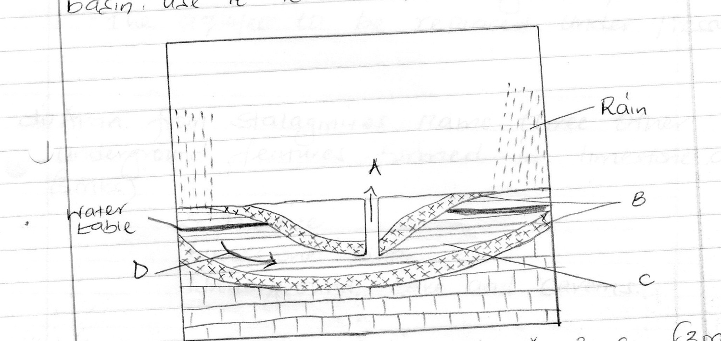

i) Name the parts marked A B, C (3mks)

A - artesian well
B - Impermeable rock
C - Aquifer/permeable rock

ii) Identify the process marked D (1mk)

percolation/infiltration

iii) State three factors which favour the location of an artesian well. (3mks)

- The aquifer must be exposed in an area of sufficient precipitation.
- The aquifer must lie in between two impermeable rocks for it to retain water.
- The aquifer must be of same permeable materials.
- The basin must dip towards a region where the land surface is lower than it is at the exposed end of the previous formation.
- There must be a partial obstruction or total blockage of exit sufficient for the water that comes in higher portion of the aquifer to be replaced under pressure.

d) i) Apart from stalagmites, name three other underground features formed in limestone areas. (3mks)

- Stalactite
- Limestone pillar
- Underground cave and caverns

ii) With the aid of a diagram describe how a stalagmite is formed. (6mks)

Rain water dissolves carbon (iv) oxide in the atmosphere. It forms a weak carbonic acid. The weak acid seeps through the roof of an underground cave. It reacts with the limestone rocks to form calcium hydrogen carbon solution. The solution drips slowly through the roof of the cave to the floor. Each drop which falls on the floor spreads out and evaporates. Residue of sodium carbonate which is in the form of tiny crystals is left on the floor. More crystals form on top of the previous ones. The accumulation of such crystals builds a structure upwards, called a stalagmite.

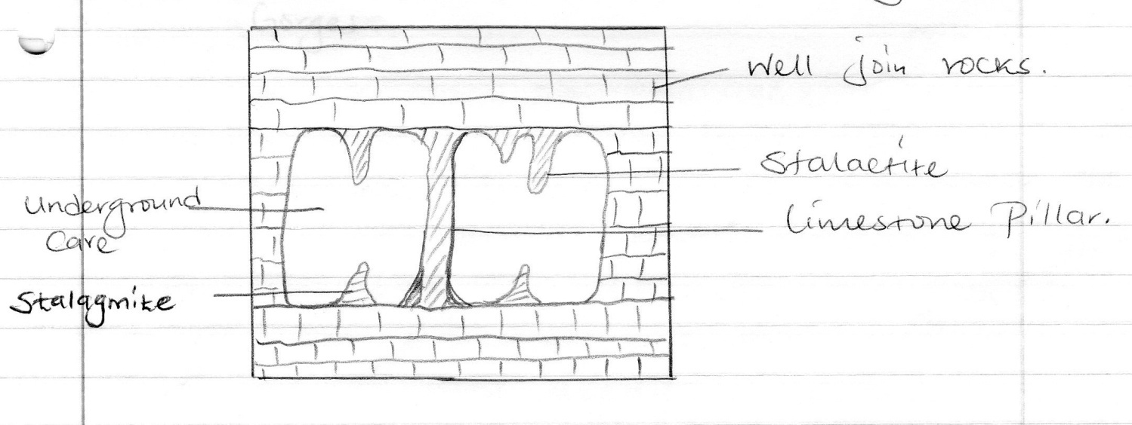

e) i) State three reasons why there are few settlement in karst landscapes. (3mks)

- The surface is rugged, thus hindering construction of transport lines.
- The surface in most places has thin soils which would not encourage agriculture.
- The surface is rocky, which is not conducive to settlement.
- The landscape experience inadequate water supply both on the surface and underground.
- The vegetation in most places is poor and would not support livestock rearing.

ii) Name two surface features found in limestone areas. (2mks)

- Dry, valleys
- Grikes
- Clints
- Swallow holes
- Doline
- Urals
- Poljes
- Gorges

8. a) i) What is secondary vegetation? (2mks)

It is the plant cover growing naturally in a place but has been interfered with by people.

1 x 2 = 2mk

ii) State five ways in which vegetation is of importance to the physical and human environments. (5mks)

- Vegetation is of aesthetic values as it adds beauty to the landscape.
- Vegetation binds soil together using its roots. It aerial parts reduce the impact of raindrops on the soil. It protects the soil against erosion.
- Plant remains decay to become humus. This improves the fertility of the soil.
- Some plants are of medicinal value to people. Their leaves, barks/into medicines.
- Some trees are used in the manufacture of paper/plywood/veneer/timber.
- Some plants are eaten by people
- Trees provide fuel.
- Vegetation cleans the environments/supplies oxygen.

Any 1 x 5 = 5mks
b) Describe three characteristics of the Mediterranean type of vegetation. (6mks)

- The vegetation is adapted to the long hot and dry summers.
- Some plants are evergreen.
- Grasses dry up during summer and germinate during winter.
- Shrubs/thickets/bush and thorn bush are common.
- Woody shrub is common in very dry areas.
- Some plants have small, spiny leaves while others have thick skinned leathery leaves.
- Some plants have long roots.
- Some plants have thick barks.
- Some plants have large and fleshy bulbous roots.
- Some plants have fleshy leaves while others have shiny/waxy leaves.
- Some trees are deciduous.

Any 3 x 2 = 6mks

c) Explain three factors which influence the distribution of vegetation in Kenya. (6mks)

- Variation in rainfall: Areas which have high rainfall tend to have forest while those with lower amounts have savanna grasslands. Those with little rainfall have scrub which gives way to desert type of drought resistant plants.
- Variation in temperature: the hot and moist lowlands have a wide variety of plants varying from tropical forests to tall grass. Hot and drier parts have scrub/scanty vegetation. Cooler highlands have fewer trees species and cold mountain tops below snowline have heath and moorland. Cold peaks have bare rock/snow.
- Soils: the light but deep sandy soils of the coast support palms while grasses are scattered and sometimes mixed with shrubs. Loamy and volcanic soils support a wide variety of plants. Saline soils support limited variety of plants.
- Drainage: Presence of water courses enhances the presence of luxuriant vegetation along the riverbanks because of abundant moisture for the plants. Well drained soils support a wide variety of plants. Waterlogged areas support swamp vegetation. Salty water at the coast support the growth of mangrove.
- Human activities: Mining and farming interfere with the original vegetation. Deforestation deplets the original vegetation and may lead to desertification.

Any 3 x 2 = 6mks

d) The students of Kaburia secondary are to carry out a field study of vegetation across a slope.

i) Formulate two hypotheses they could have made for the study.

- The density of vegetation is a function of the slope.
- The type of vegetation depends on the angle of slope.
- The trees are taller on gentle slopes than on the steeper ones.
- Plant roots penetrate deeper on steep slopes than on gentle slopes.
- Is there a relationship between the dominant plant species and the slope?

Any 2 x 1 = 2mks

ii) Give four characteristics of vegetation which they would study.

- Density of vegetation
- Composition/types of vegetation
- Height of the plants
- Distribution of plant species
- Amount/density of leaf cover
- Types of leaves of the plants
- Root depth
- Type of roots
- Characteristics of the stems and their barks.

Any 4 x 1 = 4mks

9. a) Describe podzolization as a process of leaching. (2mks)

This form of leaching occurs in cool climates where the precipitation is higher than evaporation. The soils are sandy and well drained. The soils are heavily leached of all bases including calcium magnesium sodium potassium silica and sequin axides of aluminium and iron. The dissolving is done by the organic acids that are formed when rain percolates through fallen vegetation such as the leaves of coniferous trees.

b) State three ways in which mulching helps in soil conservation. (3mks)

- Reduces evaporation of water from the soil.
- Protects the soil from erosion.
- Protects the soil from erosion.
- Increases the humus content of the soil
- Increases the rate of infiltration of water into the soil.

c) Explain how the following factors influences the formation of soil.

i) Climate (4mks)

Rainfall provides water which make it possible for rocks to decays/disintegrate to from soil. Rainfall can affect the rate at which some soil forming processes can occur e.g leaching. High temperatures increase the rate of weathering/accelerate the rate of bacterial activities which generates some of the organic matter in the soil. Water ice, and winds erode, transport soil particle in other area leading to the formation of new soil e.g losses)

ii) Topography (4mks)

valley bottoms/gentle slopes encourage the formation of deep and fertile soils due to deposition accumulation of materials. Steep slopes encourage erosion of the top layer of soils thus slowing down formation of soil/have thin soils, flat plains/floods plains are saturated with water therefore slows down forming processes. Slope influence arrangement/sequence of soil. Steep slopes are more exposed to the sun/rain which influence weathering of parents rock/soil forms.

d) i) What is soil catena? (2mks)

Soil catena is the sequence of different soils from the same parent rock on a slope.

ii) Draw a labelled diagram to show a well – developed soil profile. (3mks)
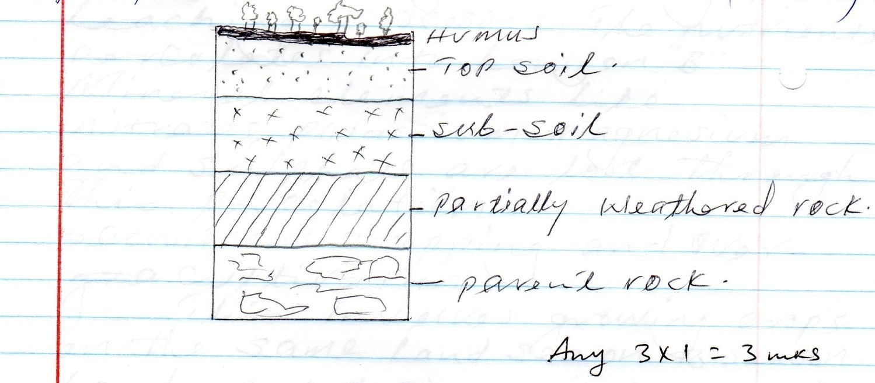
Any 3 x 1 = 3mks

e) Explain five causes of soil degeneration. (5mks)

- Soil Erosion

This removes the vegetative cover which protects the soil thus interfering with the soil texture. Wind erosion in arid areas can lead to loss of soil fertility.

- Burning of land

Clearing forms through slash and burn methods used in shifting cultivation can lead to soil degeneration.

- Mono-corpping/mono culture

Planting one type of crop repeatedly year after year, on the same plot can lead to soil degeneration.

- Leaching

Soil nutrients are lost to lower horizons during the leaching processes. The nutrients percolates into horizon B. mineral elements like nitrates potassium magnesium and sulphate are lost through this porcoloation

- Continuous cropping and over cultivation

This involves growing crops on the same land season to season. Land is not given time to rest. The soils became exhausted because the crops continue sucking the nutrients.

- Change of pH

Use of fertilizers on land continually may affect the soil pH value.

- Human activities

Ploughing of steep land down slope increases soil degeneration through soil erosion activities like carrying construction of roads may lead to soil degeneration because they interfere with soil structure.

10. a) i) Faulting is the process whereby crustal rocks fracture/crack due to Tectonic forces. (2mks)

ii) - Normal fault
- Reverse fault
- A tear/sheer / slip
- a thrust fault
- An anticlines fault

( 2 mks)

iii) M - Horst mountain
N - Rift valley
P - Scarp

(3mks)

b) i)

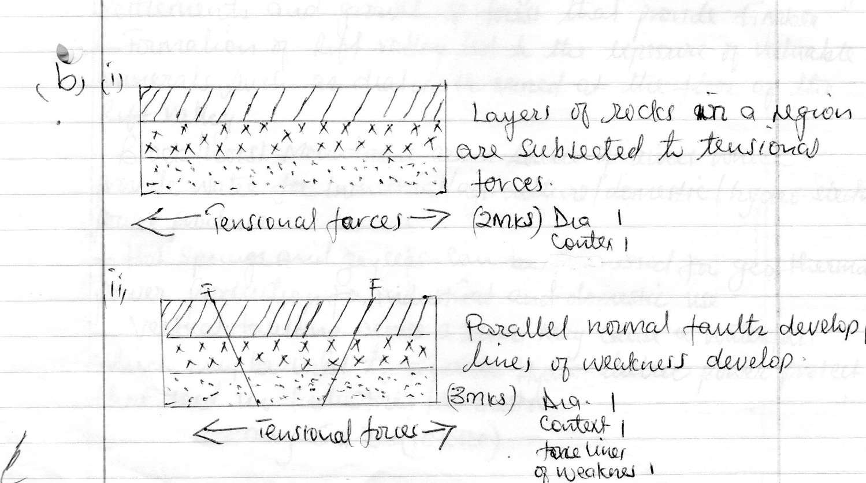

b) iii)

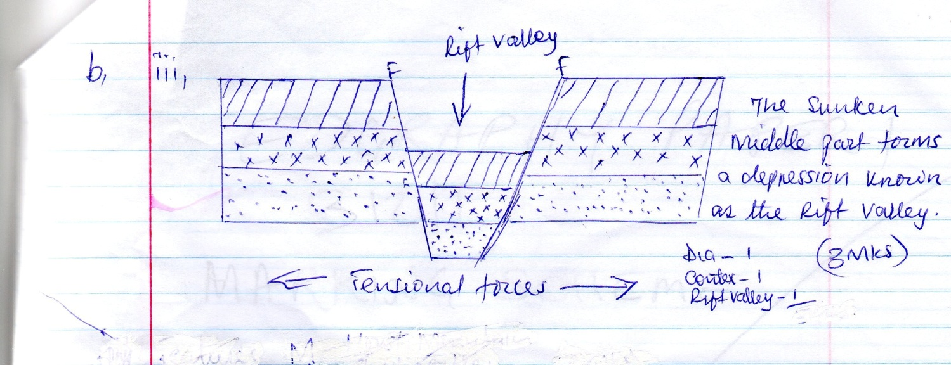

c) Explain 5 positive effects of faulting (10mks)

- Faulted features e.g rift valley and highest mountains provide unique scenery which promotes tourisms hence a source of foreign exchange.
- Some rift valley lakes are important fishing grounds/mining sites/provide water for irrigation.
- Block/host/mountains relieve high rainfall on the wind ward side which favours agriculture which encourage settlements and growth of forest that provide timber.
- Formation of rift valley led to the exposure of valuable minerals such as diatomite mined at the floor of the rift valley.
- Block/host mountains are a source of rivers which provide water for industrial/agriculture/domestic/hydro – electric power produce.
- Hot springs and geysers can be harnessed for geo – thermal power production for industrial and domestic use.
- Vertical faulting across a river may cause a water fall which may be used to generate hydro – electric power project that used in industries /domestic

Any 5 x 2 = 10mks

*** E N D ***

