312/2
GEOGRAPHY
JULY, 2019
PAPER 2
Marking scheme

BUURI EAST STANDARDS
Kenya Certificate of Secondary Education
GEOGRAPHY 312/2

SECTION A:

1. List two factors that determine the distribution of forests in Kenya. (2mks)

- Climate /rainfall/temperature
- Altitude
- Relief
- Aspect
- Soils/edaphic factors
- Animals
- Human activities
- Government policy

b) Give three economic uses of mangrove forests. (3mks)

- The bark/fruits are source of tannin
- Are sources of fuel
- Provides poles for construction / furniture making
- Are used for aqua – culture.
- Are for export/earns foreign exchange.

2. a) Name two completed hydro power stations of the seven forks. (2mks)

- Kiambere
- Kindaruma
- Gitaru
- Kamburu
- Masinga

b) State three benefits that would result from rural electrification in Kenya. (3mks)
- It would encourage setting up of industries in the rural areas.
- It would reduce the cutting down of trees.
- It would improve social amenities in the rural areas.
- Most people would invest in the rural areas.
- It would encourage development of horticultural farming.
3. a) Differentiate between emigration and immigration. (2mks)

Emigration refers to the movement of people out of their country to settle in another country while immigration refers to movement of people into a country.

b) Give three main characteristics of internal migration. (3mks)

- Rural to urban
- Urban to urban
- Urban to rural
- Rural to rural

4. a) i) Differentiate between land reclamation and land rehabilitation. (2mks)

Land reclamation is the process by which wasteland is converted into farm land for growing crops and keeping animals while land rehabilitation is the process of restoring land to its former productive state which had been lost due to human and physical factors.

ii) Name one crop grown in the polders. (1mk)

- Onions
- Tomatoes
- Barley
- Wheat
- Potatoes
- Beet root
- Oats

b) State two factors that made Mwea suitable location for an irrigation scheme. (2mks)
- Presence of perennial rivers Thiba, Murubara and Nyamindi provide adequate water throughout the year.
- Presence of black cotton soils, suitable for rice growing.
- The land is gently sloping making it possible for irrigation farming to allow flow of water by gravity.
- Presence of loamy soils made it possible to cultivate other crops to support families settled there.
- Mwea plains were sparsely populated having been previously used as communal grazing land, thus reducing cost of settling people.

5. a) State two effects of air pollution. (2mks)

- Corrosion of metals
- Foul smell
- Aggravating of lung illness
- Retarding of plant growth
- Causing headaches, dizziness, nausea, deformities, nose and eye irritation.
- Reduces visibility leading to accidents
- Acid rain
- Oxygen reduction in the atmosphere.

b) Give three reasons why it is necessary to manage and conserve our environment. (3mks)
- To serve the future generations
- For aesthetic value human beings appreciate beauty
- Protection of endangered species
- Environmental protection from degradation
- Sustenance of human life since human beings depend on the environment for their physical needs such as food, water air etc.

SECTION B:.

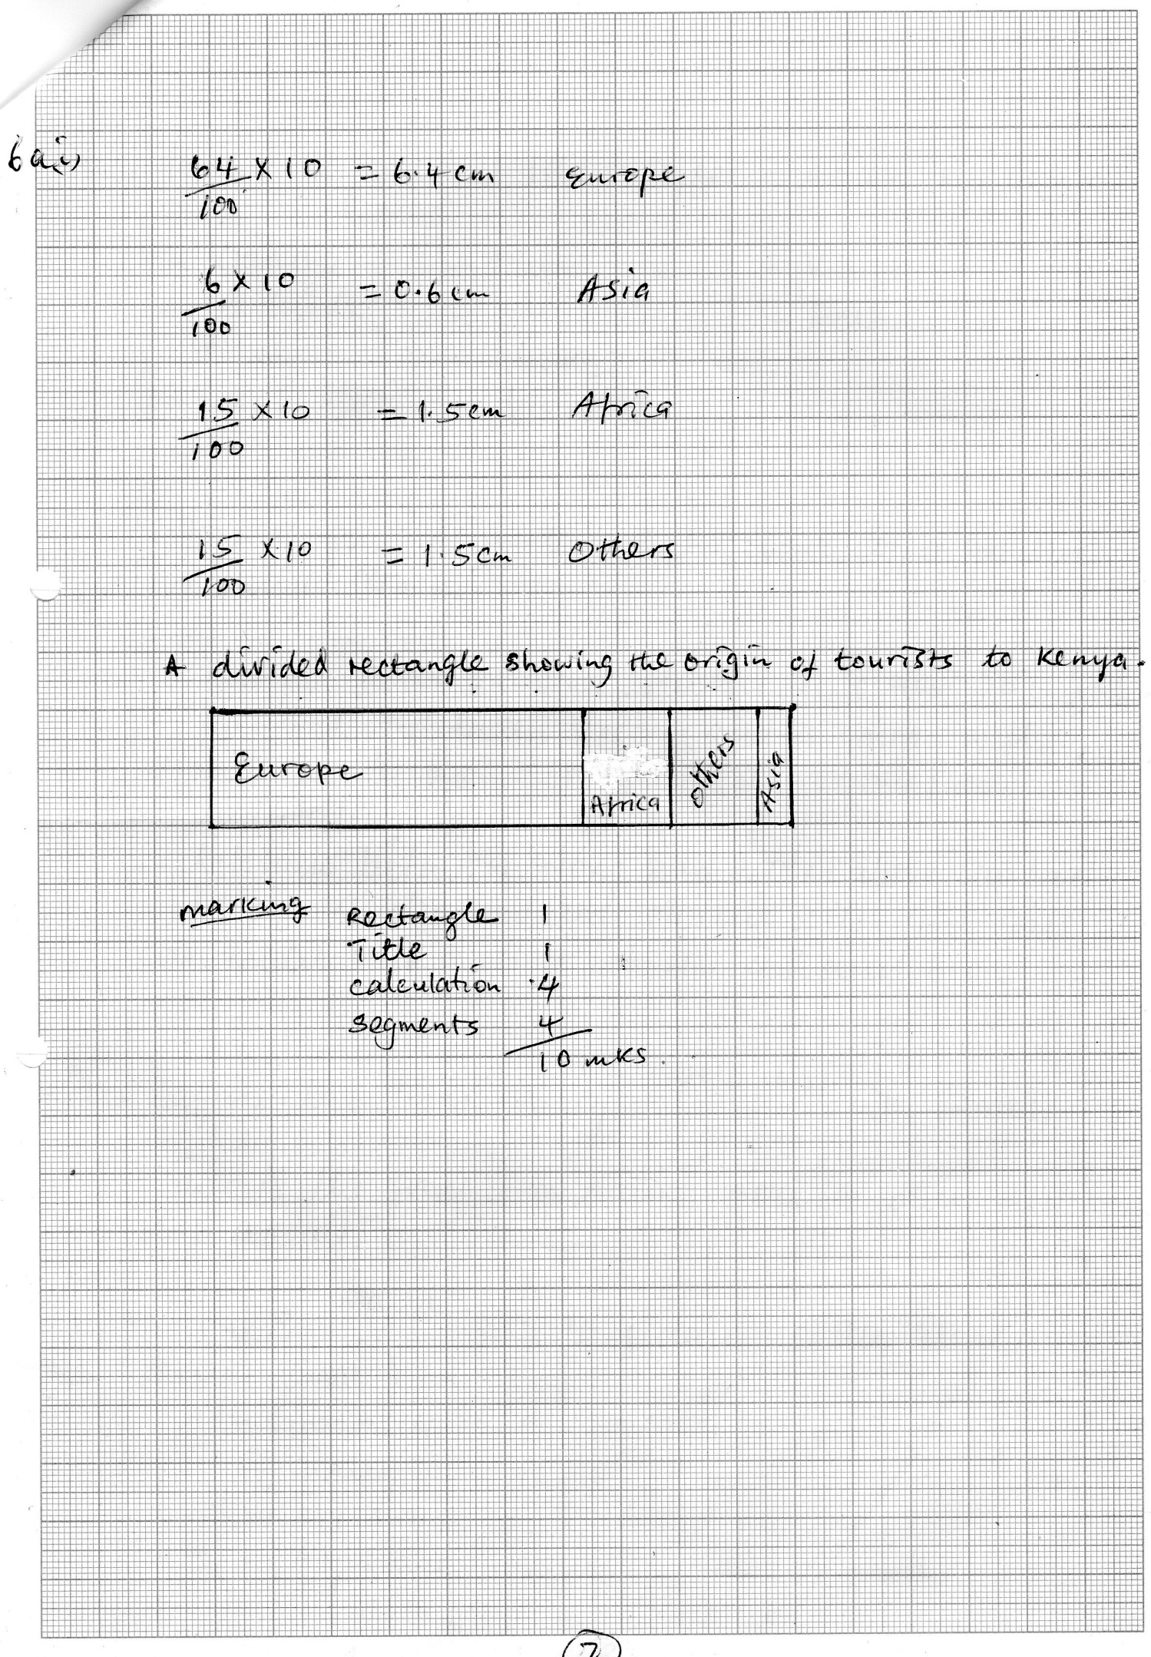
ii) Identify two advantages of using a divided rectangle to represent the data. (2mks)

- It is easy to draw/construct
- It is easy to read/interpret
- Gives a clear visual impression of individual components
- It allows comparison
- A wide range of data can be represented

b) List six features that have led to tourist attraction in Kenya. (6mks)

- Wildlife
- Beautiful scenery
- Historic and prehistoric sites
- Cultural sites
- Warm climate
- Hospitality of Kenyans
- Comfortable hotels
- Sand beaches
- Good transport network
- Security
- Games and sports
- Agricultural shows
Any 6 x 1 = 6mks

c) State three reasons why domestic tourism is encouraged in Kenya. (3mks)

- To make use of tourist facilities during low tourist seasons.
- To encourage people locally to produce handcraft to earn income.
- To facilitate interaction/cultural exchange among different communities.
- To expose Kenyans to a wider variety of recreational facilities.
- To create employment
- To earn revenue to the government
- In order for Kenyans to move around their own country.

d) What are the problems associated with tourism in Kenya. (4mks)

- Drug trafficking
- Killing of animals/poaching
- Scaring of animals
- Spread of diseases
- Unstable industry/drop in income in case of negative publicity
- Culture interference/aping of foreign culture
- School drop outs

Any 4 x 1 = 4mks
7. a) i) Name 2 counties where coffee is grown in Kenya. (2mks)

- Kiambu
- Machakos
- Nyeri
- Trans-Nzoia
- Meru
- Kisii
- Murang’a
- Kirinyaga
- Vihiga
- Embu

ii) State 4 physical factors that favour coffee growing in Kenya (4mks)

- Temperatures ranging between 14⁰c and 20 /moderate.
- Rainfall of between 1000mm and 2030mm well distributed throughout the year/moderate/high.
- \undulating landscape
- Altitude between 910M and 2100M above sea level.
- Deep well drained red volcanic soils. The soils are acidic with a pH of between 5.3 and 6.0.

b) i) Define the term “ dairy cattle farming” (2mks)

This is the practice of rearing cattle for milk and milk products.

ii) Name 3 main breeds of dairy cattle reared in Kenya. (3mks)

- Guernsey
- Jersery
- Friesian
- Ayshire

c) i) Apart from milk products, name 2 other products obtained from dairy animals (2mks)

- Hides
- Meat
- Manure from cow dung
- Biogas from cow dung

Any 2

ii) Explain the similarities of dairy cattle farming in Kenya and Denmark. (6mks)

In both countries, dairy cooperative societies assist the farmers various ways e.g providing credit facilities, extension services and marketing of the products.

Exotic breeds are reared in both countries.

Modern methods of cross – breeding using artificial insemination
are used in both countries.

In both countries zero grazing is practiced.

d) i) Name 2 exotic breeds of cattle reared in commercial ranches in both Kenya and Argentina. (2mks)

- Aberdeen Angus
- Shorthorn
- Hereford

ii) Explain 2 ways in which commercial beef cattle farming contributes to the economy of Kenya. (4mks)
\
      - Provides employment to a large number of people particularly on the ranches, slaughter houses and butcheries.
      - Beef is a source of proteins, hence it contributes to the diet of the Kenyan people.
      - Farmers involved in beef cattle farming are able to sell beef and beef products and hence earn incomes leading to improvement in their standards of living.
      - By – products like hides are raw materials in the leather industry. Shoes, handbags, belts, hats and jackets are made from hides.
      - The government earns revenue from the taxes levied on the farmers and companies making leather products.
      - Some of the animals are exported alive, thus earning the country foreign exchange.

8. a) Differentiate between transport and communication. (2mks)

Transport is the movement of goods and people from one place to another while communication is the transmission of ideas or information from one person to another.

b) Identify three problems facing mobile users. (3mks)

- It has increased the anti – social behavior such as money fraud.
- It is costly because of air time.
- It produces harmful radiations that pose health risks.
- Many cases of mobile phone theft.

c) i) List three trans – continental roads in Africa. (3mks)

- The trans – sahara highway
- The great North road
- The trans African highway

ii) Explain four problems facing railway transport in Africa. (8mks)

- African countires use different railway gauges which makes it difficult to have an integrated railway transport system.
- Construction of railways require large amount of capital that most countries lack to extend/maintain the existing lines.
- Tropical storm waters at time wash away vital sections of the railway lines thereby disrupting transport.
- Railway transport faces stiff competation from the faster / flexible means of transport such as road and air transport leading to underutilization of facilties.
- Fueling/maintenance of railway stations and other related overhead costs are high thus reducing profit margins.

d) i) Identify three types of inland waterways used for transport in Africa. (3mks)

- Rivers
- Lakes
- Canals

ii) State three ways in which the Great Lakes and St. Lawrence Sea way has contributed to the growth of industries in the region. (3mks)

- It has increased both internal and external trade.
- It has facilitated the transportation of bulky products.
- It has reduced the cost of transportation of bulky products.
- Reservoirs along the sea way provide HEP for industrial use.
- It has led to the development of lake ports and towns.
e) State three recent development that have taken place in Kenya to improve communication of information. (3mks)

- Liberalization of airwaves/licensing of more private radio/T.V stations
- Introduction of E-mail internet/fax (telefax)
- Introduction of mobile phones/cell phones
- Liberalization of the press
- Expansion of telephone facilities
- Liberalization of postal services

9. a) What is urbanization? (2mks)

It is the process whereby there is an increase of the total population in a country settling in towns/changes from primary to secondary and tertiary production leading to growth of towns.

1 x 2 = 2mk

b) i) Apart from the central business district (CBD) name three other functional zones of a town.
(3mks)

- Industrial zone
- Commuter zone
- High class residential
- Transitional/light manufacturing
- Residential zone
- Low class residential
- Suburbs

Any 3 x 1 = 3mks

ii) What are the characteristics of the central business districts?? (3mks)

- It has the highest concentration of high storey buildings in an urban centre.
- The area has very high rental value
- It is an area where most routes leading to the town converge
- It is easily accessible

Any 3 x 1 = 3mks

c) State the factors that have favoured the rapid growth of Thika town as an industrial centre. (6mks)

- There is excellent road network
- It enjoys proximity to the capital city of Nairobi
- There is availability of land for industrial growth/expansion
- There is abundant supply of water from River Chania
- There is availability of local laobur
- It is administrative centre
- There is availability of building materials
- There is adequate social amenities

Any 6 x 1 = 6mks

d) Explain four problems facing urban centres in Kenya.
(8mks)

- There is serious traffic congestion during rush hours leading to loss of time.
- The rapid growth of population has led to an acute shortage of houses leading to rising of slums
- The heaps of uncollected garbage cause a health hazard as they can lead to epidemics.
- Large unemployed population in urban centres lead to increased crime/immoral practices/beggars.
- Most urban centres suffer from water shortage due to increased number of consumers.
- Poor sewage system in some part of town cause of health harzard.
- Rapid growth of population lead to shortage of social amenities/education/health services.
- Pollution of water/air/sounds form industries/vehicles causes health hazards.

Any 4 x 2 = 8mks

e) What three benefits would be there if more commuters in urban centres in Kenya used public transport? (3mks)

- It would help to ease traffic congestion
- It would help to reduce the rate of air pollution
- It would save fuel energy
- It would require less room for parking
- Generally more financial savings will be realized.

Any 3 x 1 = 3mks

10 a) Define cottage industry . (2mks)

A cottage industry is one whose labour force consists of people working at home with their own tools or simple machinery.

b) Give three characteristics of the cottage industry in India.
(3mks)

- They are owned by individuals /families / groups.
- The cottage industries are rural based.
- The work in the industries is usually carried out manually although sometimes machines are used.
- The industries are operated in homes small workshops.
- The products are for both domestic and exports markets.
- The industry are ubiquitous or are found almost throughout the country.

C i) Briefly explain three problems facing the Ruhr industrial region (6mks)

Congestion and overcrowding. Large influx of people to the Ruhr
region in searcher of employment as led to congestion and over
crowding.

Pollution coal which is the major fuel is a major pollutant. Industries also emit smoke fumes which pollutes the environment.

Depletion of coal mines. Coals is non – renewable resource and the continued mining has led to depletion of the local mines.

ii) Outline three major car manufacturing regions in Japan. (3mks)

- The Torkyo – Yokohama industrial zone
- Osaka – kobe industrial zone
- Nagoya industrial zone

d) i) Explain four ways in which Kenya has benefited form industrialization (8mks)

- Kenya exports industrial goods thus earning foreign exchange.
- It has created employment opportunities thus raising the standards of living.
- It has led to the development of transport and communication for easy movement.
- It has facilitated the establishment of social amenities in the area where industries are located improving living standards.
- It has led to the acquisition of management / technical skill which are also used in other sectors of the economy.
- It has led to reduction of some industrial goods thus saving foreign exchange.

ii) Name three agricultural/non food industries in Kenya. (3mks)

- Textile processing industries
- Tobacco processing industries
- Pulp and paper industries
- Sisal fibre making
- Pyrethrum processing
- Foot wear ( leather tanning)

<<<< E N D >>>>

