Name……………………………………………………………………………..IndexNo…………………………………….Class………..
443/1
AGRICULTURE
PAPER 2
KASSU 1 EXAMINATION – 2018
2 HOURS
KASSU EXAMINATION
AGRICULTURE
Paper 1
2 Hours
Instructions to candidates.
1 Write your name and Index number in the spaces provided above.
2 This paper consists of three sections: A, B and C.
3 Answer all questions in sections A and B and any other question from section C.
4 Do not any pages from the question paper.
5 Candidates should check the question paper to ascertain that all the pages are printed as indicated and that no questions are missing. Number of printed pages are 12.

For Examiner’s use only
Section | Questions |  | Maximum Score | Candidate’s Score
A | 1 -17 |  | 30
B | 18- 21 |  | 20
C | 22 – 24 |  | 20
 |  |  | 20
 |  | TOTAL | 90

Section A (30 Marks)
Answer all questions in this section in the spaces provided.
1 Name four dual purpose breeds of cattle. (2mks)
…………………………………………………………………………………………………………………………………………………………………………………………………………………………………………………………………………………………………………………………………………………………………………………………………………………………………………………………………………………………………………………………………………………………………………………………………………………………………………………………………………
2 Give the characteristics that distinguishes N ewzealand white breed of rabbit from Kenya white. (1mk)
………………………………………………………………………………………………………………………………………………………………………………………………………………………………………………………………………………………………………………………………………………………………………………………………………………………………………………………………………………………………………
3 (a) What is line-breeding? (1mk)
………………………………………………………………………………………………………………………………………………………………….
(b) Why do animal breeders sometimes opt for line breeding? ( ½ mk)
………………………………………………………………………………………………………………………………………………………………….
4 Name two tractor-drawn implements that are attached to the draw-bar. (1mk)
…………………………………………………………………………………………………………………………………………………………………………………………………………………………………………………………………………………………………………………………………..
5 Give two uses of a foot bath in a plunge dip. (1mk)
……………………………………………………………………………………………………………………………………………………………………………………………………………………………………………………………………………………………………………………………………
6 State three signs of heat in a doe (female rabbit). (1 ½ mks)
……………………………………………………………………………………………………………………………………………………………………………………………………………………………………………………………………………………………………………………………………………………………………………………………………………………………………………………………………………………………………..
7 Give two reasons for “crutching” in sheep. (2mks)
……………………………………………………………………………………………………………………………………………………………………………………………………………………………………………………………………………………………………………………………………
8 Outline four signs of parturition in a dairy cow. (2mks)
…………………………………………………………………………………………………………………………………………………………………………………………………………………………………………………………………………………………………………………………………………………………………………………………………………………………………………………………………………………………………………………………………………………………………………………………………………………………………………………………………………
9 Outline four disadvantages of free range system of poultry rearing. (2mks)
…………………………………………………………………………………………………………………………………………………………………………………………………………………………………………………………………………………………………………………………………………………………………………………………………………………………………………………………………………………………………………………………………………………………………………………………………………………………………………………………………………
10 (a) Give four reasons for steaming up a dairy cow. (2mks)
…………………………………………………………………………………………………………………………………………………………………………………………………………………………………………………………………………………………………………………………………………………………………………………………………………………………………………………………………………………………………………………………………………………………………………………………………………………………………………………………………………
(b) State three functions of vitamins in livestock nutrition. (1 ½ mks)
………………………………………………………………………………………………………………………………………………………………………………………………………………………………………………………………………………………………………………………………………………………………………………………………………………………………………………………………………………………………………
11 Give three reasons why raddling is done in sheep. (1 ½ mks)
………………………………………………………………………………………………………………………………………………………………………………………………………………………………………………………………………………………………………………………………………………………………………………………………………………………………………………………………………………………………………
12 (a) List three methods used to extract honey from combs. (1 ½ mks)
………………………………………………………………………………………………………………………………………………………………………………………………………………………………………………………………………………………………………………………………………………………………………………………………………………………………………………………………………………………………………
(b) Outline three reasons why tilapia fish is commonly kept by fish farmers in Kenya. (1 ½ mks)
…………………………………………………………………………………………………………………………………………………………………………………………………………………………………………………………………………………………………………………………………………………………………………………………………………………………………………………………………………………………………………………………………………………………………………………………………………………………………………………………………………
13 Outline two reasons for liming fish ponds. (1mk)
……………………………………………………………………………………………………………………………………………………………………………………………………………………………………………………………………………………………………………………………………
14 Give a reason why sheep should be sheared during the dry season. (1mk)
…………………………………………………………………………………………………………………………………………………………………
15 List four methods of identification in dairy cattle. (2mks)
…………………………………………………………………………………………………………………………………………………………………………………………………………………………………………………………………………………………………………………………………………………………………………………………………………………………………………………………………………………………………………………………………………………………………………………………………………………………………………………………………………
16 (a) State two practices carried out on eggs before they are put in an incubator for hatching. (1mk)
……………………………………………………………………………………………………………………………………………………………………………………………………………………………………………………………………………………………………………………………………

(b) Give three measures that help control egg – eating in a deep litter system. (1 ½ mks)
………………………………………………………………………………………………………………………………………………………………………………………………………………………………………………………………………………………………………………………………………………………………………………………………………………………………………………………………………………………………………
17 (a) Identify the infective stage of a liver fluke. ( ½ mk)
……………………………………………………………………………………………………………………………………………………………..
(b) Give two reasons why drenching alone is not an effective method of controlling intestinal parasites in livestock. (1mk)
…………………………………………………………………………………………………………………………………………………………………………………………………………………………………………………………………………………………………………………………………….
SECTION B (20 Marks)
Answer all questions in this section in the spaces provided.
18 Study the illustration of tractor drawn implement and answer questions that follow.
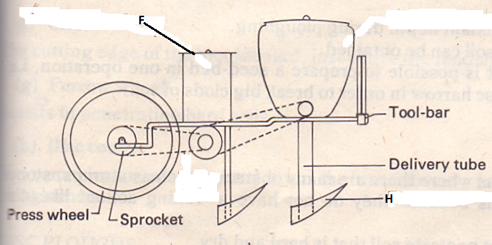
(a) Identify the implement illustrated above. (1mk)
…………………………………………………………………………………………………………………………………………………………………..
(b) Name the parts labeled F and H illustrated above. (1mk)
F…………………………………………………………………………………………………………………………………………
H…………………………………………………………………………………………………………………………………………
(C ) Give two main uses of the implement above. (1mk)
……………………………………………………………………………………………………………………………………………………………………………………………………………………………………………………………………………………………………………………………………
(d) Give two maintenance practices carried out on the implement above. (2mks)
……………………………………………………………………………………………………………………………………………………………………………………………………………………………………………………………………………………………………………………………………
19 The illustration below shows a workshop tool. Study it and answer questions that follow.
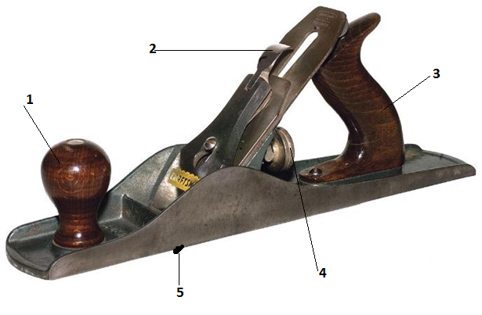
(a) Name the parts labeled 1, 2, 3 and 4. (2mks)
1……………………………………………………………………………………………………………………………………………
2……………………………………………………………………………………………………………………………………………
3…………………………………………………………………………………………………………………………………………..
4…………………………………………………………………………………………………………………………………………..
(b) Give one use of the tool illustrated above. (1mk)
………………………………………………………………………………………………………………………………………………………………….
(c ) Give two maintenance practices carried out on the part labeled 5 on the tool above. (2mks)
……………………………………………………………………………………………………………………………………………………………………………………………………………………………………………………………………………………………………………………………………
20 Study the illustration below and answer questions that follow.
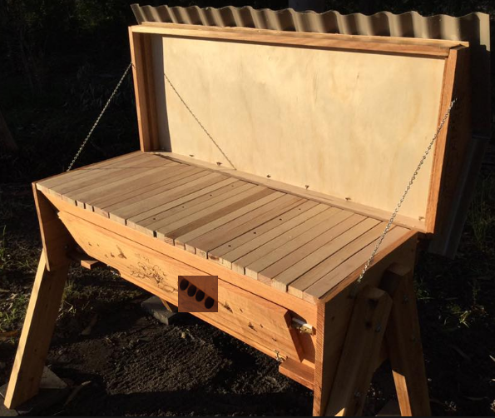
M
L
N
(a) Identify the type of bee hive illustrated above. (1mk)
………………………………………………………………………………………………………………………………………………………………….
(b) State the functions of the parts labeled L,M and N. (1 ½ mks)
L………………………………………………………………………………………………………………………………………….
M………………………………………………………………………………………………………………………………………..
N………………………………………………………………………………………………………………………………………..
(C )Name the tool used to detach honey combs from the bars during harvesting. ( ½ mk)
…………………………………………………………………………………………………………………………………………………………………
(d) Give two advantages of the type of bee hive illustrated above. (2mks)
…………………………………………………………………………………………………………………………………………………………………………………………………………………………………………………………………………………………………………………………………….
21 The illustration below shows a structure of a tractor cooling system. Study it and answer questions that follow.
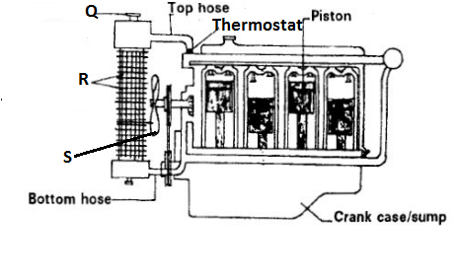
(a) Identify the structure. ( ½ mk)
…………………………………………………………………………………………………………………………………………………………………
(b) Name the parts labeled Q , R and S. ( 1 ½ mks)
Q………………………………………………………………………………………………………………………………………
R……………………………………………………………………………………………………………………………………….
S……………………………………………………………………………………………………………………………………….
(c ) Give three maintenance practices of the system illustrated above. (3mks)
………………………………………………………………………………………………………………………………………………………………………………………………………………………………………………………………………………………………………………………………………………………………………………………………………………………………………………………………………………………………………

SECTION C (40 Marks)
Answer any Two questions from this section in the spaces provided after every question.
22 (a) Describe how the four stroke cycle engine operates. ( 12mks)
……………………………………………………………………………………………………………………………………………………………………………………………………………………………………………………………………………………………………………………………………………………………………………………………………………………………………………………………………………………………………………………………………………………………………………………………………………………………………………………………………………………………………………………………………………………………………………………………………………………………………………………………………………………………………………………………………………………………………………………………………………….……………………………………………………………………………………………………………………………………………………………………………………………………………………………………………………………………………………………………………………………………………………………………………………………………………………………………………………………………………………………………………………………………………………………………………………………………………………………………………………………………………………………………………………………………………………………………………………………………………………………………………………………………………………………………………………………………………………………………………………………………………….……………………………………………………………………………………………………………………………………………………………………………………………………………………………………………………………………………………………………………………………………………………………………………………………………………………………………………………………………………………………………………………………………………………………………………………………………………………………………………………………………………………………………………………………………………………………………………………………………………………………………………………………………………………………………………………………………………………………………………………………………………….
(b) Outline four functions of the gear box in a tractor. (4mks)
………………………………………………………………………………………………………………………………………………………………………………………………………………………………………………………………………………………………………………………………………………………………………………………………………………………………………………………………………………………………………………………………………………………………………………………………………………………………………………………………………………………………………………………………………………………………………………………………………………………………………………………………………………………………………………………………………………………………………………………………………………

(c) Give four advantages of biogas as source of power in the farm. (4mks)
……………………………………………………………………………………………………………………………………………………………………………………………………………………………………………………………………………………………………………………………………………………………………………………………………………………………………………………………………………………………………………………………………………………………………………………………………………………………………………………………………………………………………………………………………………………………………………………………………………………………………………………………………………………………………………………………………………………………………………………………………………….
23 (a) Explain calf Pneumonia disease under the following sub-headings.
(i) Give three predisposing factors. (3mks)
…………………………………………………………………………………………………………………………………………………………………………………………………………………………………………………………………………………………………………………………………………………………………………………………………………………………………………………………………………………………………………………………………………………………………………………………………………………………………………………………………………
(ii) State five symptoms of the disease. (5mks)
……………………………………………………………………………………………………………………………………………………………………………………………………………………………………………………………………………………………………………………………………………………………………………………………………………………………………………………………………………………………………………………………………………………………………………………………………………………………………………………………………………………………………………………………………………………………………………………………………………………………………………………………………………………………………………………………………………………………………………………………………………….
(iii) Give two control measures of the disease. (2mks)
……………………………………………………………………………………………………………………………………………………………………………………………………………………………………………………………………………………………………………………………………
(b) Describe ten uses of fences in the farm. (10 mks)
……………………………………………………………………………………………………………………………………………………………………………………………………………………………………………………………………………………………………………………………………………………………………………………………………………………………………………………………………………………………………………………………………………………………………………………………………………………………………………………………………………………………………………………………………………………………………………………………………………………………………………………………………………………………………………………………………………………………………………………………………………………………………………………………………………………………………………………………………………………………………………………………………………………………………………………………………………………………………………………………………………………………………………………………………………………………………………………………………………………………………………………………………………………………………………………………………………………………………………………………………………………………………………………………………………………………………………………………………………………………………………………………
24 (a) Describe the life cycle of a three –host tick. (6mks)
………………………………………………………………………………………………………………………………………………………………………………………………………………………………………………………………………………………………………………………………………………………………………………………………………………………………………………………………………………………………………………………………………………………………………………………………………………………………………………………………………………………………………………………………………………………………………………………………………………………………………………………………………………………………………………………………………………………………………………………………………………………………………………………………………………………………………………………………………………………………………………………………………………………………………………………………………………………………………………………………………………………………………………………………………………………………………………………………………………………………………………………
(b) Describe the process of training a dairy calf to drink milk from the bucket (5mks)
…………………………………………………………………………………………………………………………………………………………………………………………………………………………………………………………………………………………………………………………………………………………………………………………………………………………………………………………………………………………………………………………………………………………………………………………………………………………………………………………………………………………………………………………………………………………………………………………………………………………………………………………………………………………………………………………………………………………………………………………………………………………………………………………………………………………………………………………………………………………………………………………………………………………………………………………………………………………………………………………………………………….

(c)Outline six essentials of clean milk production. ( 6mks)
……………………………………………………………………………………………………………………………………………………………………………………………………………………………………………………………………………………………………………………………………………………………………………………………………………………………………………………………………………………………………………………………………………………………………………………………………………………………………………………………………………………………………………………………………………………………………………………………………………………………………………………………………………………………………………………………………………………………………………………………………………………………………………………………………………………………………………………………………………………………………………………………………………………………………………………………………………………………………………………………………………………………………………………………………………………………………………………………………………………………………………………….
(d) Explain three causes of cannibalism in a flock of layers. (3mks)
……………………………………………………………………………………………………………………………………………………………………………………………………………………………………………………………………………………………………………………………………………………………………………………………………………………………………………………………………………………………………………………………………………………………………………………………………………………………………………………………………………………………………………………………………………………………………………………………………………………………………………………………………………………………………………………………………………………………………………………………………………….

