Name: ……………………………………………... Index no ……..…......................................

School: …………………………………………….. Candidate’s sign …………………….......

Class………………………………………….…..… Adm No…………………...……………...

AGRICULTURE
PAPER 1
JULY 2018
TIME: 2 HOURS

FORM FOUR MOKASA II MOCK
Kenya Certificate of Secondary Education (K.C.S.E.)
Agriculture
Paper 1

INSTRUCTIONS TO CANDIDATES:
- Write your name, index number, school, class and admission number in the spaces provided.
- Sign and write the date in the spaces provided above.
- Answer all the questions in section A and B
- Answer any two questions in section C.
- Answers should be written in the spaces provided in this booklet.
For Examiner’s Use Only:
SECTION | QUESTIONS | MAXIMUM SCORE | CANDIDATES SCORE
A | 1-15 | 30
B | 16-19 | 20
C |  | 20
 |  | 20
 | TOTAL | 90

This paper consists of 12 printed pages. Candidates should check to ascertain that all pages are printed as indicated and that no questions are missing.
SECTION A (30MARKS)
- State four ways by which biological agents can enhance the process of soil formation.
(2mks)
………………………………………………………………………………………………………………………………………………………………………………………………………………………………………………………………………………………………………………………………………………………………………………………………………………………………………………………………………………………………………………………………………………………………………………………………
- State four disadvantages of flood irrigation. (2mks)
………………………………………………………………………………………………………………………………………………………………………………………………………………………………………………………………………………………………………………………………………………………………………………………………………………………………………………………………………………………………………………………………………………………………………………………………
- Give four advantages of early planting in crop production. (2mks)
………………………………………………………………………………………………………………………………………………………………………………………………………………………………………………………………………………………………………………………………………………………………………………………………………………………………………………………………………………………………………………………………………………………………………………………………………………………………………………………………………………………………
- State four importance of good soil aeration in crop production. (2mks)
………………………………………………………………………………………………………………………………………………………………………………………………………………………………………………………………………………………………………………………………………………………………………………………………………………………………………………………………………………………………………………………………………………………………………………………………………………………………………………………………………………………………
- Distinguish between oversowing and undersowing in pasture establishment. (2mks)
………………………………………………………………………………………………………………………………………………………………………………………………………………………………………………………………………………………………………………………………………………………………………………………………
- Give four advantages of establishing a mixed grass legume pasture instead of planting a pure grass pasture. (2mks)
………………………………………………………………………………………………………………………………………………………………………………………………………………………………………………………………………………………………………………………………………………………………………………………………………………………………………………………………………………………………………………………………………………………………………………………………………………………………………………………………………………………………
- Give four farming practices that may lead to soil erosion. (2mks)
………………………………………………………………………………………………………………………………………………………………………………………………………………………………………………………………………………………………………………………………………………………………………………………………………………………………………………………………………………………………
- Give four disadvantages of chemical pest control in crop production. (2mks)
………………………………………………………………………………………………………………………………………………………………………………………………………………………………………………………………………………………………………………………………………………………………………………………………………………………………………………………………………………………………………………………………………………………………………………………………
- Give four reasons for constructing a shade over a nursery. (2mks)
………………………………………………………………………………………………………………………………………………………………………………………………………………………………………………………………………………………………………………………………………………………………………………………………………………………………………………………………………………………………
- Give four reasons for inverting soil slices during primary cultivation. (2mks)
……………………………………………………………………………………………………………………………………………………………………………………………………………………………………………………………………………………………………………………………………………………………………………………………………………………………………………………………………………………………………………………………………………………………………………………………....
- Give four factors that may influence the price of agricultural commodities. (2mks)
………………………………………………………………………………………………………………………………………………………………………………………………………………………………………………………………………………………………………………………………………………………………………………………………………………………………………………………………………………………………
- Give two examples for each of the following types of costs incurred in poultry production.
- Variable costs (1mk)
………………………………………………………………………………………..……………………………………………………………………………………………..
- Fixed costs (1mk)
……………………………………………………………………………………………………………………………………………………………………………………
- Distinguish between pollarding and coppicing as used in agro-forestry. (2mks)
………………………………………………………………………………………………………………………………………………………………………………………………………………………………………………………………………………………………………………………………………………………………………………………………
- Give four methods used for seed treatment of tree species before planting in agro-forestry. (2mks)
………………………………………………………………………………………………………………………………………………………………………………………………………………………………………………………………………………………………………………………………………………………………………………………………………………………………………………………………………………………………
- Name four statutory boards that are involved in the marketing of crop produce in Kenya.
(2mks)
………………………………………………………………………………………………………………………………………………………………………………………………………………………………………………………………………………………………………………………………………………………………………………………………………………………………………………………………………………………………………………………………………………………………………………………………………………………………………………………………………………………………
SECTION B (20MARKS)
- a) Differenciate between complete and incomplete compound fertiliser. (1mk)
………………………………………………………………………………………………………………………………………………………………………………………………………………………………………………………………………………………………………………………………………………………………………………………………
………………………………………………………………………………………………
b) Following the advice derived from soil testing that all the three primary macro nutrients are needed in a hectare of land and that 120kg N, 60kg $P_{2}O_{5}$ and 80kg $K_{2}O$ should be applied per hectare and if only the following fertilisers are available; SA 21%N, SSP 18% $P_{2}O_{5}$ and KCL 60% $K_{2}O$.Calculate the amount of each fertiliser required.
(4mks)

- The diagram below shows a grafted orange.Study it and answer the questions that follow.

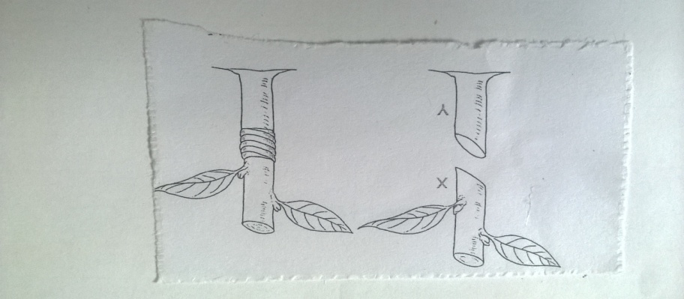
- Identify the method of grafting illustrated above. (1mk)
…………………………………………………………………………………………..
- Name the parts labelled X and Y. (1mk)
X………………………………………………………………………………………...
Y………………………………………………………………………………………...
- Outline two desirable characteristics of the part labelled Y that determines its selection. (2mks)
………………………………………………………………………………………..…………………………………………………………………………………………..……………………………………………………………………………………………..
- What is the reason for tying the parts above after grafting? (1mk)
………………………………………………………………………………………..……………………………………………………………………………………………..
- Study the illustration below that show a tomato plant and answer the questions thatfollow
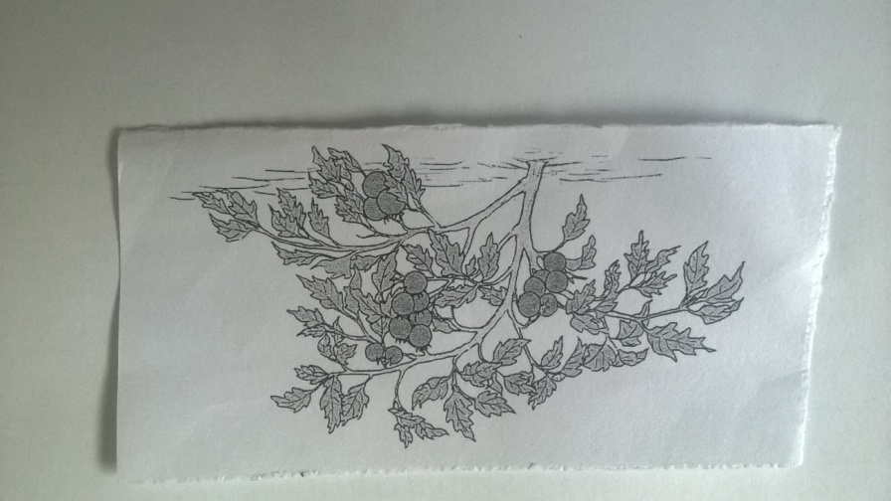

- Give two management practices that have not been carried out on the plant. (2mks)
………………………………………………………………………………………..……………………………………………………………………………………………............................................................................................................................................
- Describe the procedure followed when spraying a tomato crop with a fungicide powder using a knapsack sprayer to control blight. (3mks)
………………………………………………………………………………………..…………………………………………………………………………………………..…………………………………………………………………………………………..…………………………………………………………………………………………..…………………………………………………………………………………………..…………………………………………………………………………………………..…………………………………………………………………………………………..…………………………………………………………………………………………..……………………………………………………………………………………………..
- The diagrams below show some common weeds.Study them and answer the questions that follow.
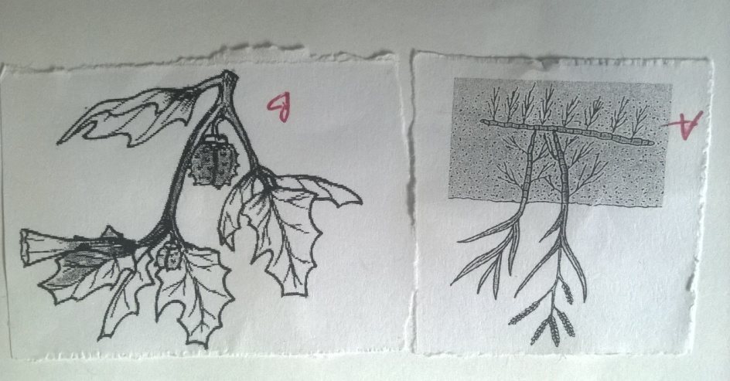
- Identify the weeds labelled A and B. (2mks)
A……………………………………………………………………………………………
B…………………………………………………………………………………………….
- Why should weed B be removed from a field of fodder crop? (1mk)
………………………………………………………………………………………………………………………………………………………………………………………………
- Give a reason why it is difficult to control weed A above. (1mk)
………………………………………………………………………………………………………………………………………………………………………………………………
- Name one category of herbicide depending on the mode of action that can be used to control weed A. (1mk)
………………………………………………………………………………………………
SECTION C (40MARKS)
- a) Describe ten uses of farm records. (10mks)
b) Describe the principles that govern the functioning of co-operative societies in Kenya.
(10mks)

- a) State and explain the different methods of farming. (10mks)
b) Describe carrot production under the following sub-headings
- Land preparation (2mks)
- Planting. (4mks)
- Field management practices. (4mks)

- a) State and explain five methods of fertiliser application. (10mks)
b) Explain five structural methods of soil and water conservation. (5mks)
c) Describe the harvesting of sugarcane. (5mks)

………………………………………………………………………………………………..…………………………………………………………………………………………………..…………………………………………………………………………………………………..…………………………………………………………………………………………………..…………………………………………………………………………………………………..…………………………………………………………………………………………………..…………………………………………………………………………………………………..…………………………………………………………………………………………………..…………………………………………………………………………………………………..…………………………………………………………………………………………………..…………………………………………………………………………………………………..…………………………………………………………………………………………………..…………………………………………………………………………………………………..…………………………………………………………………………………………………..…………………………………………………………………………………………………..…………………………………………………………………………………………………..…………………………………………………………………………………………………..…………………………………………………………………………………………………..…………………………………………………………………………………………………..…………………………………………………………………………………………………..……………………………………………………………………………………………………..
………………………………………………………………………………………………..…………………………………………………………………………………………………..…………………………………………………………………………………………………..…………………………………………………………………………………………………..…………………………………………………………………………………………………..…………………………………………………………………………………………………..…………………………………………………………………………………………………..…………………………………………………………………………………………………..…………………………………………………………………………………………………..…………………………………………………………………………………………………..…………………………………………………………………………………………………..…………………………………………………………………………………………………..…………………………………………………………………………………………………..…………………………………………………………………………………………………..…………………………………………………………………………………………………..…………………………………………………………………………………………………..…………………………………………………………………………………………………..…………………………………………………………………………………………………..…………………………………………………………………………………………………..…………………………………………………………………………………………………..……………………………………………………………………………………………………..
………………………………………………………………………………………………..…………………………………………………………………………………………………..…………………………………………………………………………………………………..…………………………………………………………………………………………………..…………………………………………………………………………………………………..…………………………………………………………………………………………………..…………………………………………………………………………………………………..…………………………………………………………………………………………………..…………………………………………………………………………………………………..…………………………………………………………………………………………………..…………………………………………………………………………………………………..…………………………………………………………………………………………………..…………………………………………………………………………………………………..…………………………………………………………………………………………………..…………………………………………………………………………………………………..…………………………………………………………………………………………………..…………………………………………………………………………………………………..…………………………………………………………………………………………………..…………………………………………………………………………………………………..…………………………………………………………………………………………………..……………………………………………………………………………………………………..
………………………………………………………………………………………………..…………………………………………………………………………………………………..…………………………………………………………………………………………………..…………………………………………………………………………………………………..…………………………………………………………………………………………………..…………………………………………………………………………………………………..…………………………………………………………………………………………………..…………………………………………………………………………………………………..…………………………………………………………………………………………………..…………………………………………………………………………………………………..…………………………………………………………………………………………………..…………………………………………………………………………………………………..…………………………………………………………………………………………………..…………………………………………………………………………………………………..…………………………………………………………………………………………………..…………………………………………………………………………………………………..…………………………………………………………………………………………………..…………………………………………………………………………………………………..…………………………………………………………………………………………………..…………………………………………………………………………………………………..……………………………………………………………………………………………………..
………………………………………………………………………………………………..…………………………………………………………………………………………………..…………………………………………………………………………………………………..…………………………………………………………………………………………………..…………………………………………………………………………………………………..…………………………………………………………………………………………………..…………………………………………………………………………………………………..…………………………………………………………………………………………………..…………………………………………………………………………………………………..…………………………………………………………………………………………………..…………………………………………………………………………………………………..…………………………………………………………………………………………………..…………………………………………………………………………………………………..…………………………………………………………………………………………………..…………………………………………………………………………………………………..…………………………………………………………………………………………………..…………………………………………………………………………………………………..…………………………………………………………………………………………………..…………………………………………………………………………………………………..…………………………………………………………………………………………………..……………………………………………………………………………………………………..
………………………………………………………………………………………………..…………………………………………………………………………………………………..…………………………………………………………………………………………………......
………………………………………………………………………………………………..…………………………………………………………………………………………………..…………………………………………………………………………………………………..…………………………………………………………………………………………………..…………………………………………………………………………………………………..…………………………………………………………………………………………………..…………………………………………………………………………………………………..…………………………………………………………………………………………………..…………………………………………………………………………………………………..…………………………………………………………………………………………………..…………………………………………………………………………………………………..…………………………………………………………………………………………………..…………………………………………………………………………………………………..…………………………………………………………………………………………………..…………………………………………………………………………………………………..…………………………………………………………………………………………………..…………………………………………………………………………………………………..…………………………………………………………………………………………………..…………………………………………………………………………………………………..…………………………………………………………………………………………………..……………………………………………………………………………………………………..
………………………………………………………………………………………………..…………………………………………………………………………………………………..…………………………………………………………………………………………………..…………………………………………………………………………………………………..……………………………………………………………………………………………………..

