Name: _______________________________________Class:__________Adm:________
Index:_________________________Sgn:_______________Date:________________
321/1
GEOGRAPHY
Paper1
June 2018
Time: 2Hrs. 45mins.
KASSU-JET EXAMINATION 2018.
Kenya Certificate of Secondary Education (k.c.s.e.)
312/1
Paper one
GEOGRAPHY.
Instructions to the candidates.
- This paper has two sections A and B.
- Answer ALL questions in section A. In section B, answer question 6 and any other two from the remaining.

FOR EXAMINER’S USE ONLY.
SECTION A
QUESTION 6
QUESTION 7
QUESTION 8
QUESTION 9
QUESTION 10
TOTAL MARKS

SECTION A: Answer all questions in this section
1).(a) The diagram below shows the internal structure of the earth.
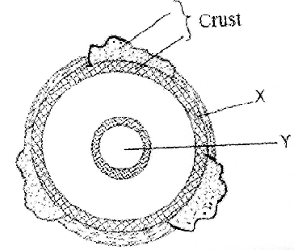
- Name the parts marked X and Y. (2marks)
- State three characteristics of the upper mantle. (3marks)
2).The map below shows the climatic regions of Kenya
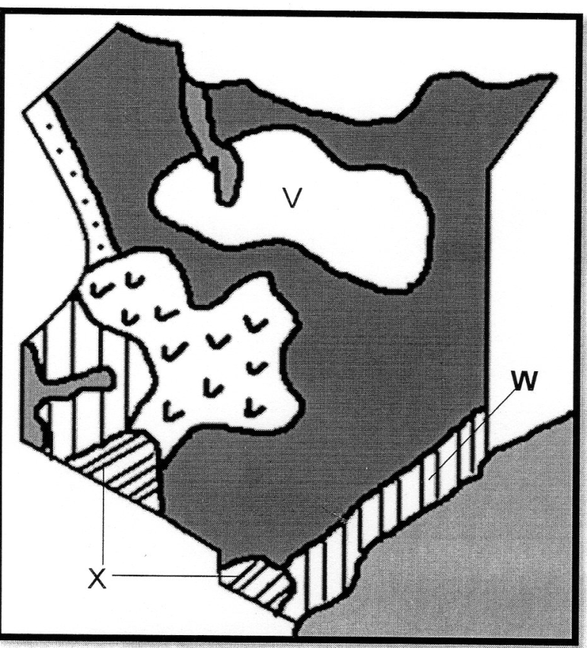
(i) Name the climatic region marked V and W. (2marks)
(ii) State three characteristics of the climatic region marked X. (3marks)
3). (a) Differentiate between earthquake intensity and earthquake magnitude. (3marks)
(b) Name three earthquake zones in the world. (3marks)
4). (a) Distinguish between oceans and seas. (3marks)
(b) State three factors causing the development of ocean currents. (3marks)
5). (a) The diagram below shows a river braid. Identify the parts marked A, B. (2marks)
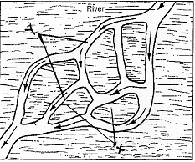
(b) State three conditions for the formation of a delta. (3marks)
SECTION B: Answer question 6 (six) and any other two from the remaining questions.
6) Study the map of Migwani 1:50,000 (sheet 151/1) provided and answer the following questions.
(a) (i) Convert the ratio scale of the map into a statement scale. (2marks)
(ii) What is the name and the sheet number of the map to the south of Migwani. (2marks)
(iii) Give the longitudinal extent of the map. (2marks)
(iv) Calculate the bearing of the trigonometric station at grid reference 9264 from Usiani School. (2marks)
(b) (i) Using a vertical scale of 1cm to represent 100metres, draw a cross section along the line J-K. (4marks)
(ii) On it mark and label the following: (4marks)
- Footpath
- Road
- Water pipeline
- Steep slope

(c) Describe the relief of the area covered by the map. (5marks)
(d) Citing evidence from the map, give two economic activities carried out in the area covered by the map. (4marks)
7). (a) (i) Identify two features formed by vertical earth movements. (2marks)
(ii) Explain how the following factors cause earth movements.
- Gravitative pressure. (2marks)
- Isostatic adjustment. (4marks)
(b) Describe the plate tectonics theory. (5marks)
(c) (i) Define faulting. (2marks)
(ii) Study the diagram below and answer the questions that follow.
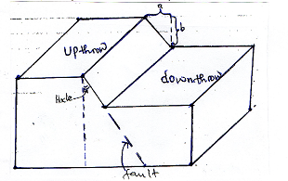
Name the parts marked: (2marks)
- A
- B
- Apart from the above type of fault, name two other types of faults. (2marks)
(d) Explain three ways in which faulting influences drainage. (6marks)
8. (a) What is secondary vegetation? (2marks)
(b) Explain how the following factors influence vegetation distribution in Kenya
- Soil fertility (2marks)
- Sunlight (2marks)
- Aspect (2marks)
(c) State six uses of savanna grassland vegetation in Kenya (6marks)
(d) The world map below shows world major vegetation zones use it to answer the questions below.
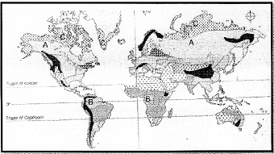
(i) Name the vegetation zones marked A, B, and C (3marks)
(ii) State the characteristics of Mediterranean vegetation (8marks)
9. (a) (i) What is the difference between weathering and mass wasting. (2marks)
(ii) Give three factors that influence the rate of weathering. (3marks)
(b) (i) Apart from block disintegration and granular disintegration, name three other processes of physical weathering. (3marks)
(ii) Describe the following processes of weathering:
- Granular disintegration. (3marks)
- Hydrolysis. (2marks)
(c) You are planning to carry out a field study on types of mass wasting.
(i) Identify three methods you would use to collect data. (3marks)
(ii) Give three types of rapid mass wasting that you are likely to observe during the field study. (3marks)
(iii) State two follow-up activities you are likely to do. (2marks)
(d) Explain the effects of mass wasting on the following:
- Tourism. (2marks)
- Soil fertility. (2marks)

10. (a) What is glaciation? (2marks)
(b) Describe the following processes of glacial erosion:
- Plucking. (4marks)
- Abrasion. (3marks)
(c) The diagram below shows features in glaciated lowland areas. Use it to answer question (i).
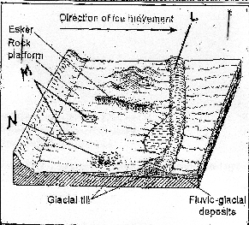

- Identify the features marked L, M, and N. (3marks)
- State three characteristics of drumlins. (3marks)
- Describe how eskers are formed. (4marks)
(c) Explain three significance of erosional features found in glaciated upland areas.
(6marks)

