Name………………………………………………………………..IndexNo…………………………
Candidates Signature………………….. Date………………………………
511/3
MUSIC
Paper 3
July 2018
2 ½ hours.

MOKASA 2 JOINT EXAMINATION
Kenya Certificate of Secondary Education
MUSIC
Paper 3
2 ½ hours.

Instructions to Candidates

- Write your name and index number in the spaces provided above
- Sign and write the date of examination in the spaces provided.
- Answer all questions in this paper
- In question 4 choose any two of the questions numbered (a), (b), (c) and (d)
- DO NOT remove any pages.
- This paper consist of 10 printed pages
- Candidates should check the question paper to ensure that all the pages are printed as indicated and no questions are missing.

For Examiners Use Only
Section | Question | Maximum Score | Candidate’s Score
A | 1a | 08
 | 1b | 07
 | 2 | 15
B | 3 | 14
 | 4 | 14
 | 5 | 10
 | 6 | 10
 | 7 | 06
C | 8 | 16
Grand Total |  | 100
SECTION A: BASIC SKILLS
- (a) Complete the following melody to 16 bars for voice, modulating to the Relative minor and returning to the tonic. Incorporate a triplet. (8 marks)
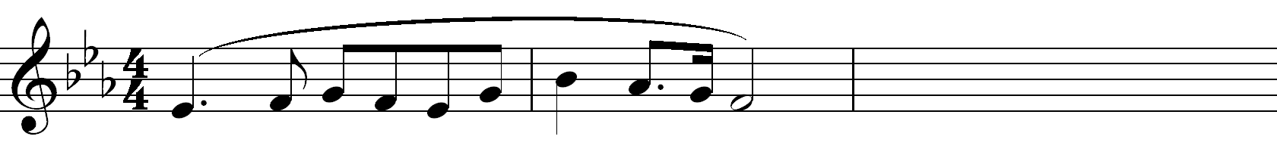

b) Using staff notation, compose a tune to the following words. Add phrase marks. (7 marks)
Praise God from whom all blessings flow, ye creatures of our God and King,
With joy and gladness let us bow, with gratitude and love we sing .

- Copy and harmonize the following Soprano melody by adding Alto, Tenor and Bass. Use the following chords: I, ii, IV, V and vi. Incorporate a cadential six-four. (15 marks)
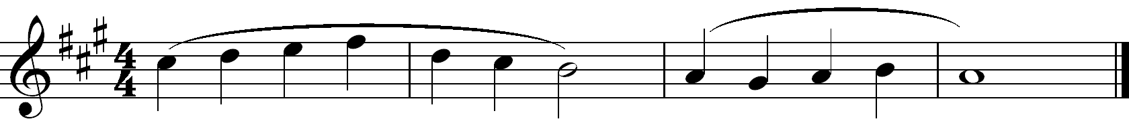

SECTION B: HISTORY AND ANALYSIS (48 marks)
3. AFRICAN MUSIC
a) Identify each of the following Kenyan instruments: (3 marks)
- Mbaito
………………………………………………………………………………………
- Abu
………………………………………………………………………………………
- Embegete
………………………………………………………………………………………
b) Outline how modern technology has affected African traditional music both positively and negatively. (4 marks)
Positive
……………………………………………………………………………………………………………………………………………………….………………………………………………...…………………..
Negative
……………………………………………………………………………………………………………………………………………………………………………………………………………………………..
c) State any three roles of costume and décor in an African traditional performance. (3 marks)
…………………………………………………………………………………………………………………………………………………………………………………………………………………………………………………………………………………………………………………………………………………………………………………………………………………………………………………………...…
d) List any four Kenyan dances that derive their names from instruments that accompany them. (4 marks)
…………………………………………………………………………………………………………………………………………………………………………………………………………………………………………………………………………………………………………………………………………………………………………………………………………………………………………………………..…

4. WESTERN MUSIC

Answer any two of the questions (a), (b), (c) and (d).

(a) Giovanni Palestrina
i) What is the nationality of Giovanni Palestrina? (1 mark)
…………………………………………………………………
ii) Explain three main influences on Palestrina’s music. (3marks)
…………………………………………………………………………………………………………………………………………………………………………………………………………………………………………………………………………………………………………………………………………………………………………………………………………………………………………………..…………
iii) List any three appointments held by Palestrina during his musical career. (3 marks)
……………………………………………………………………………………………………………………………………………………………………………………………………………………………………………………………………………………………………………………………………………………………………………………………………………………………………………………..………
b) Jean-Phillippe Rameau
i) Name the period in which Rameau lived. (1 mark)
………………………………………………………………………………………………………
ii) For which instrument did Jean Phillipe Rameau mainly compose for? (1 mark)
………………………………………………………………………………………………………
iii) List any three notable achievements by Rameau during his musical career. (3 marks)
………………………………………………………………………………………………………
………………………………………………………………………………………………………
………………………………………………………………………………………………………
iv) What is the ‘Traite de l’harmonie’ ? (2 marks)
………………………………………………………………………………………………………
………………………………………………………………………………………………………
………………………………………………………………………………………………………
………………………………………………………………………………………………………
c) Carl Philip Emmanuel Bach
- During which years did C.P.E Bach live? (1 mark)
…………………………………………………………………………………………………
- Identify the following works by C.P.E. Bach: (2 marks)
La Caroline - ……………………………………………………...
The Israelites in the Desert - …………….………………………………………..
The Resurrection of Jesus - ..…………………………………………………….
Solfeggietto - ..………………………………………………….....
- Outline any three factors that influenced Bach’s music. (3 marks)
…………………………………………………………………………………………………………………………………………………………………………………………………………………………………………………………………………………………………………………………………………………………………………………………………………………………………………………………………………………………………………………………………………………………………
d) Arnold Schoenberg
i) What is the nationality of Arnold Schoenberg? (1 mark)
………………………………………………………………………………………………………
ii) Outline any three influences on Schoenberg’s musical career. (3 marks)
………………………………………………………………………………………………………
………………………………………………………………………………………………………
………………………………………………………………………………………………………
………………………………………………………………………………………………………
iii) Identify the following works by Arnold Schoenberg: (3 marks)
The Gurreliender - ……………………………………………
Moses and Aaron - ……………………………………………
Pelleas and Melisande - …….………………………………………

5. Prescribed Traditional African Music
Maasai Folksong by Najile Boys (PPMC Recording of KMF 2014).
- Outline three main roles played by the voice in the recording? (3 marks)
…………………………………………………………………………………………………………………………………………………………………………………………………………..…………………
…………………………………………………………………………………………………..…………
- State any three styles of performance used in the recording. (3 marks)
……………………………………………………………………………………………………………………………………………………………………………………………………………………..………
…………………………………………………………………………………………………..…………
…………………………………………………………………………………………………..…………
- Outline any two ways in which a climax has been achieved in the performance. (2 marks)
…………………………………………………………………………………………………………..…
…………………………………………………………………………………………………………………………………………………………………………………………………………………………….
- Name and classify two music instruments used in the performance. (2 marks)
……………………………………………………………………………………………….……………
…………………………………………………………………………………………………….………
6. Prescribed Western Music
Joseph Haydn: Quartet in F major, Op. 3, No.5, second Movement (serenade) Andante Cantabile
- Citing bar numbers, identify four developmental devices used in the piece. (4 marks)
………………………………………………………………………………………………………
………………………………………………………………………………………………………
………………………………………………………………………………………………………
………………………………………………………………………………………………………
………………………………………………………………………………………………………
ii) Which period of music history is the composer of the piece identified with? (1 mark)
…………………………………………………………………………………………………………

iii) Citing bar numbers, identify any three characteristics of the musical period that are evident in this piece of music. (3 marks)
………………………………………………………………………………………………………………
………………………………………………………………………………………………………………
……………………………………………………………………………………………….…...…………
………………………………………………………………………………………………………………
- State the meanings of the following terms as used in this work. (2marks)
a) Espress
………………………………………………………………………………………………………………
………………………………………………………………………………………………………………
b) Con Sordino
………………………………………………………………………………………………………………
………………………………………………………………………………………………………………
7. Unprepared Analysis
Study the music extract above and answer the questions that follow.

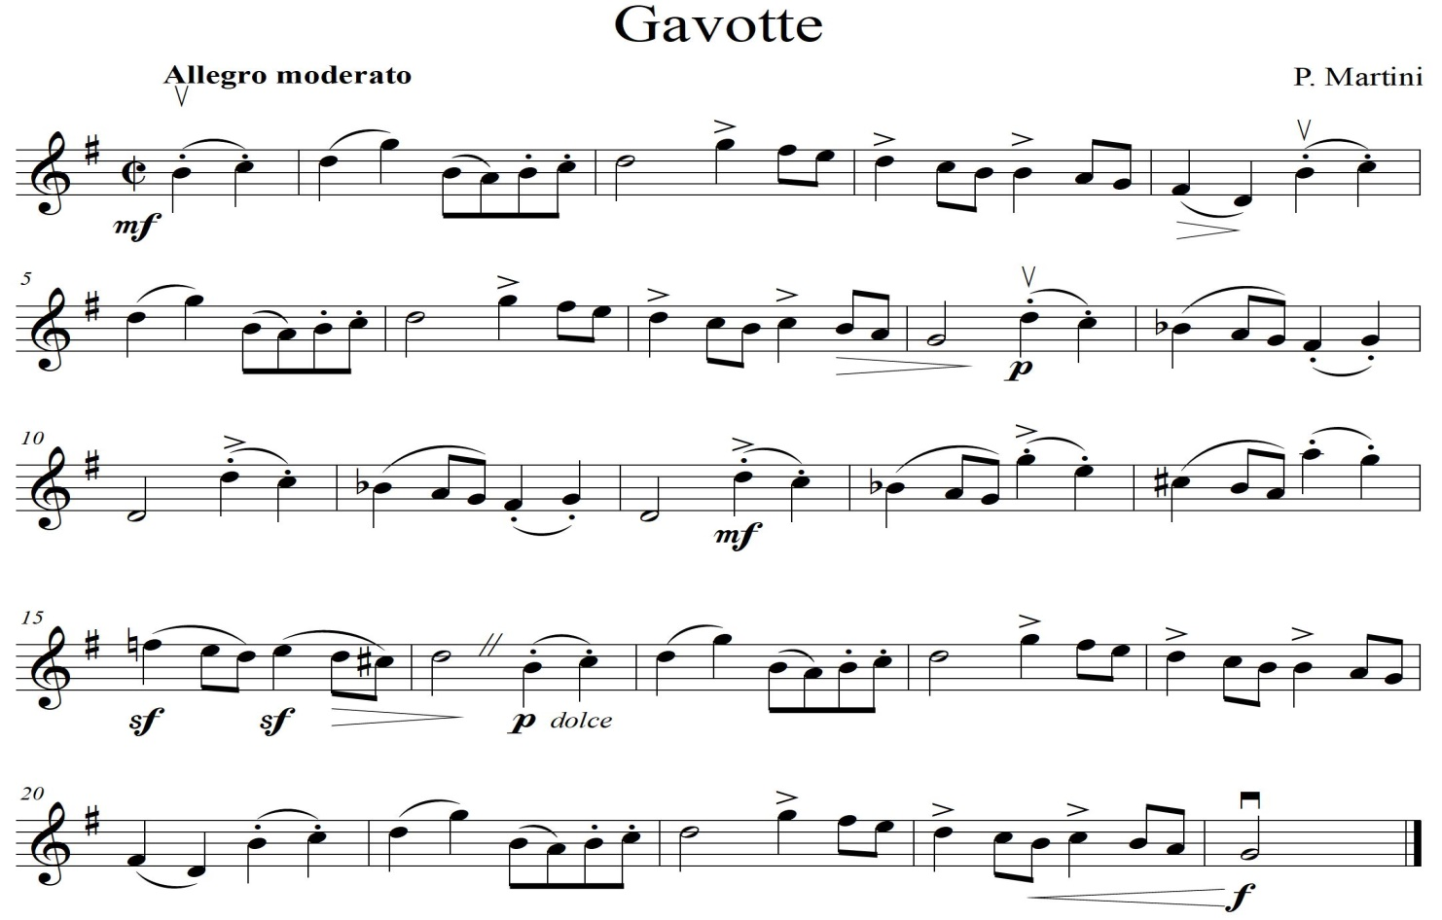

- Using bar numbers, identify the form of this piece of music. (2 marks)
………………………………………………………………………………………………………
……………………………………………………………………………………………………….
……………………………………………………………………………………………………….
- What medium suitably fits this excerpt? (1 mark)
…………………………………………………..
- Give the meaning of the tempo term used. (1 mark)
………………………………………………………………………………………………………
- Identify any two agogic signs used in the piece above and state the meaning of each. (1 mark)
……………………………………………………………………………………………………….
……………………………………………………………………………………………………….
- Define the following terms as used in the excerpt. (1 mark)
Dolce - ………………………………………………………………………..
Sf - ………………………………………………………………………………..

SECTION C: GENERAL MUSIC KNOWLEDGE (16 marks)
8. a) Transpose the following melody a Perfect 4th down into the Alto clef. (4 marks)
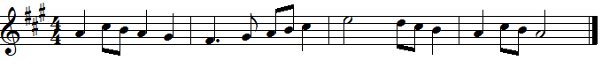

- Outline any three roles of a music producer. (3 marks)
………………………………………………………………………………………………………
………………………………………………………………………………………………………
………………………………………………………………………………………………………
………………………………………………………………………………………………………
- Define the following musical terms (6 marks)
- Trio sonata
………………………………………………………………………………………………………………………………………………………………………………………………………………
- Basso continuo
………………………………………………………………………………………………………………………………………………………………………………………………………………
- Clef
………………………………………………………………………………………………………………………………………………………………………………………………………………
- Brace
………………………………………………………………………………………………………………………………………………………………………………………………………………
v) Ensemble
………………………………………………………………………………………………………………………………………………………………………………………………………………
vi) Virtuoso
………………………………………………………………………………………………………………………………………………………………………………………………………………

- List three ways in which the growth of technology has affected the production of African Music instruments. (3 marks)
………………………………………………………………………………………………………………………………………………………………………………………………………………………………………………………………………………………………………………………………………………………………………………………………………………………………………………………………………………………………………………………………………………………………………………………………………………………………………………

