Name: Marking scheme Index no ……..…......................................

School: …………………………………………….. Candidate’s sign …………………….......

Class………………………………………….…..… Adm No…………………...……………...

AGRICULTURE
PAPER 1
JULY 2018
TIME: 2 HOURS

FORM FOUR MOKASA II MOCK
Kenya Certificate of Secondary Education (K.C.S.E.)
Agriculture
Paper 1

INSTRUCTIONS TO CANDIDATES:
- Write your name, index number, school, class and admission number in the spaces provided.
- Sign and write the date in the spaces provided above.
- Answer all the questions in section A and B
- Answer any two questions in section C.
- Answers should be written in the spaces provided in this booklet.
For Examiner’s Use Only:
SECTION | QUESTIONS | MAXIMUM SCORE | CANDIDATES SCORE
A | 1-15 | 30
B | 16-19 | 20
C |  | 20
 |  | 20
 | TOTAL | 90

This paper consists of 12 printed pages. Candidates should check to ascertain that all pages are printed as indicated and that no questions are missing.
SECTION A (30MARKS)
- State four ways by which biological agents can enhance the process of soil formation.
(2mks)
-Larger animals like elephants, cattle and man as they move they exert pressure on the rocks causing them to disintegrate.
-Mans activities like mining, cultivation and construction of buildingsreduce the size of the rocks into smaller fragments.
-The roots of growing vegetation force their way into the cracks on the rocks and exert pressure which eventually splits the rocks.
-Decomposition of plants and animal remains by soil micro-organisms.
-Mixing of soil by burrowing animals eg earthworms and termites.
- State four disadvantages of flood irrigation. (2mks)
-Requires a lot of water
-Unsuitable in slopy areas
-There is uneven distribution of water to crops.
-May result in the accumulation of a lot of salts in the soil.
- Give four advantages of early planting in crop production. (2mks)
-Enables crops to establish early and withstand competition from weeds.
-To enable crops to utilise the available rainfall in the season.
-To enable crops to escape from most pests and diseases.
-To enable crops to utilise the available nutrients in the soil before they are leached.
-To get good market from the crop when the supply is low/high prices.
-Reduces competition for labour during various operations.
- State four importance of good soil aeration in crop production. (2mks)
-To facilitate growth of crop roots/respiration of plant roots.
-Facilitates absorption of plant roots.
-Facilitates absorption of nutrients and water by plants.
-To prevent formation of certain inorganic compounds toxic to plants.
-Enhances microbial activity and hence the release of nutrients.
- Distinguish between oversowing and undersowing in pasture establishment. (2mks)
Undersowing is the establishment of a pasture under a cover crop usually maize/nurse crop.
Oversowing is the establishment of a pasturelegume/grass on an existing grass pasture.

- Give four advantages of establishing a mixed grass legume pasture instead of planting a pure grass pasture. (2mks)
-Grass-legume pasture has a higher nutritive value.
-The yield of forage per unit area is higher.
-Higher soil fertility due to nitrogen fixation.
-The grass legume mixture is more palatable.
-Assurance against total loss from pests and diseases.
-Economical in the use of fertilisers.
-Even distribution of pasture over the season due to different maturity periods.
-There is higher yield per unit area.
- Give four farming practices that may lead to soil erosion. (2mks)
-Overstocking/ overgrazing
-Planting of annual crops on steep slopes/ Continuous cropping with annual crops.
-Clean weeding
-Indiscriminate burning of vegetation before cultivation.
-Ploughing up and down the slope/ Cultivating along the slopes.
-Overcultivation/ soil pulverisation

- Give four disadvantages of chemical pest control in crop production. (2mks)
-Pesticides are expensive.
-Some are non-selective killing useful insects.
-Some pests can develop resistance to pesticides.
-Most pesticides can be toxic to man and livestock/ pollute the environment.
-Requires care and skill in handling.
- Give four reasons for constructing a shade over a nursery. (2mks)
-Protection against strong sun.
-Intercepts rain drops.
-Protects against strong winds
-Conserve soil moisture.
- Give four reasons for inverting soil slices during primary cultivation. (2mks)
-To burry organic matter.
-Expose soil to agents of weathering
-Expose pests and disease agents to predators or strong sun.
-Bring upleached plant nutrients to the surface.
-Encourage water infltration.
- Give four factors that may influence the price of agricultural commodities. (2mks)
-Price of substitutes
-Price expectations in future.
-Quality of the commodity.
-Tastes and preferences of the commodity.
- Give two examples for each of the following types of costs incurred in poultry production.
- Variable costs (1mk)
-Wages of casual labour
-Costs of feeds and water.
-Cost of drugs/ chemicals/ treatment.
-Cost of fuel/ electricity.
- Fixed costs (1mk)
-Land rent/ house rent
-Salaries of regular/ permanent labour.
-Depreciation of farm machinery
-Interest on borrowed loan
-Cost of hired equipment.
- Distinguish between pollarding and coppicing as used in agro-forestry. (2mks)
Pollarding is cutting back of the crown and the top branches of a tree whereas, coppicing is the cutting down of trees about half a metre from the ground. (Mark as a whole)
- Give four methods used for seed treatment of tree species before planting in agro-forestry. (2mks)
-Hot water treatment
-Mechanical breaking/scarification
-Light burning of seeds with hard seedcoat.
-Soaking in water.
-Seed dressing with chemicals against pests.
-Seed inoculation
- Name four statutory boards that are involved in the marketing of crop produce in Kenya.
(2mks)
-The Kenya sisal board
-Coffee board of Kenya
-Pyrethrum board of Kenya.
-Cotton board of Kenya.
-National cereals and produce board.
-Horticultural crops development authority.
SECTION B (20MARKS)
- a) Differenciate between complete and incomplete compound fertiliser. (1mk)
A complete compound fertiliser contains only two of the primary macro-nutrients/ fertiliser elements while a complete compound fertiliser contains all the three primary macronutrients/ fertiliser elements.

b) Following the advice derived from soil testing that all the three primary macro nutrients are needed in a hectare of land and that 120kg N, 60kg $P_{2}O_{5}$ and 80kg $K_{2}O$ should be applied per hectare and if only the following fertilisers are available; SA 21%N, SSP 18% $P_{2}O_{5}$ and KCL 60% $K_{2}O$.Calculate the amount of each fertiliser required. (4mks)
SA If 21kg N = 100kg SA
120kgN = ?
120X100 = 571.42kg SA/ ha
21
SSP If 18kg $P_{2}O_{5}$ =100kg SSP
60kg $P_{2}O_{5}$ = ?
60x100 =333.3kg SSP/ha
18
KCL If 60kg $K_{2}O$ =100kg KCL
80kg $K_{2}O$ =?
80x100 =133.3kg KCL/ha
60
- The diagram below shows a grafted orange.Study it and answer the questions that follow.

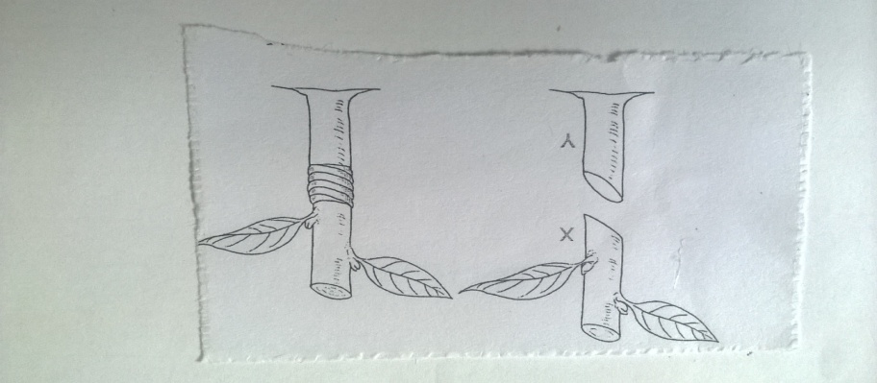
- Identify the method of grafting illustrated above. (1mk)
Whip or tongue grafting
- Name the parts labelled X and Y. (1mk)
X-Scion
Y-Root stock
- Outline two desirable characteristics of the part labelled Y that determines its selection. (2mks)
-It should be compatible with the scion.
-It should be disease and pest tolerant.
-It should be health and vigorously growing.
-It should be adaptable to different soils and soil conditions.
- What is the reason for tying the parts above after grafting? (1mk)
-To make tight contact between the scion and stock so as to facilitate acceptance.
-To ensure efficient exchange of water and air.
- Study the illustration below that show a tomato plant and answer the questions thatfollow
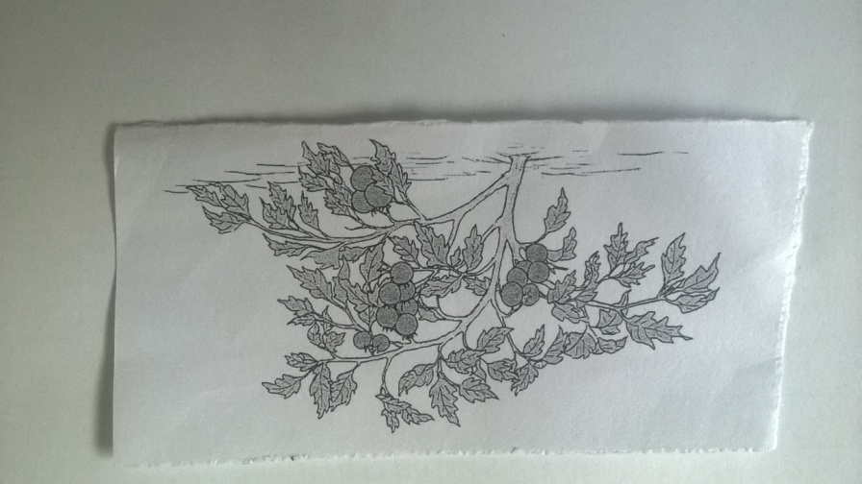

- Give two management practices that have not been carried out on the plant. (2mks)
-Staking
-Desuckering
- Describe the procedure followed when spraying a tomato crop with a fungicide powder using a knapsack sprayer to control blight. (3mks)
-Read the manufactures instructions carefully and follow.
-Measure the required amount of fungicide and the required amount of water.
-Mix the fungicide with water.
-Pour the mixture into the sprayer through a sieve.
-Agitate the contents of the knapsack sprayer to ensure thorough mixing.
-Spray the mixture onto the crop thoroughly wetting the whole plant.
- The diagrams below show some common weeds.Study them and answer the questions that follow.
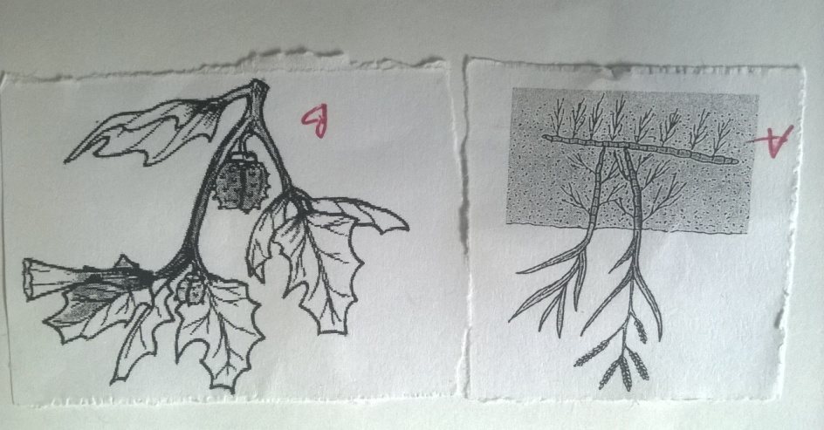
- Identify the weeds labelled A and B. (2mks)
A-Couch grass (Digitaria scalarum)
B-Thorn apple (Datura stramonium)
- Why should weed B be removed from a field of fodder crop? (1mk)
It is poisonous to livestock.
- Give a reason why it is difficult to control weed A above. (1mk)
Has underground roots and stems (rhizomes)
- Name one category of herbicide depending on the mode of action that can be used to control weed A. (1mk)
Translocated herbicide.
SECTION C (40MARKS)
- a) Describe ten uses of farm records. (10mks)
-They help a farmer in planning and making decisions in the farm.
-Help to compare the performance of different enterprises within a farm or other farms.
-Show the history of the farm.
-Guide a farmer in planning and burgeting of farm operations.
-Help to detect losses or theft on the farm.
-Help in the assessment of income tax to avoid over or under taxation.
-Help to determine the value of the farm or to determine the assets and liabilities of the farm.
-Makes it easy to share the profits and losses in partnership.
-Helps in settling disputes among heirs eg if a farmer dies without a will.
-Helps toshow whether the farm business is making profits or losses.
-Provides information to help determine a farmer’s credit worthiness.
-Helps in supporting insurance claims on death, theft and fire of farm assets.
-Provide labour information like terminal benefits eg NSSF dues.

b) Describe the principles that govern the functioning of co-operative societies in Kenya.
(10mks)
-Open membership-Regardless of race, tribe, sex, religion, education or political inclination.
-Equal voting rights-Based on the democratic principle of one man one vote.
-Principle of share limit-A member may buy shares upto a specific maximum limit to avoid domination.
-Interest on shares-Distribution of dividents is on the basis of share contributions.
-Withdrawal from membership- is voluntary and upon withdrawal members get back their share contribution.
-Loyalty-Members are expected to befaithful and loyal to their co-operative society
-Education-Members should be continuously educated to be conversant with co-operative affairs.
-Co-operative principle-Co-operatives are supposed to join the co-operative movement at the primary, district, national and international levels.
-Non-profit motive-The main objective of co-operatives is to the living standards of their members.
- a) State and explain the different methods of farming. (10mks)
Mixed farming-This is the growing of crops and rearing of livestock on the same farm.
Nomadic pastoralism-This is the moving of animals from one place to another in search of fresh pastures and water.
Shifting cultivation-Farming on a piece of land continuously until it is exhausted after which the farmer moves to a fertile ground.
Organic farming-This is the growing of crops and rearing of animals without using agricultural chemicals.
Agroforestry-This is the growing of crops and trees and in combination with each other.It is a sustainable land management system that increases the overall production of land, while helping to conserve soil.

b) Describe carrot production under the following sub-headings
- Land preparation (2mks)
-The seedbed should be well dug to a depth of about 20cm.
-The soil clods should be broken to give a fine tilth before planting.
- Planting. (4mks)
-Carrots are planted directly into the main seedbed.
-Spacing-Rows 20-30cm apart and 2-3cm between seeds.
-Seed depth-1-1.5cm
-Seed rates-2-5kg/ha
-Fertiliser application-DSP 90kg/ha during planting.
-Manure should not be applied as it induces forking and hence reduces crop
quality.

- Field management practices. (4mks)
-Thinning-Done two weeks after germination to attain 3-4cm between plants within the row.
-Weeding-The field should be kept weed free.When weeding earthing is done to encourage root expansion.
-Top dressing-After weeding apply 60kgN/ha.Irrigation should also be carried out when conditions are dry.
-Control of pests-Carrots do not have many pests.However, green aphids can be controlled by use of appropriate pesticides.

- a) State and explain five methods of fertiliser application. (10mks)
- Broadcasting-Random scattering of fertiliser on the ground for plant use.Common on pasture and cereal crops and is common with nitrogenous fertiliser.
- Placement method/hole placement-This is the application of the fetiliser in the planting holes or drills.It is recommended when applying phosphatic fertilisers.
- Side dressing-This is the placement of nitrogenous fertiliser at the side of the crop being top dressed.
- Foliar spraying-This is the application of specially formulated fertiliser solution onto the foliage of the crop.
- Drip method-This is where fertilisers are dissolved and applied to individual plants through perforated pipes or bottles.
- Fertirrigation-Fertilisers are applied through irrigation water along the irrigation channels.
b) Explain five structural methods of soil and water conservation. (5mks)
- Trash lines-These are rows of heapedtrash or crop residues made along the contours.They help trap soil and reduce the speed of running water down the slope facilitating water infiltration into the soil.
- Stone lines-These are rows of heaped stones made along the contours.They trap the soil being washed away and reduce the speed of running water and encourage water infiltration.
- Bunds (contour bunds)-These are heaps of soil on sloping land which are constructed along the contour line.Grass is planted on top of the bunds to help them hold together.
- Cut off drains/diversion drains-This is an open trench with an embankment on the lower side.They are constructed in steep slopes where ocasional large quantities of water flow down the slopes.
- Terraces-Slow down water flow and encourage infiltration.

c) Describe the harvesting of sugarcane. (5mks)
-Before the canes are harvested, samples should be taken for quality testing in the factory.
-The cane should be cut at ground level to avoid loss of yield and ensure proper establishment of the ratoon crop.
-The green tops are removed.They have enzyme invertase which moves down the cane to convert sucrose to monosaccharides (glucose and fructose) which reduces the sucrose content.
-The dry leaves are stripped off from the stem.Burned canes should be harvested immediately after burning to prevent conversion of sucrose.
-Harvesting is done using a cane harvesting machete or a panga.

