312/1
GEOGRAPHY
PAPER 1
JUNE 2018
Time 2Hrs 45Mins.
KASSU-JET EXAMINATION 2018
Kenya Certificate of Secondary Education (K.C.S.E.).
312/1
Paper 1
GEOGRAPHY.
MARKING SCHEME.
SECTION A – 312/1 MARKING SCHEME.
1(a) The diagram below shows the internal structure of the earth.

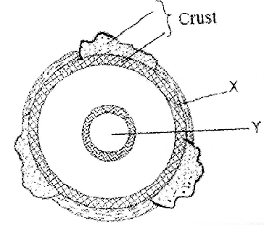

- Name the parts marked X and Y. (2marks)
X – Ocean crust
Y- Inner core
- State three characteristics of the upper mantle. (3marks)
- composed of hard rocks
- the rocks are rigid
- Extends to about0 1000º C.
2. The map below shows the climatic regions of Kenya
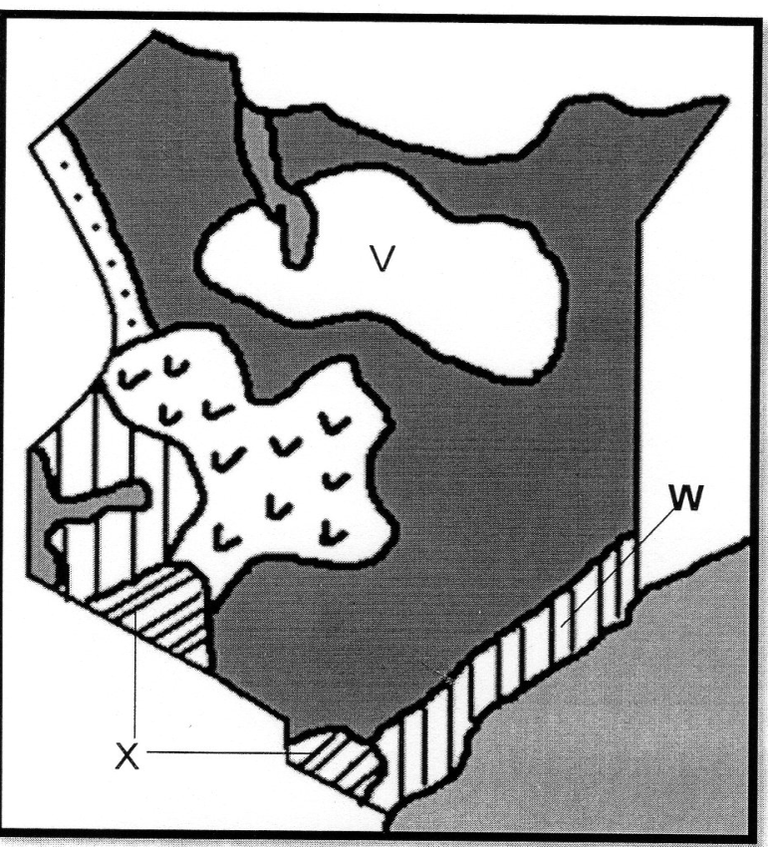
(i) Name the climatic region marked V,W. (2marks)
V – Desert climate
W – Modified equatorial climate of the coast.
(ii) State three characteristics of the climatic region marked X. (3marks)
- High temperature recorded annually 118º – 30 ºC
-Rainfall mainly convectional
-Definite two dry seasons
- Cool conditions due to pressure of ties.
3. (a) Differentiate between earthquake intensity and magnitude (2marks)
Earthquake intensity is the measure of how hard/strong the earthquake waves / seismic waves shakes the earth surface measured causing the mercacciscale while earthquake magnitude is the measure of the amount of energy given off by an earthquake measured using the Hitcher scale.
(b) Name three earthquake zones in the world (3marks)
- Cicum – pacific belt/japan/phili
- Soutor Europ / Alps
- Southern Asia/Himalayas/Indonesia
- South America/Arcades/depol/urgauy/
- coast of Alaska
- North East china
- New Zealand
- turkey
- Riftvalley / Gregory
4. (a) Distinguish between oceans and seas. (3marks)
Oceans are large and extensive body of saline water occupying basis between continents while seas are small and extensive body of saline water occupying margins of continents.
(b) State three factors causing the development of ocean currents. (3marks)
- Prevailing wind causing a frictional drag on the Ocean water surfaces.
-Rotation of the earth affecting the direction of wind both in North and Southern poles.
-The shape of the coastline
-Differences in Ocean water temperature.
5. (a) The diagram below shows a river braid. Identify the features marked X and Y (2marks)
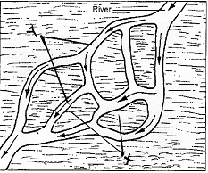
X- shoals / Eyots
Y -Braids
(b) State three conditions for the formation of a delta. (3marks)
- The river must have a large load of sediments at
- The river channel should have no obituary like small lakes sways.
-The river should be flowing slowly on entering its mouth.
-The strength of the Ocean waves should be weaker to allow deposition of sediments.
SECTION B (Answer Question 6 and any other two from the remaining.)
6) Study the map of Migwani 1:50,000 (sheet 151/1) provided and answer the following questions.
(a)(i) Convert the ratio scale of the map extract into a statement scale. (2marks)
Map scale 1:50,000
1 cm represents 50,000 cm
50,000 = = 0.5km.
Statement scale is =
1cm represent 0.5km
or
1cm represent km.
ii) What is the name and sheet number of map to the south of Migwani (2marks)
- Kitui 151/3
iii) Give the longitudinal extent of the map (2marks)
- Approximately from 3801’E to 3813’E
iv) Calculate the bearing of the trigonometrically station at grid reference 9264 from Usiani school
- 217 (2marks)
b(i) Using a vertical scale of Icm to represent 100 metres, draw a cross section along the line J-K (4marks)
(ii) On it mark and label the following (4marks)
- Foot path
- Road
- Water pipeline
- Steep slope

c) Describe the relief of the area covered by the map (5marks)
- There are many hills in the area covered by the map
- There are ridges to the Eastern part of the Easting 00
- There are river valleys which are occupied by rivers e.g river Ngoo
- There are steep slope at Mutito forest
- The area to the East of Easting 08 is flattened as evidenced by spaced contours.
- The lowest altitude is 660m while the highest altitude is 1600m above sea level.
- The land rises from East to west/ westwards
- There are many interlocking spurs along the river valleys.
- The landscape is dissected by many river valleys
- There are many narrow river valleys.
- There are gentle slopes to the coast part of the area covered by the map.

d) Citing evidence from the map, give two economic activities carried out in the area covered by the map. (4marks)
Economic Activity | Evidence
- Trading  - Transportation Business  - Communication  - Forestry  - Quarrying | Presence of numerous market centres/shops e.g at grid square 9274  Presence of roads e.g all weather road bound surface C94.  Presence of post office  Mulito/kyawea forests  Muanzoa quarry

7. (a) (i) Identify two features formed by vertical earth movements. (2marks)
- Basins
- Plateaus
- Fault scarps/escarpments
- Tilt blocks
- Rift valleys
- Submerged coasts
- Emerged coasts
(ii) Explain how the following factors cause earth movements:
- Gravitative pressure. (2marks)
- When large amounts of magma escape to the surface of the earth,large cavities or voids are left behind.
- The force of gravity exerts pressure on the crustal rocks from the voids causing them to move inwards hence causing vertical movements.
- Isostatic adjustment. (4marks)
- If ice sheets melt over the highlands or soil erosion occurs and deposition of water or soil in the sea or depression.
- A vertical isostatic uplift will occur on the highland because it is light while isostatic sinking will occur on the depression because it is heavier.
- The adjustment which is ment to maintain isostacy is called isostatic adjustment.
(b) Describe the plate tectonics theory. (5marks)
- It is the study of the movement of plates and the resultant landforms.
- The theory suggests that the earth’s lithosphere is made of semi-rigid blocks called plates.
- These plates are fractured and constantly moving relative to each other along their plate margins forming various physical features.
- Their movements are caused by convectional currents within the mantle.
(c) (i) What is faulting? (2marks)
The process through which the brittle crustal rocks fracture or break due to tectonic forces.
- Study the diagram below and answer the questions that follow:
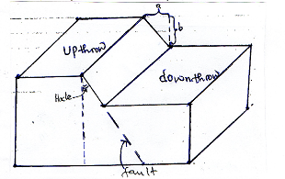
Name the parts marked;
- A----Heave
- B----Throw
- Apart from the above type of fault, name two other types of faults.
- Reversed fault
- Shear/tear fault
- Thrust fault
- Anticlinal fault
(d) Explain three ways in which faulting influences drainage.
- Faulting across a river causes it to change its course or even disappear along a fault line /fault-guided drainage pattern.
- Subsidence of the land caused by faulting may result in the formation of depressions which may be filled with water to form lakes.
- Faulting may create lines of weakness in the crust which may become passages of hot water to the surface forming hot springs and geysers.
- Fault scarps may expose underground water resulting in the formation of scarp springs
- Faulting leads to formation of block mountains which receive a lot of rain forming sources of rivers
- Faulting a cross a river or escarpment may cause a river to descend forming a waterfall.
8. (a) What is secondary vegetation? (2marks)
It is the plant cover existing naturally in a place/area but has been interfered by human activities and being in the processes of recovering.
(b) Explain how the following factors influence vegetation distribution in Kenya
- Soil fertility (2marks)
- Deep soils – trees
- Wel drained
- Water logged
- Thin grass
- Sunlight (2marks)
- Regions/areas/places experiencing huge hours of sunshine/sunlight have support variety of plant species.

- Aspect (2marks)
- -The slopes facing the sun are warmer and therefore support wide variety of plant species.
(c) State six uses of savanna grassland vegetation in Kenya (6marks)
  - The grass acts as soil cover reducing occurrence of soil erosion.
  - Grassland areas are habitats of variety of wildlife for tourist attraction.
- -grasses heavily provide humus enriching the soil fertility for arable farming.
- -some trees in the grasslands are habitats for bees providing honey.
- -Grasslands provide grazing grounds for livestock hence cattle rearing.
- -Some trees in the grasslands may provide wood for domestic and industrial use.
- -some of the trees may have wild fruits and berries consumed as food

(d) The world map below shows world major vegetation zones use it to answer the questions below.
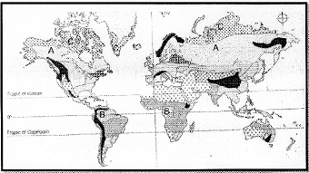
(i) Name the vegetation zones marked a,b, and c (3marks)
A – Coniferous vegetation
B- Equatorial vegetation
C – Tundra vegetation
(ii) State the characteristics of Mediterranean vegetation (8marks)
- Some plants may have long tap roots
- Some plants are evergreen
- Some trees are deciduous
- Some trees may be thick/bulcky
- Some plants may have spiny leaves
- Some plants have waxy leaves
- Some plants species are bous
- Some plants may have thick stems and leaves
- Many of the plants have sweet smelling scent.

9. (a) What is the difference between weathering and mass wasting (2marks)
Weathering is the breakdown and decomposition of solid rocks at or near the earth’s surface by physical or chemical processes without movement while mass wasting is the displacement / movement of weathered materials downslope under the influence of gravity.
(ii) Give three factors that influence the rate of weathering. (3marks)
- Climate of the area
- Nature of the rock
- Topography/angle of the slope
- Time
- Human activities
(b) (i) A part from block disintegration and granular disintegration name three other processes of physical weathering (3marks)
- Alternate weather and drying
- Pressure release / unloading / sheeting
- Exfoliation / spilling/onion skin weathering
- Frost action/congelifraction
- Crystal growth
(ii) Describe the following processes of weathering
Granular disintegration (3marks)
- This is a process where the rocks break up into small particles / grains
- It is common in areas where rocks are made up of different types of minerals particles.
- These minerals grains expand and contract at different rates when subjected to high temperatures and low temperatures respectively.
- Internal stress is created which then result into rocks crumbling and disintegrating into small grains.
Hydrolysis
- This is reaction that takes place between hydrogen ions of water and and the ions of water and the ions of the feldspar mineral found in granite rocks.

- Water combines with rock minerals

- A reaction between the hydrogen ions of water and the ions of minerals takes place.

- The minerals in the rocks are broken down to form completely new insoluble precipitation that is clay in a process called hydrolysis.
c. You are planning to carry out a field study of types of mass wasting.
i) Identify three methods you would use to collect data.
- Observing the resultant features of mass wasting.
- Taking photographs
- Interviewing resource persons.
- Counting
- Filming
ii) Give three types of rapid mass wasting that you are likely to observe during the study. (3marks)
- Earth flows
- Mud flows
- Land slides
- Rain wash / down wash.
iii) State two follow-up activities you are likely to do. (2marks)
- Holding group discussion
- Group leader presentation
- Reading more on the topic
- Asking and answering questions
- Labeling samples
- Displaying photographs
d) Explain the effects of mass wasting on the following.
- Tourism. (2marks)
-Features created through mass wasting are tourism attraction.
- Soil fertility. (2marks)
-Mass wasting facilitates soil erosion leading to soil degeneration.
-May lead to formation of fertile soils where such soils are deposited.

10. (a). what is glaciation? (2 marks)
- It is the process by which moving ice erodes, transports and deposits materials on the earth’s surface.
(b). Describe the following processes by glacial erosion.
Plucking. (3 marks)
- Pressure from the overlying mass of ice cause freeze and thaw action.
- Melting water fills the cracks / joints in the bedrocks.
- When temperature falls, water in cracks freeze.
- This freeze and thaw process is repeated several times resulting in an increase in the volume of ice within the crack.
- The part of the rock embedded in the ice is under stress as the glacier is moving forward causing part of it to break off.
Abrasion. (3marks)
- Caused by rock debris embedded in the glacier.
- The debris at the base and on the sides of the ice acts as a tool for scratching and polishing the rock surface over which the glacier moves.
- This takes place over the underlying rocks during ice movement.
(c) (i) Identify the features marked L,M, and N.

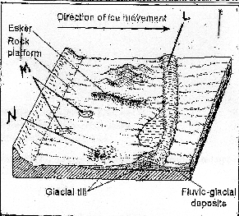

L – Terminal moraine.
M- Rock Basin Lakes/ Kettle Lakes.
M- Erratic.
(ii). State three characteristics of drumlins. (3 marks)
- Made up of unratified materials.
- Low rounded hells/ egg shaped/ oval shaped.
- Occur in groups.
- Steep on the upstream and downstream is long and gentle sloping.
- Upstream is smoothened by abrasion.
- Vary in size between 50m- 1 km.
(iii). Describe how esker are formed. (4marks.)
- A mass of ice stops moving in a lowland area.
- The ice starts melting at the base.
- Streams are formed beneath the ice and form permanent sub—glacial tunnels.
- Water flows through the tunnels under hydrostatic pressure.
- The water thus flows rapidly hence the amount of load carried is quite large.
- When the ice melts, the tunnel collapse and materials are deposited there.
- This results in formation of a long winding steep-sided ridge of deposits called an esker.
(d). Explain three significance of erosional features in a glaciated upland. (6marks)
- Hanging valleys form waterfalls which are ideal sites for generation of HEP.
- Glacial lakes provide natural route-ways and can also be used for fishing.
- Glacial features like pyramidal peaks, Arêtes and Cirques form beautiful sceneries which act as tourist attraction sites thus earning the country foreign exchange.
- Fiords formed in glaciated upland coasts form suitable sites for harbor and fish breeding grounds.
- Glaciated highlands are source of rivers that provide water for irrigation, domestic and industrial use.
- Glaciated highlands covered by snow are god sites for winter sports.
- glacial troughs provide good sites for grazing of animals.

