MARKING SCHEME
443/2
Agriculture Paper 2
SECTION A ( 30 Marks)
Answer all question in this section in the spaces provided.
1 Study the table below fill in the blanks to show the term used to refer to parturition and young ones of the following animals? (2mks)
Type of animal | Act of parturition | Term to refer to the young one
Cattle | Calving | Calf
Goats | Kidding down  ………………………………… | Kids  …………………………………..
pig | Farrowing down  ………………………………. | piglet  …………………………………..

2 Name two tools used to trim overgrown hooves in sheep. (1mk)
-hoof trimming knife
- hoof cutter
3 Name three dual purpose breeds of sheep. ( 1 ½ mks)
- Romney mash
- Corriedale
- Hampshire down

4 State four symptoms of mastitis in cattle. (2mks)
- Milk contains pus, blood, thick clots or turns watery
- Udder and teats are swollen and animals reject suckling or milking. It also kicks due to pain.
- Death of the infected quarter may occur
- The milk has a salty taste and there are fine clots or flakes particularly the fore milk
- Presence of wounds on the udder.
( 4 x ½ = 2mks)
5 State two functions of the queen bee in a bee colony. (1mk)
- Lay fertile eggs
- Keeps the colony together by producing a pheromone known as queen substance for identification.
6 State four factors affecting the digestibility of a feed. (2mks)
- Chemical composition of the feed
- The form in which the food is offered to the animal
- The species of the animal
- The ratio of energy to proteins
- The quantity of feed already present in the digestive system
7 State four harmful effects of ticks. (2mks)
- Are vectors of diseases eg East Coast fever (ECF)
- Suck blood from the host animal causing anaemia
- Their bites cause wounds which act as routes for secondary infections
- Cause irritation through their bites
- Cause damage to the skin lowering the value of hide and skins
- Some produce toxins that cause effects on the host.
8 State four conditions that may inhibit milk let-down during milking. (2mks)
- Change of milk routine
- Strange surroundings/ strangers/sudden noise/storm
- Poor milking techniques
- Sickness
- Long duration of milking
9 Give three disadvantages of using a plunge –dip for tick control. (1 ½ mks)
- It cannot be used for heavy, pregnant or sick animals as the animals are likely to get shock
- Animals may swallow some of the dip wash resulting in deaths
- Initial capital is high. Expensive to construct.

10 Name two viral diseases that affect each of the following livestock.
(a) Cattl: Foot and mouth disease, Rinderpest , Lumpy skin, Mad cow, Rift valley fever. (1mk)
(b) Poultry: New castle, Fowl pox, Gumboro, Bird flu/avian flu and Mareks disease. (1mk)
11 State four desirable factors to consider when siting a fish pond. (2mks)
- Reliable source of water
- Soil type i.e clay/ non- porous
- Topography i.e gentle sloping area
- Nature of land, avoid where big cracks appear
12 Give three advantages of cross breeding in cattle. ( 1 ½ mks)
- Hybrid vigour can be exploited
- Helps to establish grade animals
- Can be used to change the breed i.e from one breed to another
- It’s a quicker method of producing the required animal
13 State four conditions that would encourage hens to eat eggs in poultry production. (2mks)
- Presence of broken soft shelled eggs
- Bright light in the nests allowing the birds to see eggs
- Idleness
- Inadequate nests forcing birds to lay eggs on the floor
- Lack of minerals eg calcium in the diet
14 Outline four reasons for maintaining farm tools and equipment in good condition. (2mks)
- To increase durability
- To reduce the replacement cost
- To increase efficiency
- To avoid injury to the user
- To avoid damage to the tool
15 State four non-pathogenic causes of livestock diseases. (2mks)
- Nutritional causes
- Amount of food eaten by an animal
- Physical causes
- Chemical causes
- Hereditary causes
16 In the preparation of artificial colostrum, what is the role of each of the following?
(a) Caster oil ( ½ mk)
- provides a laxative effect
(b) Cod liver oil ( ½ mk)
Provides vitamins/minerals
17 What is the importance of applying milking salve on teats of a lactating cow? ( ½ mk)
- Prevents the teats from cracking

SECTION B (20 Marks)
Answer all questions in this section in the spaces provided
18 Below are illustrations of farm tools labeled A,B,C and D. Study them and answer questions that follow.
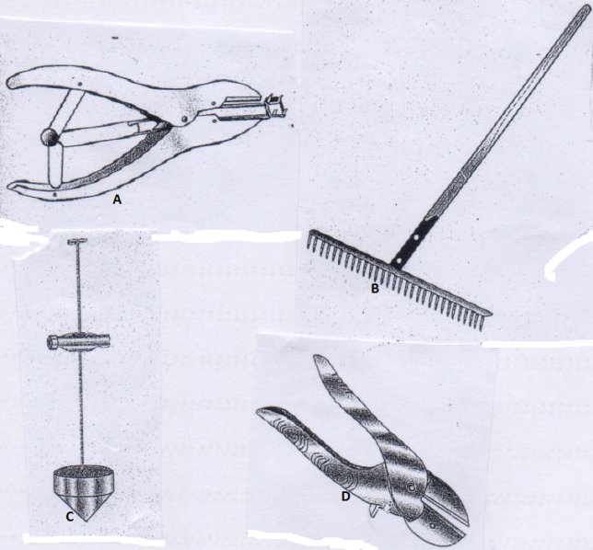
(a) Give the correct name of each of the tools illustrated above. (2mks)
A: Elastrator
B: A rake
C: Plumb bob
D: Secateur
(b) How is each of the tools B and D maintained? (1mk)
B: repair the broken handle, repair any broken or bent teeth, Oil metallic parts to prevent rust, store in a tool store.
D: Replace broken handles, Apply oil on the metallic parts to prevent rusting, grease the pivot and store properly in a tool cabinet.

(c ) State one proper use of each of the tools A and C. (2mks)
A: To enlarge the rubber ring during; castration of small livestock, dehorning of livestock and docking of lambs
C: to check for perpendicularity of the walls in a building
19 The diagram below illustrates a method of providing feed stuff to chicken in a chicken house. Study the diagram and answer the questions that follow.
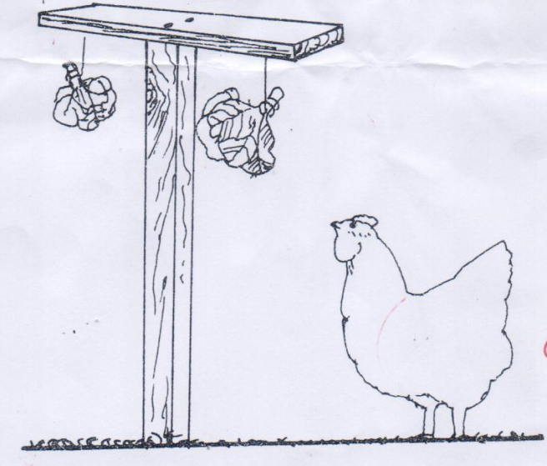
(i) What type of feed stuff is illustrated in the diagram above? (1mk)
Green vegetables
(ii) Give two reasons why the feed stuff should be suspended above the height of the chicken. (2mks)
- keep the birds busy by jumping and pecking them
- To avoid it from getting contaminated with chicken droppings
(iii) Apart from above practice, name one other practice that can be used in place of practice (ii) above. (1mk)
- Spreading grains on the floor
(iv) What other advantage of the practice named in (ii) in a deep litter house. (1mk)
- Make the birds to mix the litter when scratching in search of grains hence avoid caking of droppings.
20 The diagrams below illustrate two types of rabbit hutches labeled L and M. Study the diagrams and answer questions that follow.
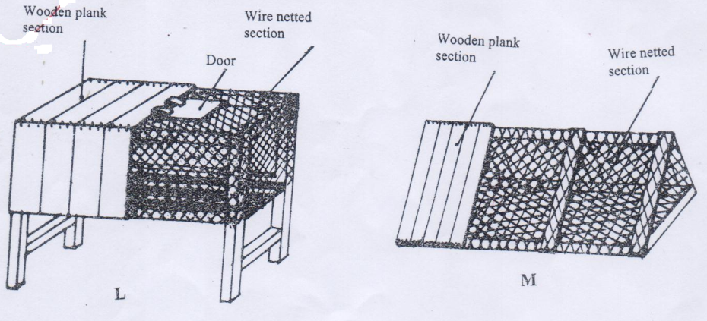
(a) In which section of the hutches should the water and feed troughs be placed? (1mk)
- wire netted section
(b) State one use of the wooden section of the hutch. (1mk)
- where the rabbits sleep at night
- where the young ones stay or kindling occurs
(c ) What additional facility should be included inside the hutches for a doe? (1mk)
- Kindling section.
(d) Identify the type of floor shown in hutch L above. (1mk)
- raised above the ground
(e) Give one advantage of the type of floor illustrated in hutch L above. (1mk)
- Facilitate drying of beddings and allow droppings to fall to the ground
- It prevents predators and rats from getting into the house.

21 Below is a diagram of an Ox-plough. Study it and answer questions that follow.
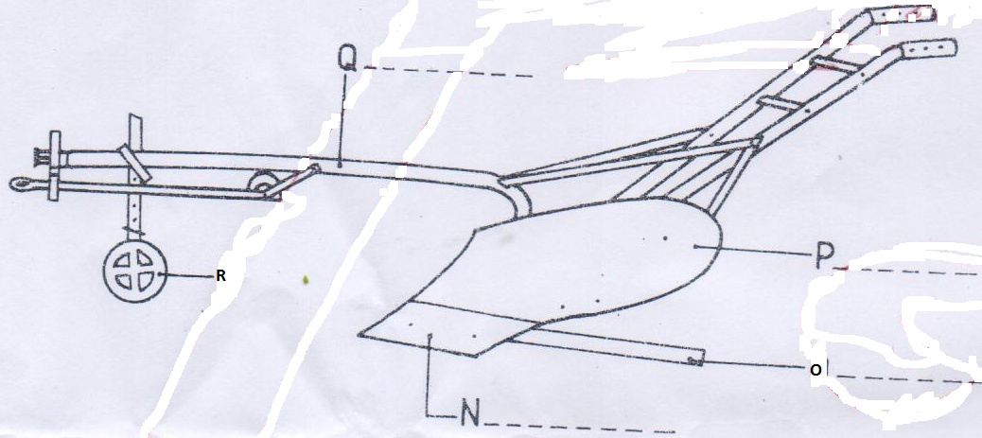
(a) Identify the parts labeled N,O,P and Q on the diagram above. (2mks)
N: share
O: Landside
P : Mouldboard
Q: Main beam
(b) State one maintenance practice that should be carried out in each of the parts labeled N and R.
N: Sharpen when necessary, Replace/ repair when broken. (1mk)
R: Clean/remove trash/soil, Grease/Lubricate the axle/Grease the moving parts, Tighten loose nuts, Replace when broken. (1mk)
(c ) What adjustment should be carried out on the implement so as to reduce the depth of ploughing. (1mk)
- By lengthening the top link
- By reducing the depth wheel

SECTION C (40 Marks)
Answer any two questions from this section. The answers be written in the spaces provided after every question.
22 (a) Describe the process of processing honey using heat method. (6mks)
Procedure of processing honey using heat method;
- Heat some water in a sufuria
- put honey combs in an enamel basin or any other container which is not made of iron
- put the container with honey combs on the boiling water
- Heat until most of the honey melts
- Separate the melted honey from the combs by straining through a muslin cloth
- Keep honey in a container to cool down
- Remove the wax layer that may form on the surface of the honey.
(1 x 6 = 6marks)
(b) Describe Foot and Mouth disease under the following sub- headings;
(i) Causal organism. (1mk)
- Infectious virus of myxovirus
(ii) Animal attacked (1mk)
Cattle
(iii) Five symptoms of attack. (5mks)
- A sharp rise in temperature at first
- Painful blisters around the mouth, udder and between the hooves
- Excessive salivation
- Difficulties in eating and loss of appetite
- Lameness
- Reduced milk yield in case of a lactating cow
- Peeling of hair from the coat and wounds on the skin.
(1 x 5 = 5 Marks)
(iv) three control measures. (3mks)
- Vaccinate animals
- Observe quarantine regulations
- Dead animals should be disposed off completely and carcass shouldn’t be opened
- ( 1 x 3 = 3 Marks)
(c ) Outline four ways through which power is made available from a tractor. (4mks)
Power transmitted from the engine is made available through;
- The propeller shaft: connects the gear box to the differential that has axles which drive the wheels making the tractor to move it pushes or pulls the implements attached to it.
- The power take off shaft (PTO Shaft): This rotates at the same speed as the crankshaft. It is connected to machines such as mowers, planters, rotavators, sprayers and fertilizer spreaders.
- Hydraulic system: operated using a lever that is near the driver’s seat. It is attached to the three point linkage which lowers or raises the mounted implements i.e ploughs, mowers, planters and sprayers.
- Draw bar: serves for the attachment of trailed implements that are used during harrowing, transportation or rolling.
(1 x 4 = 4 marks)
23 (a) Explain six requirements of a good calf pen. (6mks)
- Concrete floor
- Single housing
- Adequate space- this to allow room for exercise, feeding and watering equipment
- Proper lighting; light is necessary for synthesis of Vit D
- Proper drainage; poor drainage cause dampness which predisposes the calf to infections.
- drought free; should be constructed in a way that the side facing the windward be made of solid to prevent wind from entering. Should be well ventilated
- Leak prove roof: Roof shouldn’t be leaking to avoid wetness in the pen. Wetness encourage infections such as Pneumonia, Navel sickness and calf scours.
(1 x 6 = 6 marks)
(b) (i) Give four reasons for steaming up a dairy cow. (4mks)
- To provide nutrients for maximum growth of foetus
- To help build up energy for parturition
- To ensure birth of healthy calf
- To promote good health of the mother
- To stimulate alveoli cells, increase and maintain high milk yield after birth.
- To accustom the cow to the dairy man.
( 1 x 4 = 4marks)
(ii) Explain the management practices carried out on a dairy calf from birth and immediately after birth. (4mks)
-Watch for breech presentation and, if possible, seek for assistance of veterinarian in case of a problem.
- Remove mucus around the muzzle of the young one to allow it to breathe efficiently
- Administer artificial respiration to the young one if breathing is delayed.
- Allow the calf to suckle colostrum
- Allow the mother to lick the young one. Wipe the young one using a clean piece of cloth if the mother does not lick it.
- Tie and cut the navel cord and disinfect the wound using iodine.
- Record the weight of the calf because this will help monitor the growth.
-Take orphaned, disowned or weak calf to a warm place to avoid chilling.
- Separate the calf from the dam after it has been licked and put it in a warm pen.
( 1 x 4 = 4 marks)
(c ) Outline six signs of round worms (Ascaris spp) infestation in cattle. (6mks)
- Anorexia under heavy infestation
- Stiff dry coat or staring coat
- Eggs and adults are seen in faeces
- Dehydration and a pale mucosa
- General emaciation
- The animal may have diarrhoea
- Anaemic condition where infestation is heavy
- Pot-bellies especially in young animals.
(1 x 6 = 6 marks)
24 (a) Describe the process of egg formation in a chicken up to the point of lay. (10mks)
The formation of an egg in a chicken takes between 24 and 26 hours. The formation of the egg begins at the ovary where each ovum is held firmly by a protective device called a follicle.
- The mature ovum (yolk) is released from the ovary through the rapturing of the follicle. The egg moves down to the oviduct where it is received by the funnel.
- At the funnel also called the infundibulum, fertilization takes place as it moves through the funnel.
- Chalaza are added to hold the yolk and egg stays at this point for a quarter of an hour.
- Magnum: From the funnel the ovum moves down to the magnum where thick albumen is added and the egg stays here for 3 hours then moves down to the isthmus.
- Isthmus: this is about 10.6cm long and the yolk is added shell membranes are added. The shape of the egg is also determined here (isthmus). Water, mineral salts and vitamins are also added. Egg stays for an hour then moves to the uterus.
- Uterus (Shell gland), this is the area with high calcium deposits. The shell is added to the egg and the albumen is completed here. Shell pigment is also added and the egg stays here for 18 – 22 hours then moves down to the vagina.
- Vagina; this about 6.5 cm long and the egg is temporarily stored before it is laid, then it finally moves to the cloaca, where the egg moves through to the vent. The cloaca extends out to deposit the egg and this stops it from breaking.
( 1 x 10 = 10 mks)
NB If the process is not maintained the student loses marks. The question be marked the same way a procedural question is marked. Use tour discretion to ward the marks i.e part on uterus be awarded 2mks maximum.

(b) State the difference between four stroke cycle and two stroke cycle engine. (4mks)
Four stroke cycle Engine | Two stroke cycle engine
-Produces high power and can do heavy farm work  -Have efficient fuel and oil utilization.  - they perform a wide range of farm operations.  - Engines are efficiently cooled with water, hence engines are large.  -Exhaust gases are effectively expelled from cylinders.  - their use is limited in areas. | Produces less power and cannot be used for heavy duties in the farm  -inefficient in burning fuel to produce power.  - used for specific operations in the farm  - they air cooled engines thus limiting the size of engines.  Gases not effectively expelled.  -They can be used in wide range of farm land including hilly areas.

(c ) Describe the process of digestion in the rumen. (4mks)
- This is the first stomach compartment
- Food is temporarily stored in the rumen before regurgitation to the mouth for further chewing
- In this chamber, the food is acted upon by micro- organism
- During temporary storage, the food is fermented a condition necessary for microbial digestion.
- There is synthesis of vitamin B complex ie VitB1,Vit B2,Vit B6 and Vit K.
- Synthesis of amino acids from ammonia gas
- Breakdown of carbohydrates and cellulose to carbon dioxide and volatile fatty acids ie acetic , butyric propionic and formic acids.
- Ammonia gas and volatile fatty acids are absorbed through the walls of rumen. Gases ie methane, hydrogen and carbon dioxide are released through belching.
(1 x 4 = 4 marks)

