3171
GEOGRAPHY
Paper 1

JULY/AUGUST, 2018
MOKASA 11 JOINT EXAMINATION
Kenya Certificate of Secondary Education
312/1
Paper 1
GEOGRAPHY
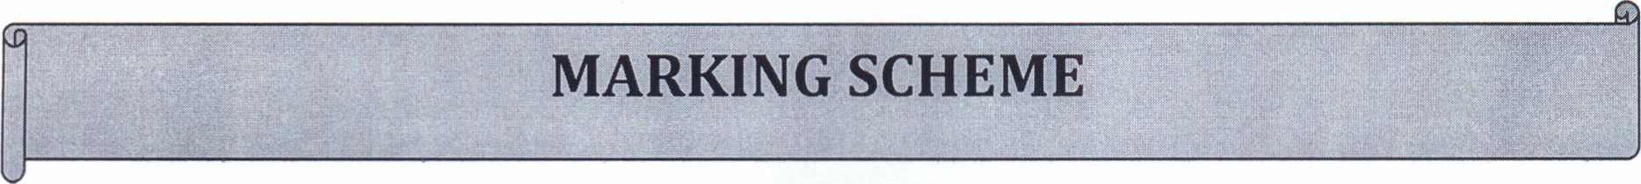
SECTION A
Answer all the questions in this section.

1. a) Define the term geography ( 2mks)
• Geography is the scientific study of the earth as a home of human kind. Or the study of distribution and the interrelationship of natural and human phenomena on the earth's surface.

b) State three importance of studying practical geography. (3mks)
- Provides knowledge about the immediate and wider environment
- Makes us understand the earth on which we live.
- Promotes awareness on the sustainable use of resources
- Promotes development of skills and critical thinking.
2. Study the figure below and use it to answer the questions that follow.
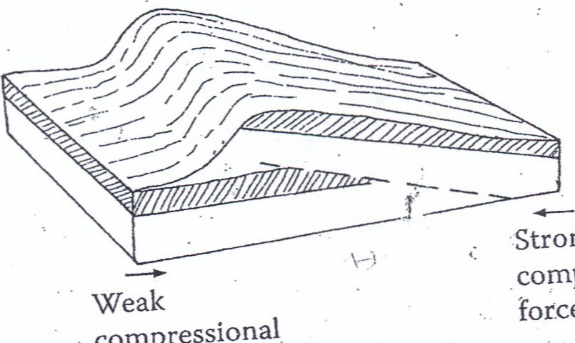
Strong
force
compressional
compressional
force

a) Identify the type of fault shown above in the diagram (Imk) A thrust fault
b.) Describe how the figure shown in (2ai) above is formed. (4mks)
•The rocks are subjected to strong forces of compression
•The forces cause a fault to develop in nearly a horizontal position
•One block of land is forced or thrust forward over the other along the fault
•This block forms a thrust fault.
3. The figure below shows an underground feature use it to answer the questions that follow.
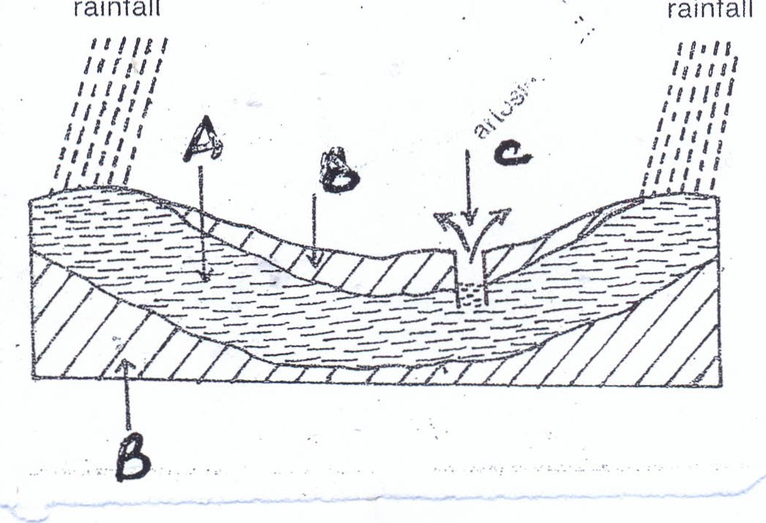
rainfall
rainfall
- Identify the parts marked A and B
  - -An acquifer ( 1 mk)
  - Impermeable rocks (Imk)
- Describe how an uvala is formed (3mks)
    - Rain water absorbs carbon dioxide in the air forming a weak carbonic acid.
    - The rain water percolates through the rock joints causing a solution along the joints
    - The solution leads to merging of severals joints forming dolines.
    - The dolines then merge during solution process forming a large depression called an uvala.
4. a) state two processes through which glacier moves.
(2mks)
- Glacier moves through plastic flowage.
- Glacier moves through basal slip
- Glacier moves through extrusion flow
Any 2x1=2mks
b) Describe the process of ice formation, (3mks)
- Accumulation of snow as a form of precipitation when the temperature fall below freezing point
- The lower layers of snow are compressed into a hard mass of due increased weight
- The harder layers /mass form a collection of grains of an ice.
- Describe how lake chala was formed. (5mks)
  - Volcanic eruption led to formation of a volcanic cone.
  - Some magma solidified in its vent blocking it from escaping.
  - Pressure piled below the plug of the volcano,an explosion eventually occurred at the top of the volcano leading to the formation of a crater and caldera.
  - When water occupied the crater a lake called chala was formed.
SECTION B
Answer question 6 and any other two questions from this section.
- Study the map of KITALE (sheet 75/3) provided and answer the questions that follow.
- Measure the distance the loose surface road C638 from the grid reference
400137 to the grid reference 472100 ( give your answer in kilometers)
(2mks)
9.6km 0. I km
- Citing evidence from the map identify the social services in the area covered by the map.(5mks)
  - Health services as shown by the hospitals.
  - Administrative services as shown by the DC'S office in kitale town.
  - Sports services as shown by sports clubs,golf courses.
  - Recreational services as shown by the clubs.
  - Religious services as shown by the church.
  - Educational services as shown by schools.
(Any 5xl=5mks)
- Describe the distribution of settlement in Kitale (5mks) There are both urban and rural settlement.
  - Rural settlement is dominant throughout the area
  - There are nucleated settlement in the south, central and the northernparts of the area.
  - There are linear settlement in some parts of the area. There are no settlements in the forests.
  - There are very few settlements close to the forerst.
  - There are few settlements in the plantations.
  - There are sparce nucleated settlements in the area. The sparce settlements are evenly distributed in the area.
(Any 5x1=5mks)
- Enlarge the area coverered by the map between the Easting 35 to Easting 39 and between Northing 29 and Northing 33 by two. (2mks ) On the enlarged map mark and name;
i) West pokot county (Imk) ii) A forest ( Imk) iii)A dam (Imk)
Give the scale of the enlarged map (2mks) 1:25000
e) Citing evidence ,explain three factors favouring trading in the area covered by the map (6mks).
- Ready market due to the presence of the many settlements in the area.
- Transport for easy movement of goods and travelers as shown by many roads and railways.
- Availability of storage facilities for safeguarding of goods
- Labour for the production of goods and services as shown by the many settlement in the area covered by the map.

(Any 3x2=6mks)
7. a) What is volcanicity? (2marks)

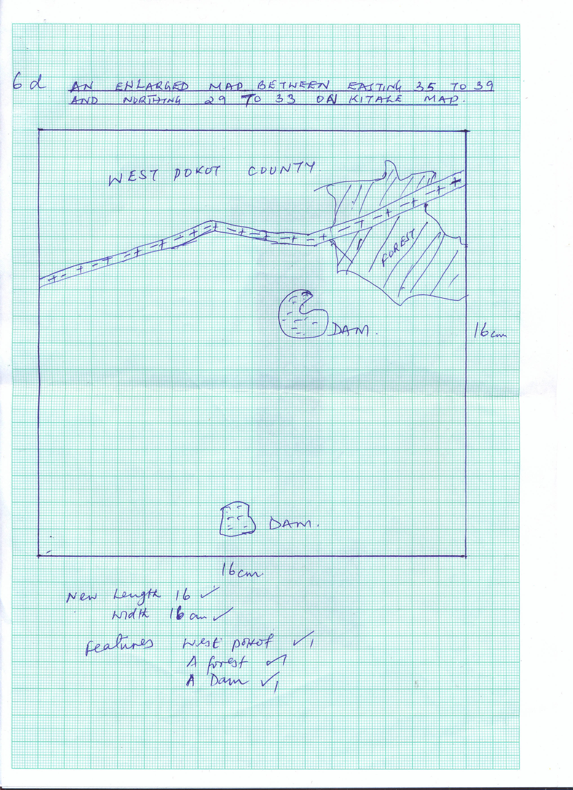
• It is a process through which magma from the interior of the earth reaches onto the earth's surface to form extrusive volcanic features
- State four differences between basic lava and acidic lava.
  - Basic lava has low silica content while acidic lava has high silica content
  - Basic lava has low viscosity while acidic lava has high viscosity.
  - Basic lava cools and solidifies slowly while acidic lava cools and solidifies quickly.
  - Basic lava has high temperature while basic lava has lower temperature. (4mks)
- Describe how the following features are formed:
(i) Hot Springs (6 marks)
  - The rain water percolates through cracks in the crustal rocks and comes into contact with hot volcanic rocks in the underground.
  - The percolating water gets accumulated into the undergrounds sumps/chambers
  - The underground water gets superheated to form steam which expands and collects in the underground chambers/sumps.
  - The stem generated leads to pressure buildup that forces hot water upwards through the rock cracks thus reaching onto the earth's surface.
  - The hot water gently bubbles/flows out of the ground calmly.
  - The quiet and continuous outflow of hot water forms a feature known as a hot spring.
(The last point must be mentioned to score full marks)
(ii) Plug Dome Volcano. (5 marks)
    - Earth movements within the earth's crust lead to the formation of a vent in the crustal rocks.
    - Highly viscous magma is forced out through the vent such that the eruption is violent leading to the weakening of the rocks around the vent, breaking them and the debris settles around the vent.
    - When the highly viscous magma reaches the earth's surface, it quickly cools and solidifies as it rises above the earth's surface.
    - More pressure from underground pushes the plug upwards further rising high above the general ground level.
*This forms a cylindrical shaped pillar of solid lava having vertical steep sides called a plug dome.
(The last point must be mentioned to score full marks)
- Explain four negative effects of volcanicity to physical environment

(8 marks)
- Some vocanic features such as mountains creates a rugged landscape making construction of transport and communication lines difficult and expensive.
- High volcanic mountains creates rain-shadow effect causing arid conditions/inadequate rainfall on the leeward side thus discouraging agriculture and human settlements.
- Active volcanic mountains may erupt producing poisonous gases polluting the environment posing a danger to human life.
- Recent volcanic lava flows makes poorly developed soils thus discouraging agriculture.
- Violent volcanic eruptions may cover human settlements causing loss of human lives and properties.

8. a) What is a river capture ? (2 marks)
• This is the diversion of head water [beheading of one river into the system of theadjacent more powerful river
b)i)Give three factors influencing the development of a drainage pattern.
- Direction of the slope
- Difference in rock resistance/hardness
- The arrangement of rock layers/rock structure
- Occurrence of a fault line through which a river flows/faulting on the landscape ( any 3x1=3mks)
(ii) Explain three factors which influence a rivers ability to transport materials

• Size of the river/amount of the river discharge
The larger the river /the more the water in the river , the higher the ability to transport its load e The speed of the river
The higher the speed, the higher the ability of the river to transport its load
Fast flowing rivers transport more materials than slow moving rivers

• The slope of the land
The steeper the slope, the higher the ability of the river to transport
Rivers deposit more materials on the flat surface but transport on steep slopes The amount of load
The higher the amount of load, the lower the rivers ability to transport
High amount of load , forces the river to deposit more than transport

• Size of individual rock particles
Fairly light particles are transported over long distances/heavy and large rock boulders are transported over short distances
Large load reduces the efficiency of the river to transport as the materials keep colliding reducing the speed and momentum of the river
(any 3 x 2=6mks)
- Describe how alluvial fan is formed using a well labeled diagram (6mks)
  - A river flows from a high land into a wide low lying plain
  - A sharp decrease in gradient and increase in channel width causes a marked reduction in the stream energy
  - This causes deposition of materials compost of fine silt ,gravel and boulders
  - The deposits spread out in different directions
  - Continuous deposition leads to accumulation of materials leading to formation of a cone shaped feature known as alluvial fan
- You are required to carry out a field study on erosion in a youthful river near your school.
- Identify two features you are likely to study (2mks)
  - Stream cut valleys
  - Rapids
  - Gorges
  - Waterfalls
  - Potholes
  - River capture
  - Interlocking spurs ( any2 x marks)
- State three activities you would carry out to determine why erosion occur at this stage
    - Measuring the gradient of the river
    - Finding out the nature of rocks/accessing rock hardness/solubility
    - Finding out the speed of the river flow
    - Counting the number of tributaries
    - Measuring the river discharge
    - Finding out the amount /nature of the load (any 3 x 1= 3 marks)
- Identify three objectives of your study. (3mks)
    - To find out the annual rate of erosion in the river
    - To find out the composition of the eroded materials
    - To find out the features formed by the river erosion in the river stage
    - To find out the processes of river erosion in the river
    - To find out the effects of the river erosion on the local community
9. a) State three characteristics of a fiord  - Has steep sided walls  - Has narrow sea inlets  - Has deeper landward end.  - Has shallow seawards end. | (3 marks)
b) Give four factors of coastal evolutions marks) |  | (4
    - The nature of the waves.
    - The nature of the coastal rocks The gradient of the coast

    - The orientation/alignment of the coast in relation to the prevailing winds
c) Describe how the following features are formed:
- A Wave-Cut Platform (6 marks)
    - Wave action through abrasion and hydraulic action erode the base of a cliff forming a notch
    - Wave action continues enlarging the notch into a cave.
    - The roof of the cave collapses and the cliff retreats
    - Further undercutting at the base of the new cliff begins causing more collapsing
    - The cliff wall retreats into the land
    - This will form a fairly flat bench-land on the cliff-visible during the low water tide called a wave-cut platform.
(The last point must be mentioned to scorefull marks
- A cuspate foreland (4 marks)
  - Its formed when two spit grow from both sides of a mainland into the sea
  - Addition of more sediments into the two spits will form beach ridges.
  - The beach ridges are smoothened by sediments enclosing a shallow lagoon.
  - Finally, the two spits meet and form a cuspate foreland.
d) Explain four significance of the Indian Ocean to the human activities
  - Moisture released into the atmosphere through evaporation leads to the formation of rainfall for agricultural activities.
  - Indian Ocean water provides variety of recreational sites for swimming, surfing and sport-fishing.
  - The continental shelf and the deep sea are habitats for varieties of fish species encouraging fishing activities
  - Submerged Rias are deep and well sheltered forming favorable sites for development of port facilities.
(any 4x2=8marks)
10. a) (i) Name any two types of desert surfaces
  - Erg/sandy desert
  - Reg/stony desert
  - Hamada/rocky desert
  - Badland
( (any 3 x 1= 3 marks)
(ii) The diagram below represent features resulting from wind erosion in a desert. Use it to answer question a (ii)
Horn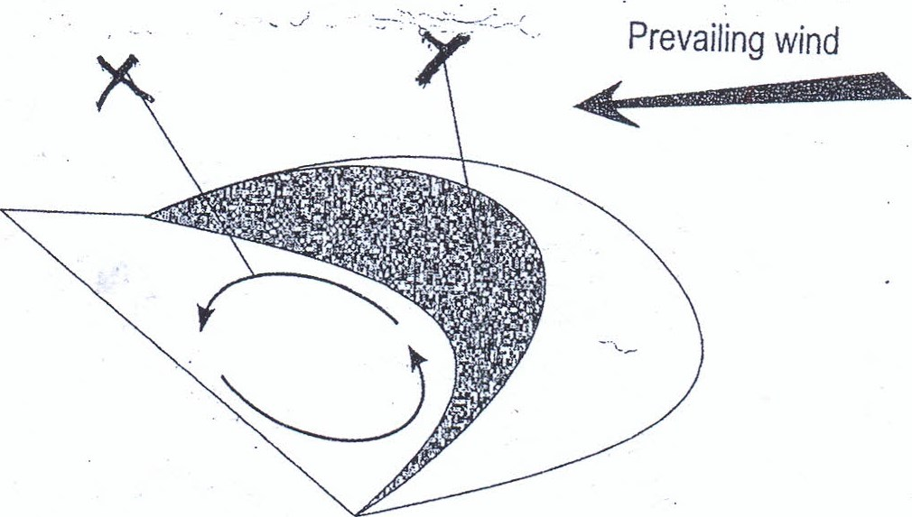
Name the features marked X and Y

2marks)
- X eddy currents
- Y steep slope
(b) Using a well labeled diagram ,describe how a butte is formed (4mks)
- Forms in desert uplands/plateaus where the underlying rocks are composted of the rocks that alternate between hard and soft rocks and where cap rock is resistant
- Weathering opens up the cracks on resistant layer
- Water from torrential rainfall forms flush floods which flow over the rocks
- The water erodes the rocks along the cracks by abrasion and hydraulic action Further deepening and widening of the valleys occurs due to lateral and vertical erosion to each the soft layers of rocks
- The soft layers of rocks is eroded faster by wind/water to form steep slopes
- This eventually leads to the formation of a flat topped hill called a mesa
- Further erosion by wind /water occurs on the mesa over a long period of time
- The hills are reduced to form small flat-topped hill called butte
(a) (i) State four physical causes of aridity
  - Insufficient rainfall/low rainfall
  - Extremely high temperatures
  - Presence of cold ocean currents
  - Presence of a relief barrier
  - Distance from large water bodies/continentality
  - Wind systems
  - Pressure systems ( any 4x 1— marks)
(iii) Explain three negative effects of climate change on agriculture
- Desertification and soil erosion are likely to increase thus leading to reduced crop yields
- As the oceans expand ,sea levels rises causing flooding of low lying areas especially along the coastal region suitable for agriculture
- Possible rise in temperatures causes increase in evaporation rates leading to increased rainfall in some areas that may be in excess to agriculture thus wastage ( 3 x 2= 6marks)
(d) Explain three significance of desert landscape to human activities
- Desert features .e.g. zeugens/rock pedestals/yardangs are tourist attractions Deflation hollows may contain water used for domestic use/livestock use/irrigation
- Loess forms fertile soils used for farming
- Seasonal streams may be dammed to provide water for irrigation during the dry seasons Dry landscape/areas is an area suitable for testing military weapons/military training
- Sand dunes may cover roads making transport difficult Wadis/badland/unstable sand dunes make transport facilities difficult/expensive/barrier to lines of transport
- The hot desert has high solar insolation for solar energy production Desert scenery with clear skies provide good sites for shooting of films
- Rocky desert surfaces discourage settlement
- The playas/salt pans are utilized for the extraction of salts
- The torrential rains experienced in the desert cause floods which can easily destroyed dwellings/burry transport lines
- The hot deserts are extensively covered by sand which is used for recreation/desert cruise in the Dubai desert (any 3 x 2= 6marks)

